Task No: 5  Date:13/10/25 | Write a Spark application to perform word count in the input file.  Tools: APACHE SPARK | CO2

Task 4.1: Apache Spark Installation
Aim:
To download, install and configure the Apache Spark in Windows operating system.

Procedure:
- Download and install Java Development Kit (JDK) version 8 or higher, and ensure the RAM size, least 8 GB.
- Download and install Python latest version from https://www.python.org/
- Visit the Apache Spark website at https://spark.apache.org/downloads.html to download the latest stable release of Spark. [figure 1]
- Type the following command in the command prompt to check the java and python version:
    - java --version
    - python --version
- Create a new folder named Spark in the root of your C: drive and locate the Spark file you downloaded.
- Right-click the file and extract it to C:\Spark using the tool you have on your system
- Download the winutils.exe file for the underlying Hadoop version for the Spark installation, from the URL https://github.com/cdarlint/winutils
[figure 2]
- Configure Environment Variables
- Click Start and type environment.
- Select the result labeled Edit the system environment variables.
- A System Properties dialog box appears. In the lower-right corner, click Environment Variables and then click New in the next window.
- For Variable Name type SPARK_HOME. [figure 3,4]
- For Variable Value type C:\Spark\spark-2.4.5-bin-hadoop2.7 and click OK. If you changed the folder path, use that one instead.
- In the top box, click the Path entry, then click Edit. Be careful with editing the system path. Avoid deleting any entries already on the list.
- The system highlights a new line. Enter the path to the Spark folder C:\Spark\spark-2.4.5-bin-hadoop2.7\bin. We recommend using %SPARK_HOME%\bin to avoid possible issues with the path. [figure 5,6,7]
- Repeat this process for Hadoop and Java. For Hadoop, the variable name is HADOOP_HOME and for the value use the path of the folder you created earlier: C:\hadoop. Add C:\hadoop\bin to the Path variable field, but we recommend using %HADOOP_HOME%\bin.
- For Java, the variable name is JAVA_HOME and for the value use the path to your Java JDK directory (in our case it’s C:\Program Files\Java\jdk1.8.0_251).
- Launch Spark, To start Spark, enter the command
- C:\Spark\spark-2.4.5-bin-hadoop2.7\bin>spark-shell
- If you set the environment path correctly, you can type spark-shell to launch Spark.
- Finally, the Spark logo appears, and the prompt displays the Scala shell.
- Open a web browser and navigate to http://localhost:4040/.

- Launch pyspark, enter the command
C:\Spark\spark-2.4.5-bin-hadoop2.7\bin>pyspark

Thus:
Thus Apache Spark downloaded, installed and configured the in Windows operating system, Successfully.

Figure 1
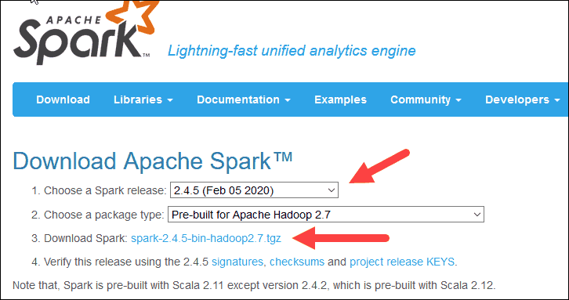

Figure 2
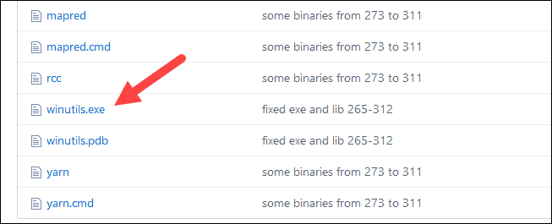

Figure 3
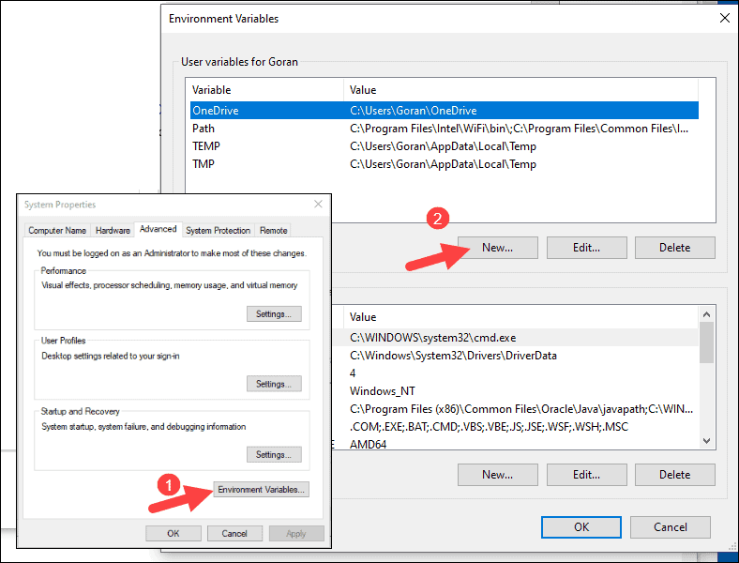

Figure 4

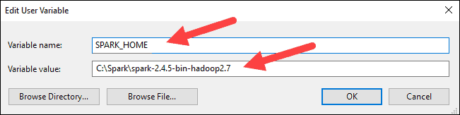

Figure 5
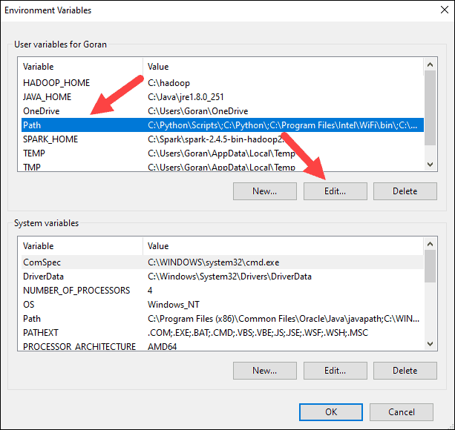

Figure 6
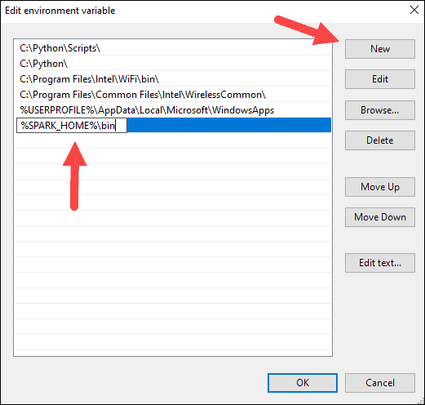

Task 4.2: Spark application to perform word count

Aim:
To implement the spark application to perform the word count using pyspark

Procedure:
- Check the spark installation, environmental variables setup
- Import necessary libraries from pyspark
- Create a SparkConf and SparkContext (or SparkSession):
- Load the input data
- Read the input file and Calculating words count
- Perform the word count operation
- Save the output, Stop the SparkContext or SparkSession
- Stopping Spark-Session and Spark context
Program:
import findspark
findspark.init()
from pyspark.sql import SparkSession
spark = SparkSession.builder\
.master("local")\
.appName('Firstprogram')\
.getOrCreate()
sc=spark.sparkContext
text_file = sc.textFile("firstprogram.txt")
counts = text_file.flatMap(lambda line: line.split(" ")) \
.map(lambda word: (word, 1)) \
.reduceByKey(lambda x, y: x + y)
output = counts.collect()
for (word, count) in output:
print("%s: %i" % (word, count))
sc.stop()
spark.stop()

File Name: firstprogram.txt
Chennai formerly known as Madras, is the capital city of Tamil Nadu, the southernmost Indian state.
Output:
Chennai: 1
Formerly: 1
Known: 1
as: 1
Madras: 1
Is: 1
the: 2
Capital: 1
City: 1
Of: 1
Tamil: 1
Nadu: 1
southernmost: 1
Indian: 1
state.: 1

Result:
Thus the Program to count the words in the given file using Pyspark application was implemented successfully.

