Vel Tech Rangarajan Dr. Sagunthala R&D Institute of Science and Technology

(Deemed to be University Estd. u/s 3 of UGC Act, 1956)

School of Computing
B.Tech. – Computer Science and Engineering
VTR UGE2021- (CBCS)

Academic Year: 2025–2026
SUMMER SEMESTER - SS2526
Course Code : 10211CS207
Course Name: Database Management Systems
Slot No : S2L5
DBMS TASK - 1 REPORT
Title: Conceptual Design through FTR
Submitted by:
VTUNO | REGISTER NUMBER | STUDENT NAME
VTU27512 | 24UECS1400 | T.MOKSHITHA

🎯 1.a – Identifying Entities
These are the main objects or concepts that store data:
- CricketBoard
- Team
- Player
- Match
- Ground
- Umpire

📋 1.b – Identifying Attributes
Here are attributes for each entity (primary key underlined):
- CricketBoard(BoardID, Name, Address, Contact_No)
- Team(TeamID, Name, Coach, Captain)
- Player(PlayerID, FName, LName, Age, DateofBirth, PlayingRole)
- Match(MatchID, Date, Time, Result)
- Ground(GroundID, Name, Location, Capacity)
- Umpire(UmpireID, FName, LName, Age, DateofBirth, Country)

🔗 1.c – Relationships, Cardinality, and Type
Relationship | Entities Involved | Cardinality | Type
Board-Manages-Team | CricketBoard – Team | 1 : M (One board manages many teams) | 1 to Many
Team-Has-Player | Team – Player | 1 : M (One team has many players) | 1 to Many
Match-Includes-Team | Match – Team | M : M (Matches involve multiple teams) | Many to Many
Match-IsHeldAt | Match – Ground | M : 1 (Many matches can be held at one ground) | Many to One
Match-Has-Umpire | Match – Umpire | M : M (Each match has multiple umpires, and an umpire can officiate many matches) | Many to Many

Here is an image representing the ER Diagram for the cricket database model you described:
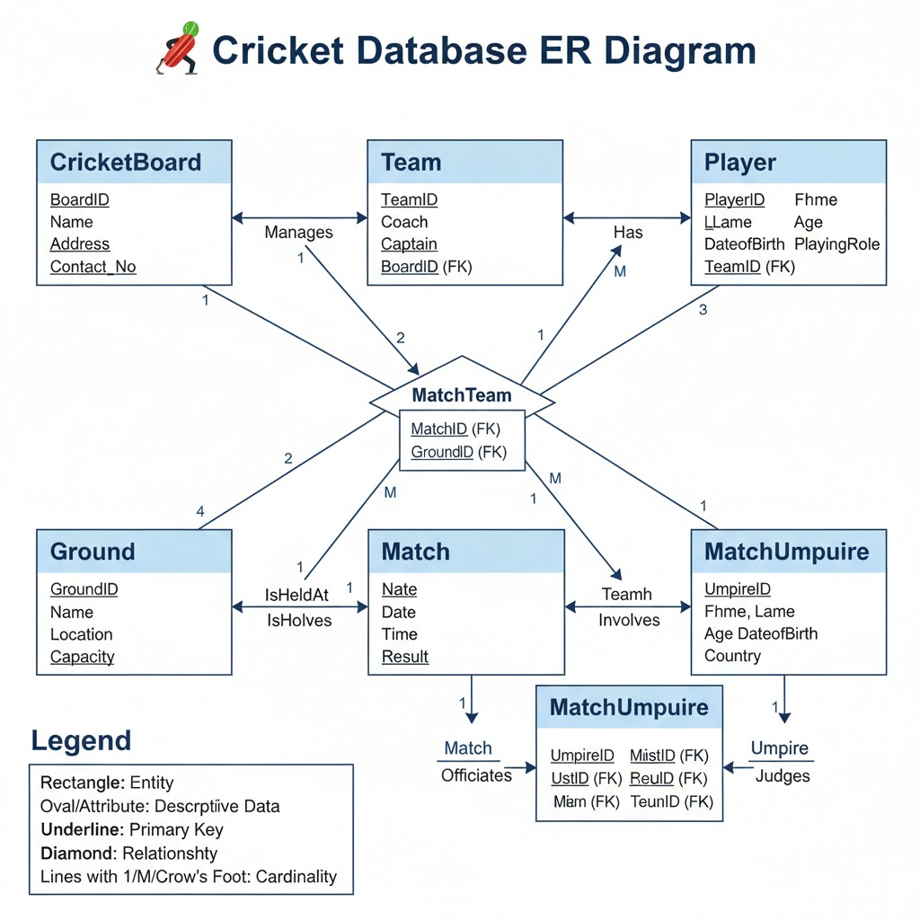

RESULT: Thus the TASK has completed successfully.

