Vel Tech Rangarajan Dr. Sagunthala R&D Institute of Science and Technology

(Deemed to be University Estd. u/s 3 of UGC Act, 1956)

School of Computing
B.Tech. – Computer Science and Engineering
VTR UGE2021- (CBCS)

Academic Year: 2025–2026
SUMMER SEMESTER - SS2526
Course Code : 10211CS207
Course Name: Database Management Systems
Slot No : S2L5
DBMS TASK - 3 REPORT
Title: Using Clauses, Operators, and Functions in Queries System Name: Online Food Ordering System
Submitted by:
VTUNO | REGISTER NUMBER | STUDENT NAME
VTU27512 | 24UECS1400 | T.MOKSHITHA
Task 3: Using Clauses, Operators, and Functions in Queries System Name: Online Food Ordering System

Aim: To perform query processing on databases for different retrieval results using DML and DRL operations with aggregate functions, date functions, string functions, set clauses, and operators.

CREATE TABLE Customer ( Cust_ID INT PRIMARY KEY,
Cust_Name VARCHAR(100), Cust_Contact VARCHAR(10) UNIQUE, Cust_Email VARCHAR(100) NOT NULL,
Cust_Address VARCHAR(100)

);

CREATE TABLE Restaurant ( Rest_ID INT PRIMARY KEY,
Rest_Name VARCHAR(100), Rest_Location VARCHAR(200), Rest_Contact VARCHAR(10)
);

CREATE TABLE Menu_Item ( Item_ID INT PRIMARY KEY,
Item_Name VARCHAR(100), Price INT CHECK (Price > 0), Category VARCHAR(50), Rest_ID INT,
FOREIGN KEY (Rest_ID) REFERENCES Restaurant(Rest_ID)

);

CREATE TABLE OrderTable ( Order_ID INT PRIMARY KEY,
Cust_ID INT, Order_Date DATE, Order_Total INT,
Payment_Status VARCHAR(50),

FOREIGN KEY (Cust_ID) REFERENCES Customer(Cust_ID)

);

CREATE TABLE Delivery ( Delivery_ID INT PRIMARY KEY, Order_ID INT,
Delivery_Status VARCHAR(50), Delivery_Time DATE,
FOREIGN KEY (Order_ID) REFERENCES OrderTable(Order_ID)
);

- Insert Values into Customer Table
INSERT INTO Customer VALUES (1, 'Alice', '9876543210', 'alice@example.com', 'Street 123');

INSERT INTO Customer VALUES (2, 'Bob', '9123456789', 'bob@example.com', 'Street 456');

INSERT INTO Customer VALUES (3, 'Charlie', '9988776655', 'charlie@example.com', 'Street 789');

- Insert Values into Restaurant Table

INSERT INTO Restaurant VALUES (1, 'Food Paradise', 'Downtown', '9988771234'); INSERT INTO Restaurant VALUES (2, 'Tasty Treats', 'Uptown', '8877664321'); INSERT INTO Restaurant VALUES (3, 'Global Eats', 'City Center', '7766552211');

- Insert Values into Menu_Item Table

INSERT INTO Menu_Item VALUES (1, 'Pizza', 500, 'Italian', 1); INSERT INTO Menu_Item VALUES (2, 'Burger', 300, 'Fast Food', 1); INSERT INTO Menu_Item VALUES (3, 'Sushi', 800, 'Japanese', 2);
INSERT INTO Menu_Item VALUES (4, 'Pasta', 400, 'Italian', 1);

INSERT INTO Menu_Item VALUES (5, 'Noodles', 350, 'Chinese', 3);

- Insert Values into OrderTable Table

INSERT INTO OrderTable VALUES (1, 1, '2025-01-20', 800, 'Paid');

INSERT INTO OrderTable VALUES (2, 2, '2025-01-21', 500, 'Unpaid');

INSERT INTO OrderTable VALUES (3, 3, '2025-01-22', 700, 'Paid');

- Insert Values into Delivery Table
INSERT INTO Delivery VALUES (1, 1, 'Delivered', '2025-01-20 14:30:00');

First insert into OrderTable
INSERT INTO OrderTable VALUES (2, 2, '2025-01-25', 500, 'Pending');

-- Then insert into Delivery
INSERT INTO Delivery VALUES (2, 2, 'Pending', NULL);

INSERT INTO Delivery VALUES (3, 3, 'Delivered', '2025-01-22 16:00:00');

Task 3: Using Clauses, Operators, and Functions in Queries Queries and Outputs
- Aggregate Functions

Query 1: Find the total revenue generated by all orders.

Output:

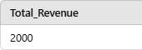

Query 2: Find the total number of menu items offered by each restaurant.
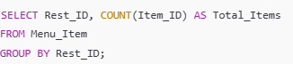

Output:
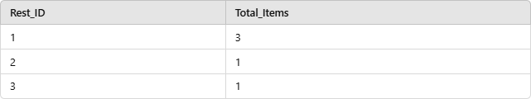

Query 3: Find the average price of all menu items.
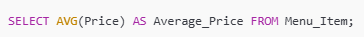

Output:
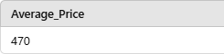

- Date Functions

Query 1: Retrieve orders placed in the last 7 days.
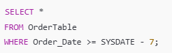

Output:

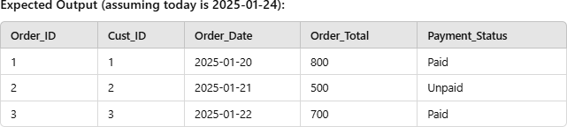

Query 2: Find the orders and their delivery time if delivered today.

SELECT OrderTable.Order_ID, Delivery.Delivery_Time
FROM OrderTable
INNER JOIN Delivery
ON OrderTable.Order_ID = Delivery.Order_ID;

Output:

- String Functions

Query 1: Find all customers whose names contain the letter 'a'.
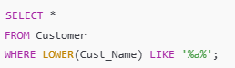

Output:
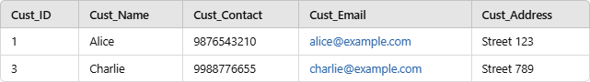

Query 2: Display all menu item names in uppercase.

Output:

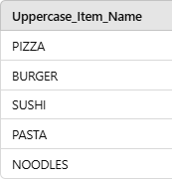

- Set Clauses

Query 1: Update the payment status of all unpaid orders to 'Paid'.
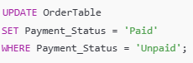

Output:
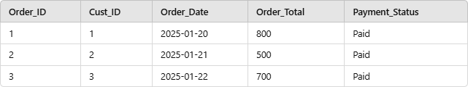

Query 2: Reduce the price of all menu items by 10%.
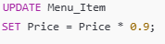

Output:
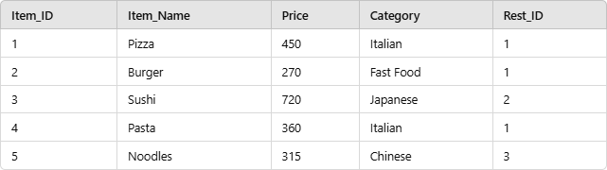

- Operators

Query 1: Retrieve orders where the total is greater than 600.
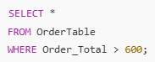

Output:
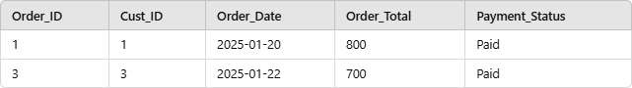

Query 2: Retrieve menu items that belong to category 'Italian' or have a price less than 350.
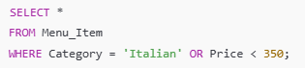

Output:
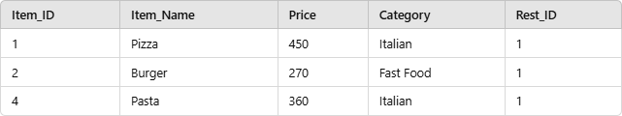
RESULT:Thus the task has completed successfully.

