Vel Tech Rangarajan Dr. Sagunthala R&D Institute of Science and Technology

(Deemed to be University Estd. u/s 3 of UGC Act, 1956)

School of Computing
B.Tech. – Computer Science and Engineering
VTR UGE2021- (CBCS)

Academic Year: 2025–2026
SUMMER SEMESTER - SS2526
Course Code : 10211CS207
Course Name: Database Management Systems
Slot No : S2L5
DBMS TASK - 12 REPORT
Title: MINI PROJECT
Submitted by:
VTUNO | REGISTER NUMBER | STUDENT NAME
VTU27619 | 24UECS0620 | K.laveeniya likhitha

Identifying Entities such as Students, Exams, Questions, and Results
In an online examination system, several key entities interact to manage data about students, tests, questions, and performance results.
1. Student Entity
- Attributes: Student_ID (PK), Name, Email, Password, Department, Year, Roll_No, Contact_No - Description: Represents every individual taking an exam. Each student can register for multiple exams and have multiple result records.
2. Exam Entity
- Attributes: Exam_ID (PK), Exam_Name, Subject, Date, Duration, Total_Marks - Description: Represents each exam conducted. An exam can have multiple questions and multiple students appearing for it.
3. Question Entity
- Attributes: Question_ID (PK), Exam_ID (FK), Question_Text, Option_A, Option_B, Option_C, Option_D, Correct_Answer, Marks - Description: Represents each question belonging to a specific exam. Questions are linked to exams using Exam_ID.
4. Result Entity
- Attributes: Result_ID (PK), Student_ID (FK), Exam_ID (FK), Marks_Obtained, Percentage, Grade, Rank - Description: Stores the outcome of each student’s performance in each exam. Links both student and exam entities.
5. Relationships:
- Student–Exam: Many-to-many (through Result table). - Exam–Question: One-to-many. - Student–Result: One-to-many. - Exam–Result: One-to-many.
Together, these entities form the foundation of the database schema for an online exam system, enabling tracking of student activity, exam content, and performance analysis
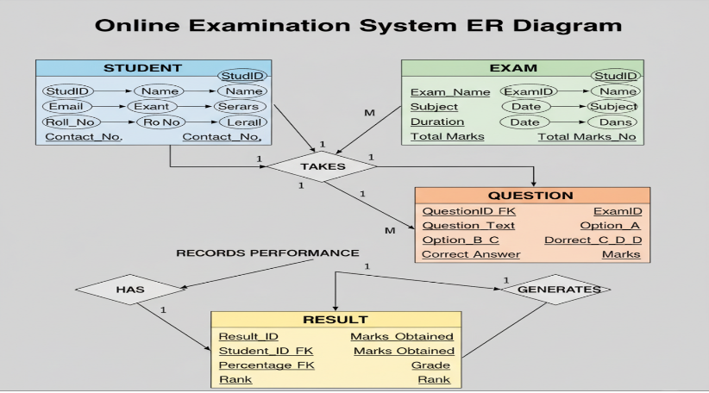

- Normalizing the Relations to Reduce Redundancy in Question and Result Storage
Normalization is the process of organizing data to minimize redundancy and improve data integrity.
Unnormalized Form (UNF) Exam(Exam_ID, Exam_Name, Student_ID, Student_Name, Question_ID, Question_Text, Marks_Obtained)
Here, exam, student, and question data are all stored in one table, causing redundancy. First Normal Form (1NF)
Remove repeating groups; ensure atomic values.
Tables:
- Exam(Exam_ID, Exam_Name, Subject, Date, Duration) - Question(Question_ID, Exam_ID, Question_Text, Option_A, Option_B, Option_C, Option_D, Correct_Answer)

- Student(Student_ID, Name, Email, Department)
- Result(Result_ID, Student_ID, Exam_ID, Marks_Obtained)

Second Normal Form (2NF)
Remove partial dependencies. Each attribute depends fully on the primary key.

Third Normal Form (3NF)
Remove transitive dependencies (e.g., Grade depends on Marks_Obtained, so store separately).

After normalization: - No redundant question or result data. - Updates easier and data integrity maintained.

- SQL Queries to Retrieve Scores and Rank Students by Performance
Assume normalized tables:
Student(Student_ID, Name)
Exam(Exam_ID, Exam_Name)
Result(Result_ID, Student_ID, Exam_ID, Marks_Obtained)
Retrieve each student’s score:
SELECT S.Name, E.Exam_Name, R.Marks_Obtained FROM Student S
JOIN Result R ON S.Student_ID = R.Student_ID
JOIN Exam E ON R.Exam_ID = E.Exam_ID
WHERE E.Exam_ID = 101;
Calculate total marks:
SELECT S.Student_ID, S.Name, SUM(R.Marks_Obtained) AS Total_Marks
FROM Student S JOIN Result R ON S.Student_ID = R.Student_ID
GROUP BY S.Student_ID, S.Name;

Rank students by performance:
SELECT S.Student_ID, S.Name,
SUM(R.Marks_Obtained) AS Total_Marks, RANK() OVER (ORDER BY SUM(R.Marks_Obtained) DESC) AS Rank_Position
FROM Student S JOIN Result R ON S.Student_ID = R.Student_ID
GROUP BY S.Student_ID, S.Name;

Find top 3 students:
SELECT * FROM (
SELECT S.Student_ID, S.Name, SUM(R.Marks_Obtained) AS Total_Marks,
RANK() OVER (ORDER BY SUM(R.Marks_Obtained) DESC) AS Rank_Position
FROM Student S JOIN Result R ON S.Student_ID = R.Student_ID
GROUP BY S.Student_ID, S.Name )
Ranked WHERE Rank_Position <= 3;
Student_id | Name | Total_marks | Rank_position
2 | bob | 177 | 1
1 | alice | 173 | 2
3 | charlie | 168 | 3

- How ACID Properties Are Maintained During Online
Submissions
ACID stands for Atomicity, Consistency, Isolation, and Durability — the properties ensuring reliable database transactions during online submissions.

Atomicity: Each submission is treated as a single transaction. Either all answers are stored or none. Managed via BEGIN, COMMIT, ROLLBACK.

Consistency: Database moves from one valid state to another. Constraints like valid Student_IDs and marks ≤ total marks maintain data correctness.

Isolation: Concurrent submissions don’t interfere. Locking or MVCC ensures one user’s submission doesn’t affect another.

Durability: Once committed, data is permanent even after system failures. Achieved through journaling, write-ahead logs, and backups.

Thus, ACID ensures online exam systems remain reliable, isolated, and recoverable under heavy load.

- CRUD Operations using MongoDB for Exam Results

CRUD Operations using MongoDB for Exam Results
Create:
db.results.insertMany([
{ student_id: 101, exam_id: "EX001", marks: 85, grade: "A" },
{ student_id: 102, exam_id: "EX001", marks: 78, grade: "B"
} ]);
Read:
db.results.find();
db.results.find({ exam_id: "EX001" });
db.results.find({ exam_id: "EX001" }).sort({ marks: -1 }).limit(1);
Update:
db.results.updateOne(
{ student_id: 102, exam_id: "EX001" },
{ $set: { marks: 80, grade: "A" } }
);
Delete:
db.results.deleteOne({ student_id: 103, exam_id: "EX002" });
Aggregation for ranking:
db.results.aggregate([
{ $group: { _id: "$student_id", total: { $sum: "$marks" } } },
{ $sort: { total: -1 } }
]);
RESULT: THUS THE PROGRAMS HAS EXECUTED SUCESSFULLY

