WEEK--11
SESSION 1 HASHSET OPERATIONS ﻿
TASK 1 CONTAINS DUPLICATE ﻿
PROGRAM ﻿
class Solution {﻿
public boolean containsDuplicate(int[] nums) {﻿
HashSet<Integer> set = new HashSet<>();﻿
for (int num : nums) {﻿
if (set.contains(num)) {﻿
return true;﻿
}﻿
set.add(num);﻿
}﻿
return false;﻿
}﻿
}﻿
OUTPUT
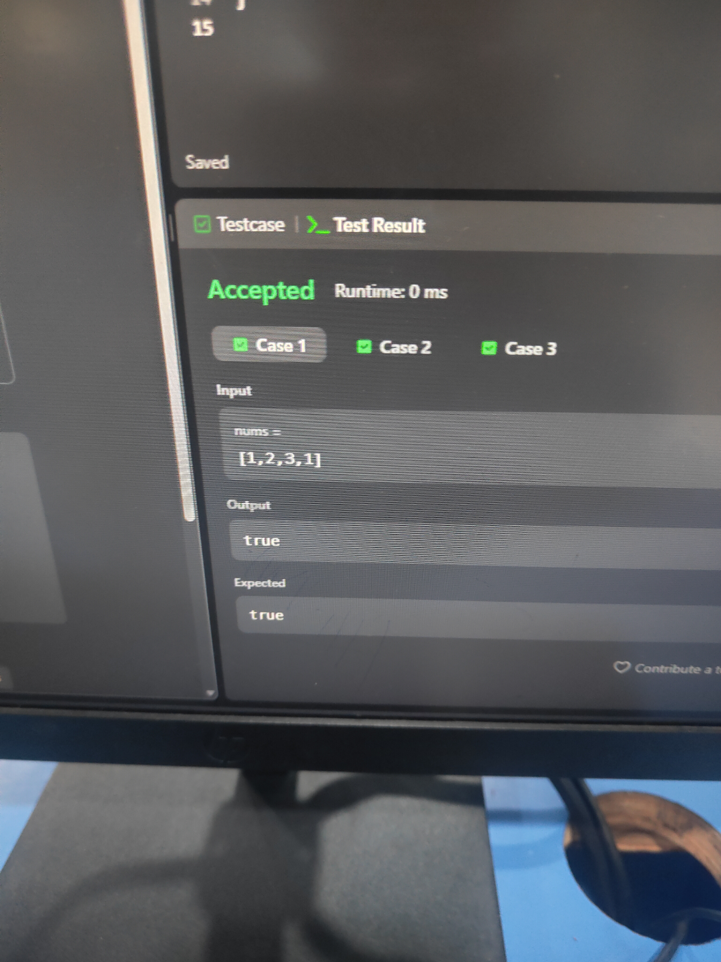
TASK 2 INTERSECTION OF TWO ARRAYS.﻿
PROGRAM ﻿
import java.util.*;﻿
class Solution {﻿
public int[] intersection(int[] nums1, int[] nums2) {﻿
HashSet<Integer> set1 = new HashSet<>();﻿
HashSet<Integer> result = new HashSet<>();﻿
for (int num : nums1) {﻿
set1.add(num);﻿
}﻿
for (int num : nums2) {﻿
if (set1.contains(num)) {﻿
result.add(num);﻿
}﻿
}﻿
int[] ans = new int[result.size()];﻿
int i = 0;﻿
for (int num : result) {﻿
ans[i++] = num;﻿
}﻿
return ans;﻿
}﻿
}﻿
OUTPUT
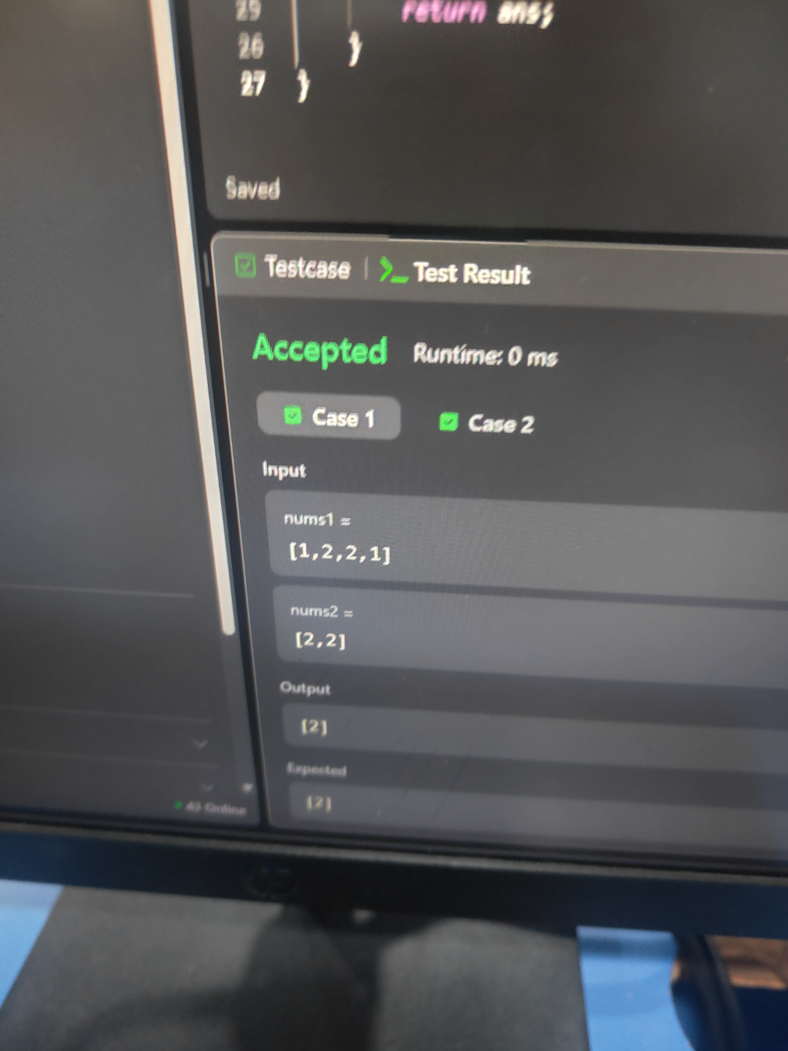
SESSION 2 HASH MAP﻿
TASK 1 FIND COMMON CHARACTERS.﻿
PROGRAM ﻿
import java.util.*;﻿
class Solution {﻿
public List<String> commonChars(String[] words) {﻿
List<String> result = new ArrayList<>();﻿
int[] minFreq = new int[26];﻿
Arrays.fill(minFreq, Integer.MAX_VALUE);﻿
for (String word : words) {﻿
int[] freq = new int[26];﻿
for (char c : word.toCharArray()) {﻿
freq[c - 'a']++;﻿
}﻿
for (int i = 0; i < 26; i++) {﻿
minFreq[i] = Math.min(minFreq[i], freq[i]);﻿
}﻿
}﻿
for (int i = 0; i < 26; i++) {﻿
while (minFreq[i] > 0) {﻿
result.add(String.valueOf((char) ('a' + i)));﻿
minFreq[i]--;﻿
}﻿
}﻿
return result;﻿
}﻿
}﻿
OUTPUT
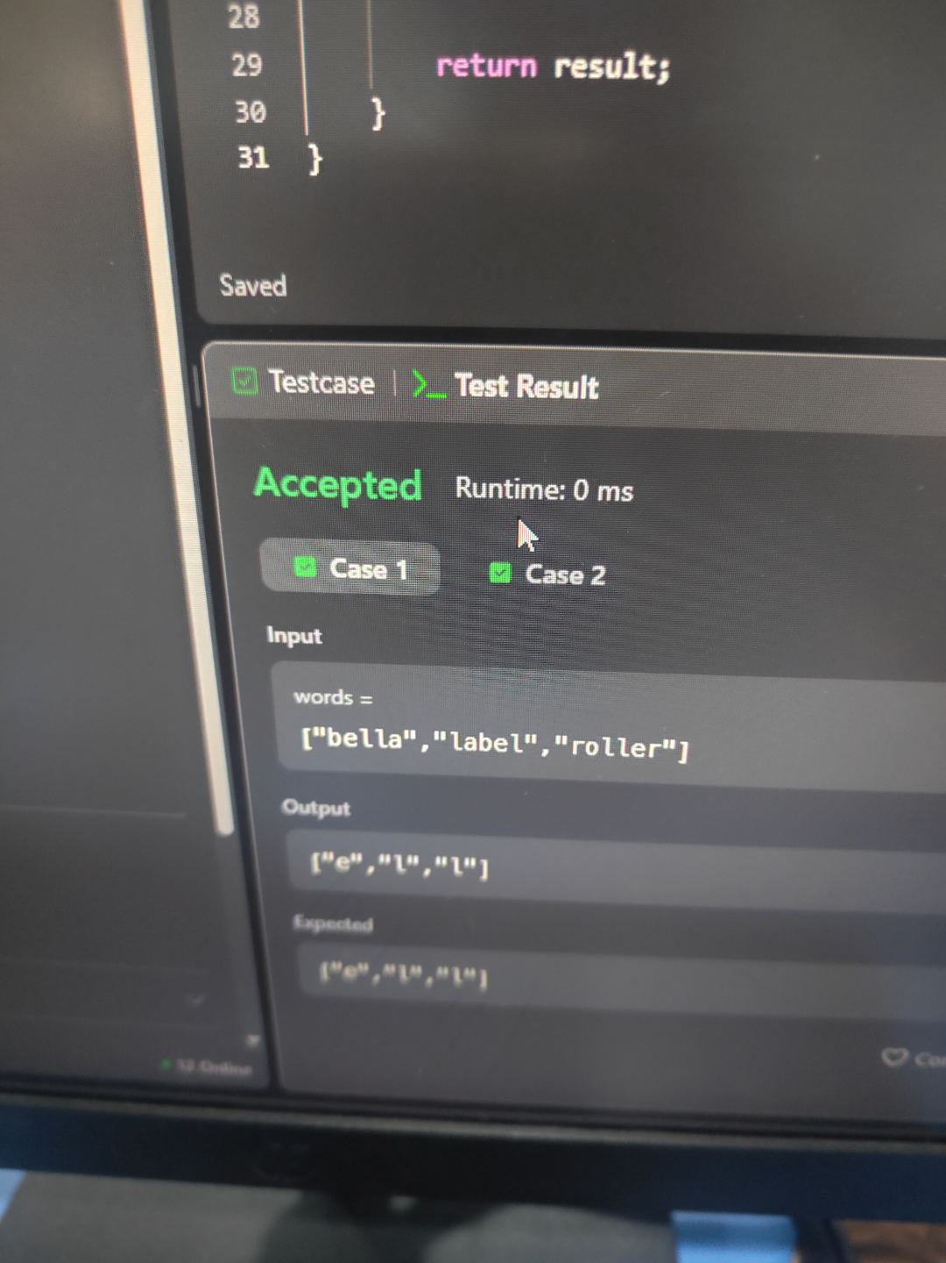
TASK 2 GROUP ANAGRAMS ﻿
PROGRAM ﻿
import java.util.*;﻿
class Solution {﻿
public List<List<String>> groupAnagrams(String[] strs) {﻿
Map<String, List<String>> map = new HashMap<>();﻿
for (String str : strs) {﻿
char[] chars = str.toCharArray();﻿
Arrays.sort(chars);﻿
String key = new String(chars);﻿
if (!map.containsKey(key)) {﻿
map.put(key, new ArrayList<>());﻿
}﻿
map.get(key).add(str);﻿
}﻿
return new ArrayList<>(map.values());﻿
}﻿
}﻿
OUTPUT
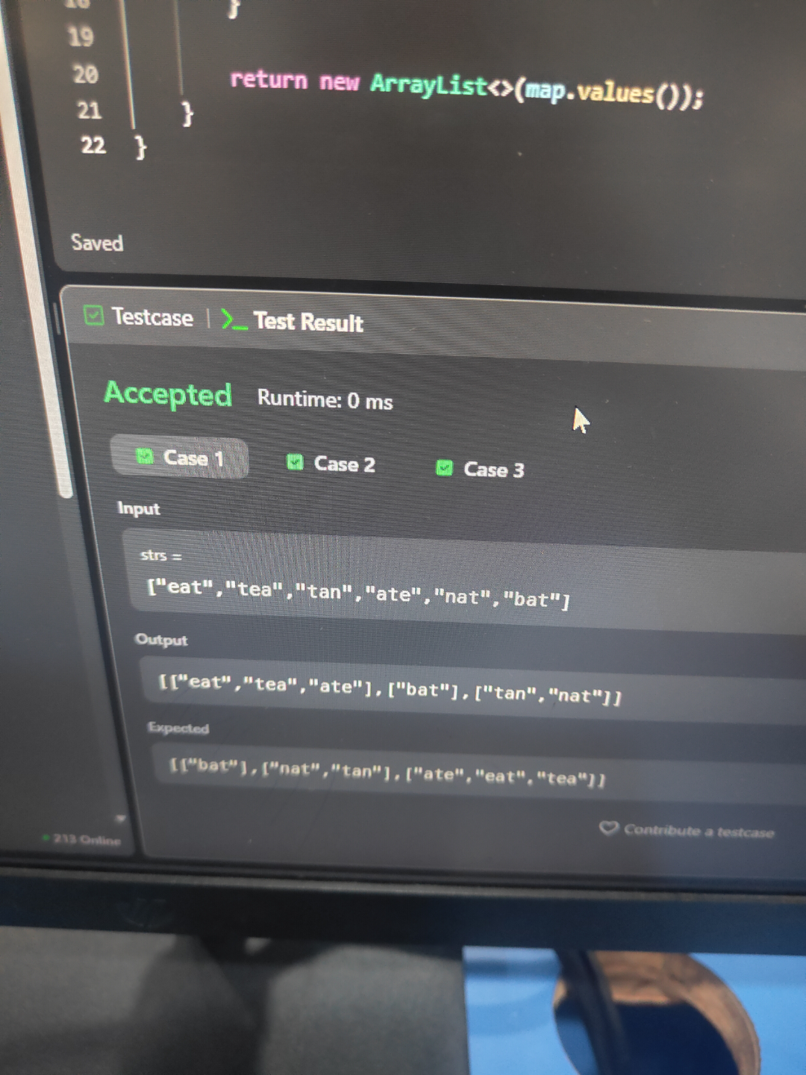
SESSION 3 HASH MAP﻿
TASK 1 WORD PATTERN ﻿
PROGRAM ﻿
import java.util.*;﻿
class Solution {﻿
public boolean wordPattern(String pattern, String s) {﻿
String[] words = s.split(" ");﻿
if (pattern.length() != words.length) {﻿
return false;﻿
}﻿
HashMap<Character, String> map = new HashMap<>();﻿
HashSet<String> used = new HashSet<>();﻿
for (int i = 0; i < pattern.length(); i++) {﻿
char ch = pattern.charAt(i);﻿
String word = words[i];﻿
if (map.containsKey(ch)) {﻿
if (!map.get(ch).equals(word)) {﻿
return false;﻿
}﻿
} else {﻿
if (used.contains(word)) {﻿
return false;﻿
}﻿
map.put(ch, word);﻿
used.add(word);﻿
}﻿
}﻿
return true;﻿
}﻿
}﻿
OUTPUT
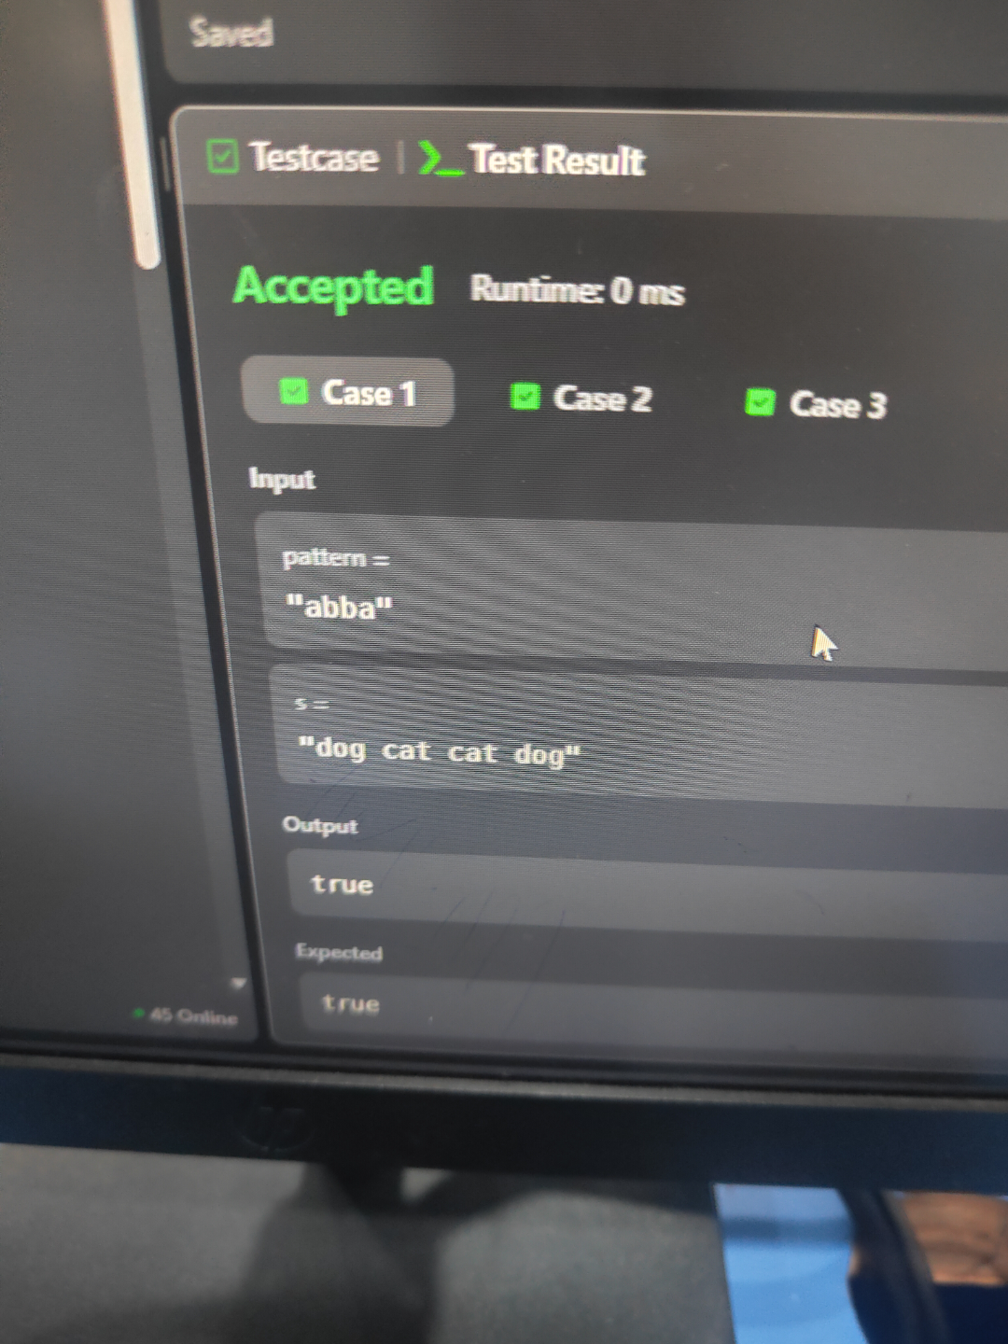
TASK 2 EMPLOYEE IMPORTANCE﻿
PROGRAM ﻿
import java.util.*;﻿
class Solution {﻿
public int getImportance(List<Employee> employees, int id) {﻿
Map<Integer, Employee> map = new HashMap<>();﻿
for (Employee employee : employees) {﻿
map.put(employee.id, employee);﻿
}﻿
return dfs(map, id);﻿
}﻿
private int dfs(Map<Integer, Employee> map, int id) {﻿
Employee employee = map.get(id);﻿
int total = employee.importance;﻿
for (int subId : employee.subordinates) {﻿
total += dfs(map, subId);﻿
}﻿
return total;﻿
}﻿
}﻿
OUTPUT
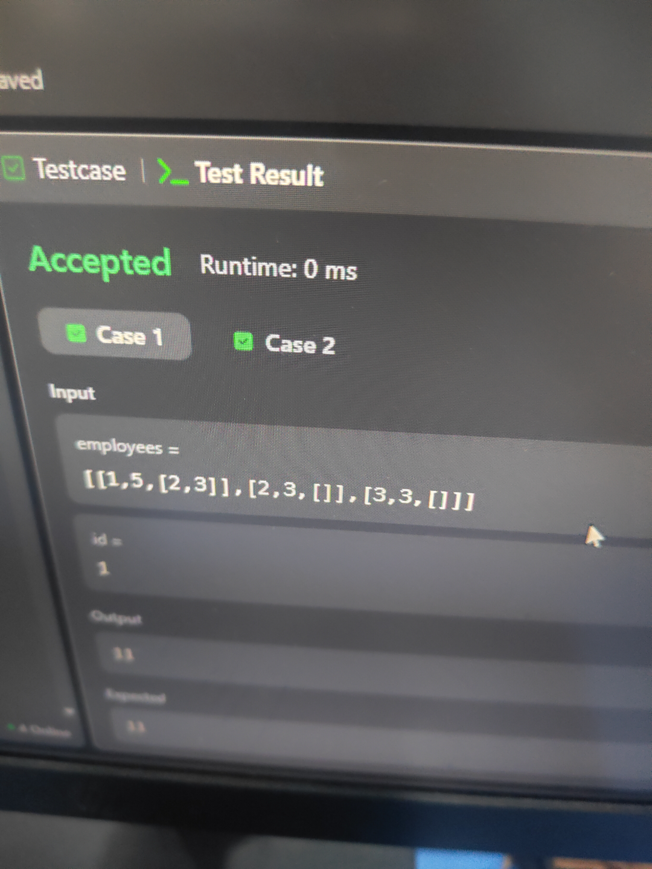
SESSION 4 FREQUENCY BASED PROBLEMS﻿
TASK 1 SORT CHARACTERS BY FREQUENCY ﻿
PROGRAM ﻿
import java.util.*;﻿
class Solution {﻿
public String frequencySort(String s) {﻿
HashMap<Character, Integer> map = new HashMap<>();﻿
for (char c : s.toCharArray()) {﻿
map.put(c, map.getOrDefault(c, 0) + 1);﻿
}﻿
List<Character> chars = new ArrayList<>(map.keySet());﻿
Collections.sort(chars, new Comparator<Character>() {﻿
public int compare(Character a, Character b) {﻿
return map.get(b) - map.get(a);﻿
}﻿
});﻿
StringBuilder result = new StringBuilder();﻿
for (char c : chars) {﻿
int count = map.get(c);﻿
while (count > 0) {﻿
result.append(c);﻿
count--;﻿
}﻿
}﻿
return result.toString();﻿
}﻿
}﻿
OUTPUT
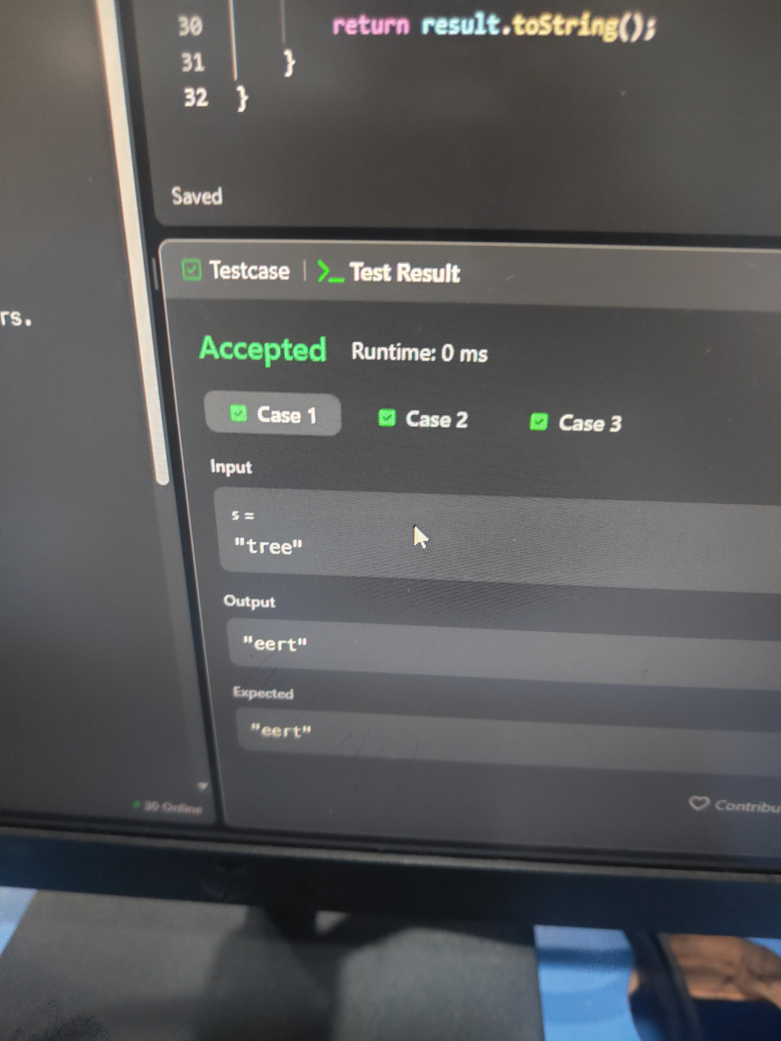
TASK 2 FIRST UNIQUE CHARACTER IN A STRING﻿
PROGRAM ﻿
class Solution {﻿
public int firstUniqChar(String s) {﻿
int[] freq = new int[26];﻿
for (char c : s.toCharArray()) {﻿
freq[c - 'a']++;﻿
}﻿
for (int i = 0; i < s.length(); i++) {﻿
if (freq[s.charAt(i) - 'a'] == 1) {﻿
return i;﻿
}﻿
}﻿
return -1;﻿
}﻿
}﻿
OUTPUT



