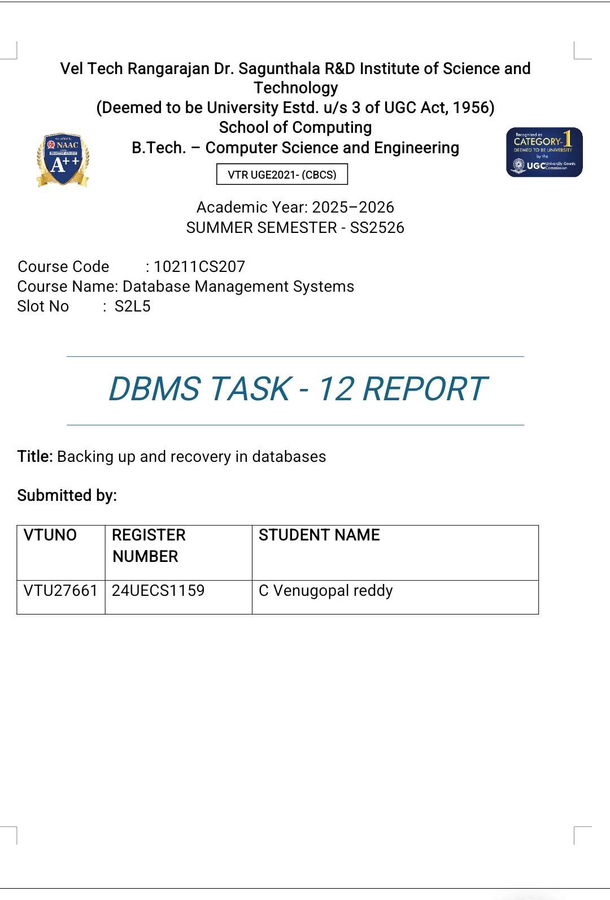

Task 3: Online Examination Management System

Identify Entities
Entity | Attributes | Description
Student | student_id (PK), name, email, password, course | Stores student details
Exam | exam_id (PK), exam_name, date, duration, total_ | mSatorrkess exam details
Question | question_id (PK), exam_id (FK), question_text, o | pCti on_tai,nospqtiuoens_tibo,nospftoiorne_acc,hoepxtiaomn_d, co
Result | result_id (PK), student_id (FK), exam_id (FK), sc | oSreto, reasnkperformance results

rrect_option

Relationships: A Student can take many Exams, an Exam contains multiple Questions, and a Result links a Student and an Exam.

Normalization
Normalization steps applied to reduce redundancy and ensure data integrity.
1NF: Each field is atomic and contains unique data.
2NF: Removed partial dependencies between attributes.
3NF: Removed transitive dependencies to keep only key-based attributes. Normalized Tables: Student, Exam, Question, Result.

SQL Queries
  - Retrieve Student Scores:
SELECT s.student_id, s.name, e.exam_name, r.score FROM Result r
JOIN Student s ON r.student_id = s.student_id JOIN Exam e ON r.exam_id = e.exam_id;
  - Rank Students by Performance:
SELECT s.name, e.exam_name, r.score,
RANK() OVER (PARTITION BY e.exam_id ORDER BY r.score DESC) AS rank FROM Result r
JOIN Student s ON r.student_id = s.student_id JOIN Exam e ON r.exam_id = e.exam_id;

ACID Properties in Online Submissions

Property | Explanation
Atomicity | Each submission is saved completely or not at all.
Consistency | Database rules like score ≤ total_marks are enforced.
Isolation | Parallel submissions don’t affect each other.
Durability | Data remains safe even after a crash or restart.

- CRUD Operations using MongoDB

Create:
db.results.insertOne({ student_id:101, exam_id:501, score:85, rank:2 });

Read:
db.results.find({ student_id:101 });

Update:
db.results.updateOne({ student_id:101, exam_id:501 }, { $set:{ score:90 }
});

Delete:
db.results.deleteOne({ student_id:101, exam_id:501 });

Summary: This system efficiently manages students, exams, questions, and results using normalized relational design, SQL ranking queries, ACID compliance, and MongoDB CRUD operations.

