TASK 2: Access and Print the Element at a Given Index in an Array
Aim:
To write a Java program to access and print the element at a given index in an array.
Algorithm:
- Start the program.
- Declare and initialize an integer array.
- Read the index value from the user.
- Check whether the entered index is within the valid range.
- If the index is valid, display the corresponding array element.
- Otherwise, display "Invalid Index".
- Stop the program.
Program:
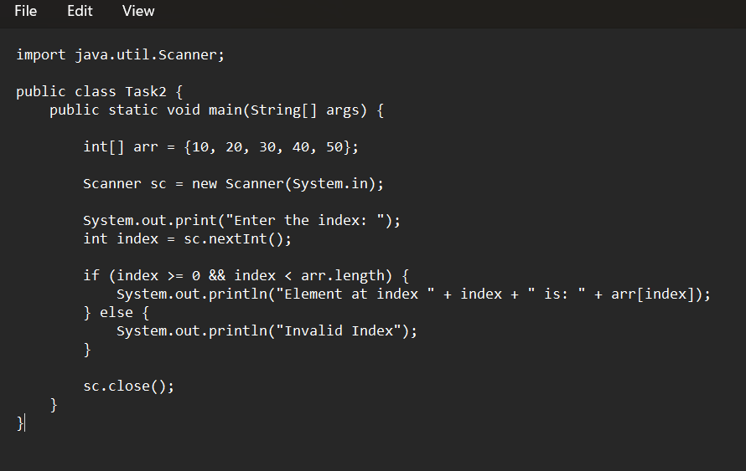Output:
Enter the index: 3
Element at index 3 is: 40
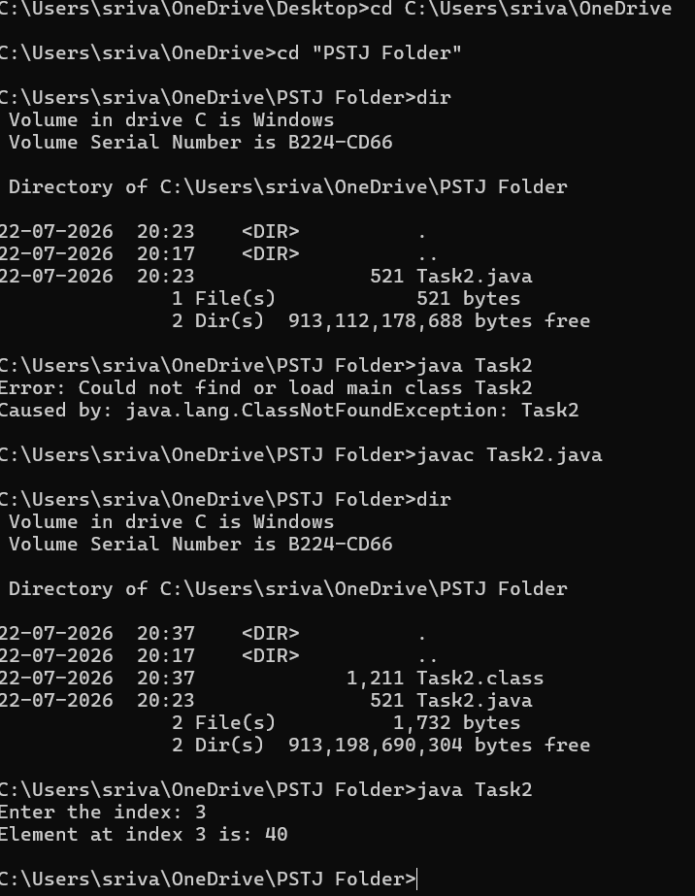

Result:
Thus, the Java program to access and print the element at a given index in an array was executed successfully.

TASK 3: Iterate Over an Array and Print All Elements
Aim:
To write a Java program to iterate over an array and print all the elements of an array.
Algorithm:
- Start the program.
- Declare and initialize an integer array.
- Use a for loop to traverse the array.
- Print each element of the array.
- Stop the program.
Program:
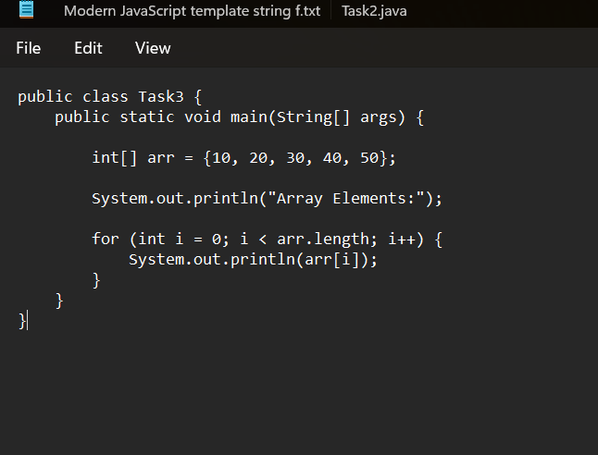
Output:
Array Elements:
10
20
30
40
50

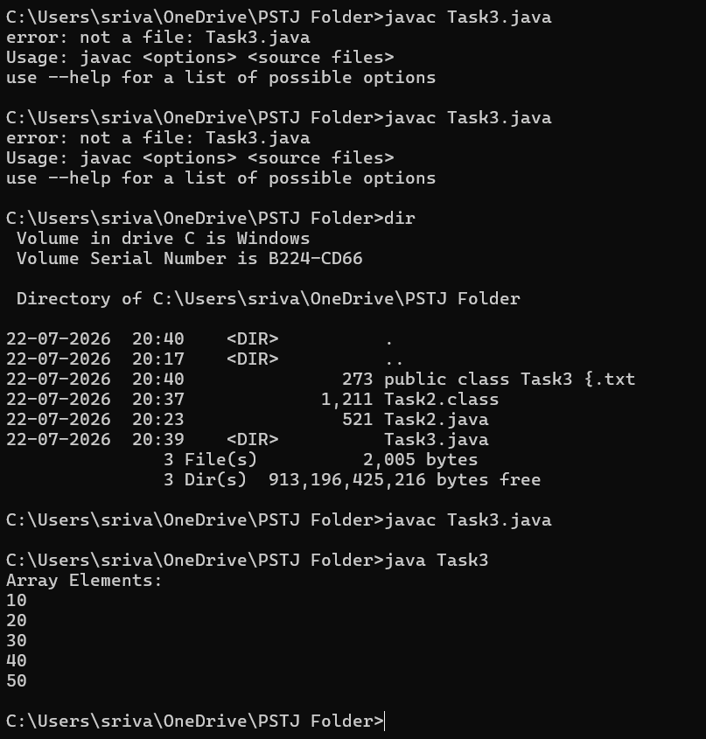
Result:
Thus, the Java program to iterate over an array and print all the elements of an array was executed successfully.

