TASK6.1:
PROGRAM:
OUTPUT:
TASK6.2:
PROGRAM:
OUTPUT:
TASK6.3:
PROGRAM:
import java.io.*;
import java.util.*;

public class Solution {

public static String twoStrings(String s1, String s2) {
boolean[] seen = new boolean[26];

// Mark characters present in s1
for (int i = 0; i < s1.length(); i++) {
seen[s1.charAt(i) - 'a'] = true;
}

// Check if s2 contains any character from s1
for (int i = 0; i < s2.length(); i++) {
if (seen[s2.charAt(i) - 'a']) {
return "YES";
}
}

return "NO";
}

public static void main(String[] args) throws IOException {
BufferedReader br = new BufferedReader(new InputStreamReader(System.in));
int q = Integer.parseInt(br.readLine().trim());

StringBuilder sb = new StringBuilder();
while (q-- > 0) {
String s1 = br.readLine().trim();
String s2 = br.readLine().trim();
sb.append(twoStrings(s1, s2)).append("\n");
}
System.out.print(sb.toString());
}
}
OUTPUT:
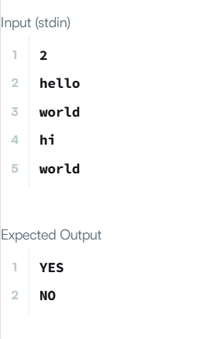
TASK6.4:
PROGRAM:
class Solution {
public boolean rotateString(String s, String goal) {
return s.length() == goal.length() && (s + s).contains(goal);
}
}
OUTPUT:
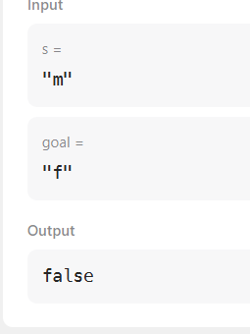
TASK6.5:
PROGRAM:
import java.io.*;
import java.util.*;

class Result {

/*
* Complete the 'marsExploration' function below.
*
* The function is expected to return an INTEGER.
* The function accepts STRING s as parameter.
*/

public static int marsExploration(String s) {
int alteredCount = 0;

for (int i = 0; i < s.length(); i++) {
char expectedChar;

// Determine what the character should be based on its position in the "SOS" triplet
if (i % 3 == 1) {
expectedChar = 'O';
} else {
expectedChar = 'S';
}

// If the received character doesn't match the expected character, increment count
if (s.charAt(i) != expectedChar) {
alteredCount++;
}
}

return alteredCount;
}

}

public class Solution {
public static void main(String[] args) throws IOException {
BufferedReader bufferedReader = new BufferedReader(new InputStreamReader(System.in));
BufferedWriter bufferedWriter = new BufferedWriter(new OutputStreamWriter(System.out));

String s = bufferedReader.readLine();

int result = Result.marsExploration(s);

bufferedWriter.write(String.valueOf(result));
bufferedWriter.newLine();

bufferedReader.close();
bufferedWriter.close();
}
}

OUTPUT:
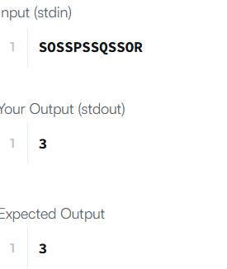
TASK6.6:
PROGRAM:
import java.util.ArrayList;
import java.util.List;

class Solution {
public List<Integer> findAnagrams(String s, String p) {
List<Integer> result = new ArrayList<>();
int sLen = s.length();
int pLen = p.length();

if (sLen < pLen) {
return result;
}

int[] pCount = new int[26];
int[] sCount = new int[26];

// Count frequencies for string p and the first window in s
for (int i = 0; i < pLen; i++) {
pCount[p.charAt(i) - 'a']++;
sCount[s.charAt(i) - 'a']++;
}

// Check the first window
if (matches(pCount, sCount)) {
result.add(0);
}

// Slide the window across string s
for (int i = pLen; i < sLen; i++) {
// Add new character to the right of the window
sCount[s.charAt(i) - 'a']++;
// Remove old character from the left of the window
sCount[s.charAt(i - pLen) - 'a']--;

// If frequencies match, add the starting index of the window
if (matches(pCount, sCount)) {
result.add(i - pLen + 1);
}
}

return result;
}

// Helper method to compare two frequency arrays
private boolean matches(int[] arr1, int[] arr2) {
for (int i = 0; i < 26; i++) {
if (arr1[i] != arr2[i]) {
return false;
}
}
return true;
}
}
OUTPUT:
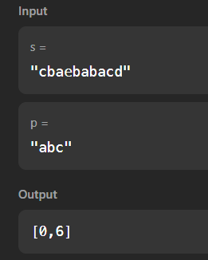

TASK6.7:
PROGRAM:
import java.io.*;
import java.util.*;

class Result {

/*
* Complete the 'palindromeIndex' function below.
*
* The function is expected to return an INTEGER.
* The function accepts STRING s as parameter.
*/

public static int palindromeIndex(String s) {
int left = 0;
int right = s.length() - 1;

while (left < right) {
if (s.charAt(left) == s.charAt(right)) {
left++;
right--;
} else {
// Mismatch found, test by skipping either left or right character
if (isPalindrome(s, left + 1, right)) {
return left;
}
if (isPalindrome(s, left, right - 1)) {
return right;
}
return -1; // Neither removal creates a palindrome
}
}

return -1; // Already a palindrome
}

// Helper method to check if a substring is a palindrome
private static boolean isPalindrome(String s, int low, int high) {
while (low < high) {
if (s.charAt(low) != s.charAt(high)) {
return false;
}
low++;
high--;
}
return true;
}
}

public class Solution {
public static void main(String[] args) throws IOException {
BufferedReader bufferedReader = new BufferedReader(new InputStreamReader(System.in));
BufferedWriter bufferedWriter = new BufferedWriter(new OutputStreamWriter(System.out));

int q = Integer.parseInt(bufferedReader.readLine().trim());

for (int qItr = 0; qItr < q; qItr++) {
String s = bufferedReader.readLine();

int result = Result.palindromeIndex(s);

bufferedWriter.write(String.valueOf(result));
bufferedWriter.newLine();
}

bufferedReader.close();
bufferedWriter.close();
}
}
OUTPUT:
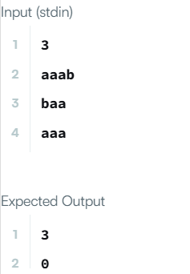

TASK6.7:
PROGRAM:
class Solution {
public int strStr(String haystack, String needle) {
int hLen = haystack.length();
int nLen = needle.length();

if (nLen == 0) {
return 0;
}

if (hLen < nLen) {
return -1;
}

// Slide through haystack up to the point where needle can still fit
for (int i = 0; i <= hLen - nLen; i++) {
// Check if the substring matches needle
if (haystack.substring(i, i + nLen).equals(needle)) {
return i;
}
}

return -1;
}
}
OUTPUT:
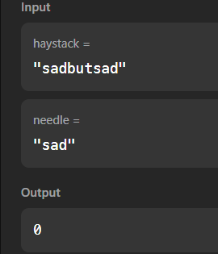

TASK6.7:
PROGRAM:
import java.io.*;
import java.util.*;
import java.text.*;
import java.math.*;
import java.util.regex.*;

class Arithmetic {
public int add(int a, int b) {
return a + b;
}
}
class Adder extends Arithmetic {
}

public class Solution{
public static void main(String []args){
// Create a new Adder object
Adder a = new Adder();

// Print the name of the superclass on a new line
System.out.println("My superclass is: " + a.getClass().getSuperclass().getName());

// Print the result of 3 calls to Adder's `add(int,int)` method as 3 space-separated integers:
System.out.print(a.add(10,32) + " " + a.add(10,3) + " " + a.add(10,10) + "\n");
}
}
OUTPUT:
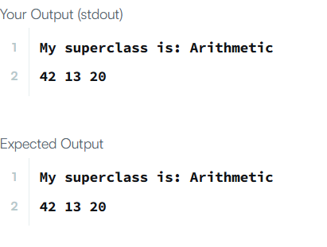
TASK6.8:
PROGRAM:
import java.io.*;
import java.util.*;
import java.text.*;
import java.math.*;
import java.util.regex.*;

class Arithmetic {
public int add(int a, int b) {
return a + b;
}
}
class Adder extends Arithmetic {
}

public class Solution{
public static void main(String []args){
// Create a new Adder object
Adder a = new Adder();

// Print the name of the superclass on a new line
System.out.println("My superclass is: " + a.getClass().getSuperclass().getName());

// Print the result of 3 calls to Adder's `add(int,int)` method as 3 space-separated integers:
System.out.print(a.add(10,32) + " " + a.add(10,3) + " " + a.add(10,10) + "\n");
}
}
OUTPUT:
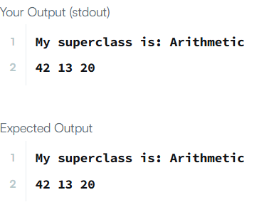
TASK 6.9:
PROGRAM:
import java.io.IOException;
import java.lang.reflect.Method;

class Printer {
public <T> void printArray(T[] array) {
for (T element : array) {
System.out.println(element);
}
}
}

public class Solution {
public static void main(String args[]) {
Printer myPrinter = new Printer();
Integer[] intArray = { 1, 2, 3 };
String[] stringArray = { "Hello", "World" };
myPrinter.printArray(intArray);
myPrinter.printArray(stringArray);
int count = 0;

for (Method method : Printer.class.getDeclaredMethods()) {
String name = method.getName();
if (name.equals("printArray"))
count++;
}

if (count > 1)
System.out.println("Method overloading is not allowed!");
}
}
OUTPUT:
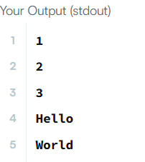
TASK6.10:
PROGRAM:
import java.util.*;

class ThroneInheritance {
String king;
Map<String, List<String>> map;
Set<String> dead;

public ThroneInheritance(String kingName) {
king = kingName;
map = new HashMap<>();
dead = new HashSet<>();
map.put(king, new ArrayList<>());
}

public void birth(String parentName, String childName) {
map.putIfAbsent(parentName, new ArrayList<>());
map.putIfAbsent(childName, new ArrayList<>());
map.get(parentName).add(childName);
}

public void death(String name) {
dead.add(name);
}

public List<String> getInheritanceOrder() {
List<String> order = new ArrayList<>();
dfs(king, order);
return order;
}

private void dfs(String current, List<String> order) {
if (!dead.contains(current)) {
order.add(current);
}
List<String> children = map.get(current);
if (children != null) {
for (String child : children) {
dfs(child, order);
}
}
}
}
OUTPUT:
