Task No: 1  Date: | Task 1 Design a multi-dimensional data model schema namely Star, Snowflake and Fact Constellations for a Categorical data using SQL Server Management Studio (SSMS). (Perform the above for Banking, Healthcare, Manufacturing, Sales and Automobile)  Tools: SQL Server Management Studio (SSMS), Microsoft Azure SQL Pool

Task: 1a
AIM:

PROCEDURE:
To practice creating a star schema data model from scratch, install SQL Server Management Studio, Microsoft SQL Server
Step 1: Install Diagram Support.
- Create a new database “BigData”
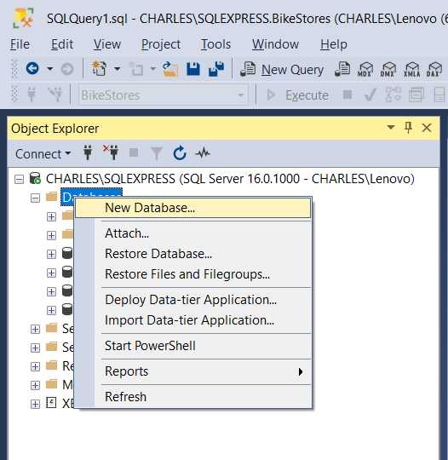
- Databases -> BigData -> Database Diagrams > Install Diagram Support
- Select the “Yes” in the pop-up window to close the window to one or more create support objects
Step 2: Create New Database Diagram.
- Right-click on the menu item “Database Diagrams” and select the “New Database Diagram” item.

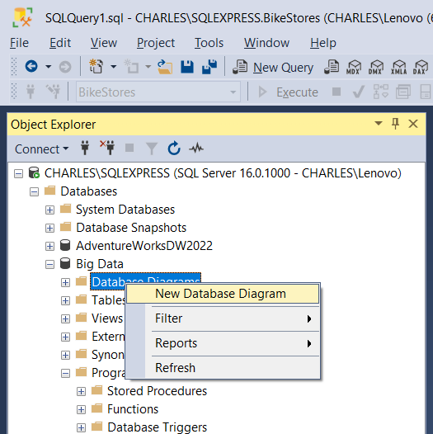
- A pop-up window with a title “Add Table” shows up. Click on the “Close” button at the bottom of the new window to close the window

Step 3: Create User-Defined Data Types
- Right-click on the item “Databases -> data_modeling -> Programmability -> Types -> User-Defined Data Types” in the Object Explore panel and select the menu item “New User-Defined Data Type” in the context menu.
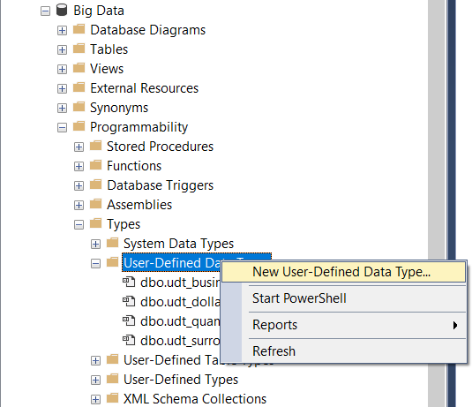

- A new window appears. Enter a value “udt_surrogate_key” in the name field and select the data type with “int”. Then, click on the “OK” button to create a new data type.
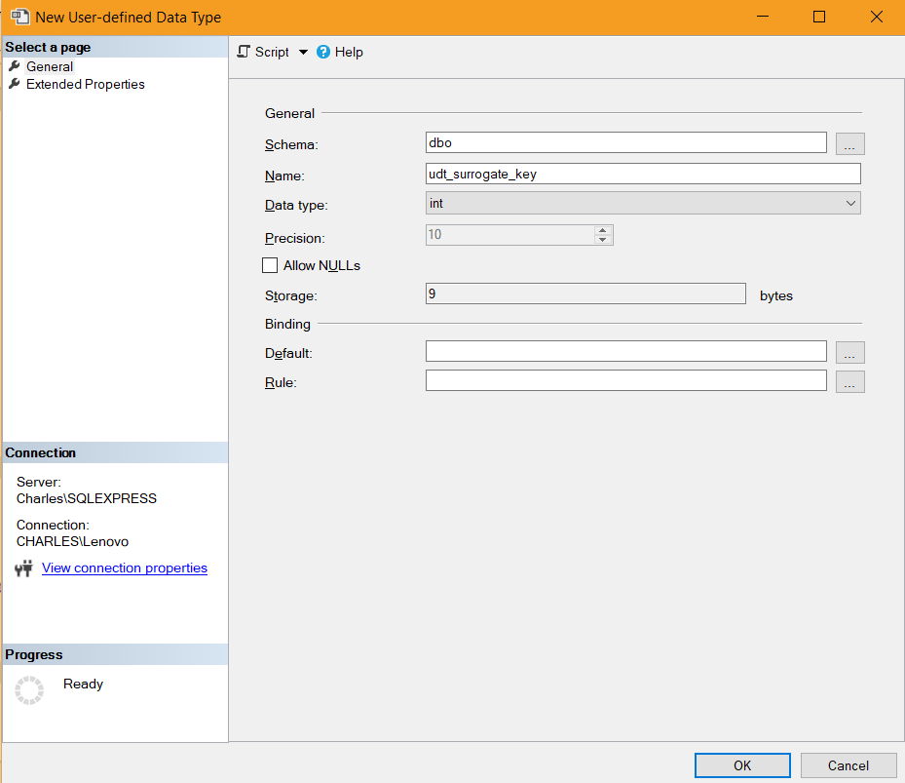
- Follow the preceding procedure described in this step, create other user-defined data types.
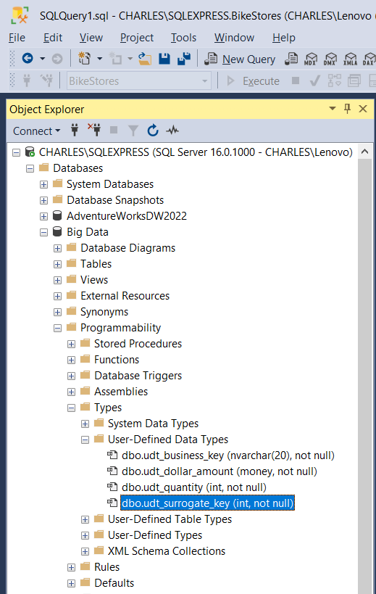
Step 4: Create a Dimension Table in SSMS.
- Right-click on an empty space in the middle panel, select the “New Table…” menu item in the context menu
- A small pop-up window shows up and enter a value “dim_date” as the table name. Click the “OK” button to close this window and start a new pop-up window.
- In the new window, enter a value “date_key” as a column name and select the user-defined data type “udt_surrogate_key” as the data type. Then uncheck the “Allow Nulls” checkbox.
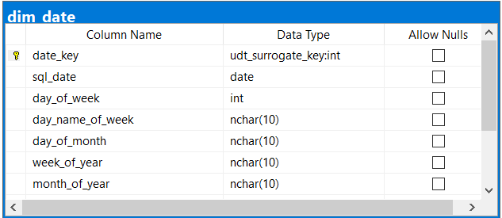

- Right-click on trigonal icon beside the text “date_key”, select the “Set Primary Key” menu item in the context menu.

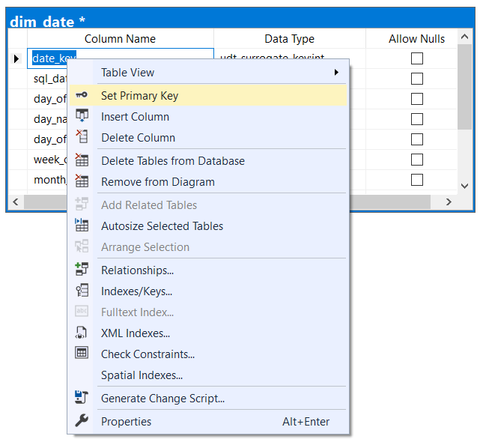
Step 5: Save the New Diagram.
- Click on the “Save” button on the window’s toolbar.
- A pop-up window shows up to ask a name of the diagram. Enter a value “fact_sale_order” as the name for the diagram then click on the “OK” button.
Step 6: Create All Dimension Tables.
- Repeat Step 5 to create other dimension tables.
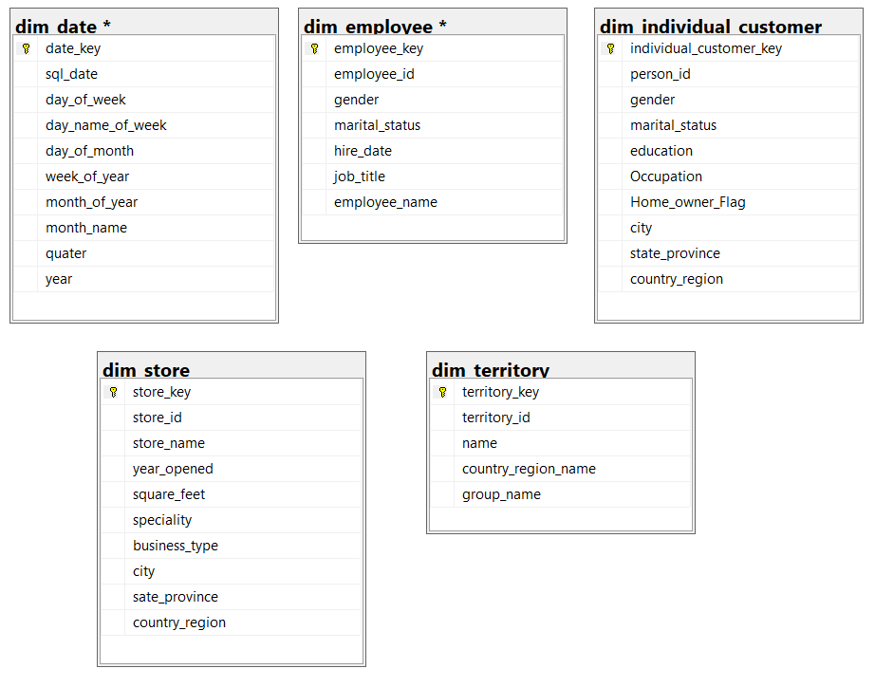
Step 7: Create a Fact Table.
- Right-click on an empty space in the diagram panel, select the “New Table…” menu item from the context menu
- enter a value “fact_sales_order” as the fact table name in the new pop-up window.
- Click the window by clicking on the “OK” button.
- The second pop-up window appears. Enter all dimension table keys and select the user-defined data type “udt_surrogate_key” as their data types. Uncheck all “Allow Nulls” checkboxes.
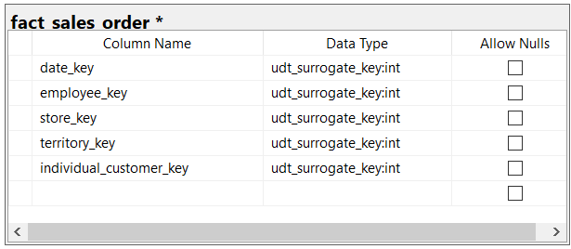
Step 8: Establish Relationship Between Dimension tables and Fact table
- In the diagram panel, drag the key icon in the table “dim_table” over the “date_key” in the table “fact_sales_order”. Two pop-up windows appear immediately.
- In the first pop-up window presents the relationship name, “FK_fact_sales_order_dim_date”. All the foreign names will use this format.
- verify if the keys are linked correctly and click OK button
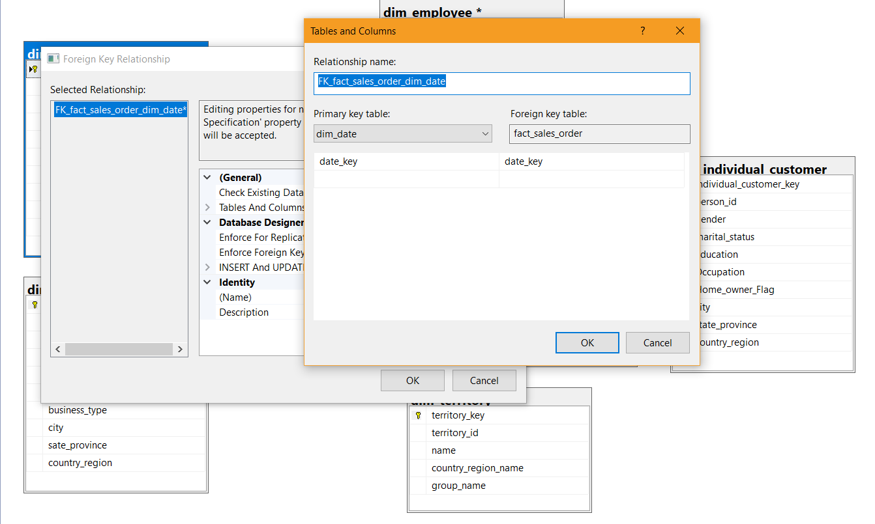
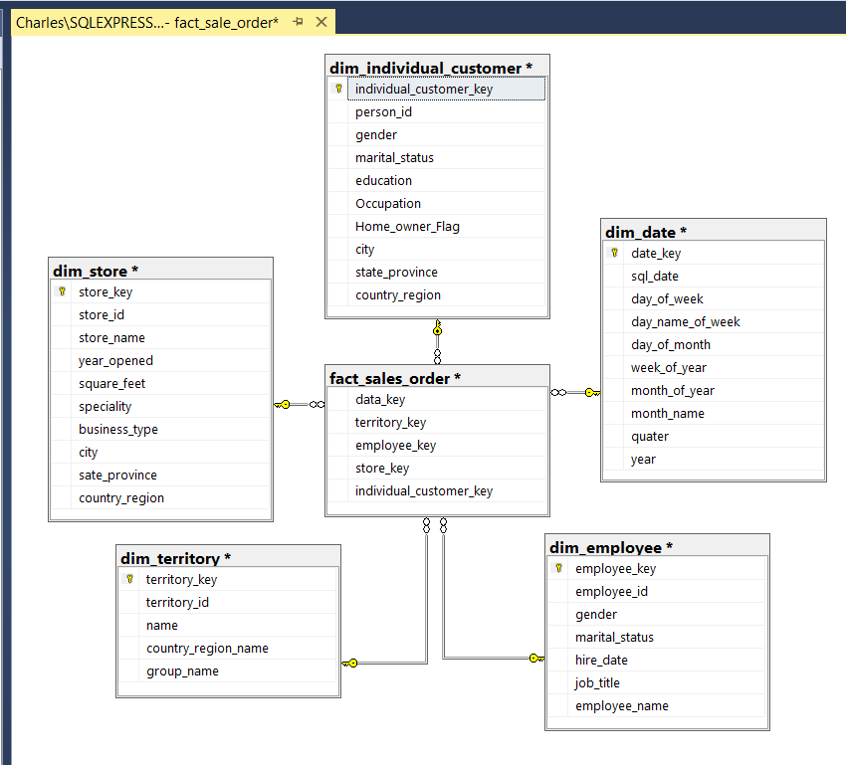

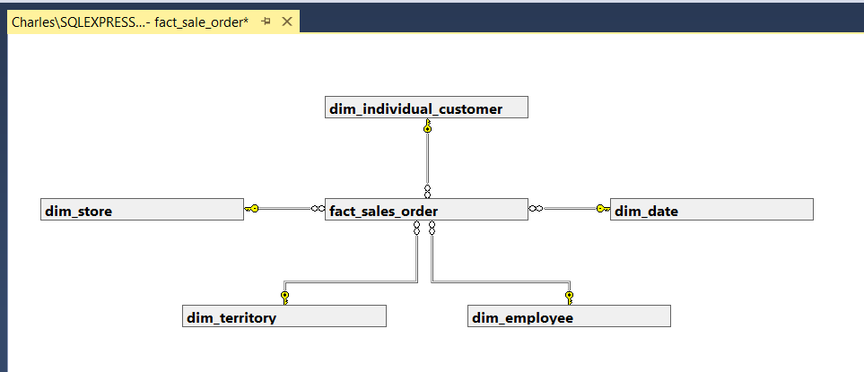

Result: Thus the program on Design a multi-dimensional data model schema namely Star, Snowflake and Fact Constellations for a Categorical data using SQL Server Management Studio (SSMS). (Perform the above for Banking, Healthcare, Manufacturing, Sales and Automobile) was executed successfully.

