Vel Tech Rangarajan Dr. Sagunthala R&D Institute of Science and Technology
VTR UGE2021- (CBCS)


(Deemed to be University Estd. u/s 3 of UGC Act, 1956) School of Computing

B.Tech. – Computer Science and Engineering
Academic Year: 2025–2026
SUMMER SEMESTER - SS2526

Course Code : 10211CS207
Course Name : Database Management Systems
Slot No : S2L3

DBMS TASK - 1 REPORT

Title: Conceptual Design through FTR

Submitted by:

VTUNO | REGISTER NUMBER | STUDENT NAME
VTU29255 | 24UECS0866 | R KARUNAKAR REDDYU

pg. 1

Task1
Conceptual Design through FTR Aim:
Using basic database design methodology and ER modeler, design Entity Relationship Diagram by satisfying the following sub tasks:
1. a Identifying the entities.
1. b Identifying the attributes.
1. c Identification of relationships, cardinality, type of relationship.
1. d Reframing the relations with keys and constraint.
- e Using create, develop ER/ER diagram

  - Identifying the entities
    - CricketBoard
    - Team
    - Player
    - Match
    - Ground
    - Umpire
  - Identifyingtheattributes
    - CricketBoard(BoardID, Name, Address, Contact_No)
    - Team(TeamID, Name, Coach, Captain)
    - Player(PlayerID, FName, LName, Age, DateofBirth, PlayingRole, email, contact_no)
    - Match( MatchID, Date, Time, Result)
    - Ground(GroundID, Name, Location, Capacity)
    - Umpire(UmpireID, FName, LName, Age, DateofBirth, Country, email, contact_no)

  - Identification of relationships, cardinality, type of relationship.
    - Board-Team Relationship: The Board will have a one-to-many relationship with Teams since the board can have multiple teams affiliated with it, but a team can only be associated with one board.
    - Team-Player Relationship: Teams and Players will have a many-to-many relationship since a team can have multiple players, and a player can be a part of multiple teams over time.
1.c,3. Match-Team Relationship: Matches will have a many-to-many relationship with Teams, as a match involves two teams, and a team can participate in multiple matches.
1.c.4. Match-Ground Relationship: Matches will have a one-to-one relationship with Grounds, as each match takes place in one specific ground. 1.d Reframing the relations with keys and constraint
    - Create Table CricketBoard:
SQL>create table CricketBoard(BoardID varchar(10) PRIMARY KEY, Name varchar(30), Address varchar(50), Contact_No number);
Table Created
SQL>DESC CricketBoard
Column | NULL | TYPE
BoardID | NOT NULL | VARCHAR(10)
Name | - | VARCHAR(30)
Address | - | VARCHAR(50)
Contact_No | - | NUMBER

    - Create Table Team:
SQL> create table Team(TeamID varchar(6) PRIMARY KEY, BoardID varchar(10), Name varchar(30), Coach varchar(30), Captain varchar(30), FOREIGN KEY(BoardID) REFERENCES CricketBoard(BoardID)); Table created.
SQL> DESC TEAM
Name Null? Type
----------------------------------------- -------- ---------------------------- TEAMID NOT NULL VARCHAR2(6)
BOARDID NOT NULL |  | VARCHAR2(10)
NAME - |  | VARCHAR2(30)
COACH - |  | VARCHAR2(30)
CAPTAIN - |  | VARCHAR2(30)
    - Create Table Player:
SQL> CREATE table Player(PlayerID varchar(6) PRIMARY KEY, TeamID varchar(6), FName varchar(30), LName varchar(30), Age number(5,2), DateofBirth date, PlayingRole varchar(25), email varchar(40), contact_no number, FOREIGN KEY(TeamID) REFERENCES Team(TeamID));
Table created.
SQL> DESC PLAYER
Name Null? Type
----------------------------------------- -------- ----------------------------
PLAYERID NOT NULL VARCHAR2(6)
TEAMID NOT NULL VARCHAR2(6)
FNAME VARCHAR2(30)
LNAME VARCHAR2(30)
AGE NUMBER(5,2)
DATEOFBIRTH DATE
PLAYINGROLE VARCHAR2(25)
EMAIL VARCHAR2(40)
CONTACT_NO NUMBER

1.d.4 Create Table Match:

SQL> create table Match( MatchID varchar(10), TeamID1 varchar(6), TeamID2 varchar(6), PlayerID varchar(6), Match_Date date, Time1 number, Result varchar(20), PRIMARY KEY(MatchID,PlayerID), FOREIGN KEY(TeamID1) REFERENCES team(TeamID),
FOREIGN KEY(TeamID2) REFERENCES team(TeamID), FOREIGN KEY(PlayerID) REFERENCES Player(PLayerID)); Table created.
SQL> DESC Match

Name Null? Type
----------------------------------------- -------- ----------------------------
MATCHID NOT NULL VARCHAR2(10)
TEAMID1 NOT NULL | VARCHAR2(6)
TEAMID2 NOT NULL | VARCHAR2(6)
PLAYERID NOT NULL | VARCHAR2(6)
MATCH_DATE | DATE
TIME1 | NUMBER
RESULT | VARCHAR2(20)

1.d.5 Create Table Ground:
SQL> create table Ground(GroundID varchar(10) PRIMARY KEY, MatchID Varchar(10),
Name varchar(30), Location varchar(30), Capacity number, FOREIGN KEY(MatchID) REFERENCES Match(MatchID));

Table created.

SQL> DESC Ground
Name Null? Type
----------------------------------------- -------- ---------------------------- GROUNDID NOT NULL VARCHAR2(10)
MATCHID NOT NULL VARCHAR2(10)
NAME VARCHAR2(30)
LOCATION VARCHAR2(30)
CAPACITY NUMBER

1.d.6 Create Table Umpire:
SQL> Create Table Umpire(UmpireID varchar(10) PRIMARY KEY, FName varchar(30), LName varchar(30), Age number(5,2), DateofBirth date, Country varchar(30), email varchar(40), contact_no number);

SQL> DESC Umpire
Name Null? Type
----------------------------------------- -------- ----------------------------
UMPIREID NOT NULL VARCHAR2(10)
FNAME | VARCHAR2(30)
LNAME | VARCHAR2(30)
AGE | NUMBER(5,2)
DATEOFBIRTH | DATE
COUNTRY | VARCHAR2(30)
EMAIL | VARCHAR2(40)
CONTACT_NO | NUMBER

1.d.6 Create Table Umpire_Umpired:
SQL> create table Umpire_Umpired(UmpireID varchar(10), MatchID Varchar(10), GroundID varchar(10), FOREIGN KEY(UmpireID) REFERENCES Umpire(UmpireID), FOREIGN
KEY(MatchID) REFERENCES Match(MatchID), FOREIGN KEY(GroundID) REFERENCES Ground(GroundID));

Table created.

SQL> DESC Umpire
Name Null? Type
----------------------------------------- -------- ----------------------------
UMPIREID NOT NULL VARCHAR2(10)
GROUNDID NOT NULL VARCHAR2(10)
MATCHID NOT NULL VARCHAR2(10)

Result:
Thus the database design methodology and ER Model design diagram has been completed successfully.

TASK2 Generating Design of other traditional database model
Aim:
Creating Hierarchical/Network model of the database by enhancing the sound abstract data by performing following tasks using forms of inheritance:
2. a Identify the specificity of each relationship, find and form surplus relations.
2. b Check is-a hierarchy/has-a hierarchy and performs generalization and/or specialization relationship.
2. c Find the domain of the attribute and perform check constraint to the applicable.
2. d Rename the relations.
2. e Perform SQL Relations using DDL, DCL commands.

2. a Identify the specificity of each relationship, find and form surplus relations.
Relationship: Cricket Board manages Team (one-to-many)
Specificity: One Cricket Board manages one or more Teams, but each Team is managed by only one Cricket Board.
Surplus Relation: No surplus relation is needed for this relationship since it is already one-tomany.

Relationship: Team has Player (many-to-one)
Specificity: One Team can have many Players, but each Player belongs to only one Team. Surplus Relation: No surplus relation is needed for this relationship since it is already manyto-one.

Relationship: Match involves Team (many-to-many)
Specificity: One Match involves two Teams, and each Team can participate in multiple Matches.
Surplus Relation: No surplus relation is needed for this relationship since it is already manyto-many.

Relationship: Match has Umpire (many-to-many)
Specificity: One Match can have multiple Umpires, and each Umpire can officiate multiple Matches.
Surplus Relation: No surplus relation is needed for this relationship since it is already manyto-many.

Based on the specificity analysis, all the relationships in the ER diagram are appropriately represented, and there are no surplus relations required for this particular model. Each relationship reflects the correct cardinality and participation constraints as per the description provided earlier.

2.b Check is-a hierarchy/has -a hierarchy and performs generalization and/or specialization relationship.

Generalization
In the ER diagram for the Tamil Nadu Cricket Board (TNCA) described earlier, we can identify potential generalizations based on common attributes or relationships among entities. Here's an example of a possible generalization:
Entities:
Player
Umpire
Attributes:
The above entities have common attributes like First_Name, Last_Name, Date_of_Birth, age, Contact_No, and Email.
Potential Generalization:
Create a superclass called "Person" to represent the common attributes shared by Player and Umpire. The "Person" entity would have the following attributes:
Person_ID (primary key)
First_Name
Last_Name
Date_of_Birth
Age
Contact_Number Email
Subclasses:
Player: Inherited attributes from "Person" and add specific attributes like Player_ID.
Umpire: Inherited attributes from "Person" and add specific attributes like Umpire_ID.

Player

Player_ID,
FName,
LName, Age,
DateofBirth,
email,
contact_no

Umpire

Umpire_ID,
FName,
LName, Age,
DateofBirth,
email,
contact_no

Person

Person_ID,

FName, LName,
Age, DateofBirth,
email, contact_no,

Role

By using generalization, we can reduce data redundancy, improve data integrity, and simplify the structure of the ER diagram. This approach also allows for easier maintenance and updates, as changes made to the attributes shared by all "Person" entities will be automatically reflected in the subclasses.

Specialization
In the context of Entity-Relationship (ER) diagrams, specialization refers to the process of defining subtypes within an entity type. It allows, to represent entities that have specific attributes or relationships distinct from the general attributes or relationships of the parent entity.

In the case of the Tamil Nadu Cricket Board Association, let's consider the specialization of the "Player" entity into two subtypes: "Batsman" and "Bowler." This specialization is based on the specific roles that players can have in cricket.

Here's the modified ER diagram with the specialization:

Player

PlayerID,
FName,
LName, Age,
DateofBirth,
email,
contact_no

Batsman

Batsman_ID

Batting_avg

Bowler

Bowler_ID

Bowling_avg

2. c Find the domain of the attribute and perform check constraint to the applicable.

For the purpose of illustration, I'll assume we are considering the "age" attribute of the "Player" entity from the ER diagram of the Tamil Nadu Cricket Association.

Finding the domain of the "age" attribute:
The "age" attribute typically represents the age of a player, and it should be a positive integer or a non-negative integer depending on how you handle the birth dates of players. For the sake of simplicity, let's assume it's a positive integer.

Check constraint to enforce the domain:
To enforce the domain on the "age" attribute and ensure that only valid values are allowed, we can create a check constraint in the database schema. The check constraint will specify the condition that the "age" attribute must satisfy.
Suppose your database schema language is SQL, here's an example of how you can add the check constraint:

SQL> ALTER TABLE Player ADD CONSTRAINT check_con CHECK (age>= 20);

Table altered.

2.d Rename the relations:

Renaming a table (relation) in SQL can be accomplished using the ALTER TABLE statement with the RENAME TO clause. The specific syntax for renaming tables varies slightly between different database management systems.

Here's the syntax for renaming a column in the Table:

SQL> Alter table Umpire RENAME column contact_no TO phone_no;

Table altered.

SQL> DESC Umpire
Name Null? Type
----------------------------------------- -------- ---------------------------- UMPIREID VARCHAR2(10)
FNAME VARCHAR2(30)
LNAME VARCHAR2(30)
AGE NUMBER(5,2)
DATEOFBIRTH DATE
COUNTRY VARCHAR2(30)
EMAIL VARCHAR2(40)
PHONE_NO NUMBER

2.e Perform SQL Relations using DDL, DCL commands.

DCL stands for "Data Control Language," which is a subset of SQL (Structured Query Language) used to control access to data in a database. DCL commands are responsible for managing user permissions, granting privileges, and controlling data security within a database system. There are two primary DCL commands:

- Grant
- Revoke

GRANT:
The GRANT command is used to provide specific privileges to users or roles, allowing them to perform certain actions on database objects (e.g., tables, views, procedures). Privileges may include SELECT, INSERT, UPDATE, DELETE, EXECUTE, and more.
SQL> create user Raj identified by kumar; User created.
SQL> grant resource to raj; Grant succeeded.
SQL> grant create session to raj; Grant succeeded.
SQL> conn Enter user-name: raj Enter password:
Connected.
SQL> create table emp(eno number,ename varchar(10)); Table created.
SQL> conn system/manager Connected.
SQL> grant all on Umpire to Raj; Grant succeeded.

Result:
Thus the Hierarchical model and Network model has been successfully created.

TASK 3
Using Clauses, Operators and Functions in queries Aim:
To perform the query processing on databases for different retrieval results of queries using DML, DRL operations using aggregate, date, string, indent functions, set clauses and operators.
- To retrieve the location of a particular match conducted by its MatchID • To retrieve the Players detail whose name start with ‘A’.
- Add a column Batting and Bowling in Player table.
- To count the number of right-hand batsman in a team.
- To display the CricketBoard details for the BoardIDs 'BID01', 'BID03', and 'BID06'.
- To select the names and IDs of players who are left-hand bowlers.
- To find the UmpireID of umpires who have not umpired any match.

CricketBoard:
BoardID | Name |  |  | Address | Contact_No
BID01 | Chennai Cricket Board |  |  | Chennai | 9988776699
BID02 | Tiruvallur Cricket Board |  |  | Chennai | 9977886699
BID03 | Viluppuram Cricket Board |  |  | Viluppuram | 9966886699
BID04 |  | Trichy Cricket Board | Trichy |  | 9955886699
BID05 |  | Madurai Cricket Board | Madurai |  | 9944886699
BID06 |  | Tuticorin Cricket Board | Tuticorin |  | 9933886699
BID07 |  | Selam Cricket Board | Selam |  | 9922886699
BID08 |  | Tiruppur Cricket Board | Tiruppur |  | 9911886699

Team:
TeamID | BoardID | Name | Coach | Captain
CCB01 | BID01 | ABS EXPRESS | G.D.RAMESH | SAMPATH KUMAR
CCB02 | BID01 | AVG EXPRESS | T.KARTHIK | Y.JOHN
TCB01 | BID02 | ANGRY BARD | TOM BABU | CINIL JOHN
TCB02 | BID02 | TIGER ROCK | S.KANNAN | BEN GEORGE
TRICB01 | BID04 | ROCK | K.PAUL | K.MUTHU
VCB01 | BID03 | RAINBOW | S.RAJESHKUMAR |  | MANIMARAN
MCB01 | BID05 | PANTHER | SARAVANAN |  | R.SUNILKUMAR
TUCB01 | BID06 | THUNDER | D ALEX |  | BARATHI
SCB01 | BID07 | EAGLE | SOMU |  | SRI HARI
TICB01 | BID08 | KINGS | D ANAND |  | MATHAN

Player:
Play erID | TeamID | FName | LName | Age | Dateo  fBirth | Playing Role | email | contact_no | Batting | Bow  ling
1 | CCB01 | Raj | N | 27 | 29JUN1996 | Bowler | rajn@gma  il.com | 9191910101 | null | left-  hand
33 | CCB01 | Balaji | D | 23 | 02JAN1999 | Batsman | balajid@g mail.com | 9191910031 | righthand | Null
02 | CCB02 | Krishna | R | 23 | 02JAN1999 | Bowler | krishnar@ gmail.com | 9191930103 | null | right  -  hand

18 | CCB02 | Kishore | K | 24 | 02SEP1998 |  | ALL  ROUN  DER | kishorek @gmail.c om | 9291930105 | left-  hand | left-  hand
19 | TCB01 | Karthick | K | 24 | 14SEP1998 |  | Batsman | karthickk @gmail.c om | 9292930107 | righthand | Null
62 | TCB01 | Amar | J | 22 | 21SEP1998 |  | Batsman | Amarj@g mail.com | 9292930508 | righthand | Null
102 | TCB02 | Akash | G | 21 | 26SEP1999 |  | Batsman | Amarj@g mail.com | 9292930510 | righthand | Null
12 | TCB02 | Premku mar | S | 21 | 13OCT-  1999 |  | Bowler | Premkum ars@gmai l.com | 9592930517 | null | right  -  hand
01 | VCB02 | Prem | V | 23 | 13APR-  1997 |  | Bowler | Premkum ars@gmai l.com | 9592950517 | null | left-  hand
21 | VCB02 | Kali | J | 21 | 11APR-  2002 |  | Batsman | Kalij@gm  ail.com | 9592950630 | righthand | Null
61 | VCB01 | Kamales  h | A | 22 | 21JUN2001 |  | Batsman | Kamalesh a@gmail.  com | 9592958730 | righthand | Null
66 | VCB01 | Ganesh | V | 24 | 21JUN1998 | Batsman |  | Ganeshv @gmail.c om | 9592958790 | righthand | Null
303 | TRICB0  1 | Arun | T | 24 | 21OCT-  1998 | Batsman |  | Ganeshv @gmail.c om | 9592958450 | righthand | Null
313 | TRICB0  1 | Srinivas an | N | 24 | 21OCT-  1998 | Batsman |  | srinivasan n@gmail.  com | 9992958450 | righthand | Null

Match:
MatchID | TeamID | TeamID | Match_Date | Time1 | Result
M01 | CCB01 | TCB01 | 22-JUN-2022 | 1.3 | TCB01 - WIN
M02 | CCB02 | TCB02 | 22-JUN-2022 | 8.3 | CCB01 - WIN
M03 | TRIBCB02 | TCB01 | 24-JUN-2022 | 8.3 | TCB01 - WIN
M04 | TRIBCB01 | TCB02 | 25-JUN-2022 | 8.3 | TRICB01 - WIN

Ground:

GroundID | MatchID | Name | Location | Capacity
GID01 | M01 | Nehru | Chennai | 10000
GID02 | M02 | GK | Coimbatore | 10000
GID03 | M03 | Sankar | Nellai | 6000

Umpire:
Umpire  ID | FName | LNa me | Ag  e | DateofBi rth | Count  ry | email | contact_ no
UID01 | Venkates h | T | 45 | 21-JUN-  1978 | INDI A | venkatesh@gmail.  com | 9665571  435
UID02 | Muthuku mar | R | 46 | 01-JUN-  1979 | INDI A | mutukumarr@gma  il.com | 9665571  460
UID03 | Somu | K | 42 | 01-JUN-  1983 | INDI A | somuk@gmail.co m | 9664471  460

Umpire_Umpired:
UmpireID | MatchID | GroundID
UID01 | M01 | GID01
UID02 | M03 | GID02

3.1: To retrieve the location of a particular match conducted by its MatchID
SQL> SELECT LOCATION FROM GROUND WHERE MatchID=’M03’;
PlayerID | TeamID | FName | LName | Age | DateofBirth | PlayingRole | Email
62 | TCB01 | Amar | J | 22 | 21-SEP-  1998 | Batsman | Amarj@gmail.com
102 | TCB02 | Akash | G | 21 | 26-SEP-  1999 | Batsman | Amarj@gmail.com
Resul:
Location
Nellai

3.2: To retrieve the Players detail whose name start with ‘A’.
SQL> Select * from Player where FName like 'A%';

3.3: Add a column Batting and Bowling in Player table.
SQL> Alter table player add Batting varchar(10);
Table Altered
SQL> Alter table player add Bowling varchar(10);
Table Altered
3.4: To count the number of right-hand batsman in a team.
SQL> Select count(*) from Player where Batting='right-hand';

Result:
count(*)
9

303 | TRICB01 | Arun | T | 24 | 21-OCT-  1998 | Batsman | Ganeshv@gmail.com
3.5: To display the CricketBoard details for the BoardIDs 'BID01', 'BID03', and 'BID06'.

SQL> Select * from CricketBoard where BoardID in('BID01','BID03','BID06');
BoardID | Name | Address | Contact_No
BID01 | Chennai Cricket Board | Chennai | 9988776699
BID03 | Viluppuram Cricket Board | Viluppuram | 9966886699
BID06 | Tuticorin Cricket Board | Tuticorin | 9933886699

3.6: To select the names and IDs of players who are left-hand bowlers.
SQL> Select playerID, FName, LName from player where Bowling='left-hand';
PlayerID | FName | LName
1 | Raj | N
18 | Kishore | K
01 | Prem | V

3.7: To find the UmpireID of umpires who have not umpired any match.
SQL> select a.UmpireID from Umpire a where UmpireID NOT IN(select UmpireID from Umpire_Umpired); Result:
UmpireID
UID03

Result:
Thus the query processing on database for different retrieval result of query using Clauses, Operators and Functions in queries has been performed successfully.

TASK 4
Using Functions in Queries and Writing Sub Queries Aim:
To perform the advanced query processing and test its heuristics using designing of optimal correlated and nested sub queries such as finding summary statistics.
1. To retrieve all team details, including the count of winning matches for each team 2. To retrieve the total number of 'Tie' matches in a team-wise manner.
- To retrieve the team details who won the matches.
- To retrieve players and match details of players who are above 25 years old.
- To retrieve the details of Team who have not played any matches.
- To retrieve the teamid, boardid, teamname, and playername for a particular playerid given.

  - To retrieve all team details, including the count of winning matches for each team.

SQL> SELECT t.TeamID, t.Name AS TeamName, t.Coach, t.Captain, COUNT(m.MatchID) AS WinningMatchCount FROM Team t LEFT JOIN Match m ON t.TeamID =
substr(m.result,1,5) GROUP BY t.TeamID, t.Name, t.Coach, t.Captain;

Output:

TeamID | TeamName | Coach | Captain |  | WinningMatchCount
CCB01 | ABS  EXPRESS | G.D.RAMESH | SAMPATH KUMAR |  | 1
CCB02 | AVG  EXPRESS | T.KARTHIK | Y.JOHN |  | 0
MCB01 | PANTHER | SARAVANAN | R.SUNILKUMAR |  | 0
SCB01 | EAGLE | SOMU | SRI HARI |  | 0
TCB01 | ANGRY BARD | TOM BABU | CINIL JOHN |  | 2
TCB02 | TIGER ROCK | S.KANNAN | BEN GEORGE |  | 0
TICB01 | KINGS | D ANAND | MATHAN |  | 0
TRICB01 | ROCK | K.PAUL | K.MUTHU |  | 0
TUCB01 | THUNDER | D ALEX | BARATHI |  | 0
VCB01 | RAINBOW | S.RAJESHKUMAR | MANIMARAN |  | 0

  - To retrieve the total number of 'Tie' matches in a team-wise manner.

SQL> SELECT t.Name AS TeamName, COUNT(*) AS TotalTieMatches FROM Team t JOIN Match_result mt ON t.TeamID = mt.TeamID JOIN Match_result m ON mt.MatchID = m.MatchID WHERE m.Result = 'Tie' GROUP BY t.Name;

TeamName | TotalTieMatches
ROCK | 1

  - To retrieve the team details who won the matches.

SQL> select * from team where teamID in (select mr.teamID from match_result mr left join team t on mr.teamId=t.teamID where mr.result='Win');

TeamID | BoardID | Name | Coach | Captain
CCB01 | BID01 | ABS EXPRESS | G.D.RAMESH | SAMPATH KUMAR
TCB01 | BID02 | ANGRY BARD | TOM BABU | CINIL JOHN
TRICB01 | BID04 | ROCK | K.PAUL | K.MUTHU

  - To retrieve players and match details of players who are above 25 years old.

SQL> SELECT p.PlayerID, p.FName AS PlayerName, p.Age, m.MatchID, m.match_Date, m.Time1, m.Result FROM Player p, match m where p.playerID in(select playerID from player where age>25);

PlayerID | PlayerName | Age | MatchID | Match_Date | Time1 | Result
1 | Raj | 27 | M01 | 22-JUN-2022 | 1.3 | TCB01 - WIN
1 | Raj | 27 | M02 | 22-JUN-2022 | 8.3 | CCB01 - WIN
1 | Raj | 27 | M03 | 24-JUN-2022 | 8.3 | TCB01 - WIN
1 | Raj | 27 | M04 | 25-JUN-2022 | 8.3 | TRICB01 - WIN
1 | Raj | 27 | M05 | 04-APR-2023 | 7.3 | Tie

  - To retrieve the details of Team who have not played any matches.

SQL> select * from team where teamID not in(select teamid from match Union select playerId from match);
TeamID | BoardID | Name | Coach | Captain
VCB01 | BID03 | RAINBOW | S.RAJESHKUMAR | MANIMARAN
MCB01 | BID05 | PANTHER | SARAVANAN | R.SUNILKUMAR
TUCB01 | BID06 | THUNDER | D ALEX | BARATHI
TICB01 | BID08 | KINGS | D ANAND | MATHAN

  - To retrieve the teamid, boardid, teamname, and playername for a particular playerid given.

SQL> SELECT t.teamid, t.boardid, t.name, p.fname FROM team t JOIN player p ON t.teamid = p.teamid WHERE p.playerid = '66';
TeamID | BoardID | Name | FName
VCB01 | BID03 | RAINBOW | Ganesh

Result:
Thus the query using joins and writing subqueries has been done successfully. TASK 5
Writing Join Queries, equivalent, and/or recursive queries:
(Tool: SQL/ Oracle, ALM: Flipped Classroom)

Aim: To Perform the advanced query processing and test its heuristics using designing of optimal correlated and nested sub queries such as finding summary statistics.
  - To retrieve all cricket boards and their teams.
  - To list all matches along with the teams and their captains.
  - To count the number of matches played by each team.
  - To find all the players who are part of the team named " TIGER ROCK ".
  - To retrieve all team details, including the count of winning matches for each team.
  - To retrieve the total number of 'Tie' matches in a team-wise manner.
  - To retrieve the team details who won the matches.
  - To retrieve players and match details of players who are above 25 years old.
  - To retrieve the details of Team who have not played any matches.
  - To retrieve the teamid, boardid, teamname, and playername for a particular playerid given.

  - To retrieve all cricket boards and their teams.

SQL> SELECT cb.Name AS CricketBoard, t.Name AS Team FROM CricketBoard cb JOIN Team t ON cb.BoardID = t.BoardID;

CricketBoard |  | Team
Chennai Cricket Board |  | ABS EXPRESS
Chennai Cricket Board |  | AVG EXPRESS
Tiruvallur Cricket Board |  | ANGRY BARD
Tiruvallur Cricket Board |  | TIGER ROCK
Trichy Cricket Board |  | ROCK
Viluppuram Cricket Board |  | RAINBOW
Madurai Cricket Board |  | PANTHER
Tuticorin Cricket Board |  | THUNDER
Selam Cricket Board |  | EAGLE
Tiruppur Cricket Board |  | KINGS

  - List all matches along with the teams and their captains.

SQL> SELECT m.match_Date, m.Time1, m.matchID, t1.name AS team1_name, t1.captain
AS team1_captain, t2.name AS team2_name, t2.captain AS team2_captain FROM match m JOIN team t1 ON m.teamID = t1.teamID JOIN team t2 ON m.playerID = t2.teamID;

Match_D  ate | Time  1 | MatchI D | team1_na me | team1_capt ain | team2_na me | team2_capt ain
22-JUN-  2022 | 1.3 | M01 | ABS  EXPRESS | SAMPATH KUMAR | ANGRY BARD | CINIL JOHN
22-JUN-  2022 | 8.3 | M02 | AVG  EXPRESS | Y.JOHN | TIGER ROCK | BEN  GEORGE
24-JUN-  2022 | 8.3 | M03 | ROCK | K.MUTHU | ANGRY BARD | CINIL JOHN
25-JUN-  2022 | 8.3 | M04 | ROCK | K.MUTHU | TIGER ROCK | BEN  GEORGE
04-APR-  2023 | 7.3 | M05 | EAGLE | SRI HARI | AVG  EXPRESS | Y.JOHN

  - Count the number of matches played each team.

SQL> SELECT t.Name AS Team, COUNT(mt.TeamID) AS MatchesPlayed FROM Team t LEFT JOIN Match mt ON t.TeamID = mt.TeamID GROUP BY t.Name;

Team | MatchesPlayed
ABS EXPRESS | 1
ANGRY BARD | 0
AVG EXPRESS | 1
EAGLE | 1
KINGS | 0
PANTHER | 0
RAINBOW | 0
ROCK | 2
THUNDER | 0
TIGER ROCK | 0

  - To find all the players who are part of the team named "TIGER ROCK".

SQL> SELECT p.playerID, p.fname, p.teamID, t.coach, t.captain FROM player p JOIN team t ON p.teamID = t.teamID WHERE t.name = 'TIGER ROCK';

PlayerID | FName | TeamID | Coach | Captain
102 | Akash | TCB02 | S.KANNAN | BEN GEORGE
12 | Premkumar | TCB02 | S.KANNAN | BEN GEORGE

  - To retrieve all team details, including the count of winning matches for each team.

SQL> SELECT t.TeamID, t.Name AS TeamName, t.Coach, t.Captain, COUNT(m.MatchID) AS WinningMatchCount FROM Team t LEFT JOIN Match m ON t.TeamID =
substr(m.result,1,5) GROUP BY t.TeamID, t.Name, t.Coach, t.Captain;

Output:

TeamID | TeamName | Coach | Captain | WinningMatchCount
CCB01 | ABS  EXPRESS | G.D.RAMESH | SAMPATH KUMAR | 1
CCB02 | AVG  EXPRESS | T.KARTHIK | Y.JOHN | 0
MCB01 | PANTHER | SARAVANAN | R.SUNILKUMAR | 0
SCB01 | EAGLE | SOMU | SRI HARI | 0
TCB01 | ANGRY BARD | TOM BABU | CINIL JOHN | 2
TCB02 | TIGER ROCK | S.KANNAN | BEN GEORGE | 0
TICB01 | KINGS | D ANAND | MATHAN | 0
TRICB01 | ROCK | K.PAUL | K.MUTHU | 0
TUCB01 | THUNDER | D ALEX | BARATHI | 0
VCB01 | RAINBOW | S.RAJESHKUMAR | MANIMARAN | 0

  - To retrieve the total number of 'Tie' matches in a team-wise manner.

SQL> SELECT t.Name AS TeamName, COUNT(*) AS TotalTieMatches FROM Team t JOIN Match_result mt ON t.TeamID = mt.TeamID JOIN Match_result m ON mt.MatchID = m.MatchID WHERE m.Result = 'Tie' GROUP BY t.Name;

TeamName | TotalTieMatches
ROCK | 1

5.7To retrieve the team details who won the matches.

SQL> select * from team where teamID in (select mr.teamID from match_result mr left join team t on mr.teamId=t.teamID where mr.result='Win');

TeamID | BoardID | Name | Coach | Captain
CCB01 | BID01 | ABS EXPRESS | G.D.RAMESH | SAMPATH KUMAR
TCB01 | BID02 | ANGRY BARD | TOM BABU | CINIL JOHN
TRICB01 | BID04 | ROCK | K.PAUL | K.MUTHU

  - To retrieve players and match details of players who are above 25 years old.

SQL> SELECT p.PlayerID, p.FName AS PlayerName, p.Age, m.MatchID, m.match_Date,
m.Time1, m.Result FROM Player p, match m where p.playerID in(select playerID from player where age>25);

PlayerID | PlayerName | Age | MatchID | Match_Date | Time1 | Result
1 | Raj | 27 | M01 | 22-JUN-2022 | 1.3 | TCB01 - WIN
1 | Raj | 27 | M02 | 22-JUN-2022 | 8.3 | CCB01 - WIN
1 | Raj | 27 | M03 | 24-JUN-2022 | 8.3 | TCB01 - WIN
1 | Raj | 27 | M04 | 25-JUN-2022 | 8.3 | TRICB01 - WIN
1 | Raj | 27 | M05 | 04-APR-2023 | 7.3 | Tie

  - To retrieve the details of Team who have not played any matches.

SQL> select * from team where teamID not in(select teamid from match Union select playerId from match);
TeamID | BoardID | Name | Coach | Captain
VCB01 | BID03 | RAINBOW | S.RAJESHKUMAR | MANIMARAN
MCB01 | BID05 | PANTHER | SARAVANAN | R.SUNILKUMAR
TUCB01 | BID06 | THUNDER | D ALEX | BARATHI
TICB01 | BID08 | KINGS | D ANAND | MATHAN

  - To retrieve the teamid, boardid, teamname, and playername for a particular playerid given.

SQL> SELECT t.teamid, t.boardid, t.name, p.fname FROM team t JOIN player p ON t.teamid = p.teamid WHERE p.playerid = '66';
TeamID | BoardID | Name | FName
VCB01 | BID03 | RAINBOW | Ganesh

Result:
Thus the query using Join Queries, equivalent, and/or recursive queries has been done successfully.

TASK 6: Procedures, Function and Loops

Aim: To write a programming using PL/SQL Procedures, Functions and loops on Number theory and business scenarios like.
- Write a PL/SQL block that calculates the average age of players and displays the result.
- Write a PL/SQL block that inserts a new player record into the Player table.
- To create a function that returns the total number of teams in a particular Cricket Board.
- To write a non-recursive PL/SQL procedure to retrieve even-numbered PlayerIDs registered for any tournament.

Write a PL/SQL block that calculates the average age of players and displays the result.
DECLARE
total_age NUMBER := 0; num_players NUMBER := 0;
avg_age NUMBER := 0;
BEGIN
-- Using a cursor to loop through all players
FOR player_rec IN (SELECT Age FROM Player) LOOP total_age := total_age + player_rec.Age; -- Summing up the ages num_players := num_players + 1; -- Counting the number of players
END LOOP;

-- Calculating the average age IF num_players > 0 THEN
avg_age := total_age / num_players;
END IF;

-- Displaying the result
DBMS_OUTPUT.PUT_LINE('Total Players: ' || num_players); DBMS_OUTPUT.PUT_LINE('Total Age: ' || total_age);
DBMS_OUTPUT.PUT_LINE('Average Age: ' || avg_age); END;
Output:
Total Players: 14
Total Age: 342
Average Age: 24.42
Write a PL/SQL block that inserts a new player record into the Player table.
DECLARE
v_PlayerID VARCHAR(6) := &PlayerID’; -- You can generate a unique PlayerID as needed
v_TeamID VARCHAR(6) := '&TEAMID'; -- Replace with the actual TeamID v_FName VARCHAR(30) := '&Fname'; v_LName VARCHAR(30) := '&Lname'; v_Age NUMBER(5,2) := &age;
v_DateofBirth DATE := TO_DATE('&DOB', 'YYYY-MM-DD'); -- Replace with the actual DateofBirth
v_PlayingRole VARCHAR(25) := '&PlayingRole'; v_email VARCHAR(40) := '&email';
v_contact_no NUMBER := &phone; -- Replace with the actual contact number
BEGIN
INSERT INTO Player (PlayerID, TeamID, FName, LName, Age, DateofBirth, PlayingRole, email, contact_no)
VALUES (v_PlayerID, v_TeamID, v_FName, v_LName, v_Age, v_DateofBirth, v_PlayingRole, v_email, v_contact_no);
COMMIT;
DBMS_OUTPUT.PUT_LINE('Player record inserted successfully.');
EXCEPTION
WHEN OTHERS THEN
DBMS_OUTPUT.PUT_LINE('Error: ' || SQLERRM);
ROLLBACK;
END;
/
Enter the PlayerID: 676
Enter the TeamID: CCB01
Enter the FName: Rahul
Enter the LName: Sharma
Enter the Age: 23
Enter the DateofBirth: 17-07-1999
Enter the PlayingRole: AllRounder
Enter the email: rahulsharma@gmail.com
Enter the Contact_no: 9797181815

Player record inserted successfully.

To create a function that returns the total number of teams in a particular Cricket Board.
CREATE OR REPLACE FUNCTION GetTotalTeamsInBoard(BoardID VARCHAR2)
RETURN NUMBER IS
v_TotalTeams NUMBER := 0;
BEGIN
SELECT COUNT(*) INTO v_TotalTeams FROM Team WHERE BoardID = BoardID;
RETURN v_TotalTeams;
EXCEPTION
WHEN NO_DATA_FOUND THEN
-- Handle the case when the board doesn't exist or has no teams
RETURN 0;
WHEN OTHERS THEN
-- Handle other exceptions as needed
RETURN -1; -- Return a negative value to indicate an error
END GetTotalTeamsInBoard;
/
Function successfully created.
SQL>
Declare
number res;
Begin
res:= GetTotalTeamsInBoard(‘BID01’);
DBMS_OUTPUT.PUT_LINE(‘No of teams: ‘||res);
END;
/
No of teams: 2
To write a non-recursive PL/SQL procedure to retrieve even-numbered PlayerIDs registered for any tournament.
CREATE OR REPLACE PROCEDURE GetEvenNumberedPlayerIDs IS
BEGIN
FOR player_rec IN ( SELECT PlayerID FROM Player WHERE TO_NUMBER(PlayerID) MOD 2 = 0)
LOOP
DBMS_OUTPUT.PUT_LINE('Even-Numbered PlayerID: ' || player_rec.PlayerID);
END LOOP;
END GetEvenNumberedPlayerIDs;
/

Result:
Thus the PL/SQL Procedures, Functions and loops on Number theory and business scenarios experiment was successfully completed and results are verified.

TASK 7: Triggers, Views and Exceptions

Aim:
To Conduct events, views, exceptions on CRUD operations for restricting phenomenon.
- To create a trigger in PL/SQL that automatically inserts a new record in the match_result table when a new record is inserted into the match table.
- To create a view that displays the details of players along with their team details.
- To write a non-recursive PL/SQL procedure to retrieve even-numbered PlayerIDs registered for any tournament.

To create a trigger in PL/SQL that automatically inserts a new record in the match_result table when a new record is inserted into the match table.

CREATE OR REPLACE TRIGGER insert_match_result
AFTER INSERT ON match
FOR EACH ROW
BEGIN
INSERT INTO match_result (MatchID, TeamID, Result)
VALUES (:new.MatchID, :new.TeamID, 'Pending'); -- Assuming a default value of
'Pending' for Result
END;
/

To create a view that displays the details of players along with their team details.

SQL> CREATE VIEW PlayerTeamDetails AS SELECT p.playerID, p.fname AS PlayerName, p.teamID, p.coach AS PlayerCoach, p.captain AS PlayerCaptain, (SELECT t.name FROM team t WHERE t.teamID = p.teamID) AS TeamName, (SELECT t.coach FROM team t WHERE t.teamID = p.teamID) AS TeamCoach, (SELECT t.captain FROM team t WHERE t.teamID = p.teamID) AS TeamCaptain FROM player p;

SQL> Select * from PlayerTeamDetails;

To write a non-recursive PL/SQL procedure to retrieve even-numbered PlayerIDs registered for any tournament.
CREATE OR REPLACE PROCEDURE
GetEvenPlayerIDsForTournament(in_tournament_id NUMBER, out_even_player_ids
SYS.ODCINUMBERLIST) AS
BEGIN
out_even_player_ids := SYS.ODCINUMBERLIST(); -- Initialize the collection

-- Populate the collection with even-numbered PlayerIDs for the specified tournament FOR player_rec IN (SELECT PlayerID FROM Player WHERE TournamentID = in_tournament_id AND MOD(PlayerID, 2) = 0) LOOP
out_even_player_ids.EXTEND;
out_even_player_ids(out_even_player_ids.COUNT) := player_rec.PlayerID;
END LOOP;
END;
/

DECLARE
tournament_id NUMBER := 123; -- Replace with the desired tournament ID even_player_ids SYS.ODCINUMBERLIST;
BEGIN
GetEvenPlayerIDsForTournament(tournament_id, even_player_ids);

-- You can now use the even_player_ids collection as needed. -- For example, to print the even PlayerIDs:
FOR i IN 1..even_player_ids.COUNT LOOP
DBMS_OUTPUT.PUT_LINE('Even PlayerID: ' || even_player_ids(i));
END LOOP;
END;
/



Result:
Thus the Triggers, Views and Exceptions experiment was successfully completed results are verified.

TASK 8: Normalizing databases using functional dependencies upto BCNF (Tool: GU/ Table Normalization Tool, ALM:Jigsaw) CO3, K3

Upon relational tables created in task-2, perform normalization up to BCNF based on given Dependencies as following for the assumed relations specified below.
Employee Database:
- Identify employee attributes: Employee_ID, Name, Department, Job_Title, Manager_ID, Hire_Date, Salary.
- Define relational schema: Employee (Employee_ID, Name, Department, Job_Title, Manager_ID, Hire_Date, Salary).
- Determine functional dependencies (FDs) between attributes:
- Employee_ID -> Name, Department, Job_Title, Manager_ID, Hire_Date, Salary
- Department -> Manager_ID
- Manager_ID -> Name

Step 2: Convert to 1NF

- Eliminate repeating groups or arrays (none in this example).
- Create separate tables for each repeating group (none in this example).

Step 3: Convert to 2NF

- Ensure each non-key attribute depends on the entire primary key.
- Move non-key attributes to separate tables if they depend on only part of the primary key. - Create Department table: Department (Department_ID, Manager_ID, Name). - Create Employee table: Employee (Employee_ID, Name, Department_ID, Job_Title, Hire_Date, Salary).

Step 4: Convert to 3NF

- Ensure there are no transitive dependencies.
- Move non-key attributes to separate tables if they depend on another non-key attribute.
- Create Manager table: Manager (Manager_ID, Name).
- Update Department table: Department (Department_ID, Manager_ID).

Step 5: Convert to BCNF

- Ensure every determinant is a candidate key.
- Check for overlapping candidate keys.
- Decompose relations to eliminate redundancy.

- No further decomposition needed.

Using Griffith Tool

- Input relational schema and functional dependencies.
- Griffith tool generates a dependency graph.
- Analyze the graph to identify normalization issues.
- Apply normalization rules to transform the schema.
- Verify the resulting schema meets BCNF criteria.

Griffith Tool Steps

- Create a new project in Griffith.
- Define the relational schema and FDs.
- Run the "Dependency Graph" tool.
- Analyze the graph for normalization issues.
- Apply transformations using the "Normalize" tool.
- Verify BCNF compliance using the "BCNF Check" tool.

Normalized Schema

- Employee (Employee_ID, Name, Department_ID, Job_Title, Hire_Date, Salary).
- Department (Department_ID, Manager_ID).
- Manager (Manager_ID, Name).

OUT PUT
Normalized Tables

Table Name | Attributes
Employee | Employee_ID (PK), Name, Department_ID (FK), Job_Title, Hire_Date, Salary
Department | Department_ID (PK), Manager_ID (FK)
Manager | Manager_ID (PK), Name

TASK 9: Backing up and recovery in databases CO4, K3

Perform following backup and recovery scenarios.
- Recovering a NOARCHIVELOG Database with Incremental Backups
- Restoring the Server Parameter File
- Performing Recovery with a Backup Control File

Scenario 1: Recovering a NOARCHIVELOG Database with Incremental Backups -- Step 1: Backup Database
BACKUP DATABASE [database_name] TO DISK = 'backup_file.bak' WITH NOFORMAT, NOINIT, NAME = 'Full Database Backup', SKIP, REWIND, NOUNLOAD, STATS = 10

-- Step 2: Create Incremental Backup
BACKUP DATABASE [database_name] TO DISK = 'incremental_backup.bak' WITH
DIFFERENTIAL, NOFORMAT, NOINIT, NAME = 'Incremental Database Backup', SKIP,
REWIND, NOUNLOAD, STATS = 10

-- Step 3: Simulate Data Loss
-- Intentionally delete or modify data.

-- Step 4: Restore Database
RESTORE DATABASE [database_name] FROM DISK = 'backup_file.bak' WITH
REPLACE

-- Step 5: Apply Incremental Backup
RESTORE DATABASE [database_name] FROM DISK = 'incremental_backup.bak' WITH REPLACE

-- Step 6: Recover Database
RECOVER DATABASE [database_name]

-- Step 7: Open Database
ALTER DATABASE [database_name] SET ONLINE

Scenario 2: Restoring the Server Parameter File (SPFILE)
-- Step 1: Backup SPFILE
BACKUP SERVER PARAMETER FILE TO FILE = 'spfile.bak';

-- Step 2: Simulate SPFILE Loss -- Delete or modify SPFILE.

-- Step 3: Restore SPFILE
STARTUP MOUNT
RESTORE SERVER PARAMETER FILE FROM FILE = 'spfile.bak';
SHUTDOWN
STARTUP

Scenario 3: Performing Recovery with a Backup Control File

-- Step 1: Backup Control File
BACKUP CONTROLFILE TO FILE = 'controlfile.bak';

-- Step 2: Simulate Control File Loss -- Delete or modify control file.

-- Step 3: Restore Control File
STARTUP MOUNT
RESTORE CONTROLFILE FROM FILE = 'controlfile.bak';
ALTER CONTROLFILE REUSE;

-- Step 4: Recover Database
RECOVER DATABASE USING BACKUP CONTROLFILE;

-- Step 5: Open Database
ALTER DATABASE OPEN RESETLOGS;

SQL Server Commands:
- BACKUP DATABASE
- RESTORE DATABASE
- RECOVER DATABASE
- ALTER DATABASE
- BACKUP SERVER PARAMETER FILE
- RESTORE SERVER PARAMETER FILE
- BACKUP CONTROLFILE
- RESTORE CONTROLFILE

Output
  - BACKUP CONTROLFILE completed successfully.
  - CONTROLFILE loss simulated.
  - RESTORE CONTROLFILE completed successfully.
  - RECOVER DATABASE USING BACKUP CONTROLFILE completed successfully.
  - ALTER DATABASE OPEN RESETLOGS

Result:
Database successfully recovered and opened using backup control file.

TASK 10- CRUD OPERATIONS IN DOCUMENT DATABASES

AIM:
To Perform Mongoose using NPM design on MongoDB designing document database and performing CRUD operations like creating, inserting, querying, finding and removing operations.

STEPS:
Step 1)install Mongo db using following link
https://www.mongodb.com/try/download/community

Step 2)install Mongosh using the below link
https://www.mongodb.com/docs/mongodb-shell/#download-and-install-mongosh

Step 3)To add the MongoDB Shell binary's location to your PATH environment variable:
Open the Control Panel.
In the System and Security category, click System.
Click Advanced system settings. The System Properties modal displays.
Click Environment Variables.
In the System variables section, select path and click Edit. The Edit environment variable modal displays.
Click New and add the filepath to your mongosh binary.
Click OK to confirm your changes. On each other modal, click OK to confirm your changes. To confirm that your PATH environment variable is correctly configured to find mongosh, open a command prompt and enter the mongosh --help command. If your PATH is configured correctly, a list of valid commands displays.

Step 4)Open mongo shell 4.0 from c:\programfiles\mongoDB\server\bin\mongod.exe

Step 5)Type the CRUD(CREATE READ UPDATE DELETE) COMMANDS GIVEN IN TEXT FILE.

CRUD OPERATIONS
db.createCollection("mylab") { "ok" : 1 }
> db.mylab.insertOne({item:"canvas",qty:100,tags:["cotton"],size:{h:28,w:35.5,uom:"cm"}})
{
"acknowledged" : true,
"insertedId" : ObjectId("627d13acc73990c074e6397c") }
> db.mylab.find({item:"canvas"})
{ "_id" : ObjectId("627d13acc73990c074e6397c"), "item" : "canvas", "qty" : 100, "tags" : [ "cotton" ], "size" : { "h" : 28, "w" : 35.5, "uom" : "cm" } }
> db.mylab.insertMany([{item:"journal",qty:25,tags:["blank","red"],size:{h:14,w:21,uom:"cm"} },{item:"mat",qty:85,tags:["gray"],size:{h:27.9,w:35.5,uom:"cm"}},{item:"mousepad",qty:25, tags:["gel","blue"],size:{h:19,w:22.85,uom:"cm"}}]) {
"acknowledged" : true,
"insertedIds" : [
ObjectId("627d1598c73990c074e6397d"),
ObjectId("627d1598c73990c074e6397e"),
ObjectId("627d1598c73990c074e6397f")
]
}
> db.mylab.find({},{item:1,qty:1})
{ "_id" : ObjectId("627d13acc73990c074e6397c"), "item" : "canvas", "qty" : 100 }
{ "_id" : ObjectId("627d1598c73990c074e6397d"), "item" : "journal", "qty" : 25 }
{ "_id" : ObjectId("627d1598c73990c074e6397e"), "item" : "mat", "qty" : 85 }
{ "_id" : ObjectId("627d1598c73990c074e6397f"), "item" : "mousepad", "qty" : 25 }
> db.mylab.find({},{item:1,qty:1}).pretty()
{
"_id" : ObjectId("627d13acc73990c074e6397c"),
"item" : "canvas",
"qty" : 100
}
{
"_id" : ObjectId("627d1598c73990c074e6397d"),
"item" : "journal",
"qty" : 25 }
{ "_id" : ObjectId("627d1598c73990c074e6397e"), "item" : "mat", "qty" : 85 } {
"_id" : ObjectId("627d1598c73990c074e6397f"),
"item" : "mousepad",
"qty" : 25
}
> db.mylab.find({item:"canvas"}).pretty().sort({item:-1})
{
"_id" : ObjectId("627d13acc73990c074e6397c"),
"item" : "canvas",
"qty" : 100,
"tags" : [
"cotton"
],
"size" : {
"h" : 28,
"w" : 35.5,
"uom" : "cm"
}
}
> db.mylab.deleteOne({item:"journal"}
... ...
> db.mylab.find({},{item:1,qty:1}).pretty()
{
"_id" : ObjectId("627d13acc73990c074e6397c"),
"item" : "canvas",
"qty" : 100
}
{
"_id" : ObjectId("627d1598c73990c074e6397d"),
"item" : "journal",
"qty" : 25 }
{ "_id" : ObjectId("627d1598c73990c074e6397e"), "item" : "mat", "qty" : 85 } {
"_id" : ObjectId("627d1598c73990c074e6397f"),"item" : "mousepad","qty" : 25}

Out put

After insertOne

{ "acknowledged" : true, "insertedId" : ObjectId("627d13acc73990c074e6397c") }

After insertMany

{
"acknowledged" : true,
"insertedIds" : [
ObjectId("627d1598c73990c074e6397d"),
ObjectId("627d1598c73990c074e6397e"),
ObjectId("627d1598c73990c074e6397f")
]
}

Find (item & qty only):

{ "item" : "canvas", "qty" : 100 }
{ "item" : "journal", "qty" : 25 }
{ "item" : "mat", "qty" : 85 }
{ "item" : "mousepad", "qty" : 25 }

After deleteOne({item:"journal"}):

{ "acknowledged" : true, "deletedCount" : 1 }

Final find()

{ "item" : "canvas", "qty" : 100 }
{ "item" : "mat", "qty" : 85 }
{ "item" : "mousepad", "qty" : 25 }

Result:
The implementation of CRUD operations like creating, inserting, finding and removing operations using MongoDB is successfully executed.

TASK 11- CRUD OPERATIONS IN GRAPH DATABASES

AIM:
To perform CRUD operations like creating, inserting, querying, finding, deleting operations on graph spaces.

- Create Node with Properties
Properties are the key-value pairs using which a node stores data. You can create a node with properties using the CREATE clause. You need to specify these properties separated by commas within the flower braces “{ }”.

Syntax
Following is the syntax to create a node with properties.
CREATE (node:label { key1: value, key2: value, . . . . . . . . . })

- Returning the Created Node
To verify the creation of the node, type and execute the following query in the dollar prompt.
MATCH (n) RETURN n

- Creating Relationships
We can create a relationship using the CREATE clause. We will specify relationship within the square braces “[ ]” depending on the direction of the relationship it is placed between hyphen “ - ” and arrow “ → ” as shown in the following syntax.

Syntax
Following is the syntax to create a relationship using the CREATE clause.
CREATE (node1)-[:RelationshipType]->(node2)

- Creating a Relationship Between the Existing Nodes
You can also create a relationship between the existing nodes using the MATCH clause.

Syntax
Following is the syntax to create a relationship using the MATCH clause. MATCH (a:LabeofNode1), (b:LabeofNode2)
WHERE a.name = "nameofnode1" AND b.name = " nameofnode2"
CREATE (a)-[: Relation]->(b)
RETURN a,b

- Deleting a Particular Node
To delete a particular node, you need to specify the details of the node in the place of “n” in the above query.

Syntax
Following is the syntax to delete a particular node from Neo4j using the DELETE clause.
MATCH (node:label {properties . . . . . . . . . . })
DETACH DELETE node

Create a graph database for student course registration, create student and dept node and insert values of properties.

create(n:student{Sid: "VTU14500", Sname:"John",
deptname:"CSE" }
)
OUTPUT
Added 1 label, created 1 node, set 3 properties, completed after 232 ms.

Create(n:student {Sid: "VTU14501",
Sname:"Dharsana",
deptname:"EEE"})

OUTPUT
Added 1 label, created 1 node, set 3 properties, completed after 16 ms.

Create(n:student { Sid: "VTU14502",
Sname:"vijay",
deptname:"CSE"
})

OUTPUT
Added 1 label, created 1 node, set 3 properties, completed after 12 ms.

Create(n:dept{deptname:"cse",deptid:"d001"})

OUTPUT:
Added 1 label, created 1 node, set 2 properties, completed after 72 ms.

Select all the nodes in your database using match command

- match(n) return(n)

OUTPUT
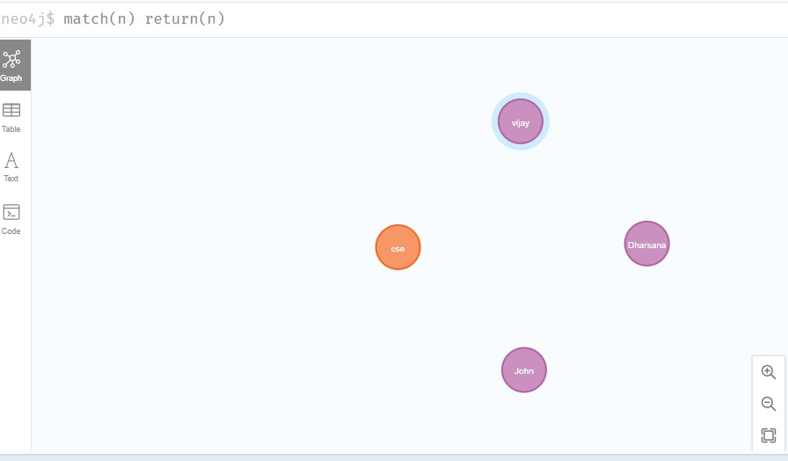

- match(n:student) return(n)

OUTPUT:

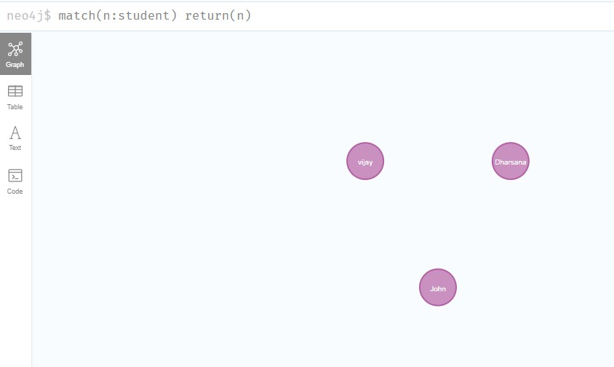

- Create relationship between student and cse .

MATCH(s:student),(d:dept) WHERE s.Sname ='vijay' AND d.deptname='cse'
CREATE(s)-[st:STUDIED_AT]->(d) return s,d

OUTPUT:
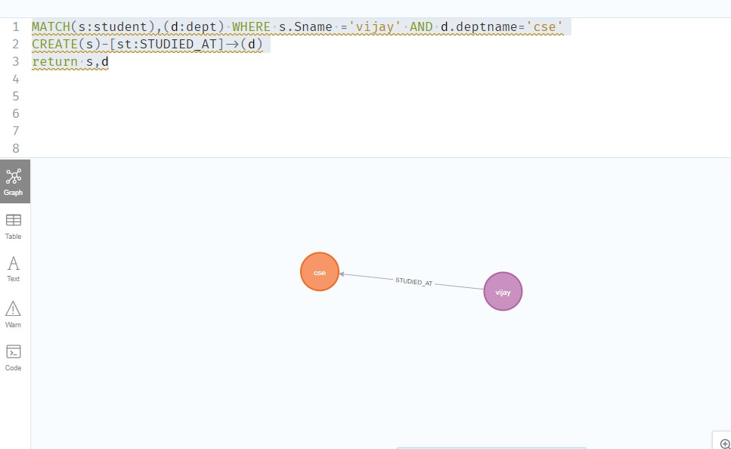

MATCH(s:student),(d:dept) WHERE s.Sname ='John' AND d.deptname='cse'
CREATE(s)-[st:STUDIED_AT]->(d)
return s,d

OUTPUT:

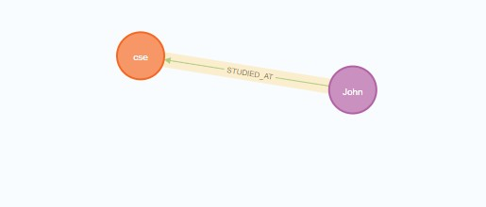

match(n) return(n)
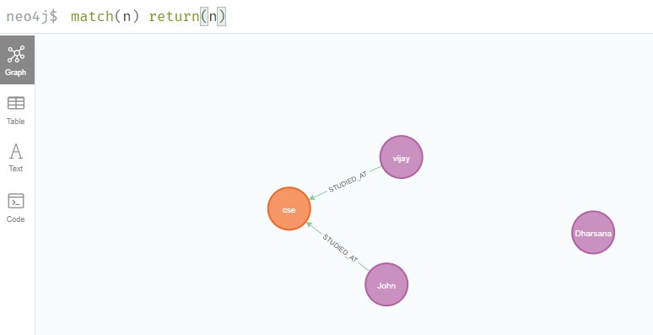

- Delete a node from student

match(n:student{Sname:'Dharsana'}) DELETE(n)

OUTPUT:
Deleted 1 node, complaeted after 10834 ms.

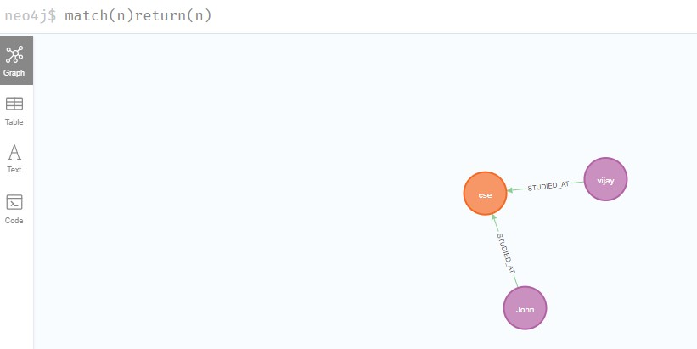

Result
The implementation of CRUD operations like creating, inserting, finding and removing operations using GraphDB is successfully executed.

