Vel Tech Rangarajan Dr. Sagunthala R&D Institute of Science and Technology

(Deemed to be University Estd. u/s 3 of UGC Act, 1956)

School of Computing
B.Tech. – Computer Science and Engineering
VTR UGE2021- (CBCS)

Academic Year: 2025–2026
SUMMER SEMESTER - SS2526
Course Code : 10211CS207
Course Name : Database Management Systems
Slot No : S8L12

DBMS TASK - 7 REPORT
Title: Triggers, Views and Exceptions

Submitted by:
VTUNO | REGISTER NUMBER | STUDENT NAME
VTU29298 | 24UECS0639 | K.Nikhitha

TASK 7:
Triggers, Views and Exceptions
Aim:
To Conduct events, views, exceptions on CRUD operations for restricting phenomenon.
a) To create a trigger in PL/SQL that automatically inserts a new record in the match_result table when a new record is inserted into the match table.
b) To create a view that displays the details of players along with their team details.
c) To write a non-recursive PL/SQL procedure to retrieve even-numbered PlayerIDs registered for any Match with exception handling.

- To create a trigger in PL/SQL that automatically inserts a new record in the match_result table when a new record is inserted into the match table.

SQL>CREATE TABLE Match_Result (ResultIDvarchar(10) PRIMARY KEY, MatchIDvarchar(10), TeamIDvarchar(6), Result varchar(20), FOREIGN KEY(MatchID) REFERENCES Match(MatchID), FOREIGN KEY(TeamID) REFERENCES Team(TeamID));

SQL>CREATE OR REPLACE TRIGGER trg_insert_match_result AFTER INSERT ON Match
FOR EACH ROW
DECLARE
N NUMBER;
BEGIN
N:=INSTR(UPPER(:NEW.RESULT),'WIN');
IF N>0 AND INSTR(UPPER(:NEW.RESULT),UPPER(:NEW.TEAMID1))>0 THEN
INSERT INTO Match_Result(ResultID, MatchID, TeamID, Result)
VALUES ('R'||:NEW.MatchID||'1', :NEW.MatchID, :NEW.TeamID1, 'WIN');
INSERT INTO Match_Result(ResultID, MatchID, TeamID, Result)
VALUES ('R'||:NEW.MatchID||'2', :NEW.MatchID, :NEW.TeamID2, 'FAIL');
ELSE
INSERT INTO Match_Result(ResultID, MatchID, TeamID, Result)
VALUES ('R'||:NEW.MatchID||'1', :NEW.MatchID, :NEW.TeamID1, 'FAIL');
INSERT INTO Match_Result(ResultID, MatchID, TeamID, Result)
VALUES ('R'||:NEW.MatchID||'2', :NEW.MatchID, :NEW.TeamID2, 'WIN');
END IF;
END;

SQL>insert into matchvalues('M01','CCB01','TCB01','22-JUN-2022',1.3,'TCB01 - WIN');
SQL>insert into matchvalues('M02','CCB02','TCB02','22-JUN-2022',8.3,'CCB01 - WIN');
SQL>insert into matchvalues('M03','TRIB01','TCB01','24-JUN-2022',8.3,'TCB01 - WIN');
SQL>insert into matchvalues('M04','TRIB01','TCB02','25-JUN-2022',8.3,'TRICB01 - WIN');
SQL>insert into match values('M05','TCB01','TCB02',DATE '2025-09-20',16.00,'TCB02 - WIN');

SQL> Select * from Match_Result;
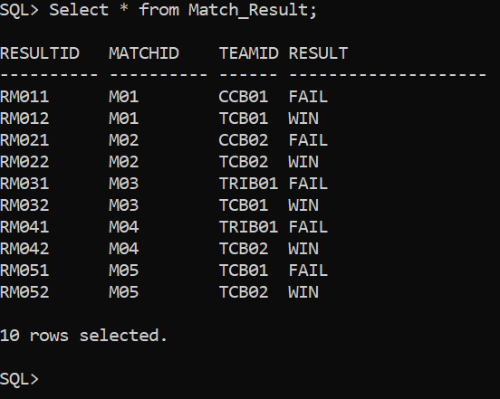

- To create a view that displays the details of players along with their team details.
SQL>CREATE OR REPLACE VIEW Player_Team_View AS SELECT p.PlayerID, p.FName AS FirstName, p.PlayingRole AS PlayingRole, p.Batting AS BattingStyle, p.Bowling AS BowlingStyle, t.TeamID AS TeamID, t.Name AS TeamName, t.Coach AS Coach, t.Captain AS Captain FROM Player p JOIN Team t ON p.TeamID = t.TeamID;
SQL> Select * from Player_Team_View;
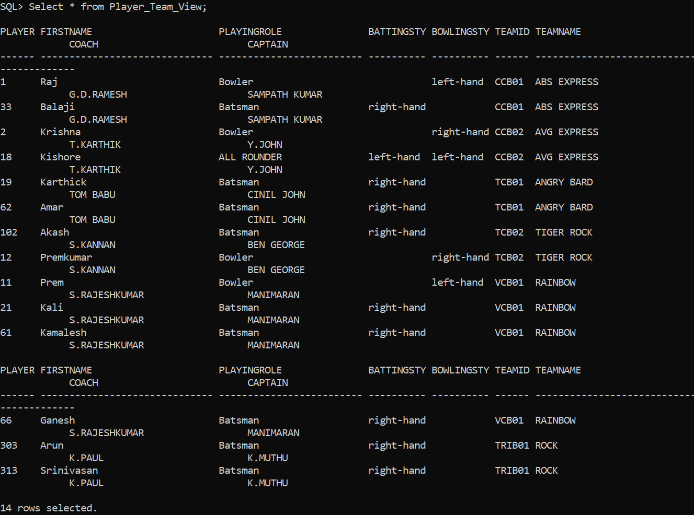
- To write a non-recursive PL/SQL procedure to retrieve even-numbered PlayerIDs registered for any Matchwith exception handling.
CREATE OR REPLACE PROCEDURE Get_Even_PlayerIDs_For_Matches IS
CURSOR even_players IS
SELECT DISTINCT p.PlayerID, p.FName, p.LName, m.MatchID
FROM Player p
JOIN Team t ON p.TeamID = t.TeamID
JOIN Match m ON (m.TeamID1 = t.TeamID OR m.TeamID2 = t.TeamID)
WHERE MOD(TO_NUMBER(REGEXP_SUBSTR(p.PlayerID, '\d+$')), 2) = 0;

v_countNUMBER := 0;
BEGIN
DBMS_OUTPUT.PUT_LINE('Even-numbered PlayerIDs registered for Matches:');

FOR rec IN even_players LOOP
v_count := v_count + 1;
DBMS_OUTPUT.PUT_LINE('MatchID: ' || rec.MatchID ||
' | PlayerID: ' || rec.PlayerID ||
' | Name: ' || rec.FName || ' ' || rec.LName);
END LOOP;

-- Handle case where no records found
IF v_count = 0 THEN
RAISE NO_DATA_FOUND;
END IF;

EXCEPTION
WHEN NO_DATA_FOUND THEN
DBMS_OUTPUT.PUT_LINE('No even-numbered PlayerIDs found for any match.');
WHEN OTHERS THEN
DBMS_OUTPUT.PUT_LINE('Error: ' || SQLERRM);
END;
/

SQL> set serveroutput on
SQL> /

Procedure created.

SQL>SET SERVEROUTPUT ON;

SQL>EXEC Get_Even_PlayerIDs_For_Matches;

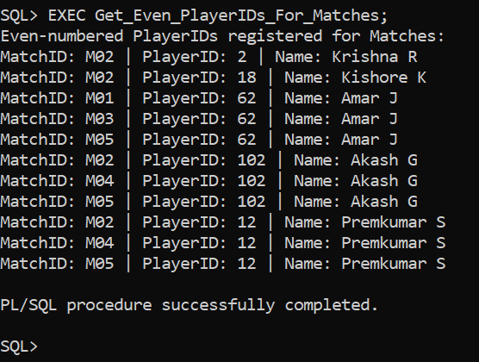

Result:
Thus the Triggers,Views andExceptions experiment was successfully completed results are verified.

