Vel Tech Rangarajan Dr. Sagunthala R&D Institute of Science and Technology

(Deemed to be University Estd. u/s 3 of UGC Act, 1956)

School of Computing
B.Tech. – Computer Science and Engineering
VTR UGE2021- (CBCS)

Academic Year: 2025–2026
SUMMER SEMESTER - SS2526
Course Code : 10211CS207
Course Name: Database Management Systems
Slot No : S2L5
DBMS TASK - 5 REPORT
Title: Writing Join Queries, Equivalent, and/or Recursive Queries
Submitted by:
VTUNO | REGISTER NUMBER | STUDENT NAME
VTU29699 | 24UECS0825 | P.Yaghnasri

Task 5: Writing Join Queries, Equivalent, and/or Recursive Queries
Case Study: Online Food Ordering System
Objective: To perform advanced query processing and test its heuristics by designing optimized complex queries and their equivalent forms, including recursive queries, for the Online Food Ordering System.

Join Queries
Query 1: Retrieve all orders along with the corresponding customer's name.
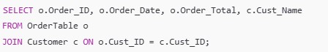
Expected Output:
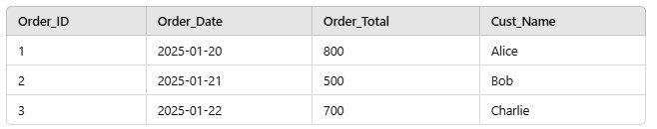
Query 2: Retrieve all menu items along with the restaurant name that offers them.
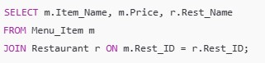
Expected Output:
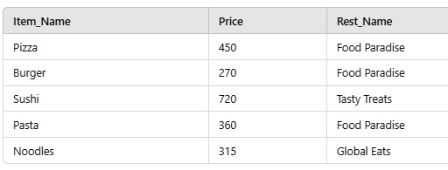
Query 3: Retrieve all orders and their delivery status.
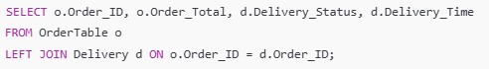
Expected Output:
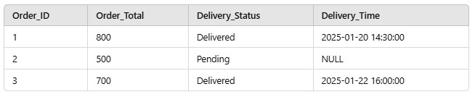

INNER JOIN
An INNER JOIN retrieves records that have matching values in both tables.
Query: Retrieve all orders along with their customer names.
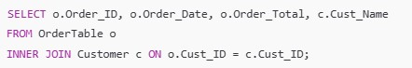
Expected Output:
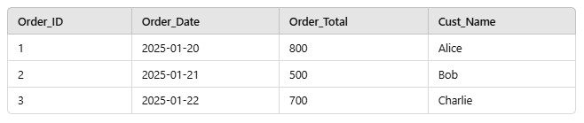

LEFT OUTER JOIN
A LEFT OUTER JOIN retrieves all records from the left table and the matched records from the right table. If no match is found, NULL is returned for columns from the right table.
Query: Retrieve all customers, even those who haven’t placed any orders.
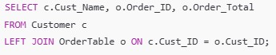
Expected Output:
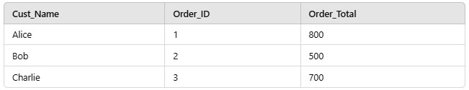

RIGHT OUTER JOIN
A RIGHT OUTER JOIN retrieves all records from the right table and the matched records from the left table. If no match is found, NULL is returned for columns from the left table.
Query: Retrieve all orders and the names of customers who placed them. Include orders even if the customer details are missing.
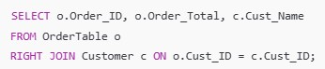
Expected Output:
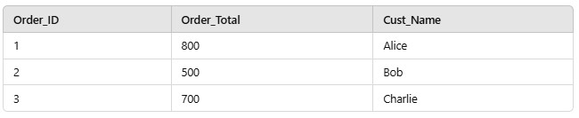

FULL OUTER JOIN
A FULL OUTER JOIN retrieves all records from both tables. If no match is found, NULL is returned for unmatched rows from either table.
Query: Retrieve all customers and all orders, even if there is no match.
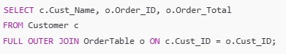
Expected Output:
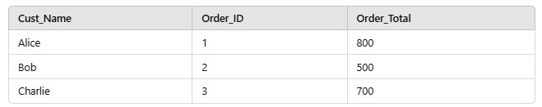
Note: Oracle doesn’t support FULL OUTER JOIN directly. Use _{UNION} of LEFT JOIN and RIGHT JOIN.

CROSS JOIN
A CROSS JOIN returns the Cartesian product of the two tables. Every row from the first table is combined with every row from the second table.
Query: Retrieve all possible combinations of customers and menu items.
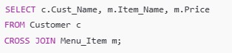
Expected Output:
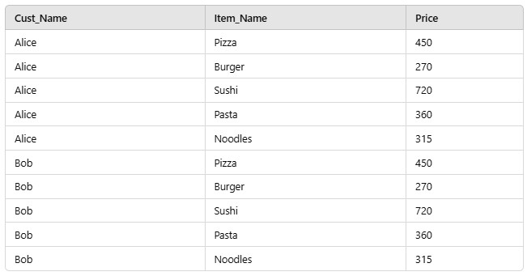

SELF JOIN
A SELF JOIN joins a table with itself. It is useful for hierarchical or comparison data.
Query: Retrieve all menu items that belong to the same restaurant as another item.
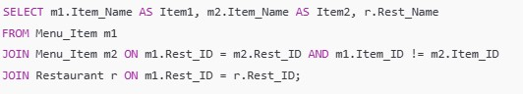
Expected Output:
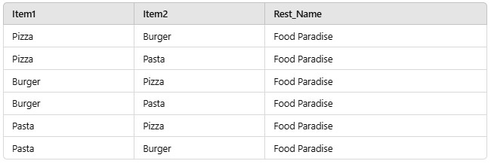

Equivalent Queries
Query 1: Retrieve all customers who placed orders using a join (equivalent to a subquery).
Using Join:
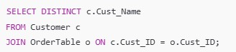
Equivalent Subquery:
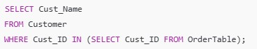
Query 2: Retrieve the restaurant offering the most expensive menu item.
Using Join:
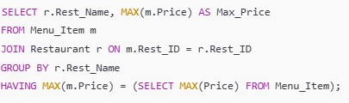
Equivalent Subquery:
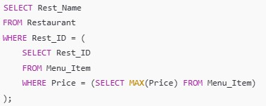

Recursive Queries
Oracle SQL supports recursion using the WITH clause for hierarchical data.
Query 1: Generate a recursive query to find all ancestors of a given category in a hypothetical "Menu Category" table.
Assume we have a table:
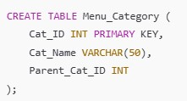
Sample Data:
INSERT INTO Menu_Category (Cat_ID, Cat_Name, Parent_Cat_ID) VALUES (1, 'Food', NULL);
INSERT INTO Menu_Category (Cat_ID, Cat_Name, Parent_Cat_ID) VALUES (2, 'Italian',
1);
INSERT INTO Menu_Category (Cat_ID, Cat_Name, Parent_Cat_ID) VALUES (3, 'Chinese', 1);
INSERT INTO Menu_Category (Cat_ID, Cat_Name, Parent_Cat_ID) VALUES (4, 'Pizza',
2);
INSERT INTO Menu_Category (Cat_ID, Cat_Name, Parent_Cat_ID) VALUES (5, 'Pasta',
2);
Recursive Query:
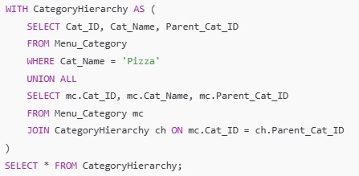
Expected Output for 'Pizza':
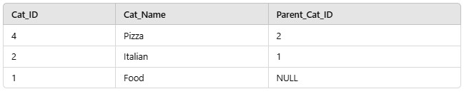

Optimizing Complex Queries
Query 1: Find customers who placed orders totaling more than 1000 across all their orders.
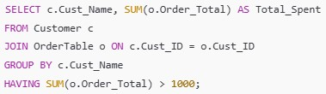
Query 2: Retrieve all restaurants and their total number of menu items using a join.
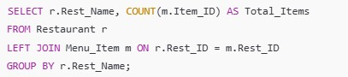

RESULT:Thus the task has executed successfully.

