Vel Tech Rangarajan Dr. Sagunthala R&D Institute of Science and Technology

(Deemed to be University Estd. u/s 3 of UGC Act, 1956)

School of Computing
B.Tech. – Computer Science and Engineering
VTR UGE2021- (CBCS)

Academic Year: 2025–2026
SUMMER SEMESTER - SS2526
Course Code : 10211CS207
Course Name: Database Management Systems
Slot No : S2L5
DBMS TASK - 2 REPORT
Title: Executing DML and DDL Commands
Submitted by:
VTUNO | REGISTER NUMBER | STUDENT NAME
VTU29703 | 24UECS1025 | YERASI. AKSHAYA

TASK 2: Executing DML and DDL Commands
Here the commands are given for the Online food ordering system try to execute these commands in the lab.
Step 1: Go to windows Type Run SQL
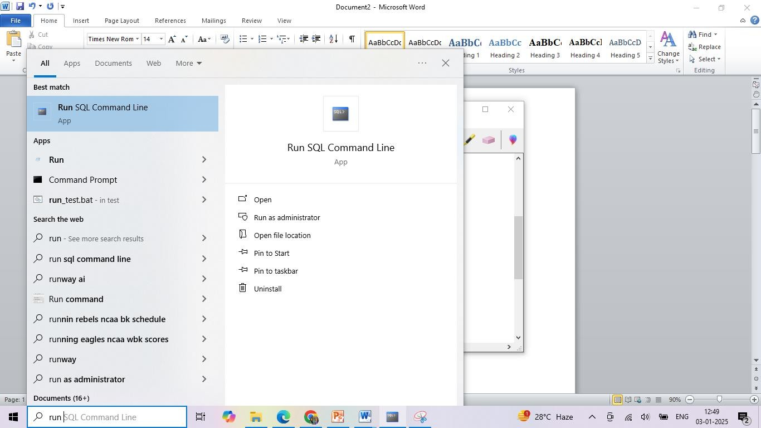
Step 2: Type “connect”
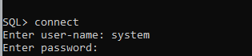
Step 3: Enter Username: system and Password: system Step 4: Start typing the commands
The SQL commands to create, insert, select, and display a table for an online food ordering system

Create Tables

Customers Table:
CREATE TABLE Customers ( CustomerID INT PRIMARY KEY, Name VARCHAR(100),

Email VARCHAR(100),
PhoneNumber VARCHAR(15), Address VARCHAR(255)
);

FoodItems Table:
CREATE TABLE FoodItems ( FoodID INT PRIMARY KEY, FoodName VARCHAR(100), Price DECIMAL(10, 2),
Category VARCHAR(50)
);
This is the sample how your commands are executed
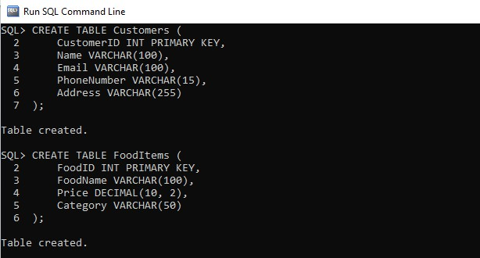

Orders Table:
CREATE TABLE Orders ( OrderID INT PRIMARY KEY,
CustomerID INT, OrderDate DATE,
TotalAmount DECIMAL(10, 2),
FOREIGN KEY (CustomerID) REFERENCES Customers(CustomerID)
);

OrderDetails Table:
CREATE TABLE OrderDetails (

OrderDetailID INT PRIMARY KEY, OrderID INT,
FoodID INT, Quantity INT,
Subtotal DECIMAL(10, 2),
FOREIGN KEY (OrderID) REFERENCES Orders(OrderID), FOREIGN KEY (FoodID) REFERENCES FoodItems(FoodID)
);

Insert Records

  - Insert into Customers Table

INSERT
INTO Customers (CustomerID, Name, Email, PhoneNumber, Address) VALUES (1, 'John Doe', 'john.doe@example.com', '1234567890', '123 Elm
Street');
INSERT INTO Customers (CustomerID, Name, Email, PhoneNumber, Address) VALUES (2, 'Jane Smith', 'jane.smith@example.com', '9876543210', '456
Oak Avenue');
SELECT * FROM Customers;

Insert into FoodItems Table

INSERT
INTO FoodItems (FoodID, FoodName, Price, Category) VALUES (1, 'Cheese Pizza', 8.99, 'Pizza');
INSERT
INTO FoodItems (FoodID, FoodName, Price, Category) VALUES (2, 'Chicken Burger', 5.49, 'Burger');
INSERT
INTO FoodItems (FoodID, FoodName, Price, Category) VALUES (3, 'Veggie Salad', 4.99, 'Salad');
INSERT
INTO FoodItems (FoodID, FoodName, Price, Category) VALUES (4, 'Chocolate Cake', 3.99, 'Dessert');
SELECT * FROM FoodItems;

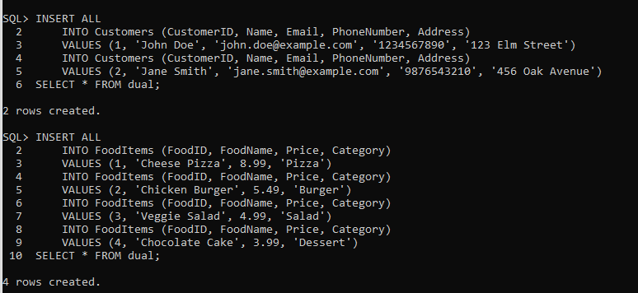

Insert into Orders Table

INSERT
INTO Orders (OrderID, CustomerID, OrderDate, TotalAmount) VALUES (1 Orders, 1, DATE '2025-01-03', 18.47);
INSERT
INTO Orders (OrderID, CustomerID, OrderDate, TotalAmount) VALUES (2, 2, DATE '2025-01-03', 9.48);
SELECT * FROM Orders;

Insert into OrderDetails Table

INSERT INTO OrderDetails (OrderDetailID, OrderID, FoodID, Quantity, Subtotal) VALUES (1, 1, 1, 2, 17.98);
INSERT INTO OrderDetails (OrderDetailID, OrderID, FoodID, Quantity, Subtotal) VALUES (2, 1, 4, 1, 3.99);
INSERT INTO OrderDetails (OrderDetailID, OrderID, FoodID, Quantity, Subtotal) VALUES (3, 2, 2, 1, 5.49);
INSERT INTO OrderDetails (OrderDetailID, OrderID, FoodID, Quantity, Subtotal) VALUES (4, 2, 3, 1, 4.99);
SELECT * FROM OrderDetails;

Select Data
  - Select All Customers:
SELECT * FROM Customers;

Select All Food Items:
SELECT * FROM FoodItems;

Select All Orders:
SELECT * FROM Orders;

Select All Order Details:
SELECT * FROM OrderDetails;

RESULT: Thus the task has completed successfully.

