Vel Tech Rangarajan Dr. Sagunthala R&D Institute of Science and Technology

(Deemed to be University Estd. u/s 3 of UGC Act, 1956)

School of Computing
B.Tech. – Computer Science and Engineering
VTR UGE2021- (CBCS)

Academic Year: 2025–2026
SUMMER SEMESTER - SS2526
Course Code : 10211CS207
Course Name: Database Management Systems
Slot No : S2L5
DBMS TASK - 4 REPORT
Title: Using Functions in Queries and Writing Subqueries
Submitted by:
VTUNO | REGISTER NUMBER | STUDENT NAME
VTU29703 | 24UECS1025 | YERASI AKSHAYA

Task 4: Using Functions in Queries and Writing Subqueries
Case Study: Online Food Ordering System
Objective: To perform advanced query processing and test heuristics by designing optimal correlated and nested subqueries, such as finding summary statistics, for the Online Food Ordering System.
- Using Aggregate Functions with Subqueries
Query 1: Find the customer(s) who placed the highest order total.
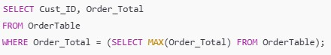
Output:
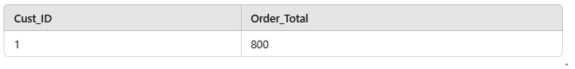
Query 2: List all menu items whose price is above the average price of all menu items.
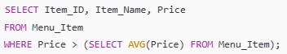
Output:
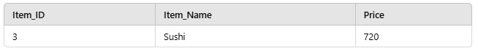
- Nested Subqueries
Query 1: Find the names of customers who placed orders worth more than 600.
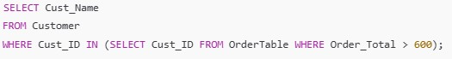
Output:
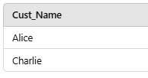
Query 2: Retrieve the name of the restaurant(s) offering the most expensive menu item.
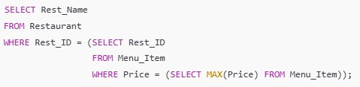
Output:
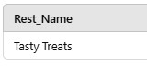
Query 1: Retrieve the category of menu items with the highest average price.
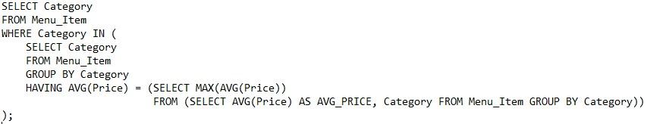
Output:
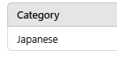
- Correlated Subqueries
Query 1: Find all orders where the total is greater than the average total of all orders.
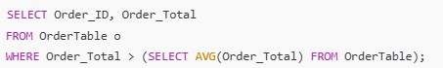
Output:
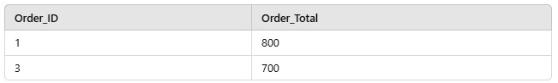
Query 2: Find customers who have placed more than one order.
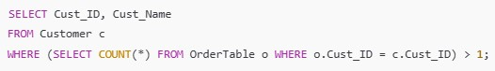
Output:
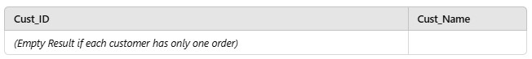
Query 3: Retrieve the list of menu items priced above the average price for their category.
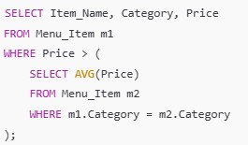
Output:
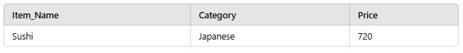
Query 4: Find customers who have placed orders with totals higher than the average order total of all customers.
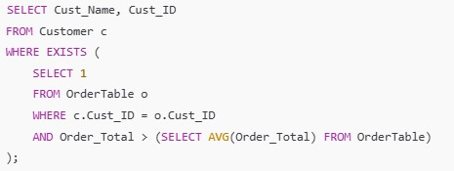
Output:
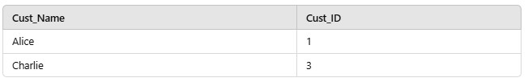
- Summary Statistics with Subqueries
Query 1: Retrieve the total revenue generated by each restaurant.
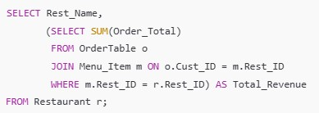
Output:
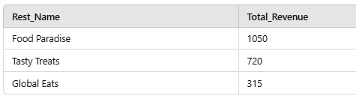
Query 2: Find the average price of menu items for each restaurant.
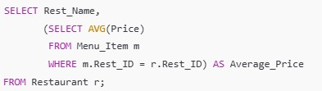
Output:
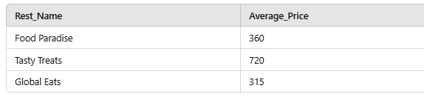

RESULT:Thus the task has completed successfully.

