Vel Tech Rangarajan Dr. Sagunthala R&D Institute of Science and Technology

(Deemed to be University Estd. u/s 3 of UGC Act, 1956)

School of Computing
B.Tech. – Computer Science and Engineering
VTR UGE2021- (CBCS)

Academic Year: 2025–2026
SUMMER SEMESTER - SS2526
Course Code : 10211CS207
Course Name: Database Management Systems
Slot No : S2L5
DBMS TASK - 6 REPORT
Title: Writing Join Queries, Equivalent, and/or Recursive Queries
Submitted by:
VTUNO | REGISTER NUMBER | STUDENT NAME
VTU29703 | 24UECS1025 | YERASI AKSHAYA

TASK 6 :
Procedures, Functions, and Loops in
PL/SQL (Based on Online Food Ordering
System)
Step 1: Ensure the Necessary Tables Exist
DROP TABLE OrderTable PURGE;
DROP TABLE Delivery PURGE;
DROP TABLE Menu_Item PURGE;

CREATE TABLE OrderTable (
Order_ID NUMBER PRIMARY KEY,
Cust_ID NUMBER, Order_Date DATE,
Order_Total NUMBER(10,2),
Payment_Status VARCHAR2(20)
);

EXPECTED OUTPUT: Table created

CREATE TABLE Delivery (
Order_ID NUMBER PRIMARY KEY,
Delivery_Status VARCHAR2(20),
FOREIGN KEY (Order_ID) REFERENCES OrderTable(Order_ID)
);

EXPECTED OUTPUT: Table created
CREATE TABLE Menu_Item (
Item_ID NUMBER PRIMARY KEY,
Item_Name VARCHAR2(100),
Price NUMBER(10,2)
);

EXPECTED OUTPUT: Table created

INSERT INTO OrderTable VALUES (1, 101, TO_DATE('2024-02-01', 'YYYY-MMDD'), 250.50, 'Pending');

OUTPUT: 1 row created
INSERT INTO OrderTable VALUES (2, 102, TO_DATE('2024-02-02', 'YYYY-MMDD'), 400.75, 'Paid');

OUTPUT: 1 row created
INSERT INTO OrderTable VALUES (3, 103, TO_DATE('2024-02-03', 'YYYY-MMDD'), 150.00, 'Pending');

OUTPUT: 1 row created

INSERT INTO Delivery VALUES (1, 'Pending'); OUTPUT: 1 row created
INSERT INTO Delivery VALUES (2, 'Delivered'); OUTPUT: 1 row created
INSERT INTO Delivery VALUES (3, 'Pending');

OUTPUT: 1 row created

INSERT INTO Menu_Item VALUES (1, 'Pizza', 500); OUTPUT: 1 row created
INSERT INTO Menu_Item VALUES (2, 'Burger', 300); OUTPUT: 1 row created
INSERT INTO Menu_Item VALUES (3, 'Pasta', 450); OUTPUT: 1 row created

1. Procedure to Update Payment Status
Step 1: Create a Procedure

CREATE OR REPLACE PROCEDURE Update_Payment_Status ( p_Order_ID IN NUMBER,
p_New_Status IN VARCHAR2
) AS
BEGIN
UPDATE OrderTable
SET Payment_Status = p_New_Status
WHERE Order_ID = p_Order_ID;

COMMIT;

DBMS_OUTPUT.PUT_LINE( 'Payment status updated successfully for Order ID: ' || p_Order_ID );
END;
/

Expected Output:
Procedure created

Step 2: Execution

SET SERVEROUTPUT ON
BEGIN
Update_Payment_Status(1, 'Paid');
END; /
Expected Output:
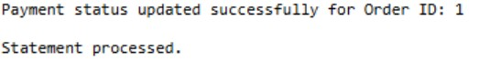

Query 2: Function to Calculate Total Revenue
Step 1: Create a Function

CREATE OR REPLACE FUNCTION Get_Total_Revenue
RETURN NUMBER AS
v_Total_Revenue NUMBER;
BEGIN
SELECT SUM(Order_Total)
INTO v_Total_Revenue
FROM OrderTable;

RETURN v_Total_Revenue;
END; /
Expected Output:
Function created

Step 2: Execution

SELECT Get_Total_Revenue FROM dual;

Expected Output:
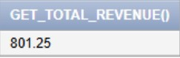
Query 3: Loop: Mark All Undelivered Orders as "Delayed"

DECLARE
v_Order_ID OrderTable.Order_ID%TYPE;
CURSOR cur IS
SELECT Order_ID
FROM Delivery
WHERE Delivery_Status = 'Pending';
BEGIN
OPEN cur;
LOOP
FETCH cur INTO v_Order_ID;
EXIT WHEN cur%NOTFOUND;

UPDATE Delivery
SET Delivery_Status = 'Delayed'
WHERE Order_ID = v_Order_ID;

DBMS_OUTPUT.PUT_LINE('Order ' || v_Order_ID || ' marked as Delayed.');
END LOOP;
CLOSE cur;

COMMIT;
END; /
Expected Output:
procedure successfully completed.
Order 1 marked as Delayed.
Order 3 marked as Delayed.

Query 4: Procedure to Get Order Details by Customer ID
Step 1: Create a Procedure

CREATE OR REPLACE PROCEDURE Get_Customer_Orders ( p_Cust_ID IN NUMBER
) AS
BEGIN
FOR order_rec IN (
SELECT Order_ID, Order_Date, Order_Total, Payment_Status
FROM OrderTable
WHERE Cust_ID = p_Cust_ID
) LOOP
DBMS_OUTPUT.PUT_LINE(
'Order ID: ' || order_rec.Order_ID || ', Date: ' || order_rec.Order_Date ||
', Total: ' || order_rec.Order_Total ||
', Status: ' || order_rec.Payment_Status
);
END LOOP;
END;
/
Expected Output:
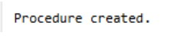

Step 2: Execution
BEGIN
Get_Customer_Orders(101);
END;

Expected Output:
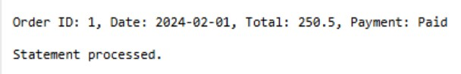

Query 5: Procedure to Apply Discount on Menu Items
Step 1: Create a Procedure
CREATE OR REPLACE PROCEDURE Apply_Discount ( discount_percent IN NUMBER
)
IS
BEGIN
UPDATE Menu_Item
SET Price = Price - (Price * discount_percent / 100);

COMMIT;

DBMS_OUTPUT.PUT_LINE('Discount Applied: ' || discount_percent || '%');
END;
/
Expected Output:
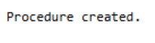
Step 2: Execution
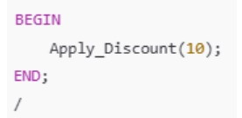
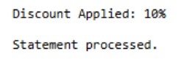
Expected Output:

RESULT:Thus the program has excecuted sucessfully.

