1) 1. Java Date and Time
class Result {

public static String findDay(int month, int day, int year){

LocalDate date = LocalDate.of(year , month , day);
return date.getDayOfWeek().toString();
}
}
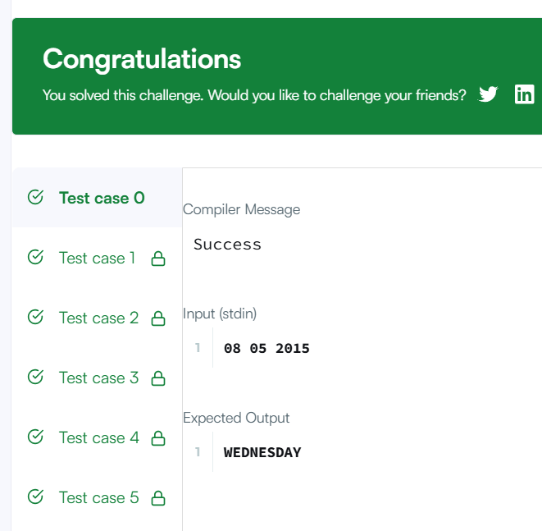

2) Number of Days Between Two Dates
import java.time.*;
import java.time.temporal.ChronoUnit;

class Solution {
public int daysBetweenDates(String date1, String date2) {

LocalDate d1 = LocalDate.parse(date1);
LocalDate d2 = LocalDate.parse(date2);

return (int) Math.abs(ChronoUnit.DAYS.between(d1 , d2));

}
}
