1) Day of the Year
class Solution {
public int dayOfYear(String date) {
int year = Integer.parseInt(date.substring(0, 4));
int month = Integer.parseInt(date.substring(5, 7));
int day = Integer.parseInt(date.substring(8, 10));
int[] days = {31, 28, 31, 30, 31, 30, 31, 31, 30, 31, 30, 31};
int answer = day;
for (int i = 0; i < month - 1; i++) {
answer += days[i];
}
if ((year % 400 == 0 || (year % 4 == 0 && year % 100 != 0)) && month > 2) {
answer++;
}
return answer;
}
}
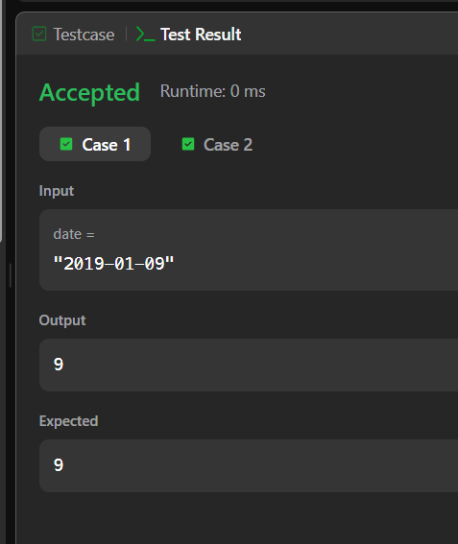
2) Day of the Week
import java.time.LocalDate;
import java.time.format.TextStyle;
import java.util.Locale;

class Solution {
public String dayOfTheWeek(int day, int month, int year) {
LocalDate date = LocalDate.of(year, month, day);
return date.getDayOfWeek().getDisplayName(
TextStyle.FULL,
Locale.ENGLISH
);
}
}
