1)
class Solution {
public boolean halvesAreAlike(String s) {

int mid = s.length() / 2;
int countA = 0;
int countB = 0;

for (int i = 0; i < mid; i++) {
if ("aeiouAEIOU".indexOf(s.charAt(i)) != -1) {
countA++;
}
}

for (int i = mid; i < s.length(); i++) {
if ("aeiouAEIOU".indexOf(s.charAt(i)) != -1) {
countB++;
}
}

return countA == countB;
}
}
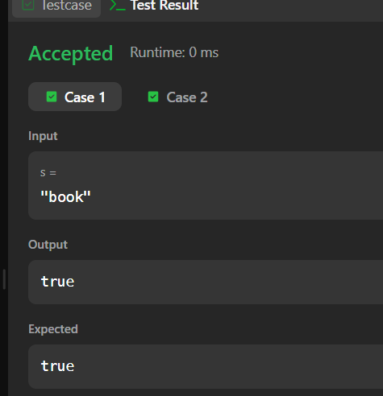
2)
import java.util.*;

class Main {
public static void main(String[] args) {
Scanner sc = new Scanner(System.in);

int T = sc.nextInt();

while (T-- > 0) {
String s = sc.next();

int n = s.length();
int mid = n / 2;

int[] left = new int[26];
int[] right = new int[26];

for (int i = 0; i < mid; i++) {
left[s.charAt(i) - 'a']++;
}

int start;

if (n % 2 == 0) {
start = mid;
} else {
start = mid + 1;
}

for (int i = start; i < n; i++) {
right[s.charAt(i) - 'a']++;
}

if (Arrays.equals(left, right)) {
System.out.println("YES");
} else {
System.out.println("NO");
}
}
}
}
