1)
import java.io.*;
import java.util.*;

public class Solution {

public static List<Integer> compareTriplets(List<Integer> a, List<Integer> b) {
int alice = 0;
int bob = 0;

for (int i = 0; i < 3; i++) {
if (a.get(i) > b.get(i)) {
alice++;
} else if (a.get(i) < b.get(i)) {
bob++;
}
}

List<Integer> result = new ArrayList<>();
result.add(alice);
result.add(bob);

return result;
}

public static void main(String[] args) throws IOException {
BufferedReader bufferedReader = new BufferedReader(new InputStreamReader(System.in));
BufferedWriter bufferedWriter = new BufferedWriter(new OutputStreamWriter(System.out));

String[] aTemp = bufferedReader.readLine().replaceAll("\\s+$", "").split(" ");

List<Integer> a = new ArrayList<>();

for (int i = 0; i < 3; i++) {
a.add(Integer.parseInt(aTemp[i]));
}

String[] bTemp = bufferedReader.readLine().replaceAll("\\s+$", "").split(" ");

List<Integer> b = new ArrayList<>();

for (int i = 0; i < 3; i++) {
b.add(Integer.parseInt(bTemp[i]));
}

List<Integer> result = compareTriplets(a, b);

for (int i = 0; i < result.size(); i++) {
bufferedWriter.write(String.valueOf(result.get(i)));

if (i != result.size() - 1) {
bufferedWriter.write(" ");
}
}

bufferedWriter.newLine();

bufferedReader.close();
bufferedWriter.close();
}
}
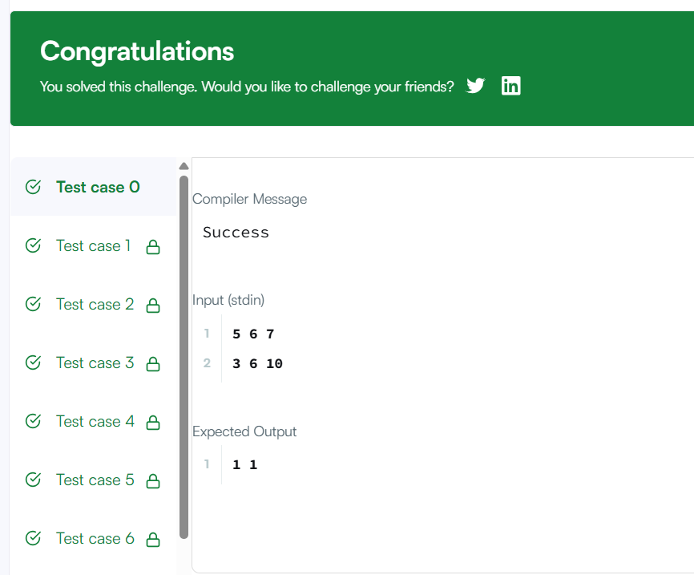
2)
import java.util.*;

class Solution {
public boolean containsDuplicate(int[] nums) {

HashSet<Integer> set = new HashSet<>();

for (int i = 0; i < nums.length; i++) {

if (set.contains(nums[i])) {
return true;
}

set.add(nums[i]);
}

return false;
}
}
