1)
import java.io.*;
import java.util.*;

public class Solution {

public static String timeConversion(String s) {

String period = s.substring(8);
int hour = Integer.parseInt(s.substring(0, 2));

if (period.equals("AM")) {
if (hour == 12) {
hour = 0;
}
} else {
if (hour != 12) {
hour = hour + 12;
}
}

return String.format("%02d", hour) + s.substring(2, 8);
}

public static void main(String[] args) throws IOException {

BufferedReader bufferedReader =
new BufferedReader(new InputStreamReader(System.in));

BufferedWriter bufferedWriter =
new BufferedWriter(new OutputStreamWriter(System.out));

String s = bufferedReader.readLine();

String result = timeConversion(s);

bufferedWriter.write(result);
bufferedWriter.newLine();

bufferedReader.close();
bufferedWriter.close();
}
}
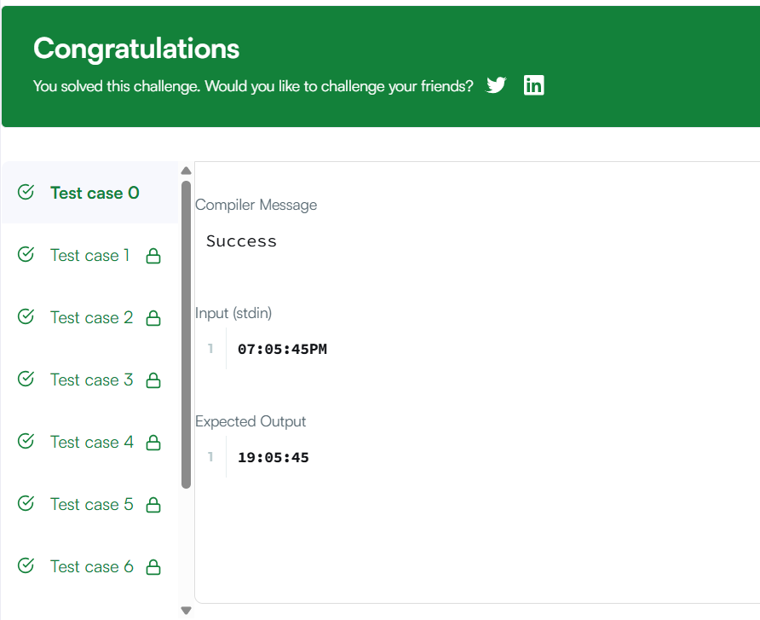
2)
class Solution {
public void moveZeroes(int[] nums) {
int index=0;
for(int i = 0; i < nums.length ;i++){

if(nums[i]!=0){
nums[index]=nums[i];
index++;
}
}
while(index<nums.length){
nums[index]=0;
index++;

}
}
}
