1)
import java.io.*;
import java.util.*;

public class Solution {

public static int diagonalDifference(List<List<Integer>> arr) {

int n = arr.size();

int leftDiagonal = 0;
int rightDiagonal = 0;

for (int i = 0; i < n; i++) {

leftDiagonal += arr.get(i).get(i);

rightDiagonal += arr.get(i).get(n - 1 - i);
}

return Math.abs(leftDiagonal - rightDiagonal);
}

public static void main(String[] args) throws IOException {

BufferedReader bufferedReader =
new BufferedReader(new InputStreamReader(System.in));

BufferedWriter bufferedWriter =
new BufferedWriter(new OutputStreamWriter(System.out));

int n = Integer.parseInt(bufferedReader.readLine().trim());

List<List<Integer>> arr = new ArrayList<>();

for (int i = 0; i < n; i++) {

String[] row =
bufferedReader.readLine().trim().split(" ");

List<Integer> currentRow = new ArrayList<>();

for (int j = 0; j < n; j++) {
currentRow.add(Integer.parseInt(row[j]));
}

arr.add(currentRow);
}

int result = diagonalDifference(arr);

bufferedWriter.write(String.valueOf(result));
bufferedWriter.newLine();

bufferedReader.close();
bufferedWriter.close();
}
}
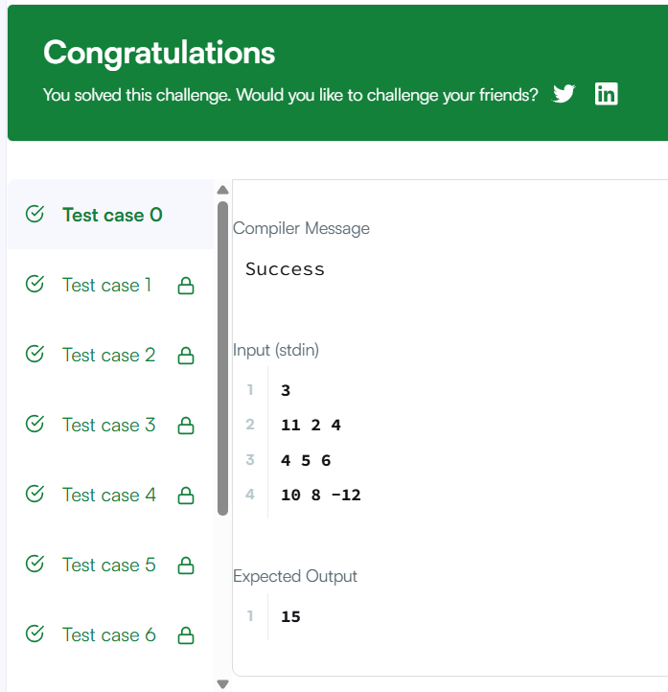
2)
class Solution {
public int[][] transpose(int[][] matrix) {

int m = matrix.length;
int n = matrix[0].length;

int[][] result = new int[n][m];

for (int i = 0; i < m; i++) {
for (int j = 0; j < n; j++) {
result[j][i] = matrix[i][j];
}
}

return result;
}
}
