1)
class Solution {
public int[][] matrixBlockSum(int[][] mat, int k) {

int m = mat.length;
int n = mat[0].length;

int[][] answer = new int[m][n];

for (int i = 0; i < m; i++) {
for (int j = 0; j < n; j++) {

int r1 = Math.max(0, i - k);
int r2 = Math.min(m - 1, i + k);

int c1 = Math.max(0, j - k);
int c2 = Math.min(n - 1, j + k);

for (int r = r1; r <= r2; r++) {
for (int c = c1; c <= c2; c++) {
answer[i][j] += mat[r][c];
}
}
}
}

return answer;
}
}
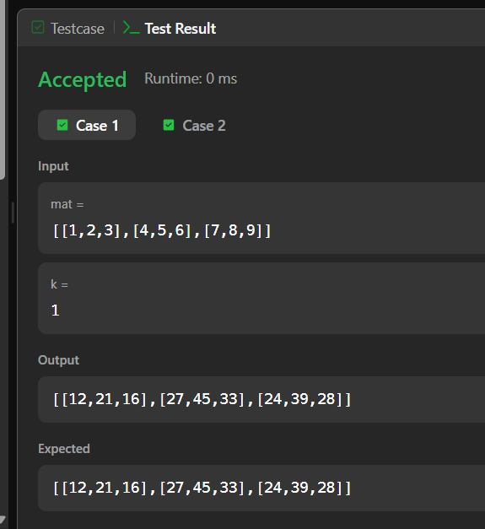
2)
import java.io.*;
import java.util.*;

public class Solution {

public static void matrixRotation(List<List<Integer>> matrix, int r) {

int m = matrix.size();
int n = matrix.get(0).size();

int layers = Math.min(m, n) / 2;

for (int layer = 0; layer < layers; layer++) {

List<Integer> values = new ArrayList<>();

int top = layer;
int left = layer;
int bottom = m - 1 - layer;
int right = n - 1 - layer;

// Top row
for (int j = left; j <= right; j++) {
values.add(matrix.get(top).get(j));
}

// Right column
for (int i = top + 1; i <= bottom; i++) {
values.add(matrix.get(i).get(right));
}

// Bottom row
for (int j = right - 1; j >= left; j--) {
values.add(matrix.get(bottom).get(j));
}

// Left column
for (int i = bottom - 1; i > top; i--) {
values.add(matrix.get(i).get(left));
}

int len = values.size();
int shift = r % len;

List<Integer> rotated = new ArrayList<>();

for (int i = shift; i < len; i++) {
rotated.add(values.get(i));
}

for (int i = 0; i < shift; i++) {
rotated.add(values.get(i));
}

int index = 0;

// Put values back - top row
for (int j = left; j <= right; j++) {
matrix.get(top).set(j, rotated.get(index++));
}

// Put values back - right column
for (int i = top + 1; i <= bottom; i++) {
matrix.get(i).set(right, rotated.get(index++));
}

// Put values back - bottom row
for (int j = right - 1; j >= left; j--) {
matrix.get(bottom).set(j, rotated.get(index++));
}

// Put values back - left column
for (int i = bottom - 1; i > top; i--) {
matrix.get(i).set(left, rotated.get(index++));
}
}

// Print matrix
for (int i = 0; i < m; i++) {
for (int j = 0; j < n; j++) {
System.out.print(matrix.get(i).get(j));

if (j < n - 1) {
System.out.print(" ");
}
}
System.out.println();
}
}

public static void main(String[] args) throws IOException {

BufferedReader br =
new BufferedReader(new InputStreamReader(System.in));

String[] firstLine = br.readLine().split(" ");

int m = Integer.parseInt(firstLine[0]);
int n = Integer.parseInt(firstLine[1]);
int r = Integer.parseInt(firstLine[2]);

List<List<Integer>> matrix = new ArrayList<>();

for (int i = 0; i < m; i++) {

String[] row = br.readLine().split(" ");

List<Integer> currentRow = new ArrayList<>();

for (int j = 0; j < n; j++) {
currentRow.add(Integer.parseInt(row[j]));
}

matrix.add(currentRow);
}

matrixRotation(matrix, r);
}
}
