1) 1. Java Dequeue
import java.util.*;

public class Solution {
public static void main(String[] args) {
Scanner sc = new Scanner(System.in);

int n = sc.nextInt();
int m = sc.nextInt();

Deque<Integer> deque = new ArrayDeque<>();
Map<Integer, Integer> map = new HashMap<>();

int max = 0;

for (int i = 0; i < n; i++) {
int num = sc.nextInt();

deque.addLast(num);
map.put(num, map.getOrDefault(num, 0) + 1);

if (deque.size() > m) {
int removed = deque.removeFirst();

map.put(removed, map.get(removed) - 1);

if (map.get(removed) == 0) {
map.remove(removed);
}
}

if (deque.size() == m) {
max = Math.max(max, map.size());
}
}

System.out.println(max);
}
}
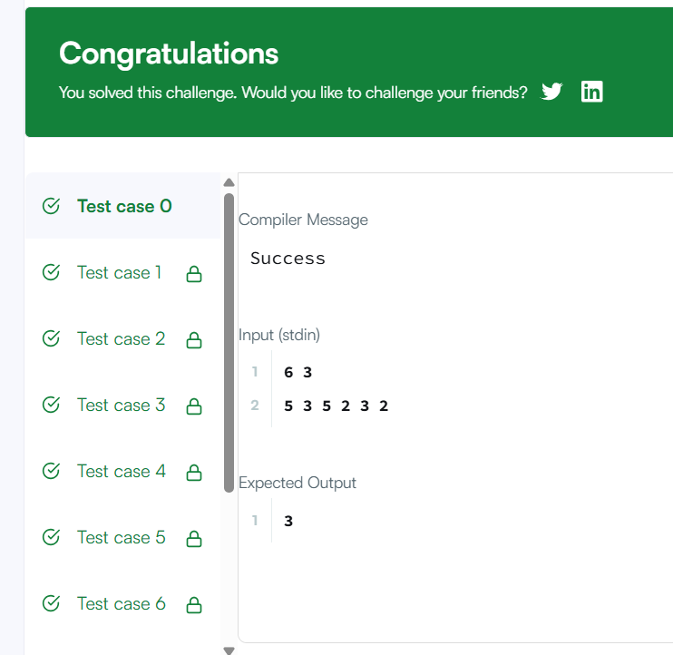

2) Java Hashset
import java.io.*;
import java.util.*;
import java.text.*;
import java.math.*;
import java.util.regex.*;

public class Solution {

public static void main(String[] args) {
Scanner s = new Scanner(System.in);
int t = s.nextInt();

String[] pair_left = new String[t];
String[] pair_right = new String[t];

for (int i = 0; i < t; i++) {
pair_left[i] = s.next();
pair_right[i] = s.next();
}

Set<String> pairs = new HashSet<>();

for (int i = 0; i < t; i++) {
String pair = pair_left[i] + " " + pair_right[i];

pairs.add(pair);

System.out.println(pairs.size());
}
}
}
