1) Remove Element
class Solution {
public int removeElement(int[] nums, int val) {
int k = 0;
for (int i = 0; i < nums.length; i++) {
if (nums[i] != val) {
nums[k] = nums[i];
k++;
}
}

return k;
}
}
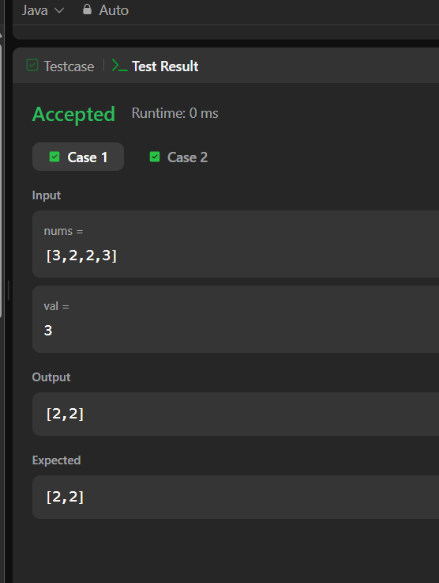
2) Remove Duplicates from Sorted Array
class Solution {
public int removeDuplicates(int[] nums) {
int i = 0;

for (int j = 1; j < nums.length; j++) {
if (nums[i] != nums[j]) {
i++;
nums[i] = nums[j];
}
}

return i + 1;
}
}
