1)Maximum Subarray
import java.util.*;
class Solution {
public int maxSubArray(int[] nums) {
int current = nums[0];
int max = nums[0];

for(int i = 1;i<nums.length;i++){
current = Math.max(nums[i] , current+nums[i]);
max =Math.max(max,current);
}

return max;
}
}
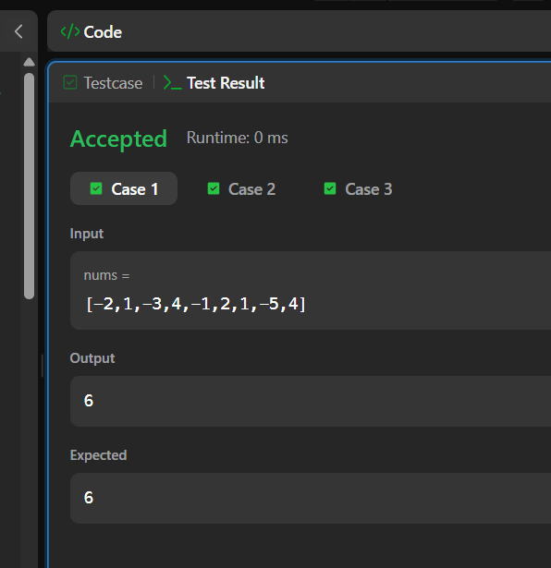
2) Find the Highest Altitude
class Solution {
public int largestAltitude(int[] gain) {
int current = 0;
int highest = 0;

for (int i = 0; i < gain.length; i++) {
current = current + gain[i];

if (current > highest) {
highest = current;
}
}

return highest;
}
}

