1) 1. Group Anagrams
class Solution {
public List<List<String>> groupAnagrams(String[] strs) {
Map<String, List<String>> map = new HashMap<>();

for (String s : strs) {
char[] chars = s.toCharArray();
Arrays.sort(chars);

String key = new String(chars);

if (!map.containsKey(key)) {
map.put(key, new ArrayList<>());
}

map.get(key).add(s);
}

return new ArrayList<>(map.values());
}
}
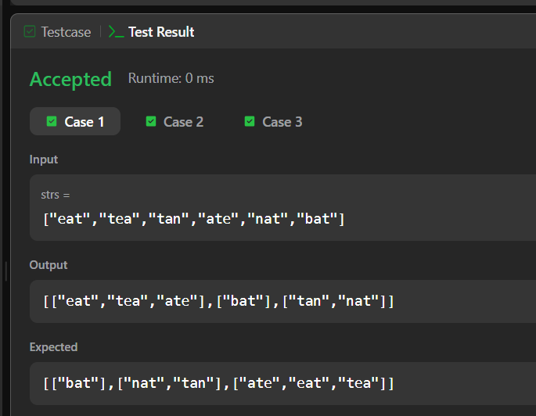
2) Top K Frequent Elements
class Solution {
public int[] topKFrequent(int[] nums, int k) {
Map<Integer, Integer> map = new HashMap<>();

for (int num : nums) {
map.put(num, map.getOrDefault(num, 0) + 1);
}

List<Integer>[] bucket = new List[nums.length + 1];

for (int num : map.keySet()) {
int frequency = map.get(num);

if (bucket[frequency] == null) {
bucket[frequency] = new ArrayList<>();
}

bucket[frequency].add(num);
}

int[] result = new int[k];
int index = 0;

for (int i = bucket.length - 1; i >= 0 && index < k; i--) {
if (bucket[i] != null) {
for (int num : bucket[i]) {
result[index] = num;
index++;

if (index == k) {
break;
}
}
}
}

return result;
}
}
