- Sorting: Comparator

class Solution {
public int[] runningSum(int[] arr) {
int n = arr.length;
for (int i =1; i<n;i++){
arr[i]=arr[i]+arr[i-1];
}
return arr;
}
}
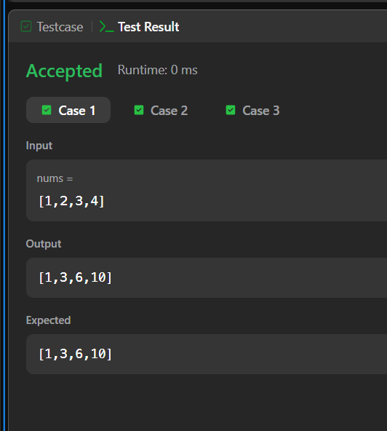

2) Richest Customer Wealth
class Solution {
public int maximumWealth(int[][] accounts) {

int maxWealth = 0;
for(int i=0; i<accounts.length ;i++){
int wealth =0;
for(int j =0; j<accounts[i].length;j++){
wealth += accounts[i][j];

}
maxWealth = Math.max(maxWealth , wealth );
}

return maxWealth;
}
}
