1)Squares of a Sorted Array
class Solution {
public int[] sortedSquares(int[] nums) {
int n = nums.length;
int[] result = new int[n];
int left = 0;
int right = n - 1;
int index = n - 1;
while (left <= right) {
int leftSquare = nums[left] * nums[left];
int rightSquare = nums[right] * nums[right];
if (leftSquare > rightSquare) {
result[index] = leftSquare;
left++;
} else {
result[index] = rightSquare;
right--;
}
index--;
}
return result;
}
}

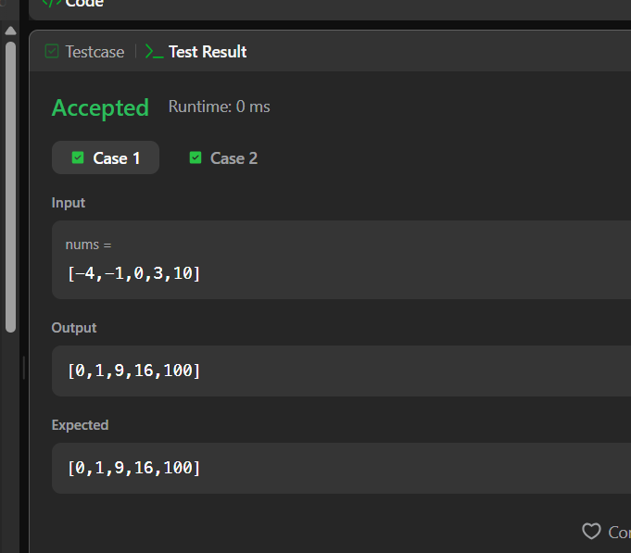

2)Find Pivot Index
class Solution {
public int pivotIndex(int[] nums) {
int total =0;
for(int num:nums){
total += num;
}

int leftSum=0;
for(int i =0; i< nums.length ; i++){
int rightSum = total - leftSum - nums[i];

if(leftSum== rightSum){
return i;
}
leftSum += nums[i];
}
return -1;
}
}


