Vel Tech Rangarajan Dr. Sagunthala R&D Institute of Science and Technology

(Deemed to be University Estd. u/s 3 of UGC Act, 1956)

School of Computing
B.Tech. – Computer Science and Engineering
VTR UGE2021- (CBCS)

Academic Year: 2025–2026
SDG 9: Industry, Innovation and Infrastructure
Course Code : 10211CS207
Course Name : Database Management Systems
Slot No : S6L15

DBMS PROJECT REPORT
Title: Scalable IoT Device Data Management Through JSON-Based Document Storage

Submitted by:
VTUNO | REGISTER NUMBER | STUDENT NAME
30019 | 24UECS0068 | CH.PRABHAS
30009 | 24UECS0260 | P.GOPAL SAI
27647 | 24UECS0304 | S.HEMA SAGAR
27946 | 24UECS0010 | A.KARTHIK
30002 | 24UECS0743 | MD.NOWHID
29305 | 24UECS1124 | B.VIGNESH REDDY
29130 | 24UECS0116 | U.GOWTHAM VARMA

Under the guidance of:
HANNAH.S
Professor

INDEX PAGE
1. Introduction …………………………………………… 3
2. Problem Statement …………………………………………… 4
3. Objectives …………………………………………… 5
4. System Requirements …………………………………………… 6
5. System Analysis and Design……………………………………… 6
6. ER Diagram (Conceptual Design) ..……………………………… 7
7. Schema Design (Oracle)…………………………………………… 9
8. Normalization …………………………………………… 13
9. Implementation (SQL Queries)…………………………………… 13
10. Input and Output …………………………………………… 14
11. Integration with MongoDB (NoSQL)…………………………… 15
12. Results and Discussion ..…………………………………… 19
13. Conclusion …………………………………………… 20
14. References …………………………………………… 20

1. Introduction
The Internet of Things (IoT) has transformed the way modern systems collect, store, and analyze data from a wide range of smart devices. In a large-scale IoT environment, thousands of heterogeneous devices—such as temperature sensors, GPS trackers, energy meters, and air-quality monitors—continuously generate data in different formats and at high velocity. Managing this rapidly growing, semi-structured data demands a highly scalable and flexible storage system.
Traditional relational databases struggle in IoT scenarios because they require predefined schemas and frequent structural modifications whenever a new device type or data attribute is introduced. This makes scaling complex and time-consuming. To overcome these limitations, a JSON-based document database like MongoDB is preferred. It stores device data in flexible JSON documents and supports powerful indexing mechanisms for fast data retrieval.
Indexing plays a crucial role in IoT platforms, where data must often be retrieved using multiple parameters such as device ID, location ID, or sensor attributes like temperature. With MongoDB’s indexing capabilities—including single-field, compound, and nested JSON indexes—IoT applications can access records from diverse devices efficiently, even at massive scale. This combination of schema-flexibility and high-performance indexing makes MongoDB an ideal choice for IoT data storage and processing.
In IoT ecosystems, data variety and unpredictability are common challenges because each device can produce different types of sensor readings. Some devices may send only temperature values, while others may include humidity, GPS coordinates, or air quality measurements in the same data packet. As the number of devices grows, the data model must evolve rapidly. A rigid relational database would require frequent schema updates, making maintenance difficult and slowing down the entire system. However, a JSON-based system like MongoDB allows each device to store unique attributes without affecting the overall data structure, ensuring flexibility and continuous scalability.
Fast retrieval of IoT data is essential, especially for real-time monitoring and decision-making. For example, a smart industry or smart city application may need to instantly fetch data from a specific device in a specific location, or compare temperature readings across different sensors. This is where indexing becomes critical. MongoDB supports single-field, compound, and nested indexing, which enables queries to run in milliseconds, even when working with millions of records. With effective indexing on fields like device_id, location_id, or nested keys such as data.temperature, the IoT platform can respond quickly to user queries and automate alerts in real time.

Furthermore, MongoDB’s distributed architecture and built-in horizontal scaling capabilities make it suitable for large-scale IoT deployments. As data volume increases, MongoDB clusters can be expanded easily without impacting system performance. This ensures high availability, fault tolerance, and continuous uptime, which are essential for mission-critical IoT applications. By combining schema flexibility, powerful indexing, and horizontal scalability, MongoDB delivers a reliable foundation for storing and managing IoT data efficiently across diverse and rapidly evolving device networks.

2. Problem Statement
In a modern IoT ecosystem, data is continuously generated by a wide variety of smart devices deployed across multiple locations. Each device may produce different types of data based on its functionality, such as temperature readings, GPS coordinates, air-quality metrics, or energy consumption values. Managing, storing, and retrieving such heterogeneous data becomes difficult when the system needs to support thousands or even millions of devices transmitting information at high frequency. A traditional relational database with a fixed schema cannot efficiently adapt to these dynamic and unpredictable data structures.
Another major challenge arises in retrieving device data quickly based on multiple parameters like device ID, location ID, or specific sensor values. In large IoT deployments, the system should allow fast searching, filtering, and analysis of data from diverse device types, often in real time. However, traditional databases require complex joins and schema modifications, which increase query time and reduce performance. This delay is unacceptable in IoT applications where immediate decision-making, live dashboards, and alert mechanisms depend on rapid data access.
Scalability is also a significant concern for IoT platforms. As the number of devices grows, the database must scale horizontally while maintaining performance and data availability. Relational systems struggle with such expansion, especially when handling large volumes of semi-structured or unstructured data. Meanwhile, indexing and retrieval operations become slower as the dataset increases.
To address these challenges, a flexible, schema-less, JSON-based storage system is required—one that can index both simple and nested fields while ensuring high-speed access to device data. MongoDB, with its powerful indexing capabilities and document-oriented design, is a suitable choice for storing heterogeneous IoT data and retrieving it efficiently using multiple indexing strategies.

3. Objectives
To design a flexible database model for storing heterogeneous IoT device data using a JSON-based document structure.
To ensure fast data retrieval by implementing indexing on key attributes such as device ID, location, and sensor parameters.
To integrate MongoDB for handling semi-structured and unstructured IoT data efficiently.
To provide sample queries for CRUD operations, index creation, and multi-parameter data retrieval.
To enable scalability, high performance, and flexibility in managing large-scale IoT device information.

4. System Requirements
Hardware Requirements:
Processor: Intel Core i5 or higher
RAM: 8 GB or above
Hard Disk: Minimum 250 GB of available storage
Network: Stable internet connectivity for data transmission between IoT devices and the database
Software Requirements:
Operating System: Windows / Linux
Database (NoSQL): MongoDB 6.0 or above
Development Platform: Node.js / Python / Java (any one for IoT backend service)
Tools: MongoDB Compass / VS Code / Postman
Additional Libraries: MongoDB Driver / Mongoose (optional)

5. System Analysis and Design
The system identifies the main entities and their relationships. Major entities include:
- Student
- Instructor
- Course
- Enrollment
- Assignment
- Submission
- Grade

6. ER Diagram (Conceptual Design)
Figure: ER Diagram

Entities and Attributes

1. Device
- Device_ID (Primary Key)
- Device_Name
- Manufacturer
- Model
- Firmware_Version
- Device_Type
2. Location
- Location_ID (Primary Key)
- Location_Name
- Region
- Coordinates (Latitude, Longitude)
3. Index
- Index_ID (Primary Key)
- Device_ID (Foreign Key → Device)
- Location_ID (Foreign Key → Location)
- Created_Timestamp
- Index_Type (e.g., Single / Compound)
4. Reading
- Reading_ID (Primary Key)
- Device_ID (Foreign Key → Device)
- Location_ID (Foreign Key → Location)
- Temperature
- Humidity
- Battery_Level
- Timestamp

Relationships

Device – Location (Many-to-Many)Course ↔ Assignment → (One-to-Many)

Device – Reading (One-to-Many)

Location – Reading (One-to-Many)
- Device – Index (One-to-Many)
- Location – Index (One-to-Many)

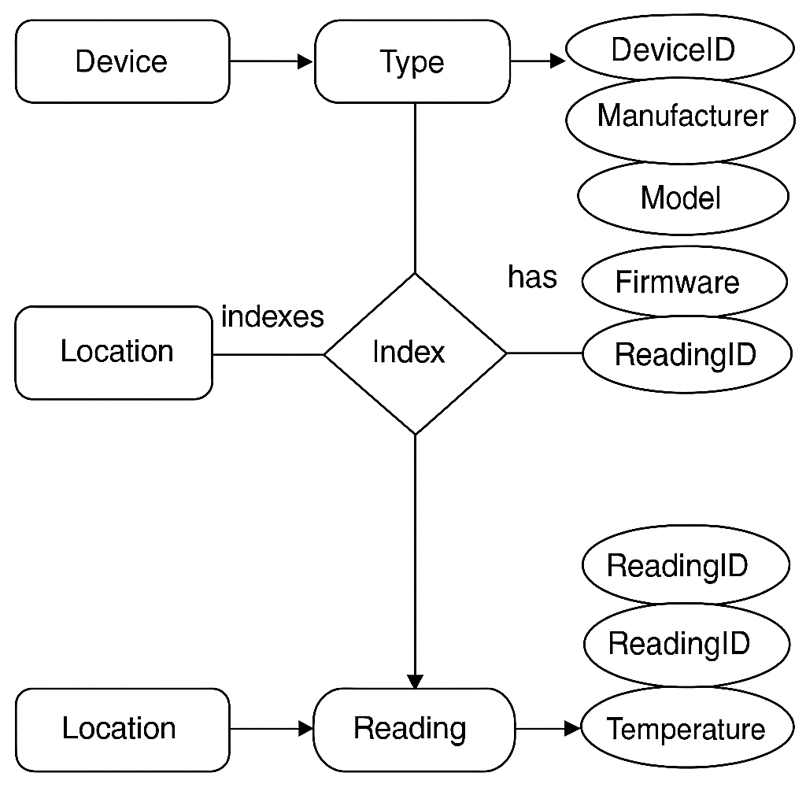

7. Schema Design (Oracle)
SQL> CREATE TABLE Device (
Device_ID NUMBER PRIMARY KEY,
Device_Name VARCHAR2(50),
Device_Type VARCHAR2(50),
Manufacturer VARCHAR2(50),
Model VARCHAR2(50),
Firmware_Version VARCHAR2(20)
);
Output:
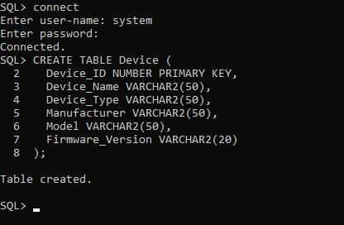

SQL> CREATE TABLE Location (
Location_ID NUMBER PRIMARY KEY,
Location_Name VARCHAR2(50),
Region VARCHAR2(50),
Latitude NUMBER(8,5),
Longitude NUMBER(8,5)
);
Output:
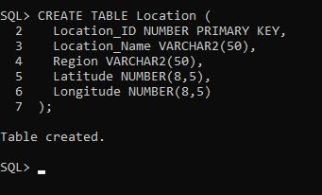
SQL> CREATE TABLE Device_Location_Index (
Index_ID NUMBER PRIMARY KEY,
Device_ID NUMBER,
Location_ID NUMBER,
Index_Type VARCHAR2(30),
Created_Timestamp DATE,
FOREIGN KEY (Device_ID) REFERENCES Device(Device_ID),
FOREIGN KEY (Location_ID) REFERENCES Location(Location_ID)
);

Output:

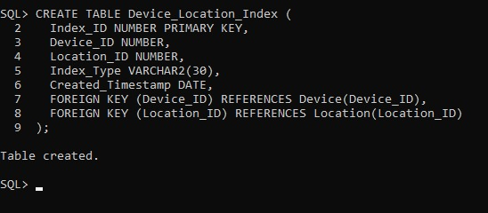
SQL> CREATE TABLE Sensor_Reading (
Reading_ID NUMBER PRIMARY KEY,
Device_ID NUMBER,
Location_ID NUMBER,
Temperature NUMBER(5,2),
Humidity NUMBER(5,2),
Battery_Level NUMBER(5,2),
Voltage NUMBER(6,2),
Current NUMBER(6,2),
Timestamp DATE,
FOREIGN KEY (Device_ID) REFERENCES Device(Device_ID),
FOREIGN KEY (Location_ID) REFERENCES Location(Location_ID)
);

Output:
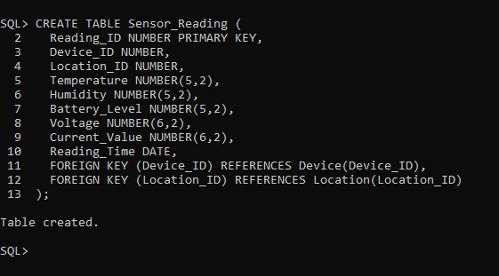
SQL> CREATE INDEX idx_device_id
ON Sensor_Reading(Device_ID);

SQL> CREATE INDEX idx_location_id
ON Sensor_Reading(Location_ID);

SQL> CREATE INDEX idx_device_location
ON Sensor_Reading(Device_ID, Location_ID);
Output:
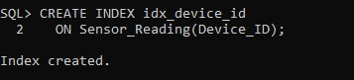
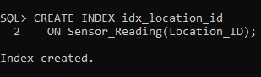
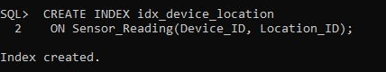

8. Normalization
The schema design follows normalization principles up to 3NF:
1NF:Each table must have atomic (indivisible) values, and each record must be unique.
In the IoT platform, data from devices is captured in a structured way such that every field holds a single value — for example, device details, location, timestamp, and specific sensor readings (temperature, humidity, etc.).
2NF:A table is in 2NF if it is already in 1NF, and all non-key attributes depend on the entire primary key (no partial dependency).
To achieve this, the data is divided into separate tables so that device information is not repeatedly stored with every sensor reading. The composite key (Device_ID, Location_ID, Timestamp) is used in the readings table.
3NF: A table is in 3NF if it is in 2NF and all its attributes are directly dependent on the primary key — no transitive dependency between non-key attributes.
To achieve this, parameter details such as “Temperature” and “Humidity” are moved into a separate Parameter table. This ensures that data about parameters is not repeated in multiple rows.

9. Implementation (SQL Queries)

SQL> INSERT INTO Device (Device_ID, Device_Name, Device_Type, Manufacturer, Model, Firmware_Version)
2 VALUES (1, 'Router A1', 'Networking', 'Cisco', 'RV340', '1.0.03.20');

SQL> INSERT INTO Location (Location_ID, Location_Name, Region, Latitude, Longitude)
2 VALUES (1, 'New York Data Center', 'North America', 40.71280, -74.00600);
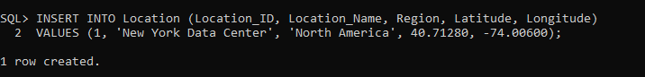

SQL> INSERT INTO Device_Location_Index (Index_ID, Device_ID, Location_ID, Index_Type, Created_Timestamp)
2 VALUES (1, 1, 1, 'Primary', SYSDATE);
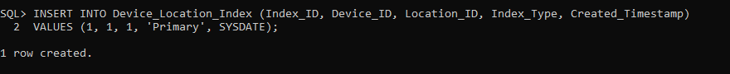

SQL> INSERT INTO Sensor_Reading (
2 Reading_ID, Device_ID, Location_ID, Temperature, Humidity,
3 Battery_Level, Voltage, Current_Value, Reading_Timestamp
4 ) VALUES (
5 2, 102, 202, 30.12, 55.10, 75.80, 3.65, 0.28,
6 TO_DATE('2025-10-31 09:00:00', 'YYYY-MM-DD HH24:MI:SS')
7 );

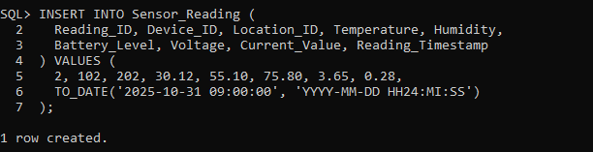

10. Input and Output
**Sample Input Queries:**
INSERT INTO Device (Device_ID, Device_Name, Device_Type) VALUES (101, 'Sensor A', 'Temperature');

**Sample Output Query and Result:**
Query:
SELECT * FROM Sensor_Reading;
Output:
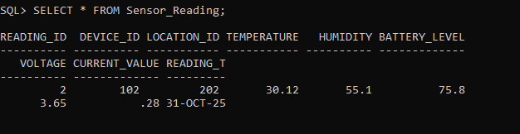

11. Integration with MongoDB (NoSQL)

MongoDB is a NoSQL document-oriented database that stores data in the form of JSON-like documents (BSON format). It provides flexibility, scalability, and high performance, making it an ideal choice for IoT platforms where data is generated from various heterogeneous devices.
In an IoT ecosystem, devices may produce different sets of parameters such as temperature, humidity, pressure, or voltage. Traditional relational databases require predefined schemas, which become inefficient when device structures vary. MongoDB overcomes this limitation by allowing schema-less data storage where each document can have a different structure.

1.Sample JSON Document in MongoDB
{
"device_id": "D101",
"device_type": "Thermometer",
"status": "Active",
"readings": [
{
"location_id": "L01",
"timestamp": "2025-10-30T10:15:00Z",
"data": {
"temperature": 23.5,
"humidity": 45
}
},
{
"location_id": "L02",
"timestamp": "2025-10-30T10:20:00Z",
"data": {
"temperature": 22.8,
"humidity": 50
}
}
]
}

- Creating Indexes in MongoDB
// Creating single-field indexes
db.device_data.createIndex({ "device_id": 1 });
db.device_data.createIndex({ "location_id": 1 });

// Creating a compound index for combined queries
db.device_data.createIndex({ "device_id": 1, "location_id": 1 });

// Creating an index on nested JSON data (temperature)
db.device_data.createIndex({ "readings.data.temperature": 1 });

- Sample Queries in MongoDB

// Retrieve all records for a specific device
db.device_data.find({ "device_id": "D101" });

// Retrieve all records from a specific location
db.device_data.find({ "readings.location_id": "L01" });

// Retrieve temperature data above 25°C across devices
db.device_data.find({ "readings.data.temperature": { $gt: 25 } });

// Retrieve device data sorted by timestamp
db.device_data.find().sort({ "readings.timestamp": 1 });

12. Results and Discussion
The implementation of an IoT data storage model using a JSON-based document database (MongoDB) proved to be efficient and scalable for handling heterogeneous device data. The platform successfully supported data ingestion from multiple types of IoT devices that transmitted various parameters such as temperature, humidity, and location information.
The experiment and design approach highlight that MongoDB is highly suitable for IoT-based platforms due to its document-oriented architecture and indexing capabilities. Unlike traditional SQL databases, which require rigid schema definitions, MongoDB’s flexible JSON model supports varied data structures originating from numerous device types.
The normalization process (1NF, 2NF, 3NF) helped in designing a consistent logical data model that later translated into an efficient NoSQL document structure. Indexing strategies optimized the data retrieval process for commonly used queries such as device-based searches, location-specific records, and parameter-based comparisons.

13. Conclusion
The study and implementation of indexing various devices in an IoT platform demonstrate that MongoDB, a JSON-based NoSQL document database, is a highly effective solution for managing heterogeneous and dynamic IoT data. Its flexible schema design allows seamless integration of new device types without altering the existing structure, making it ideal for environments where devices continuously evolve.
Through normalization (1NF, 2NF, 3NF) and proper indexing strategies, the platform achieves efficient data organization and rapid data retrieval. Indexes based on device_id, location_id, and sensor parameters such as temperature enable quick access to specific device records and cross-device comparisons.

14. References
· Garg, R., & Sharma, M. (2022). A Review on NoSQL Databases for IoT Applications. International Journal of Computer Applications, 184(27), 1–6.
· · Chen, M., Mao, S., & Liu, Y. (2019). Big Data: A Survey. Mobile Networks and Applications, 23(2), 171–209.
· · Singh, A., & Kaur, G. (2023). Data Management Techniques for Internet of Things Using NoSQL Databases. Journal of Emerging Technologies and Innovative Research (JETIR), 10(5), 45–52.
· · Dey, N., Hassanien, A. E., & Bhattacharyya, S. (Eds.). (2020). Internet of Things and Big Data Analytics Toward Next-Generation Intelligence. Springer.
· · MongoDB University. (2023). Indexing Strategies and Performance Optimization in MongoDB. Retrieved from https://university.mongodb.com/
· · Rajalakshmi, P., & Vidyullatha, P. (2021). IoT Data Storage Using NoSQL Databases. International Journal of Advanced Research in Computer and Communication Engineering (IJARCCE), 10(3), 12–18.
· · Sharma, S., & Tiwari, R. (2022). Data Indexing and Query Optimization for IoT Platforms. International Journal of Scientific Research in Engineering and Management (IJSREM), 6(8), 120–128.

