Task2.1
import random
def guess_number():
# Generate a random number between 1 and 9
target_number = random.randint(1, 9)

while True:
# Prompt the user to enter a guess
user_guess = int(input("Guess a number between 1 and 9: "))

# Check if the guess is correct
if user_guess == target_number:
print("Well guessed!")
break
else:
print("Wrong guess. Try again.")

# Call the function
guess_number()

output:
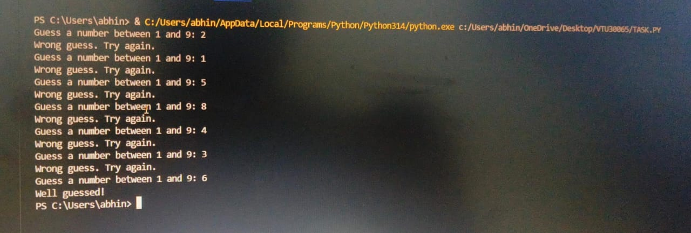
2.2
for number in range(1, 51):
if number % 3 == 0 and number % 5 == 0:
print("FizzBuzz")
elif number % 3 == 0:
print("Fizz")
elif number % 5 == 0:
print("Buzz")
else:
print(number)

output:
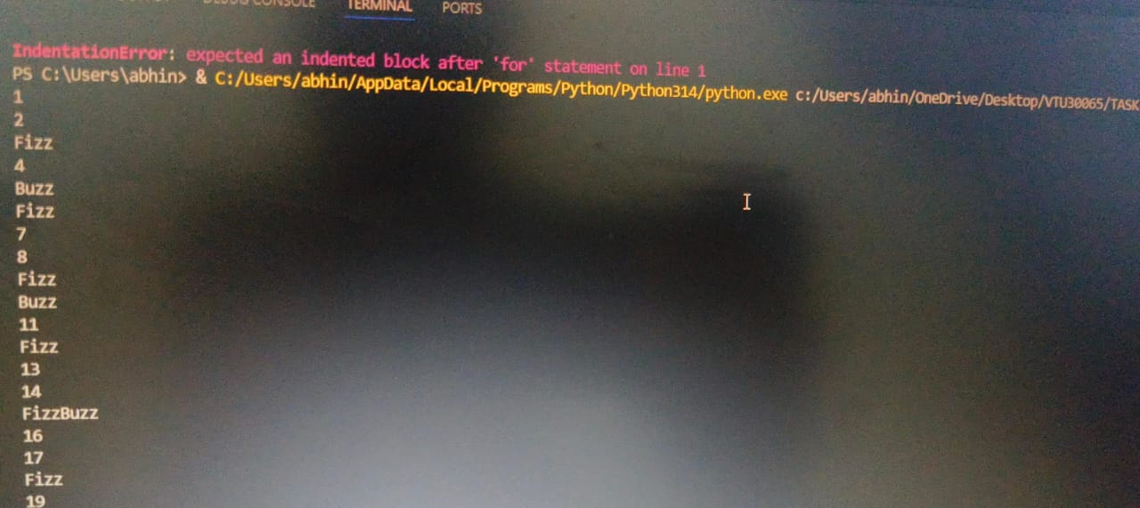

2.3

nums = list(input("Enter a sequence of comma-separated 4-digit binary numbers: ").split(','))
# example: 0101,1000,1001,1010
res = [i for i in nums if int(i, 2) % 6==0]
print(res)

output:
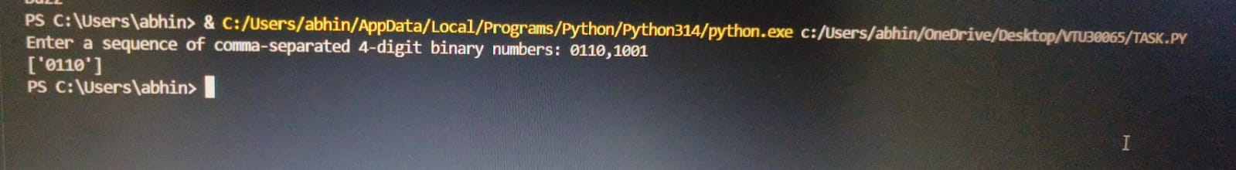

2.4
def count_even_odd(numbers):
even_count = 0
odd_count = 0
for num in numbers:
if num % 2 == 0:
even_count += 1
else:
odd_count += 1
return even_count, odd_count

input_numbers = input("Enter a series of numbers separated by spaces: ")
numbers = list(map(int, input_numbers.split()))
even_count, odd_count = count_even_odd(numbers)

print("Number of even numbers:", even_count)
print("Number of odd numbers:", odd_count)

output:
