Task3.1
import datetime

# Input
input_date = input("Enter the date in MM DD YYYY format: ")

try:
month, day, year = map(int, input_date.split())
if 2000 < year < 3000:
x = datetime.datetime(year, month, day)
day_name = x.strftime("%A").upper()
print(day_name)
else:
print("Year is not within the specified constraints.")
except ValueError:
print("Invalid input. Please enter the date in MM DD YYYY format.")
except Exception as e:
print(f"An error occurred: {e}")

output:
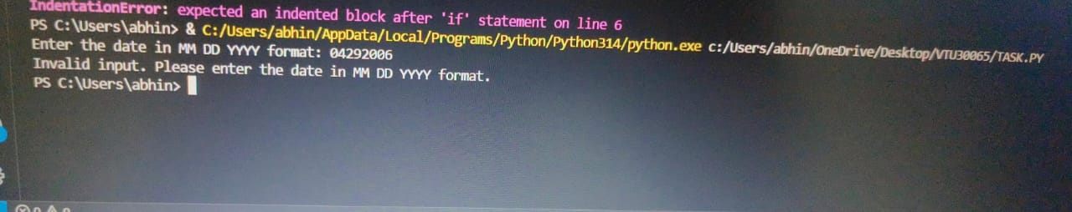

3.2
from math import pow

def compute_armstrong(x):
# Convert the number x to a string to count its digits
n = len(str(x))

# Calculate the sum of each digit raised to the power n
armstrong_sum = sum(pow(int(i), n) for i in str(x))

# Return True if the sum equals the original number
return armstrong_sum == x

# Input from user
number = int(input("Enter a number: "))

# Check and print the result
if compute_armstrong(number):
print(f"{number} is an Armstrong number")
else:
print(f"{number} is not an Armstrong number")

output:
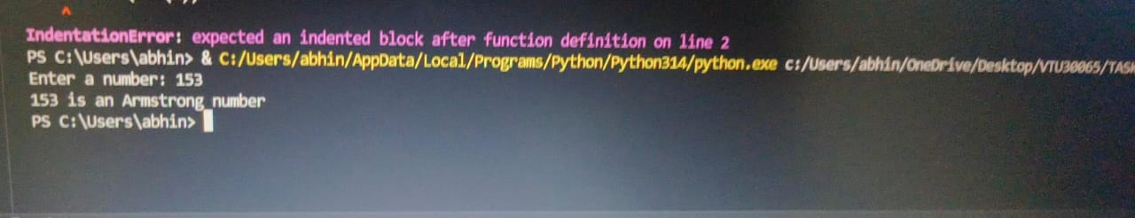

3.3
import math

def edistance(x, y):
distance = math.sqrt((y[0] - x[0])**2 + (y[1] - x[1])**2)
return distance
from euclidean_distance_module import edistance
3d.py
X = (1, 3)
Y = (2, 3)

result = edistance(X, Y)

print("Euclidean distance between X and Y:", result)

output:
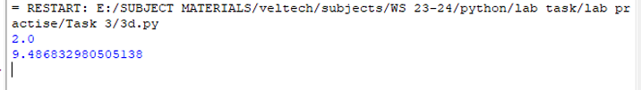

3.4
__init__.py
//IT SHOULD BE AN EMPTY FILE
Mod1.py
def display():
print("Hello World")
Mod2.py
def sum(a, b):
return a+b
sample_task3.py
from T3 import mod1
from T3 import mod2
mod1.display()
res = mod2.sum(1, 2)
print(res)

output:
