Task5.1
Program:
def search(arr, x):
for i in range(len(arr)):
if arr[i] == x:
return i
return -1

# Example usage:
arr = [10, 20, 80, 30, 60, 50, 110, 100, 130, 170]
x = 110
result = search(arr, x)

if result != -1:
print("Element", x, "is present at index", result)
else:
print("Element", x, "is not present in the array")

output:
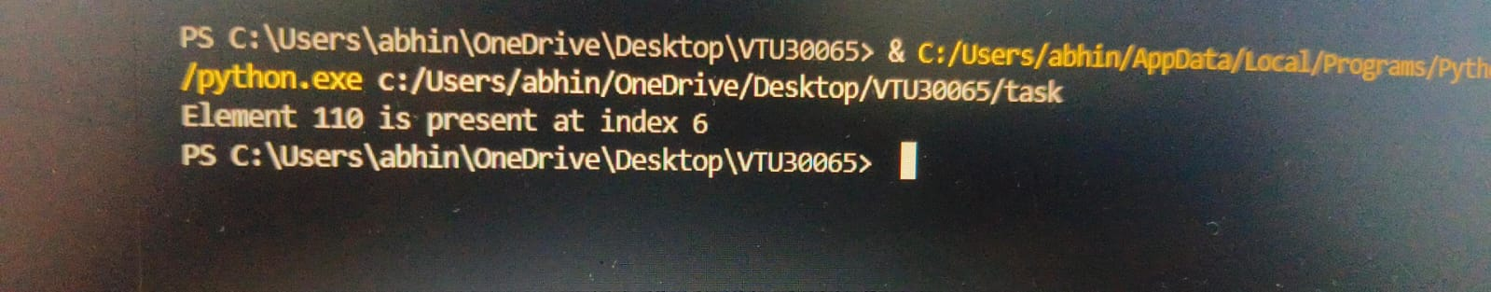

5.2
Program:
def binary_search(nums, target):
left = 0
right = len(nums) - 1

while left <= right:
mid = left + (right - left) // 2 # Prevents overflow
if nums[mid] == target:
return mid
elif nums[mid] < target:
left = mid + 1
else:
right = mid - 1

return -1 # Target not found

# List is initialized
nums = [-1, 0, 3, 5, 9, 12]
target = 9
print(binary_search(nums, target)

output:
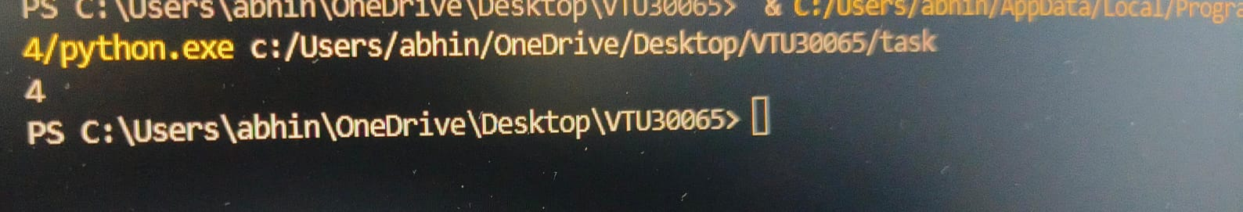

5.3
Program:
def bubble_sort(arr):
n = len(arr)
for i in range(n):
for j in range(0, n - i - 1):
if arr[j] > arr[j + 1]:
arr[j], arr[j + 1] = arr[j + 1], arr[j]

def find_sequence(arr):
if not arr:
print("No integers to process.")
return
smallest = arr[0]
largest = arr[-1]
print("Sequence of integers: from", smallest, "to", largest)

# Step 1: Get the number of integers
try:
n = int(input("Enter the number of integers: "))
if n <= 0:
print("Please enter a positive number.")
else:
# Step 2: Receive the integers
integers = []
print("Enter the integers:")
for _ in range(n):
integers.append(int(input()))

# Step 3: Sort the integers using bubble sort
bubble_sort(integers)

# Optional: Print sorted list
print("Sorted integers:", integers)

# Step 4: Print the start and end of sequence
find_sequence(integers)

except ValueError:
print("Invalid input. Please enter valid integers.")

output:
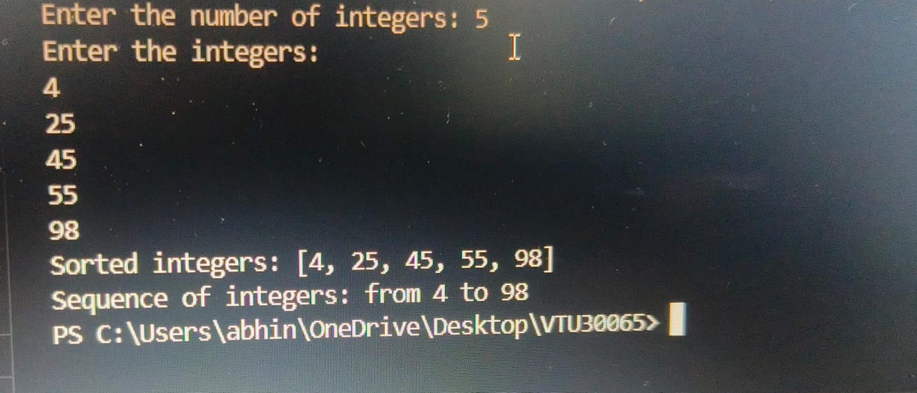

5.4
Program:
def selection_sort(scores):
n = len(scores)
for i in range(n):
min_index = i
for j in range(i + 1, n):
if scores[j] < scores[min_index]:
min_index = j
scores[i], scores[min_index] = scores[min_index], scores[i]
print("After iteration", i + 1, ":", scores)

# Sample input
exam_scores = [87, 65, 92, 78, 55, 70, 82]

print("Initial exam scores:", exam_scores)
print("Sorting using Selection Sort:")
selection_sort(exam_scores)
print("Final sorted exam scores:", exam_scores)

output:
