Task6.1
Program:
import os

def copy_files(file_paths):
for file_path in file_paths:
if os.path.exists(file_path):
try:
with open(file_path, 'r') as original_file:
original_content = original_file.read()

# Use os.path.splitext to handle file names correctly
base, ext = os.path.splitext(file_path)
copy_file_path = base + '_copy' + ext

with open(copy_file_path, 'w') as copy_file:
copy_file.write(original_content)

print(f"Contents copied from '{file_path}' to '{copy_file_path}' successfully.")

except Exception as e:
print(f"An error occurred while copying '{file_path}': {e}")
else:
print(f"Error: File '{file_path}' not found.")

# Example usage:
file_list = ['file1.txt', 'file2.txt', 'file3.txt'] # Replace with real file paths
copy_files(file_list)
output:
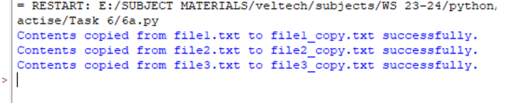

6.2
Program:
def create_file_and_count_occurrences():
# Creating a file
file_name = input("Enter the file name to create: ")

try:
with open(file_name, 'w') as file:
print("Enter the contents of the file (press Enter on an empty line to finish):")
while True:
line = input()
if not line:
break
file.write(line + '\n')

# Displaying contents of the file
print("\nContents of the file:")
with open(file_name, 'r') as file:
print(file.read())

# Counting occurrences of a letter
letter = input("\nEnter the letter to count occurrences: ")

if len(letter) != 1:
print("Please enter exactly one character.")
return

with open(file_name, 'r') as file:
content = file.read()
count = content.count(letter)

print(f"\nThe letter '{letter}' occurs {count} times in the file.")

except Exception as e:
print(f"An error occurred: {e}")

# Calling the function
create_file_and_count_occurrences()

output:
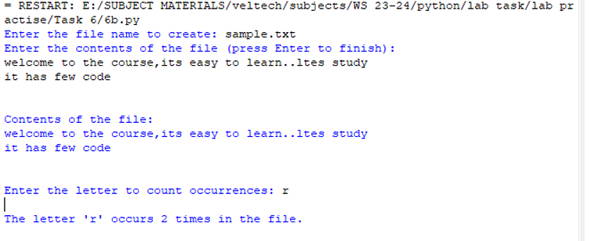

6.3
Program:
def create_file_and_count_words():
# Creating a file
file_name = input("Enter the file name to create: ")
with open(file_name, 'w') as file:
print("Enter the contents of the file (press Enter to finish):")
while True:
line = input()
if not line:
break
file.write(line + '\n')

# Displaying contents of the file
print("\nContents of the file:")
with open(file_name, 'r') as file:
print(file.read())

# Counting words in the file
with open(file_name, 'r') as file:
content = file.read()
word_count = len(content.split())
print(f"\nThe number of words in the file is: {word_count}")

# Calling the function
create_file_and_count_words()

output;
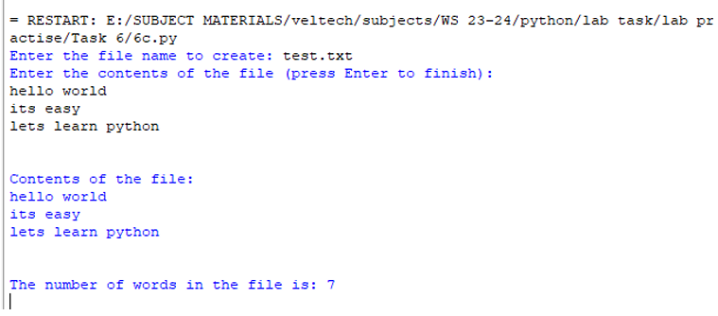

6.4
Program:
import csv

with open('apple_quality.csv', 'r') as file:
data = csv.reader(file)
for row in data:
print(row)

s
