Task8.1
Program:
def fibonacci():
a, b = 0, 1
for _ in range(10): # Generate first 10 Fibonacci numbers
yield a
a, b = b, a + b

fibonacci_series = fibonacci() # Create a generator object

for number in fibonacci_series: # Print the numbers
print(number, end=" ")

output:
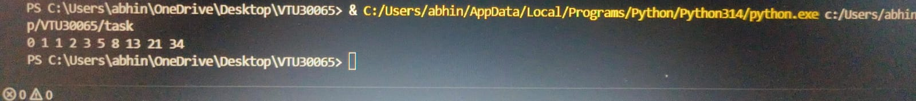

8.2
Program:
def squares():
for i in range(5): # Generate squares of numbers 0 through 4
yield i ** 2

# Create a generator object for squares of numbers 0 through 4
squares_generator = squares()

# Iterate over the generator object and print the squares
for square in squares_generator:
print(square)
output:
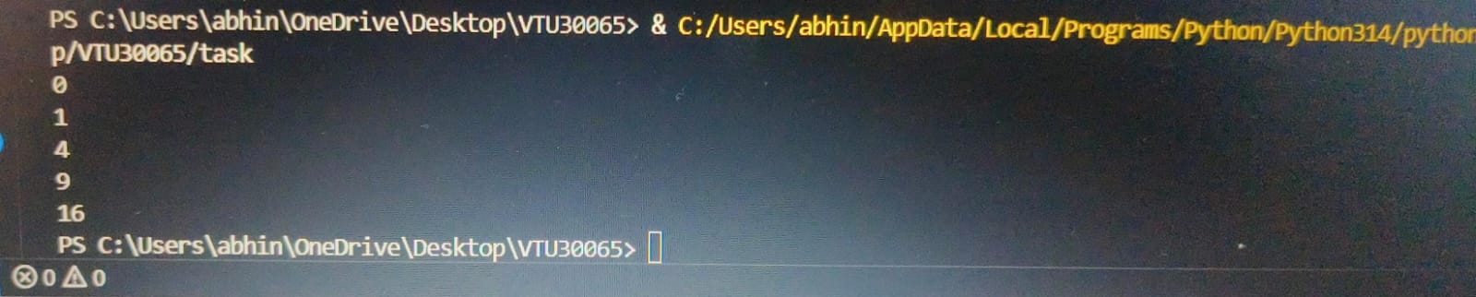
8.3
Program:
def operation_decorator(func):
def wrapper(x, y):
print("Performing arithmetic operation...")
result = func(x, y)
print("Operation completed.")
return result
return wrapper

# Applying decorator to arithmetic operations
@operation_decorator
def add(x, y):
return x + y

@operation_decorator
def divide(x, y):
if y == 0:
return "Cannot divide by zero!"
else:
return x / y

result_add = add(5, 3)
print("Result of addition:", result_add)

result_divide = divide(15, 0)
print("Result of division:", result_divide)

output:
