4.1
sample = []
sample.insert(0, 12)
print(sample) # [12]
sample.insert(1, 4)
print(sample) # [12, 4]
sample.insert(2, 2)
print(sample) # [12, 4, 2]
sample.insert(3, 4)
print(sample) # [12, 4, 2, 4]
sample.remove(4)
print(sample) # [12, 2, 4]
sample.append(21)
print(sample) # [12, 2, 4, 21]
sample.sort()
print(sample) # [2, 4, 12, 21]
sample.pop()
print(sample) # [2, 4, 12]
sample.reverse()
print(sample) # [12, 4, 2]
a = list(range(10))
print(a) # [0, 1, 2, 3, 4, 5, 6, 7, 8, 9]

output:
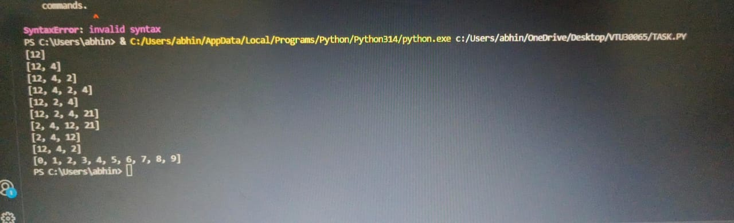

4.2
alist = []

# Read input
for i in range(int(input("Enter number of students: "))):
name = input("Enter name: ")
score = float(input("Enter score: "))
alist.append([name, score])

# Find the second lowest score
second_highest = sorted(set([score for name, score in alist]))[1]

# Get names with that score, sort them alphabetically, and print
print('\n'.join(sorted([name for name, score in alist if score == second_highest])))
output:
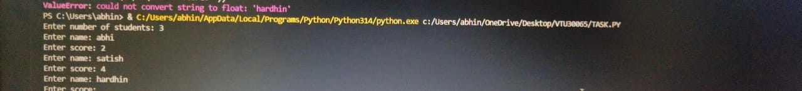

4.3
n = int(input())
a = map(int, input().split())
t = tuple(a)
print(hash(t))

output:
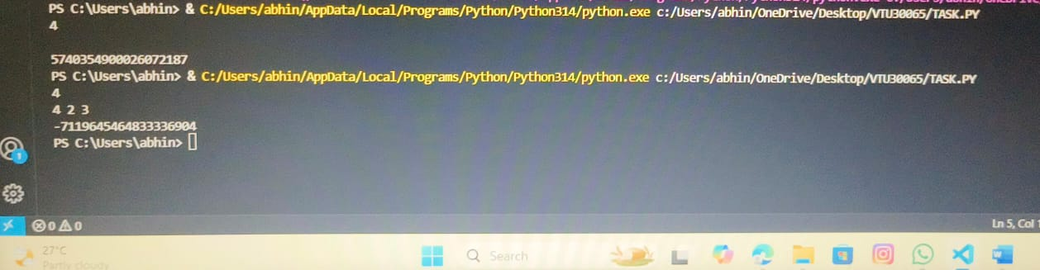

4.4
def min_paint_balloons(s):
# Count the number of amber and brass balloons
amber_count = s.count('a')
brass_count = s.count('b')

# Find the minimum count between amber and brass balloons
min_paint = min(amber_count, brass_count)

return min_paint

# Input the number of test cases
T = int(input("Enter the total number of test cases: "))

# Iterate through each test case
for i in range(T):
# Input the string representing balloon colors
s = input().strip() # strip() removes leading and trailing whitespace

# Calculate and print the minimum number of balloons needed to be painted
print(min_paint_balloons(s))

output:
