7.1
Program:
def find_discount(qty):
if qty <= 10:
return 0
elif 11 <= qty <= 20:
return 15
else:
return 20

def buy():
ICode = int(input("Enter Item Code: "))
Item = input("Enter Item Name: ")
Price = float(input("Enter Price: "))
Qty = int(input("Enter Quantity: "))

Discount = find_discount(Qty) # Discount percentage
discount_amount = (Price * Qty * Discount) / 100
Netprice = Price * Qty - discount_amount

return ICode, Item, Price, Qty, Discount, Netprice

def show_all(ICode, Item, Price, Qty, Discount, Netprice):
print("\n--- Purchase Summary ---")
print("Item Code:", ICode)
print("Item:", Item)
print("Price per item:", Price)
print("Quantity:", Qty)
print("Discount (%):", Discount)
print("Net Price:", round(Netprice, 2))

# Run the program
ICode, Item, Price, Qty, Discount, Netprice = buy()
show_all(ICode, Item, Price, Qty, Discount, Netprice)

output:
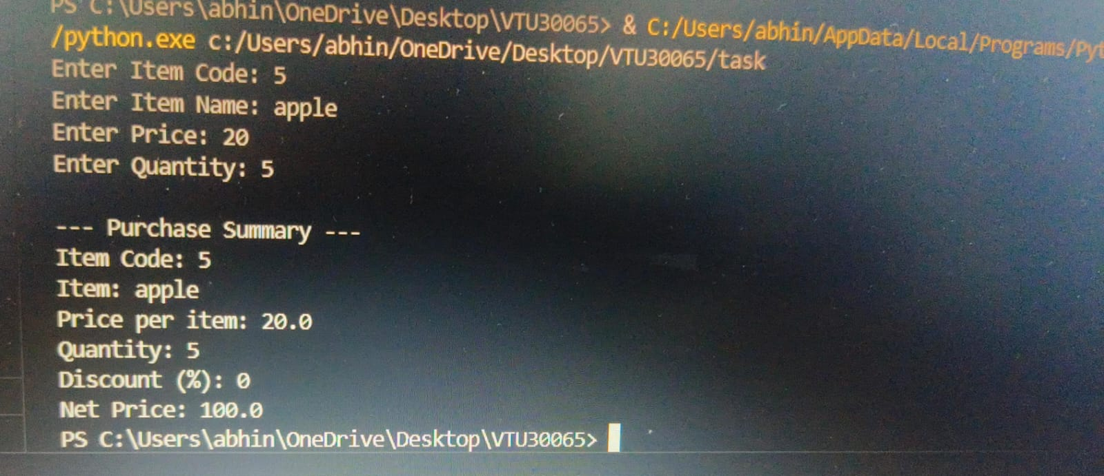

7.2
Program:
def cube_product_of_natural_numbers(n):
product = 1
for i in range(1, n + 1):
product *= i ** 3
return product

# Get input from the user
n = int(input("Enter the value of N: "))

# Calculate the cube product
result = cube_product_of_natural_numbers(n)

# Output the result
print("Cube product of the first", n, "natural numbers is:", result)

output:
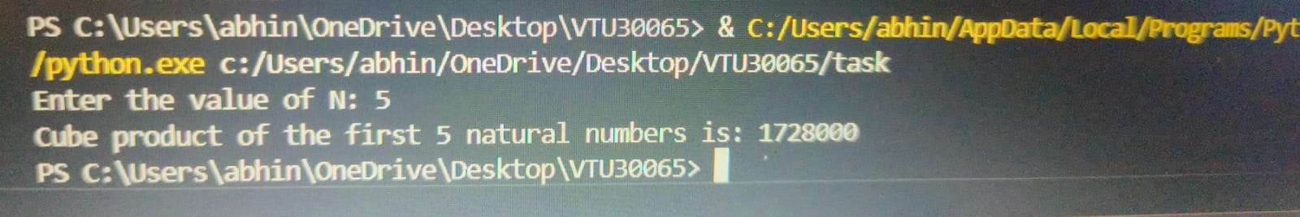

7.3
Program:
def func_compute(n):
return lambda x: x * n

result = func_compute(2)
print("Double the number of 15 =", result(15))

result = func_compute(3)
print("Triple the number of 15 =", result(15))

result = func_compute(4)
print("Quadruple the number of 15 =", result(15))

result = func_compute(5)
print("Quintuple the number of 15 =", result(15))
output:
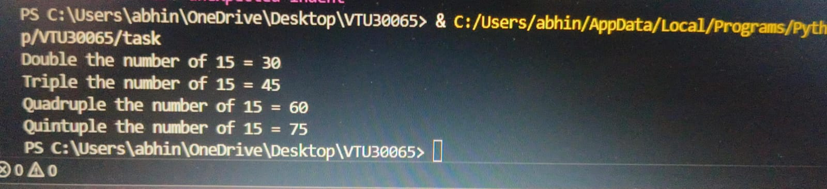
7.4
Program:
def categorize_tickets(ticket_ids):
adult_tickets = list(filter(lambda x: x % 2 == 0, ticket_ids))
child_tickets = list(filter(lambda x: x % 2 != 0, ticket_ids))
return adult_tickets, child_tickets

ticket_ids = [101, 202, 305, 410, 513, 620, 723, 830, 945, 1050]

# Categorize the tickets
adult_tickets, child_tickets = categorize_tickets(ticket_ids)

# Print the results
print("Adult Tickets:", adult_tickets)s
print("Child Tickets:", child_tickets)

output:


