

School of Computing

Department of Computer Science and Engineering

USE CASE REAL LIFE EXAMPLE

Program- Department Name | B.Tech – CSE
Academic Year/Semester | 2026-27 / Summer
Faculty Name | Dr. S. Hemamalini
Course Code/Course Name | 10211CS227 / Problem solving and Testing
Slot No & Date | S3-2 / 22-10-2026
Student Name | Bhavanam Chennakesava Reddy
Title of the Complex Engineering problem / problems | SUPER MARKET BILLING SYSTEM
Description / Complexity Addressed | The Super Market Billing System addresses the complexities involved in managing supermarket products, processing customer bills, calculating discounts, and maintaining accurate inventory records. The system allows users to add and remove products, calculate the total bill based on quantity and price, apply discounts, update stock after sales, and generate sales reports. It validates user inputs, prevents billing for unavailable products or insufficient stock, and handles invalid transactions. It demonstrates the use of programming constructs, methods, conditional statements.
CO’s Mapped | CO1, CO2, CO3, CO4, CO5
PO’s / PSO’s Mapped | PO1, PO2, PO3, PO5, PSO2
SDG Mapped with number | SDG 12: Responsible Consumption and Production.
Justification for SDG Mapped | The Super Market Billing System supports SDG 12 – Responsible Consumption and Production by promoting efficient inventory management and reducing product wastage. The system maintains accurate stock records, updates product quantities after sales, and helps identify low-stock products. Automated billing reduces manual calculation errors and improves resource utilization. Thus, the system encourages responsible stock management and supports sustainable supermarket operations.
Proof for the solved Complex Engineering Problem | https://drive.google.com/drive/folders/1xRIlDrZpvEvbM77e1Vs3WojLz105Gwje?usp=drive_link

Signature of the Faculty

TABLE OF CONTENTS

S. No. | Contents | Page No.
1. | Use-case | 4-5
2. | Problem Statement | 6
3. | Code | 7-12
4. | Output Screenshot | 13-14
5. | Result | 15

1.CASE STUDY:
The Super Market Billing System is a software application designed to simplify and automate the billing and inventory management activities of a supermarket. The system allows the administrator to add and remove products, maintain product details, generate customer bills, calculate discounts, and display inventory information.
The main objective of this system is to reduce manual calculation errors, save time during billing, and maintain accurate records of products and sales.
The system demonstrates important programming concepts such as:
- Product Management: Adding, updating, and removing products from inventory.
- Billing Operations: Calculating the total price based on product quantity and unit price.
- Discount Calculation: Applying discounts to the total bill when applicable.
- Inventory Management: Tracking available stock and updating quantities after sales.
- Validation and Error Handling: Handling invalid quantities, unavailable products, and incorrect menu choices.
- Sales Analysis: Identifying the most sold products and displaying sales information.

Purpose of the System
The purpose of the Super Market Billing System is to provide a simple, reliable, and efficient way to manage supermarket billing and stock information. It improves billing accuracy, reduces paperwork, and helps supermarket staff manage daily sales and inventory effectively.

Block Diagram:

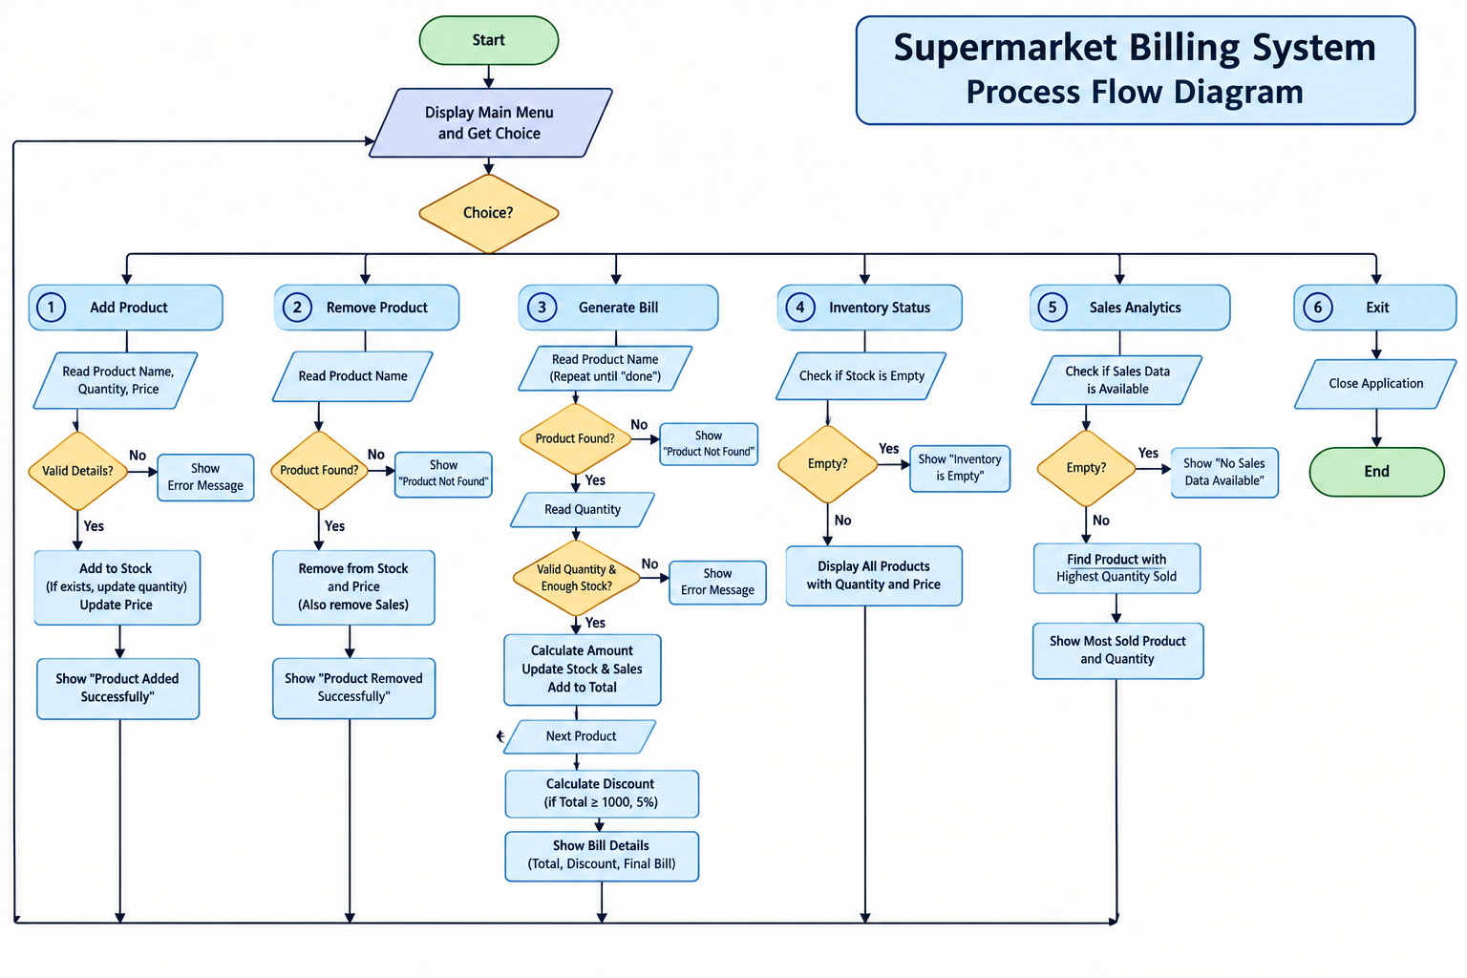

2.Problem Statement:
The Super Market Billing System aims to solve the difficulties involved in manual billing and inventory management in supermarkets. Manual billing requires employees to calculate product prices, quantities, discounts, and total amounts, which may lead to calculation errors, delays, and inaccurate stock records.
The proposed system automates these operations by providing a menu-driven application that manages products, generates bills, validates user inputs, and maintains inventory details.
Functional Requirements:
- Product Addition: Add new products with their name, quantity, and price.
- Product Removal: Remove products from the inventory when required.
- Bill Generation: Calculate the total amount for purchased products and generate an invoice.
- Discount Application: Deduct the applicable discount from the total bill.
- Inventory Status: Display available products and their remaining quantities.
- Sales Analytics: Display the most sold product and peak sales information when sales records are available.
- Input Validation: Reject negative or zero quantities where inappropriate, invalid prices, and unavailable products.
- Menu Validation: Display an error message when the user selects an invalid menu option.
- Exit: Terminate the application safely.
Complexity Addressed
The system addresses problems involving product data management, repeated billing calculations, stock updates, discount processing, and input validation. It demonstrates the use of arrays or collections, methods, conditional statements, loops, exception handling, and basic data-processing techniques.
Expected Outcome
The system should generate accurate bills, maintain updated inventory records, reject invalid transactions, and provide useful sales information. This improves the speed, accuracy, and reliability of supermarket operations.

Code

import java.util.*;

public class Main {

static Scanner sc = new Scanner(System.in);

static Map<String, Integer> stock = new HashMap<>();

static Map<String, Double> price = new HashMap<>();

static Map<String, Integer> sales = new HashMap<>();

public static void main(String[] args) {

while (true) {

System.out.println("\n===== SUPERMARKET BILLING SYSTEM =====");

System.out.println("1. Add Product");

System.out.println("2. Remove Product");

System.out.println("3. Generate Bill");

System.out.println("4. Inventory Status");

System.out.println("5. Sales Analytics");

System.out.println("6. Exit");

System.out.print("Enter Choice: ");

int choice;

try {

choice = sc.nextInt();

} catch (InputMismatchException e) {

System.out.println("Invalid Choice");

sc.nextLine();

continue;

}

sc.nextLine();

switch (choice) {

// 1. Add Product

case 1:

System.out.print("Enter Product Name: ");

String name = sc.nextLine();

System.out.print("Enter Quantity: ");

int qty = sc.nextInt();

System.out.print("Enter Price: ");

double p = sc.nextDouble();

sc.nextLine();

if (name.trim().isEmpty() || qty <= 0 || p <= 0) {

System.out.println("Invalid Product Details");

} else {

stock.put(name, stock.getOrDefault(name, 0) + qty);

price.put(name, p);

System.out.println("Product Added Successfully");

}

break;

// 2. Remove Product

case 2:

System.out.print("Enter Product Name: ");

name = sc.nextLine();

if (stock.remove(name) != null) {

price.remove(name);

sales.remove(name);

System.out.println("Product Removed Successfully");

} else {

System.out.println("Product Not Found");

}

break;

// 3. Generate Bill

case 3:

double total = 0;

while (true) {

System.out.print("Enter Product Name (done to finish): ");

name = sc.nextLine();

if (name.equalsIgnoreCase("done")) {

break;

}

if (!stock.containsKey(name)) {

System.out.println("Product Not Found");

continue;

}

System.out.print("Enter Quantity: ");

try {

qty = sc.nextInt();

} catch (InputMismatchException e) {

System.out.println("Invalid Quantity");

sc.nextLine();

continue;

}

sc.nextLine();

if (qty <= 0 || qty > stock.get(name)) {

System.out.println("Invalid Quantity or Insufficient Stock");

continue;

}

double amount = qty * price.get(name);

total += amount;

stock.put(name, stock.get(name) - qty);

sales.put(name, sales.getOrDefault(name, 0) + qty);

System.out.printf("%s: Rs. %.2f%n", name, amount);

}

if (total > 0) {

double discount = total >= 1000 ? total * 0.05 : 0;

System.out.printf("Total: Rs. %.2f%n", total);

System.out.printf("Discount: Rs. %.2f%n", discount);

System.out.printf("Final Bill: Rs. %.2f%n", total - discount);

} else {

System.out.println("No Items Purchased");

}

break;

// 4. Inventory Status

case 4:

if (stock.isEmpty()) {

System.out.println("Inventory is Empty");

} else {

System.out.println("\n----- INVENTORY STATUS -----");

for (String item : stock.keySet()) {

System.out.println(

item + " - Quantity: " + stock.get(item)

+ ", Price: Rs. " + price.get(item)

);

}

}

break;

// 5. Sales Analytics

case 5:

if (sales.isEmpty()) {

System.out.println("No Sales Data Available");

} else {

String best = Collections.max(

sales.entrySet(),

Map.Entry.comparingByValue()

).getKey();

System.out.println("Most Sold Product: " + best);

System.out.println("Quantity Sold: " + sales.get(best));

}

break;

// 6. Exit

case 6:

System.out.println("Application Closed");

sc.close();

return;

default:

System.out.println("Invalid Choice. Enter 1 to 6");

}

}

}

}

OUTPUT SCREENSHOT

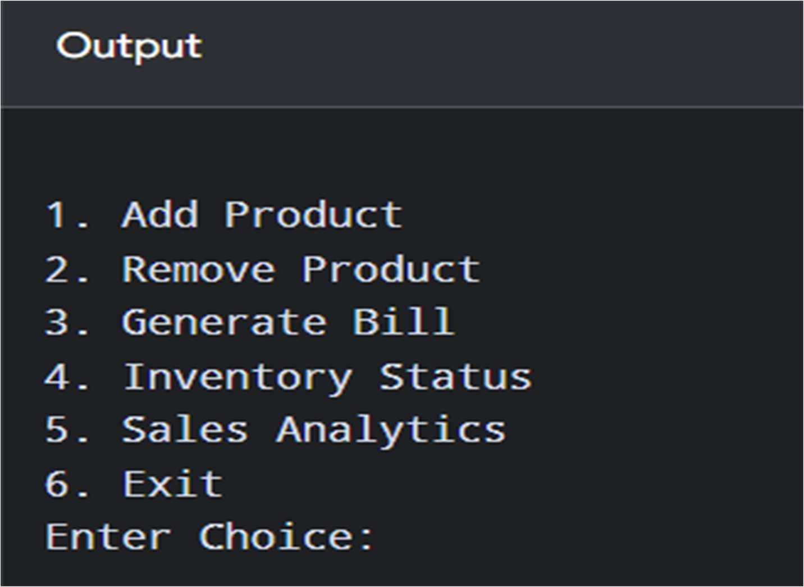

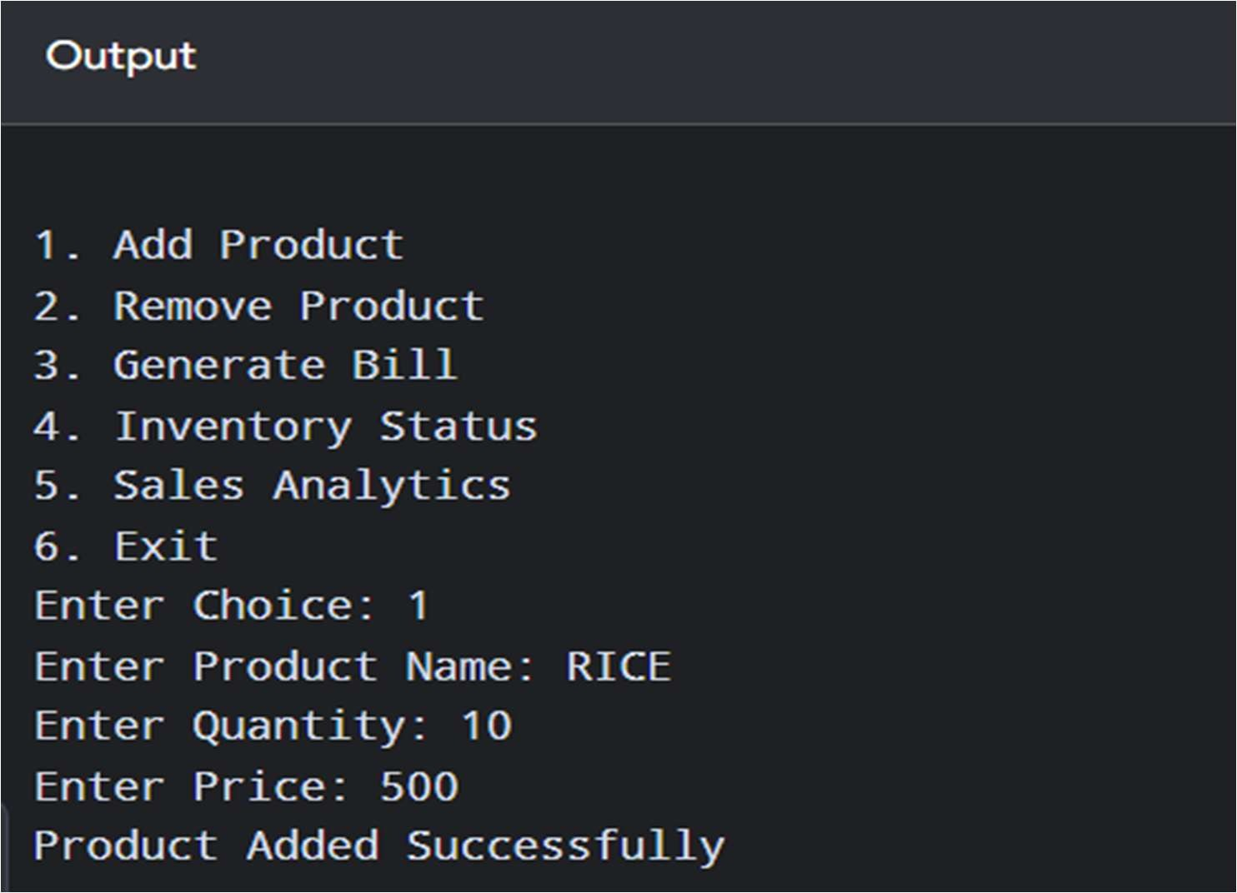

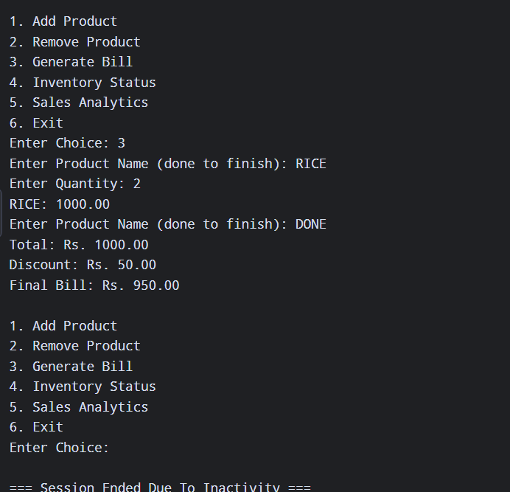

5.Result :
The Super Market Billing System was designed to automate product management, billing, discount calculation, inventory updates, and sales analysis. The system validates user inputs, handles invalid product requests, and calculates the final bill accurately. Testing with valid and invalid inputs helps verify the correctness and reliability of the application. Thus, the objective of developing a simple and efficient Super Market Billing System using Java programming concepts was achieved.

Table I: Test Cases and Execution Results for the Super Market Billing System

Test Case ID | Choice | Test Scenario | Input / Action | Expected Output | Execution Output (Copy the execution sequence of this choice) | Status
TC01 | 1 | Valid Product Addition | Product: Rice, Quantity: 10, Price: ₹500 | Product should be added successfully to inventory | Enter Choice: 1  Enter Product Name: Rice  Enter Quantity: 10  Enter Price: ₹500  Product Added Successfully | Pass
TC02 | 1 | Invalid Product Addition | Product: Rice, Quantity: -2, Price: ₹500 | System should reject invalid quantity | Enter Choice: 1  Enter Product Name: Rice  Enter Quantity: -2  Invalid Quantity. Please enter a valid quantity. | Pass
TC03 | 2 | Valid Product Removal | Product: Sugar | Product should be removed successfully from inventory | Enter Choice: 2  Enter Product Name: Sugar  Product Removed  Successfully | Pass
TC04 | 2 | Invalid Product Removal | Product: XYZ | System should display product not found message | Enter Choice: 2  Enter Product Name: XYZ  Product Not Found | Pass
TC05 | 3 | Generate Bill | Rice: Qty 2, Price ₹500; Sugar: Qty 1, Price ₹60; Discount ₹50 | Total bill should be calculated and invoice generated | Enter Choice: 3  Enter Product Name: Rice  Enter Quantity: 2  Rice: 1000.00  Enter Product Name: Sugar  Enter Quantity: 1  Sugar: 60.00  Enter Product Name: done  Total: Rs. 1060.00  Discount: Rs. 53.00  Final Bill: Rs. 1007.00 | Pass
TC06 | 3 | Invalid Billing Quantity | Product: Rice, Quantity: 0 | System should reject zero quantity | Enter Choice: 3  Enter Product Name: Rice  Enter Quantity: 0  Invalid Quantity or  Insufficient Stock | Pass
TC07 | 4 | Inventory Status | Select Choice 4 | Current inventory details should be displayed | Enter Choice: 4  Rice - Quantity: 8, Price: Rs.  500.0 | Pass
TC08 | 4 | Empty Inventory Status | Select Choice 4 when no products are available | System should indicate that inventory is empty | Enter Choice: 4  Inventory is Empty | Pass
TC09 | 5 | Sales Analytics | Select Choice 5 | Most sold product and peak sales time should be displayed | Enter Choice: 5  Most Sold Product: Rice  Quantity Sold: 2 | Pass
TC10 | 5 | No Sales Data | Select Choice 5 before any sales | System should display that no sales data is available | Enter Choice: 5  No Sales Data Available | Pass
TC11 | 6 | Exit Application | Select Choice 6 | Application should terminate successfully | Enter Choice: 6  Application Closed | Pass
TC12 | Invalid | Invalid Menu Choice | Enter Choice: 8 | System should reject invalid menu option | Enter Choice: 8  Invalid Choice. Enter 1 to 6 | Pass

