

Vel Tech Rangarajan Dr. Sagunthala R&D Institute of Science and Technology (Deemed to be University Estd. u/s 3 of UGC Act, 1956)
School of Computing
B.Tech. – Computer Science and Engineering
VTR UGE2021- (CBCS)

Academic Year: 2025–2026 SUMMER SEMESTER - SS2526

Course Code : 10211CS207
Course Name : Database Management Systems Slot No : S4-L5

DBMS TASK - 1 REPORT

Title: Conceptual Design through FTR

Submitted by:

VTUNO | REGISTER NUMBER | STUDENT NAME
VTU30122 | 24UECS0863 | R VENKATA TEJA

STUDENT-BOOK MANAGEMENT SYSTEM
Abstract:

The Student Book Management System is a software application designed to efficiently manage and organize the process of issuing, returning, and tracking books within an educational institution. This system aims to replace traditional manual record-keeping methods with a digital solution that enhances accuracy, accessibility, and time efficiency. It provides functionalities for students to search and request books, while administrators or librarians can manage book inventories, monitor availability, and maintain student borrowing records. The system also helps prevent data loss and reduces the chances of human error by maintaining a secure and centralized database. Overall, the Student Book Management System improves library operations, promotes better resource management, and supports an organized learning environment.

Aim:

Using database design methodology and ER modeling, design an Entity Relationship Diagram (ERD) that satisfies the following tasks:

- Identifying entities

- Identifying attributes

- Determining relationships and cardinality

- Defining relations with keys and constraints

- Creating the ER/EER diagram

  - Identifying the Entities

- Student

- Book

- Author

- Publisher

- Librarian

- IssueRecord

  - Identifying the Attributes

    - Student
(StudentID, Name, Department, Email, Contact_No)

    - Book
(BookID, Title, AuthorID, PublisherID, ISBN, Category, Quantity)

    - Author
(AuthorID, Name, Country)

    - Publisher
(PublisherID, Name, Address, Contact_No)

    - Librarian
(LibrarianID, Name, Email, Contact_No)

    - IssueRecord
(IssueID, StudentID, BookID, Issue_Date, Return_Date, Fine)

  - Identification of Relationships, Cardinality, and Type

Student–IssueRecord Relationship:
One student can have multiple issue records → One-to-Many (1:N).

Book–IssueRecord Relationship:
One book can be issued multiple times, but each issue record refers to one book
→ One-to-Many (1:N).
Author–Book Relationship:
One author can write multiple books, but each book has one author → One-to- Many (1:N).

Publisher–Book Relationship:
One publisher can publish multiple books, but each book is published by one publisher → One-to-Many (1:N).

Librarian–IssueRecord Relationship:
Each issue record is handled by one librarian, but a librarian can manage multiple issue records → One-to-Many (1:N).
  - Reframing the Relations with Keys and Constraints

    - Create Table Student CREATE TABLE Student (
StudentID VARCHAR(10) PRIMARY KEY, Name VARCHAR(50),
Department VARCHAR(30), Email VARCHAR(50),
Contact_No NUMBER

);

SQL> desc student;
Name Null? Type
----------------------------------------- -------- ---------------------------- STUDENTID NOT NULL VARCHAR2(10)
NAME VARCHAR2(50)
DEPARTMENT VARCHAR2(30) EMAIL VARCHAR2(50)
CONTACT_NO NUMBER

    - Create Table Author

CREATE TABLE Author (
AuthorID VARCHAR(10) PRIMARY KEY, Name VARCHAR(50),
Country VARCHAR(30)
);

SQL> desc author;
Name Null? Type

AUTHORID NOT NULL VARCHAR2(10) NAME VARCHAR2(50)
COUNTRY VARCHAR2(30)
1. d.3 Create Table Publisher

CREATE TABLE Publisher (
PublisherID VARCHAR(10) PRIMARY KEY, Name VARCHAR(50),
Address VARCHAR(100), Contact_No NUMBER
);

SQL> desc publisher;
Name Null? Type

PUBLISHERID NOT NULL VARCHAR2(10)
NAME VARCHAR2(50)
ADDRESS VARCHAR2(100) CONTACT_NO NUMBER

1. d.4 Create Table Book

CREATE TABLE Book (
BookID VARCHAR(10) PRIMARY KEY, Title VARCHAR(100),
AuthorID VARCHAR(10),
PublisherID VARCHAR(10), ISBN VARCHAR(20),
Category VARCHAR(30), Quantity NUMBER,
FOREIGN KEY (AuthorID) REFERENCES Author(AuthorID), FOREIGN KEY (PublisherID) REFERENCES Publisher(PublisherID)
);

SQL> desc book;
Name Null? Type

BOOKID NOT NULL VARCHAR2(10) TITLE VARCHAR2(100)
AUTHORID VARCHAR2(10)
PUBLISHERID VARCHAR2(10) ISBN VARCHAR2(20)
CATEGORY VARCHAR2(30)
QUANTITY NUMBER

1.d.5 Create Table Librarian

CREATE TABLE Librarian (
LibrarianID VARCHAR(10) PRIMARY KEY, Name VARCHAR(50),
Email VARCHAR(50),
Contact_No NUMBER
);

SQL> desc librarian;
Name Null? Type

LIBRARIANID NOT NULL VARCHAR2(10)
NAME VARCHAR2(50)
EMAIL VARCHAR2(50)
CONTACT_NO NUMBER

1.d.6 Create Table IssueRecord

CREATE TABLE IssueRecord (
IssueID VARCHAR(10) PRIMARY KEY, StudentID VARCHAR(10),
BookID VARCHAR(10),
LibrarianID VARCHAR(10), Issue_Date DATE, Return_Date DATE,
Fine NUMBER,
FOREIGN KEY (StudentID) REFERENCES Student(StudentID), FOREIGN KEY (BookID) REFERENCES Book(BookID),
FOREIGN KEY (LibrarianID) REFERENCES Librarian(LibrarianID)
);

SQL> desc issuerecord;
Name Null? Type

ISSUEID NOT NULL VARCHAR2(10) STUDENTID VARCHAR2(10) BOOKID VARCHAR2(10)
LIBRARIANID VARCHAR2(10)
ISSUE_DATE DATE
RETURN_DATE DATE
FINE NUMBER
  - Using Creately, Develop ER/EER Diagram

Entities:
Student, Book, Author, Publisher, Librarian, IssueRecord

Relationships:

Student ↔ IssueRecord (1:N) Book ↔ IssueRecord (1:N) Author ↔ Book (1:N) Publisher ↔ Book (1:N) Librarian ↔ IssueRecord (1:N)
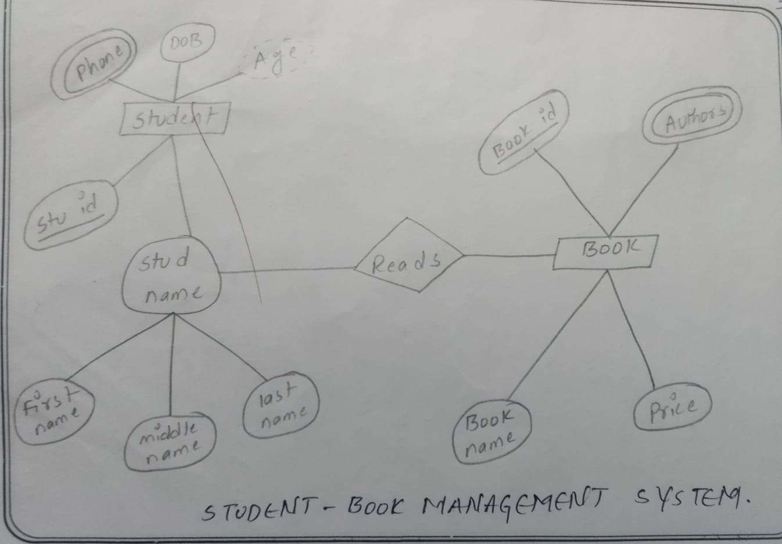
1.e. Using creately, develop ER/EER diagram

Result:
Thus, the database design methodology and ER Model for the Student Book Management System have been successfully developed and implemented using SQL and ERD tools.

