WEEK--8
SESSION 1 POLYMORPHIC BEHAVIOR IN ALGORITHM DESIGN ﻿
TASK 1 JAVA METHOD OVERRIDING.﻿
PROGRAM.﻿
import java.util.*;﻿
class Sports {﻿
String getName() {﻿
return "Generic Sports";﻿
}﻿
void getNumberOfTeamMembers() {﻿
System.out.println("Each team has n players in " + getName());﻿
}﻿
}﻿
class Soccer extends Sports {﻿
@Override﻿
String getName() {﻿
return "Soccer Class";﻿
}﻿
@Override﻿
void getNumberOfTeamMembers() {﻿
System.out.println("Each team has 11 players in " + getName());﻿
}﻿
}﻿
public class Solution {﻿
public static void main(String[] args) {﻿
Sports c1 = new Sports();﻿
Soccer c2 = new Soccer();﻿
System.out.println(c1.getName());﻿
c1.getNumberOfTeamMembers();﻿
System.out.println(c2.getName());﻿
c2.getNumberOfTeamMembers();﻿
}﻿
}﻿
OUTPUT.
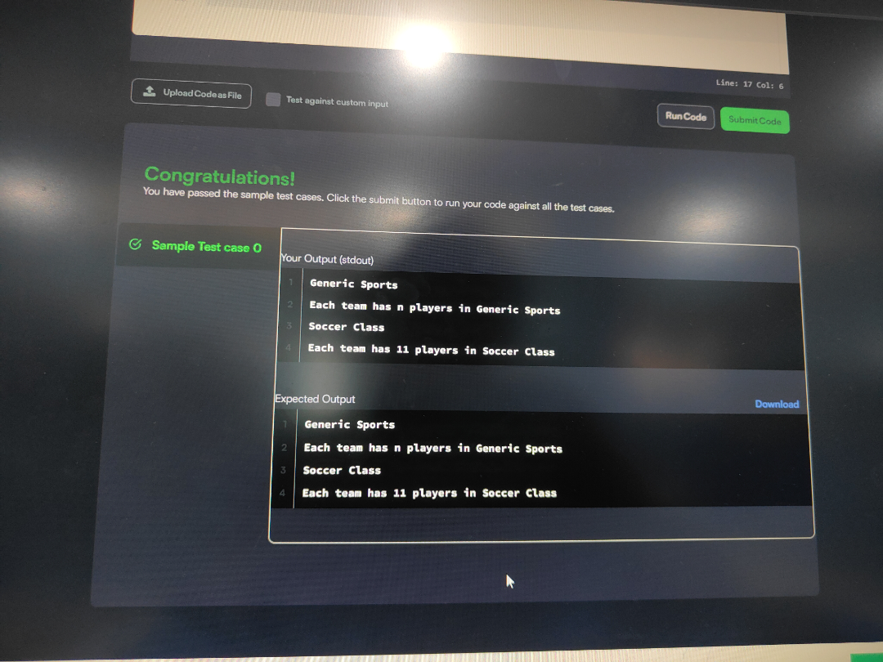
TASK 2 JAVA METHOD OVERRIDING USING SUPER.﻿
PROGRAM.﻿
import java.util.*;﻿
import java.io.*;﻿
class BiCycle {﻿
String define_me() {﻿
return "a vehicle with pedals.";﻿
}﻿
}﻿
class MotorCycle extends BiCycle {﻿
﻿
String define_me() {﻿
return "a cycle with an engine.";﻿
}﻿
MotorCycle() {﻿
System.out.println("Hello I am a motorcycle, I am " + define_me());﻿
String temp = super.define_me(); // Fixed line﻿
System.out.println("My ancestor is a cycle who is " + temp);﻿
}﻿
}﻿
class Solution {﻿
public static void main(String[] args) {﻿
MotorCycle M = new MotorCycle();﻿
}﻿
}﻿
OUTPUT.
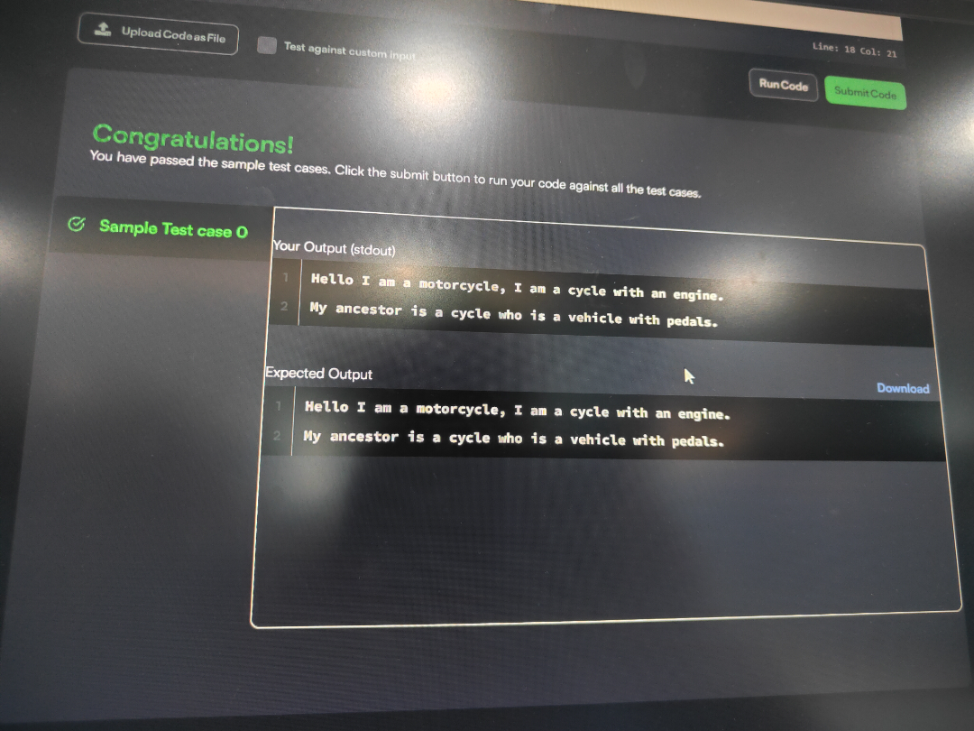
SESSION 2 DESIGN PATTERN ﻿
TASK 1 JAVA SINGLETON.﻿
PROGRAM.﻿
import java.io.*;﻿
import java.util.*;﻿
import java.text.*;﻿
import java.math.*;﻿
import java.util.regex.*;﻿
import java.lang.reflect.*;﻿
class Singleton {﻿
private static Singleton singleInstance = null;﻿
public String str;﻿
private Singleton() {﻿
}﻿
public static Singleton getSingleInstance() {﻿
if (singleInstance == null) {﻿
singleInstance = new Singleton();﻿
}﻿
return singleInstance;﻿
}﻿
}﻿
public class Main {﻿
public static void main(String args[]) throws Exception {﻿
Scanner sc = new Scanner(System.in);﻿
Singleton s1 = Singleton.getSingleInstance();﻿
Singleton s2 = Singleton.getSingleInstance();﻿
assert (s1 == s2);﻿
// Verify that the constructor is private﻿
Class c = s1.getClass();﻿
Constructor[] allConstructors = c.getDeclaredConstructors();﻿
assert allConstructors.length == 1;﻿
for (Constructor ctor : allConstructors) {﻿
if (ctor.getModifiers() != 2 ||﻿
!ctor.toString().equals("private Singleton()")) {﻿
System.out.println("Wrong class!");﻿
}﻿
}﻿
String str = sc.nextLine();﻿
s1.str = str;﻿
s2.str = str;﻿
System.out.println(﻿
"Hello I am a singleton! Let me say " + str + " to you"﻿
);﻿
}﻿
}﻿
OUTPUT.
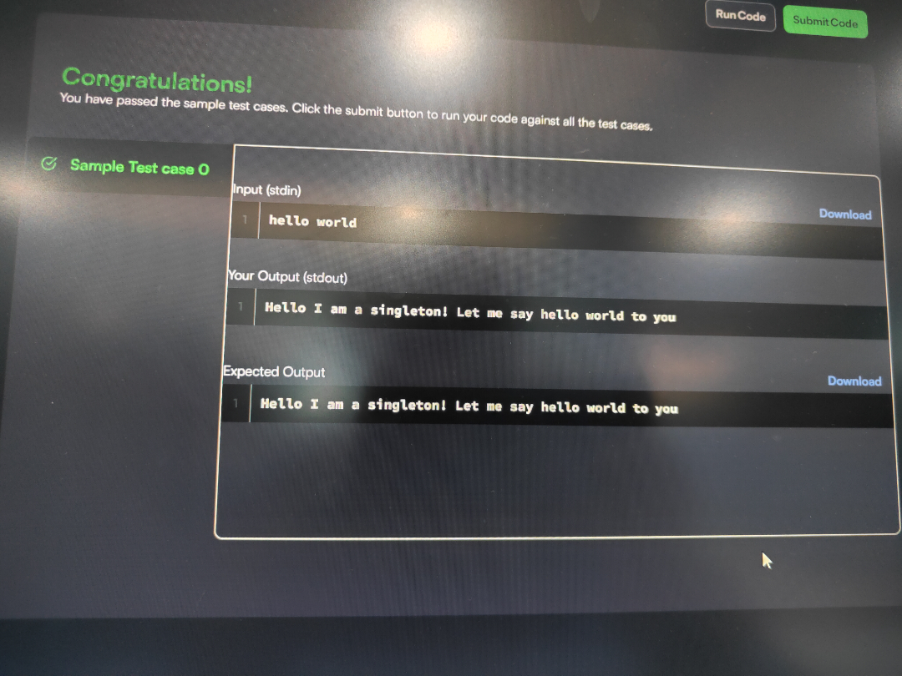
TASK 2 JAVA VISITOR PATTERN.﻿
PROGRAM.﻿
import java.io.*;﻿
import java.util.*;﻿
import java.text.*;﻿
import java.math.*;﻿
import java.util.regex.*;﻿
enum Color {﻿
RED, GREEN﻿
}﻿
abstract class Tree {﻿
private int value;﻿
private Color color;﻿
private int depth;﻿
public Tree(int value, Color color, int depth) {﻿
this.value = value;﻿
this.color = color;﻿
this.depth = depth;﻿
}﻿
public int getValue() {﻿
return value;﻿
}﻿
public Color getColor() {﻿
return color;﻿
}﻿
public int getDepth() {﻿
return depth;﻿
}﻿
public abstract void accept(TreeVis visitor);﻿
}﻿
class TreeNode extends Tree {﻿
private ArrayList<Tree> children = new ArrayList<>();﻿
public TreeNode(int value, Color color, int depth) {﻿
super(value, color, depth);﻿
}﻿
public void accept(TreeVis visitor) {﻿
visitor.visitNode(this);﻿
for (Tree child : children) {﻿
child.accept(visitor);﻿
}﻿
}﻿
public void addChild(Tree child) {﻿
children.add(child);﻿
}﻿
}﻿
class TreeLeaf extends Tree {﻿
public TreeLeaf(int value, Color color, int depth) {﻿
super(value, color, depth);﻿
}﻿
public void accept(TreeVis visitor) {﻿
visitor.visitLeaf(this);﻿
}﻿
}﻿
abstract class TreeVis {﻿
public abstract int getResult();﻿
public abstract void visitNode(TreeNode node);﻿
public abstract void visitLeaf(TreeLeaf leaf);﻿
}﻿
/* 1. Sum of all leaf values */﻿
class SumInLeavesVisitor extends TreeVis {﻿
private int sum = 0;﻿
public int getResult() {﻿
return sum;﻿
}﻿
public void visitNode(TreeNode node) {﻿
// Nothing to do for nodes﻿
}﻿
public void visitLeaf(TreeLeaf leaf) {﻿
sum += leaf.getValue();﻿
}﻿
}﻿
/* 2. Product of all red nodes */﻿
class ProductOfRedNodesVisitor extends TreeVis {﻿
private long product = 1;﻿
public int getResult() {﻿
return (int) product;﻿
}﻿
public void visitNode(TreeNode node) {﻿
if (node.getColor() == Color.RED) {﻿
product = (product * node.getValue()) % 1000000007;﻿
}﻿
}﻿
public void visitLeaf(TreeLeaf leaf) {﻿
if (leaf.getColor() == Color.RED) {﻿
product = (product * leaf.getValue()) % 1000000007;﻿
}﻿
}﻿
}﻿
/* 3. Fancy Visitor */﻿
class FancyVisitor extends TreeVis {﻿
private int evenGreenLeafSum = 0;﻿
private int evenDepthNodeSum = 0;﻿
public int getResult() {﻿
return Math.abs(evenGreenLeafSum - evenDepthNodeSum);﻿
}﻿
public void visitNode(TreeNode node) {﻿
if (node.getDepth() % 2 == 0) {﻿
evenDepthNodeSum += node.getValue();﻿
}﻿
}﻿
public void visitLeaf(TreeLeaf leaf) {﻿
if (leaf.getColor() == Color.GREEN) {﻿
if (leaf.getDepth() % 2 == 0) {﻿
evenGreenLeafSum += leaf.getValue();﻿
}﻿
}﻿
}﻿
}﻿
public class Solution {﻿
public static Tree solve() {﻿
Scanner sc = new Scanner(System.in);﻿
int n = sc.nextInt();﻿
int[] values = new int[n];﻿
Color[] colors = new Color[n];﻿
// Read values﻿
for (int i = 0; i < n; i++) {﻿
values[i] = sc.nextInt();﻿
}﻿
// Read colors﻿
for (int i = 0; i < n; i++) {﻿
colors[i] = (sc.nextInt() == 0)﻿
? Color.RED﻿
: Color.GREEN;﻿
}﻿
// Create nodes﻿
Tree[] nodes = new Tree[n];﻿
nodes[0] = new TreeNode(values[0], colors[0], 0);﻿
// Read edges and build tree﻿
int[][] edges = new int[n - 1][2];﻿
for (int i = 0; i < n - 1; i++) {﻿
edges[i][0] = sc.nextInt() - 1;﻿
edges[i][1] = sc.nextInt() - 1;﻿
}﻿
// Find parent-child relationships﻿
ArrayList<Integer>[] graph = new ArrayList[n];﻿
for (int i = 0; i < n; i++) {﻿
graph[i] = new ArrayList<>();﻿
}﻿
for (int i = 0; i < n - 1; i++) {﻿
int u = edges[i][0];﻿
int v = edges[i][1];﻿
graph[u].add(v);﻿
graph[v].add(u);﻿
}﻿
// BFS/DFS to construct tree﻿
Queue<Integer> queue = new LinkedList<>();﻿
int[] parent = new int[n];﻿
int[] depth = new int[n];﻿
Arrays.fill(parent, -1);﻿
queue.add(0);﻿
parent[0] = -2;﻿
depth[0] = 0;﻿
while (!queue.isEmpty()) {﻿
int current = queue.poll();﻿
for (int next : graph[current]) {﻿
if (parent[next] == -1) {﻿
parent[next] = current;﻿
depth[next] = depth[current] + 1;﻿
// Determine if node or leaf﻿
if (graph[next].size() == 1) {﻿
nodes[next] = new TreeLeaf(﻿
values[next],﻿
colors[next],﻿
depth[next]﻿
);﻿
} else {﻿
nodes[next] = new TreeNode(﻿
values[next],﻿
colors[next],﻿
depth[next]﻿
);﻿
}﻿
queue.add(next);﻿
}﻿
}﻿
}﻿
// Connect children to their parents﻿
for (int i = 1; i < n; i++) {﻿
TreeNode parentNode = (TreeNode) nodes[parent[i]];﻿
parentNode.addChild(nodes[i]);﻿
}﻿
return nodes[0];﻿
}﻿
public static void main(String[] args) {﻿
Tree root = solve();﻿
SumInLeavesVisitor vis1 = new SumInLeavesVisitor();﻿
ProductOfRedNodesVisitor vis2 = new ProductOfRedNodesVisitor();﻿
FancyVisitor vis3 = new FancyVisitor();﻿
root.accept(vis1);﻿
root.accept(vis2);﻿
root.accept(vis3);﻿
int res1 = vis1.getResult();﻿
int res2 = vis2.getResult();﻿
int res3 = vis3.getResult();﻿
System.out.println(res1);﻿
System.out.println(res2);﻿
System.out.println(res3);﻿
}﻿
}﻿
OUTPUT.
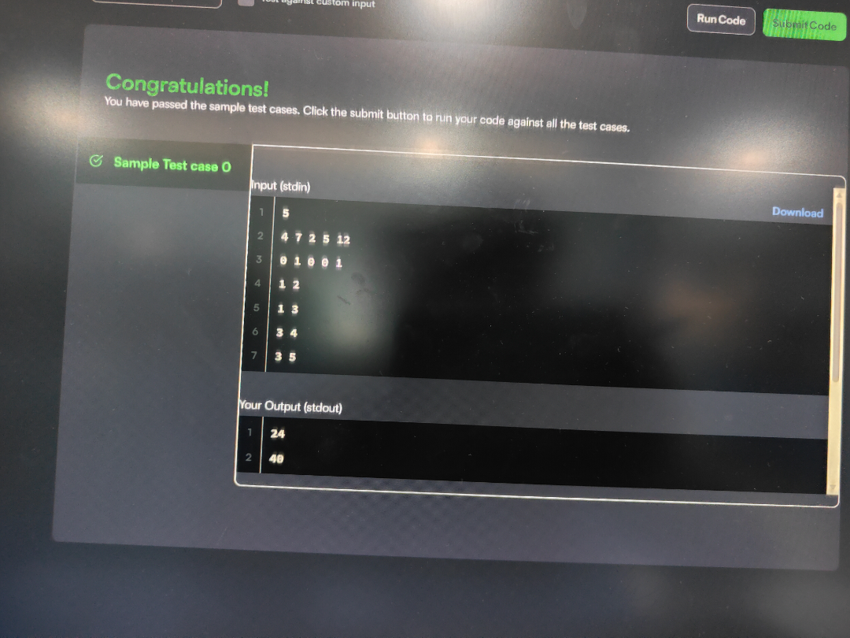
SESSION 3 INTERFACE BASED DESIGN.﻿
TASK 1 JAVA ITERATOR.﻿
PROGRAM.﻿
import java.util.*;﻿
public class Main {﻿
static Iterator func(ArrayList mylist) {﻿
Iterator it = mylist.iterator();﻿
while (it.hasNext()) {﻿
Object element = it.next();﻿
if (element instanceof String)﻿
break;﻿
}﻿
return it;﻿
}﻿
@SuppressWarnings({"unchecked"})﻿
public static void main(String[] args) {﻿
ArrayList mylist = new ArrayList();﻿
Scanner sc = new Scanner(System.in);﻿
int n = sc.nextInt();﻿
int m = sc.nextInt();﻿
for (int i = 0; i < n; i++) {﻿
mylist.add(sc.nextInt());﻿
}﻿
mylist.add("###");﻿
for (int i = 0; i < m; i++) {﻿
mylist.add(sc.next());﻿
}﻿
Iterator it = func(mylist);﻿
while (it.hasNext()) {﻿
Object element = it.next();﻿
System.out.println((String) element);﻿
}﻿
sc.close();﻿
}﻿
OUTPUT.
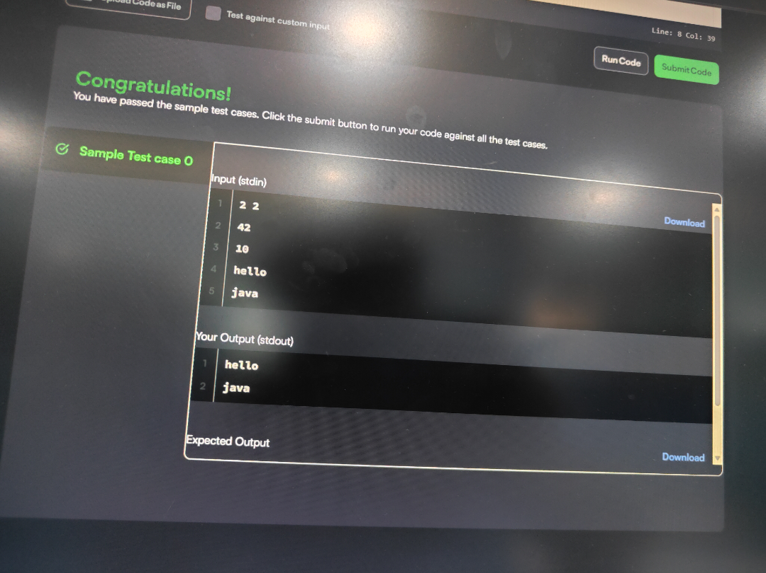
TASK 2 JAVA INTERFACE.﻿
PROGRAM.﻿
import java.util.*;﻿
interface AdvancedArithmetic {﻿
int divisor_sum(int n);﻿
}﻿
class MyCalculator implements AdvancedArithmetic {﻿
@Override﻿
public int divisor_sum(int n) {﻿
int sum = 0;﻿
for (int i = 1; i <= n; i++) {﻿
if (n % i == 0) {﻿
sum += i;﻿
}﻿
}﻿
return sum;﻿
}﻿
}﻿
class Solution {﻿
public static void main(String[] args) {﻿
MyCalculator my_calculator = new MyCalculator();﻿
System.out.print("I implemented: ");﻿
ImplementedInterfaceNames(my_calculator);﻿
Scanner sc = new Scanner(System.in);﻿
int n = sc.nextInt();﻿
System.out.print(my_calculator.divisor_sum(n) + "\n");﻿
sc.close();﻿
}﻿
/*﻿
* ImplementedInterfaceNames method takes an object﻿
* and prints the name of the interfaces it implemented﻿
*/﻿
static void ImplementedInterfaceNames(Object o) {﻿
Class[] theInterfaces = o.getClass().getInterfaces();﻿
for (int i = 0; i < theInterfaces.length; i++) {﻿
String interfaceName = theInterfaces[i].getName();﻿
System.out.println(interfaceName);﻿
}﻿
}﻿
}﻿
OUTPUT.
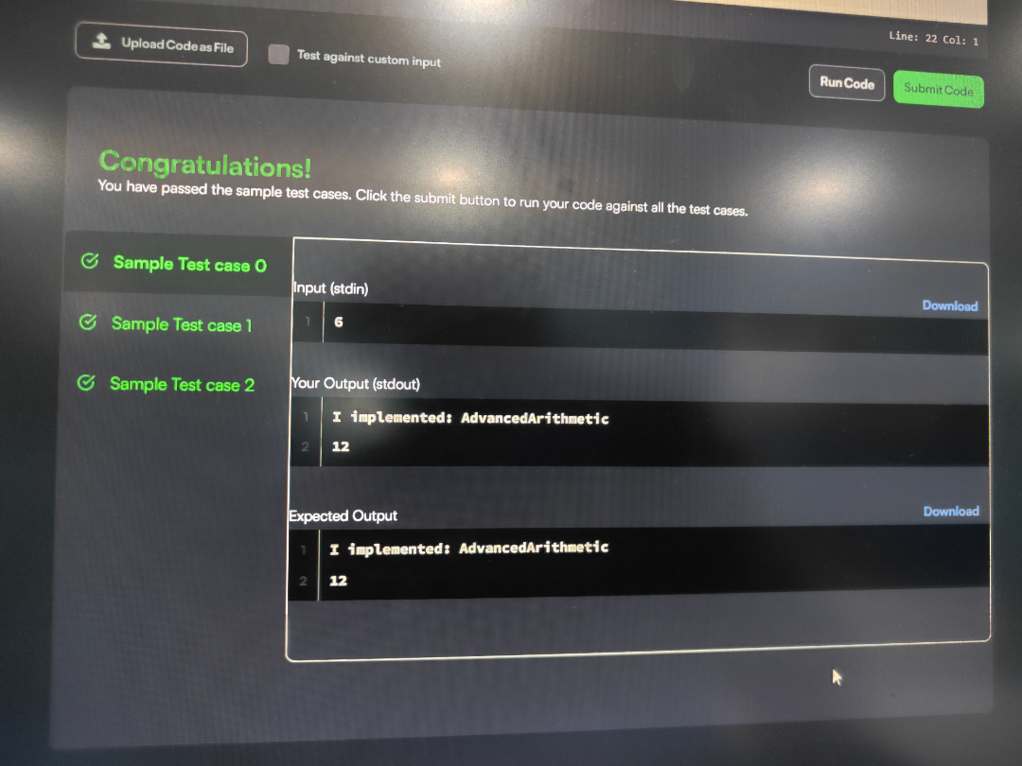
SESSION 4 IMMUTABLE OBJECTS﻿
TASK 1 JAVA HASHSET.﻿
PROGRAM.﻿
import java.io.*;﻿
import java.util.*;﻿
import java.text.*;﻿
import java.math.*;﻿
import java.util.regex.*;﻿
public class Solution {﻿
public static void main(String[] args) {﻿
Scanner s = new Scanner(System.in);﻿
int t = s.nextInt();﻿
String[] pair_left = new String[t];﻿
String[] pair_right = new String[t];﻿
for (int i = 0; i < t; i++) {﻿
pair_left[i] = s.next();﻿
pair_right[i] = s.next();﻿
}﻿
HashSet<String> set = new HashSet<String>();﻿
for (int i = 0; i < t; i++) {﻿
String pair = pair_left[i] + " " + pair_right[i];﻿
set.add(pair);﻿
System.out.println(set.size());﻿
}﻿
s.close();﻿
}﻿
}﻿
OUTPUT.
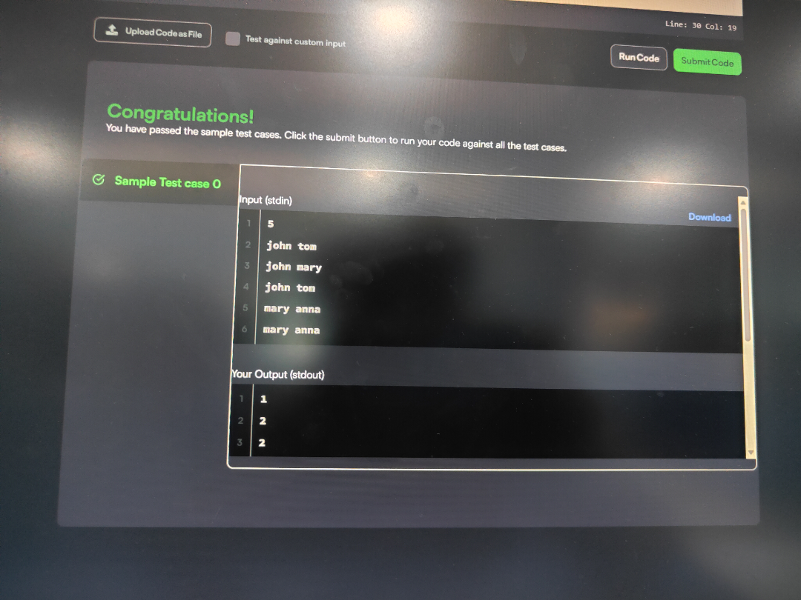
TASK 2 JAVA FACTORY.﻿
PROGRAM.﻿
import java.util.*;﻿
import java.security.*;﻿
interface Food {﻿
public String getType();﻿
}﻿
class Pizza implements Food {﻿
public String getType() {﻿
return "Someone ordered a Fast Food!";﻿
}﻿
}﻿
class Cake implements Food {﻿
public String getType() {﻿
return "Someone ordered a Dessert!";﻿
}﻿
}﻿
class FoodFactory {﻿
public Food getFood(String order) {﻿
if (order.equals("pizza")) {﻿
return new Pizza();﻿
} else {﻿
return new Cake();﻿
}﻿
}﻿
}﻿
public class Solution {﻿
public static void main(String args[]) {﻿
Do_Not_Terminate.forbidExit();﻿
try {﻿
Scanner sc = new Scanner(System.in);﻿
FoodFactory foodFactory = new FoodFactory();﻿
Food food = foodFactory.getFood(sc.nextLine());﻿
System.out.println("The factory returned " + food.getClass());﻿
System.out.println(food.getType());﻿
sc.close();﻿
} catch (Do_Not_Terminate.ExitTrappedException e) {﻿
System.out.println("Unsuccessful Termination!!");﻿
}﻿
}﻿
}﻿
class Do_Not_Terminate {﻿
public static class ExitTrappedException extends SecurityException {﻿
private static final long serialVersionUID = 1L;﻿
}﻿
public static void forbidExit() {﻿
final SecurityManager securityManager =﻿
new SecurityManager() {﻿
@Override﻿
public void checkPermission(Permission permission) {﻿
if (permission.getName().contains("exitVM")) {﻿
throw new ExitTrappedException();﻿
}﻿
}﻿
};﻿
System.setSecurityManager(securityManager);﻿
}﻿
}﻿
OUTPUT.
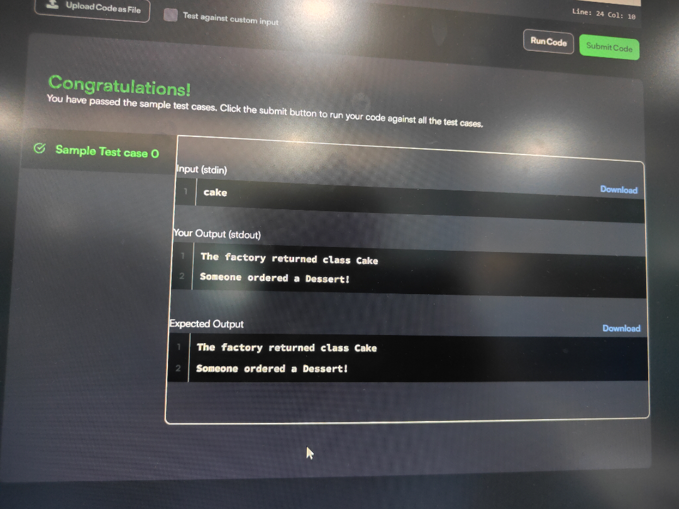
SESSION 5 EXCEPTION DRIVEN FLOW CONTROL.﻿
TASK 1JAVA EXCEPTION HANDLING.﻿
PROGRAM.﻿
import java.util.Scanner;﻿
class MyCalculator {﻿
public long power(int n, int p) throws Exception {﻿
if (n == 0 && p == 0) {﻿
throw new Exception("n and p should not be zero.");﻿
}﻿
if (n < 0 || p < 0) {﻿
throw new Exception("n or p should not be negative.");﻿
}﻿
return (long) Math.pow(n, p);﻿
}﻿
}﻿
public class Solution {﻿
public static final MyCalculator my_calculator =﻿
new MyCalculator();﻿
public static final Scanner in =﻿
new Scanner(System.in);﻿
public static void main(String[] args) {﻿
while (in.hasNextInt()) {﻿
int n = in.nextInt();﻿
int p = in.nextInt();﻿
try {﻿
System.out.println(my_calculator.power(n, p));﻿
}﻿
catch (Exception e) {﻿
System.out.println(e);﻿
}﻿
}﻿
}﻿
}﻿
OUTPUT.
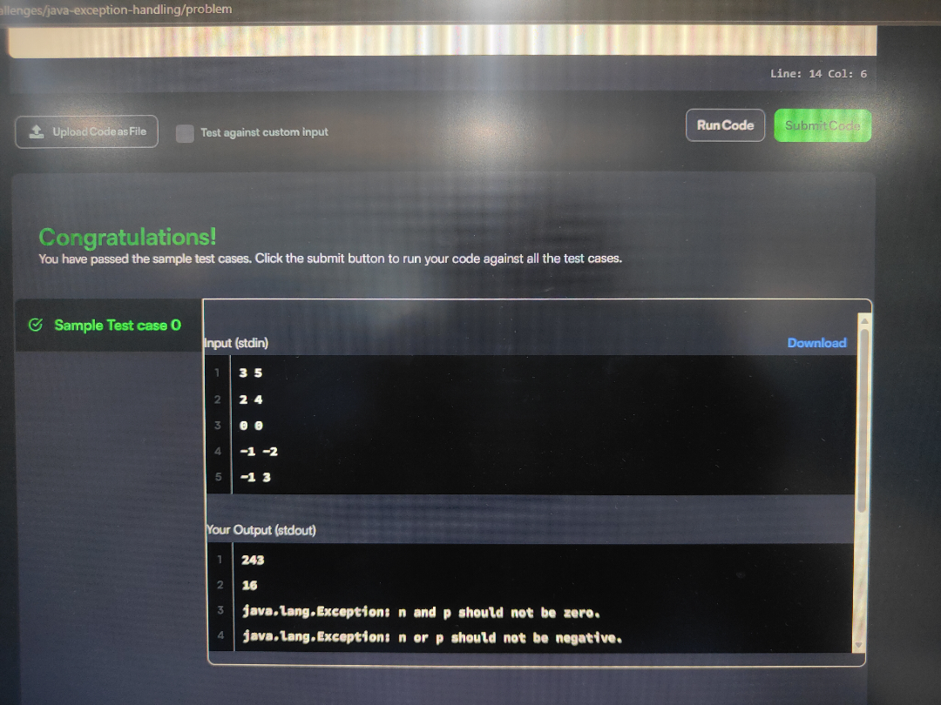
TASK 2 JAVA EXCEPTION HANDLING TRY-CATCH.﻿
PROGRAM.﻿
import java.io.*;﻿
import java.util.*;﻿
import java.text.*;﻿
import java.math.*;﻿
import java.util.regex.*;﻿
public class Solution {﻿
public static void main(String[] args) {﻿
Scanner sc = new Scanner(System.in);﻿
try {﻿
int x = sc.nextInt();﻿
int y = sc.nextInt();﻿
System.out.println(x / y);﻿
}﻿
catch (InputMismatchException e) {﻿
System.out.println("java.util.InputMismatchException");﻿
}﻿
catch (ArithmeticException e) {﻿
System.out.println(e);﻿
}﻿
sc.close();﻿
}﻿
}﻿
OUTPUT.



