TASK 1:
PROGRAM:
class Solution { public boolean containsDuplicate(int[] nums) { HashSet<Integer> set = new HashSet<>(); for (int num : nums) { if (set.contains(num)) { return true; } set.add(num); } return false; } }
OUTPUT:
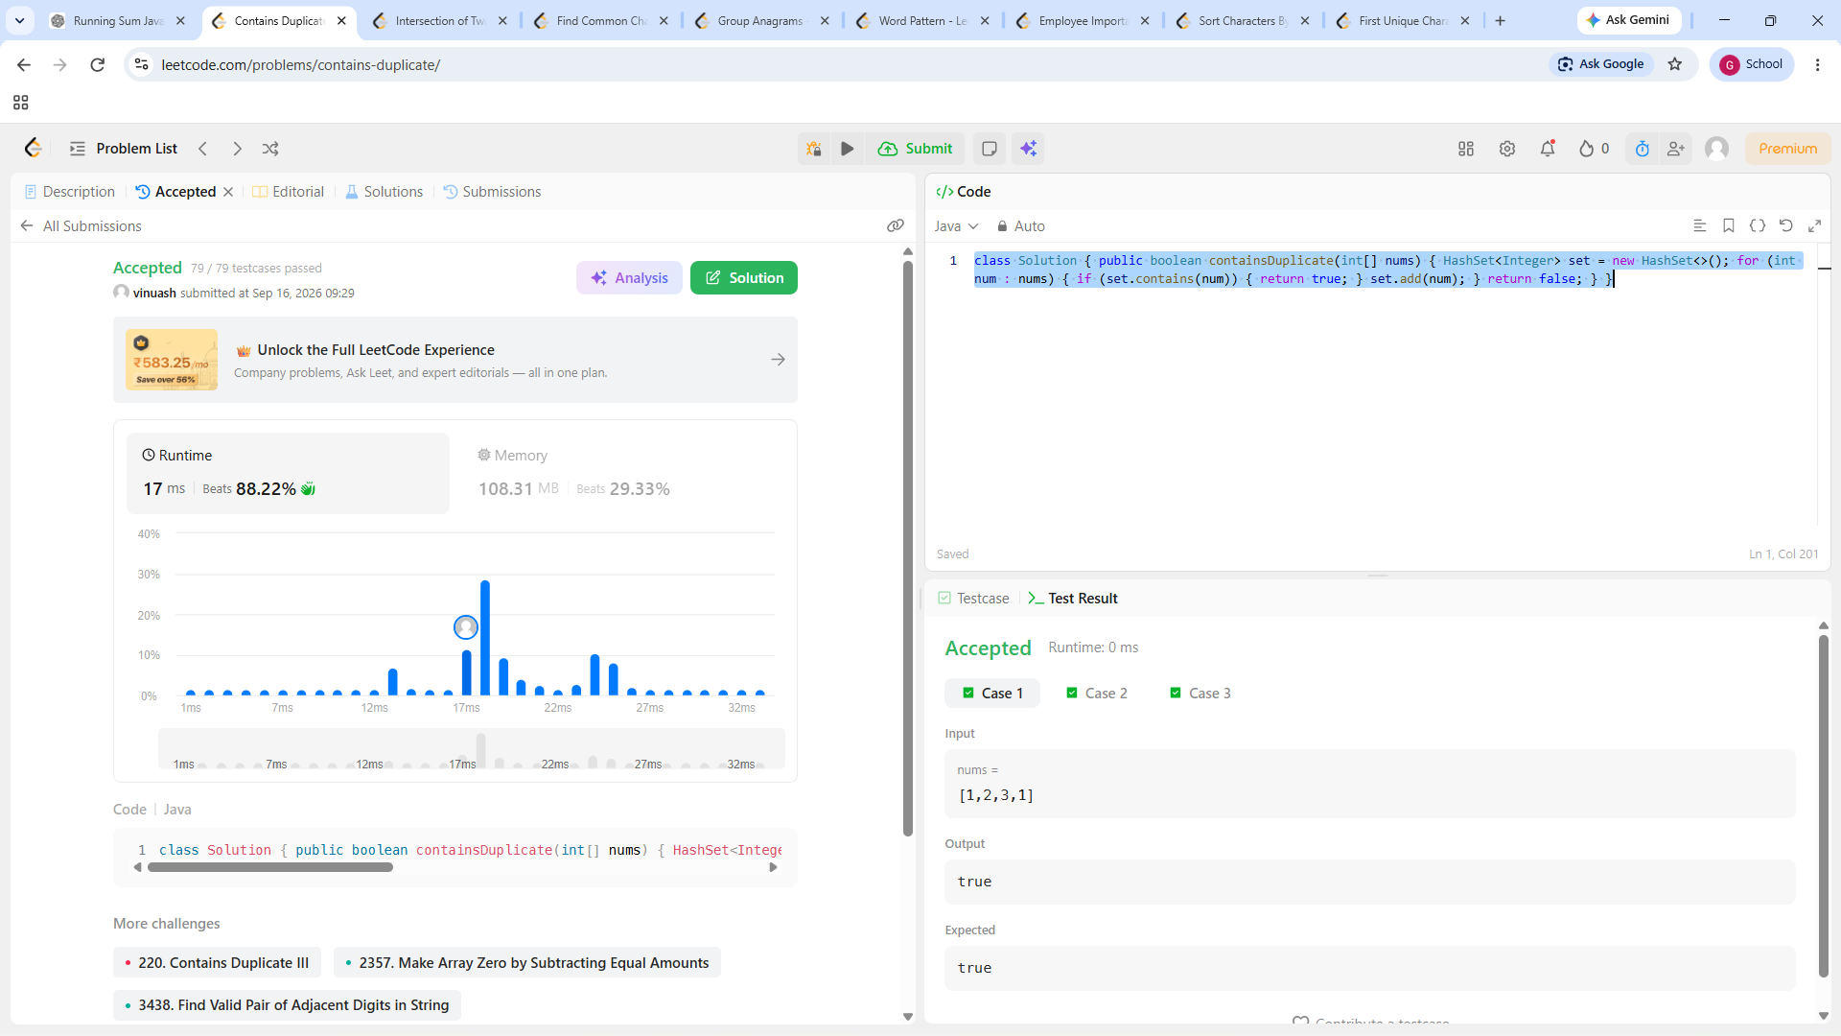

TASK 2:
PROGRAM:
class Solution {
public int[] intersection(int[] nums1, int[] nums2) {
HashSet<Integer> set = new HashSet<>();
HashSet<Integer> result = new HashSet<>();
for (int num : nums1) {
set.add(num);
}
for (int num : nums2) {
if (set.contains(num)) {
result.add(num);
}
}
int[] ans = new int[result.size()];
int i = 0;
for (int num : result) {
ans[i++] = num;
}
return ans;
}
}
OUTPUT:
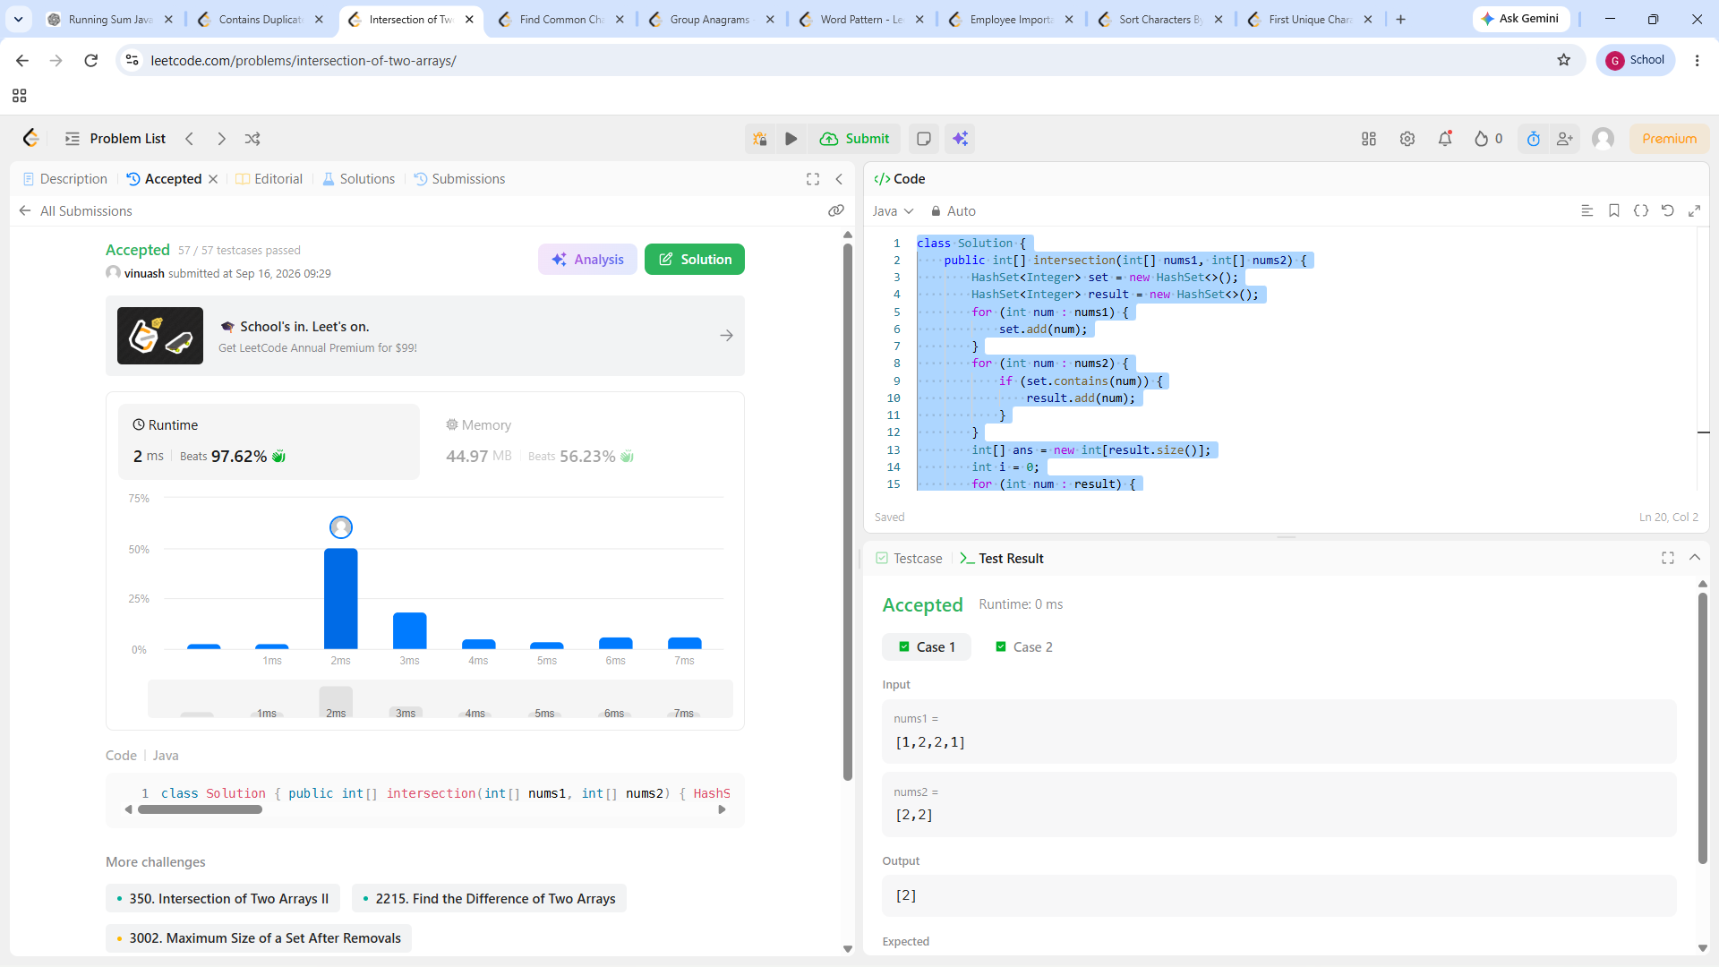

TASK 3:
PROGRAM:

import java.util.*;

class Solution {
public List<String> commonChars(String[] words) {
int[] minFreq = new int[26];
Arrays.fill(minFreq, Integer.MAX_VALUE);

for (String word : words) {
int[] freq = new int[26];

for (char c : word.toCharArray()) {
freq[c - 'a']++;
}

for (int i = 0; i < 26; i++) {
minFreq[i] = Math.min(minFreq[i], freq[i]);
}
}

List<String> result = new ArrayList<>();

for (int i = 0; i < 26; i++) {
while (minFreq[i] > 0) {
result.add(String.valueOf((char) ('a' + i)));
minFreq[i]--;
}
}

return result;
}
}
OUTPUT:
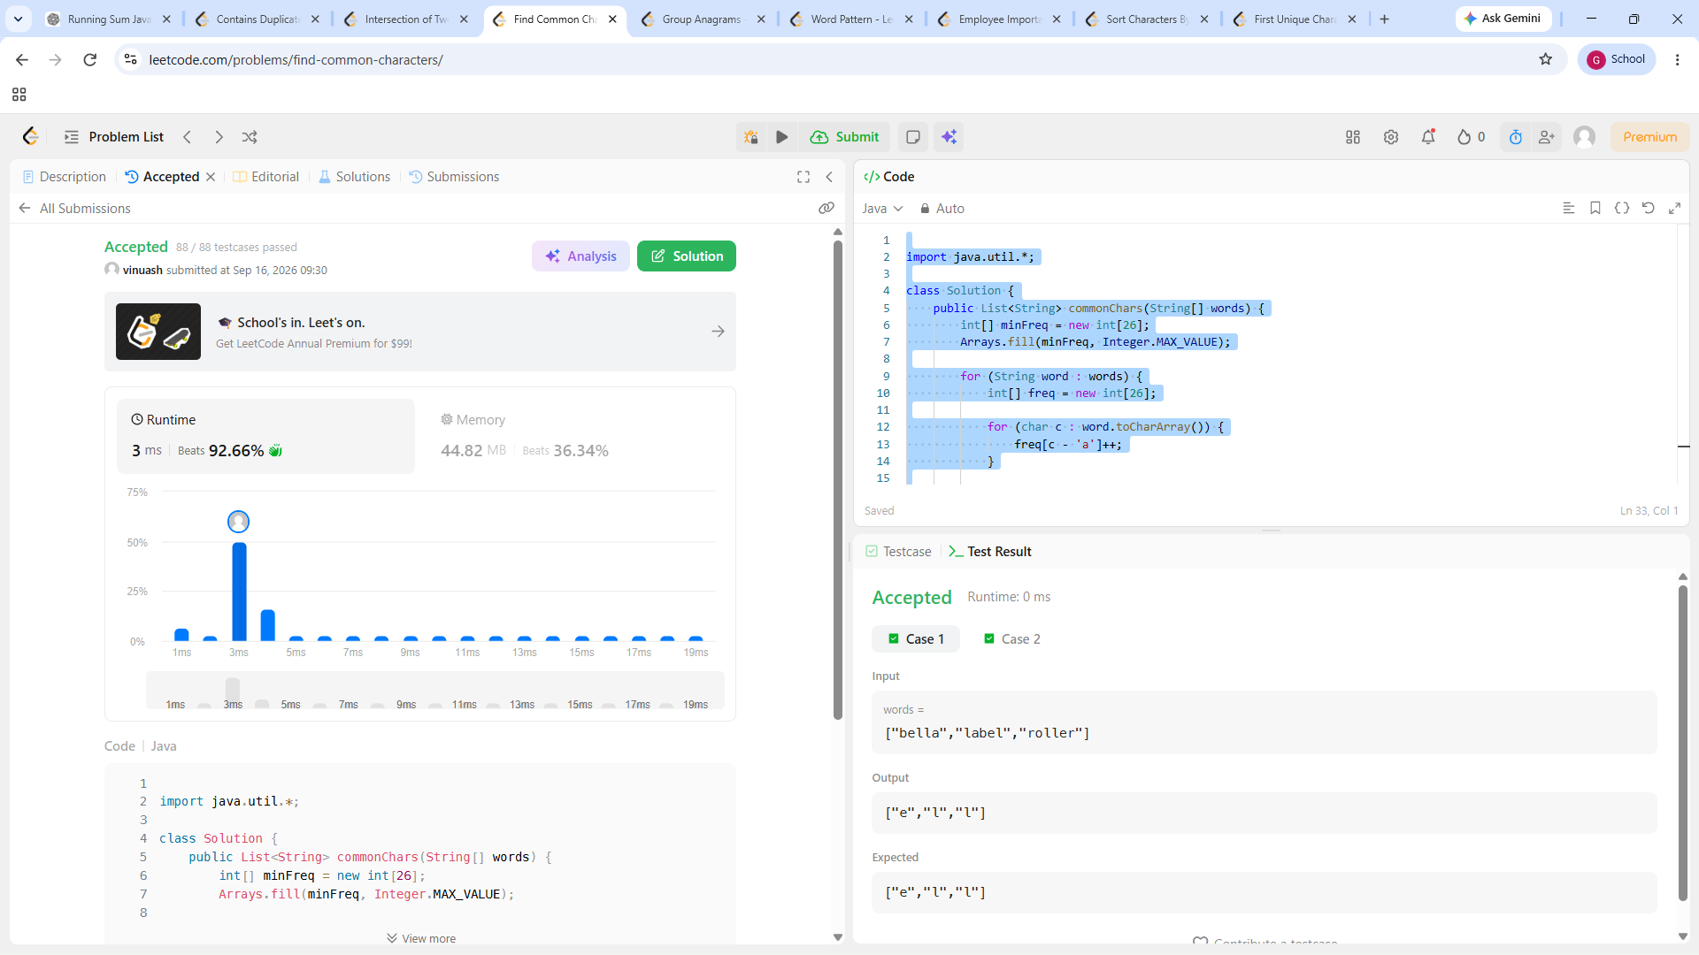
TASK 4:
PROGRAM:

import java.util.*;

class Solution {
public List<List<String>> groupAnagrams(String[] strs) {
HashMap<String, List<String>> map = new HashMap<>();

for (String str : strs) {
int[] count = new int[26];

for (char c : str.toCharArray()) {
count[c - 'a']++;
}

StringBuilder key = new StringBuilder();

for (int i = 0; i < 26; i++) {
key.append('#').append(count[i]);
}

String keyString = key.toString();

if (!map.containsKey(keyString)) {
map.put(keyString, new ArrayList<>());
}

map.get(keyString).add(str);
}

return new ArrayList<>(map.values());
}
}
OUTPUT:
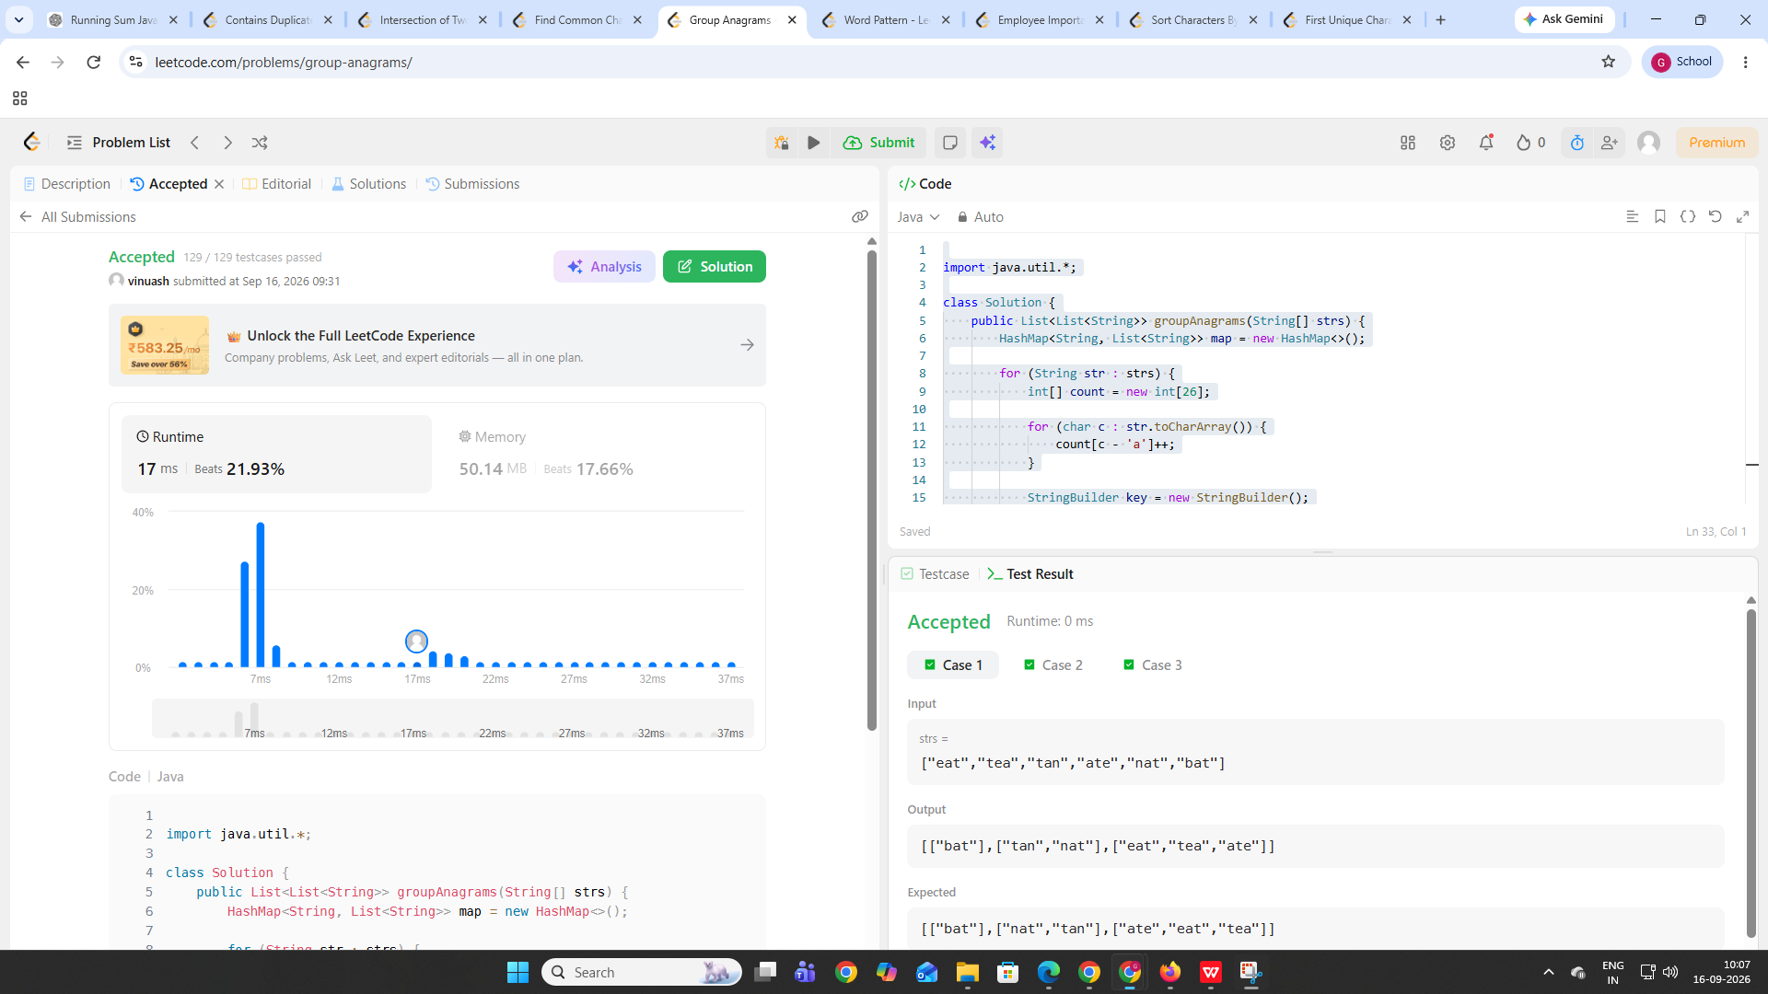

TASK 5:
PROGRAM:

import java.util.*;

class Solution {
public boolean wordPattern(String pattern, String s) {
String[] words = s.split(" ");

if (pattern.length() != words.length) {
return false;
}

HashMap<Character, String> map = new HashMap<>();
HashMap<String, Character> reverseMap = new HashMap<>();

for (int i = 0; i < pattern.length(); i++) {
char c = pattern.charAt(i);
String word = words[i];

if (map.containsKey(c) && !map.get(c).equals(word)) {
return false;
}

if (reverseMap.containsKey(word) && reverseMap.get(word) != c) {
return false;
}

map.put(c, word);
reverseMap.put(word, c);
}

return true;
}
}
OUTPUT:
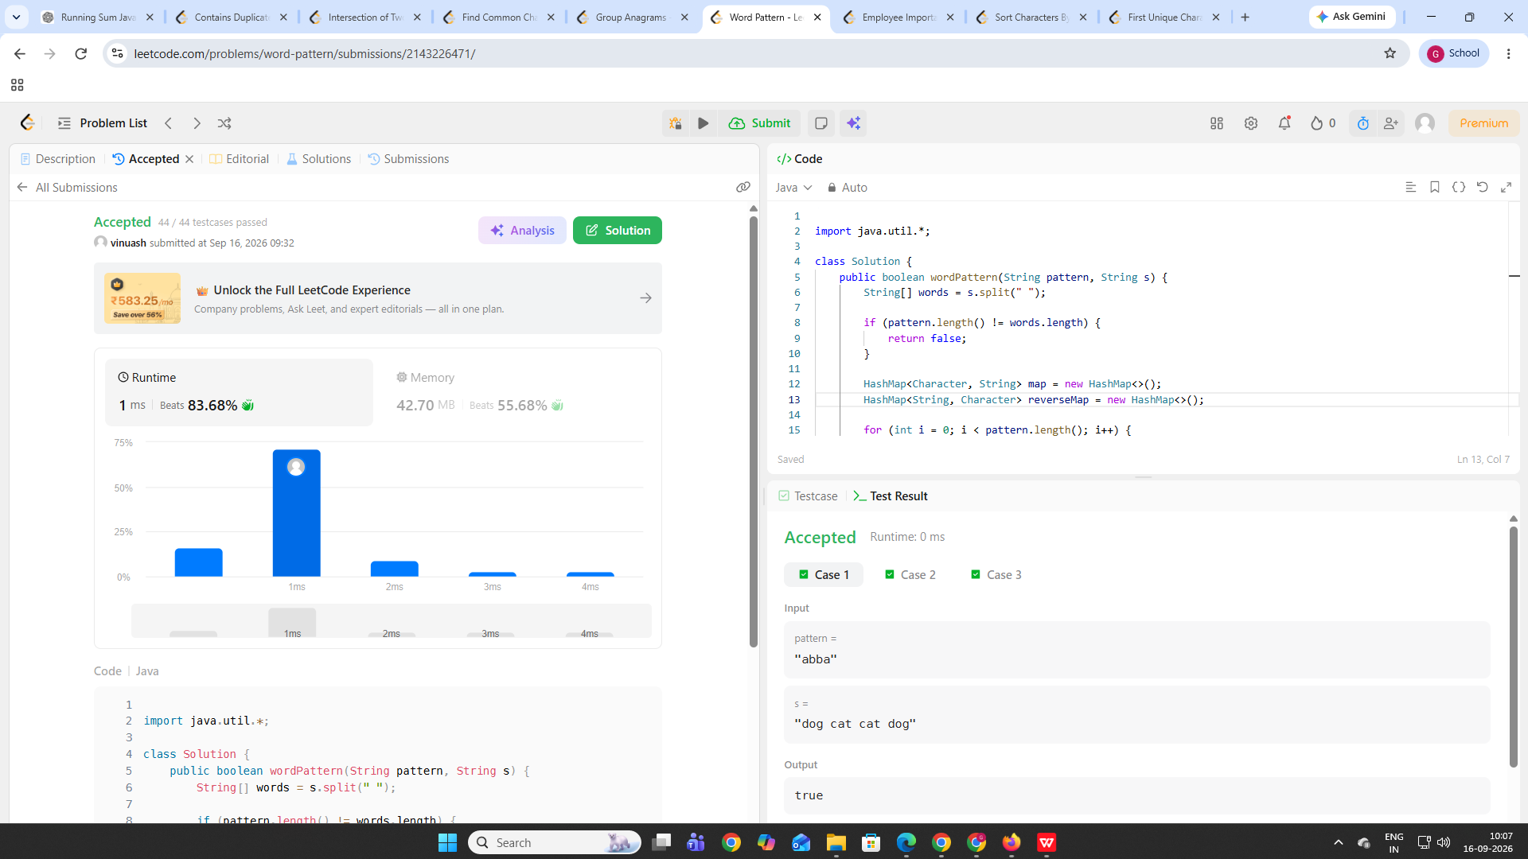

TASK 6:
PROGRAM:

class Solution {
public int getImportance(List<Employee> employees, int id) {
HashMap<Integer, Employee> map = new HashMap<>();

for (Employee employee : employees) {
map.put(employee.id, employee);
}

return dfs(map, id);
}

private int dfs(HashMap<Integer, Employee> map, int id) {
Employee employee = map.get(id);
int total = employee.importance;

for (int subordinate : employee.subordinates) {
total += dfs(map, subordinate);
}

return total;
}
}
OUTPUT:
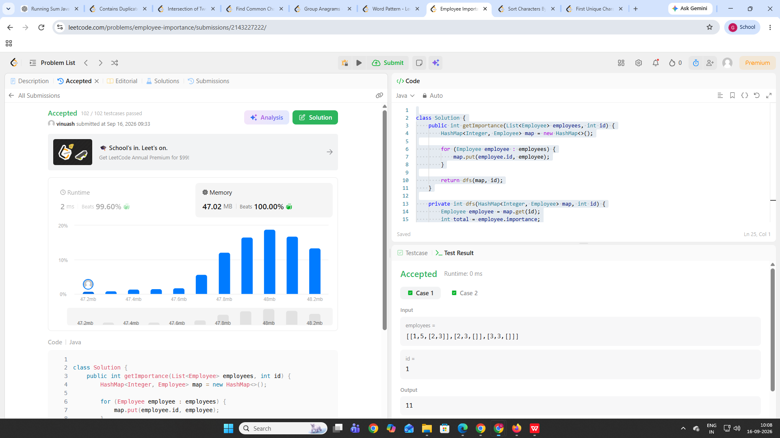

TASK 7:
PROGRAM:

import java.util.*;

class Solution {
public String frequencySort(String s) {
HashMap<Character, Integer> map = new HashMap<>();

for (char c : s.toCharArray()) {
map.put(c, map.getOrDefault(c, 0) + 1);
}

List<Character> chars = new ArrayList<>(map.keySet());

Collections.sort(chars, new Comparator<Character>() {
public int compare(Character a, Character b) {
return map.get(b) - map.get(a);
}
});

StringBuilder result = new StringBuilder();

for (char c : chars) {
for (int i = 0; i < map.get(c); i++) {
result.append(c);
}
}

return result.toString();
}
}
OUTPUT:
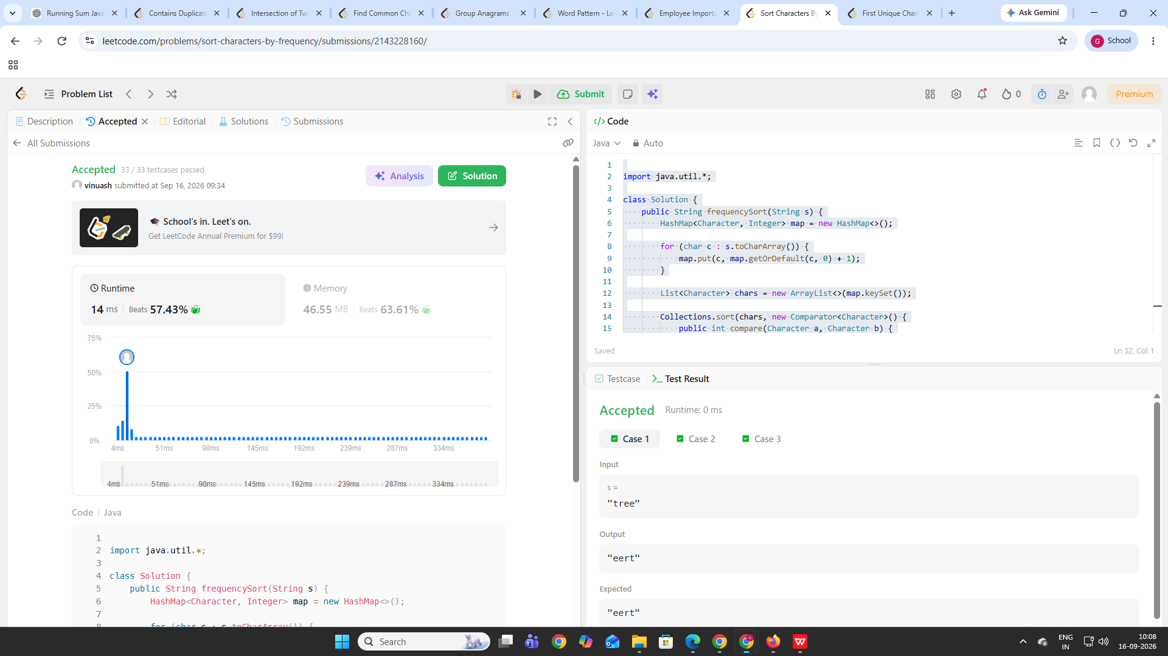

TASK 8:
PROGRAM:

class Solution {
public int firstUniqChar(String s) {
int[] freq = new int[26];

for (char c : s.toCharArray()) {
freq[c - 'a']++;
}

for (int i = 0; i < s.length(); i++) {
if (freq[s.charAt(i) - 'a'] == 1) {
return i;
}
}

return -1;
}
}

OUTPUT:
