WEEK--9
SESSION 1 BANKING SYSTEM.﻿
PROGRAM.﻿
class BankAccount {﻿
private int accountNumber;﻿
private String accountHolder;﻿
protected double balance;﻿
BankAccount(int accountNumber, String accountHolder, double balance) {﻿
this.accountNumber = accountNumber;﻿
this.accountHolder = accountHolder;﻿
this.balance = balance;﻿
}﻿
void deposit(double amount) {﻿
if (amount > 0) {﻿
balance += amount;﻿
System.out.println("Deposited: " + amount);﻿
} else {﻿
System.out.println("Invalid deposit amount");﻿
}﻿
}﻿
void withdraw(double amount) {﻿
if (amount > 0 && amount <= balance) {﻿
balance -= amount;﻿
System.out.println("Withdrawn: " + amount);﻿
} else {﻿
System.out.println("Insufficient balance");﻿
}﻿
}﻿
void displayAccount() {﻿
System.out.println("\nAccount Number : " + accountNumber);﻿
System.out.println("Account Holder : " + accountHolder);﻿
System.out.println("Balance : " + balance);﻿
}﻿
}﻿
class SavingsAccount extends BankAccount {﻿
private double interestRate;﻿
SavingsAccount(int accountNumber, String accountHolder,﻿
double balance, double interestRate) {﻿
super(accountNumber, accountHolder, balance);﻿
this.interestRate = interestRate;﻿
}﻿
void addInterest() {﻿
double interest = balance * interestRate / 100;﻿
balance += interest;﻿
System.out.println("Interest Added : " + interest);﻿
}﻿
}﻿
public class BankingSystem {﻿
public static void main(String[] args) {﻿
SavingsAccount account =﻿
new SavingsAccount(1001, "Aravind", 10000, 5);﻿
System.out.println("BANKING TRANSACTION SYSTEM");﻿
account.displayAccount();﻿
account.deposit(5000);﻿
account.withdraw(3000);﻿
account.addInterest();﻿
System.out.println("\nAfter Transactions:");﻿
account.displayAccount();﻿
}﻿
}﻿
OUTPUT.
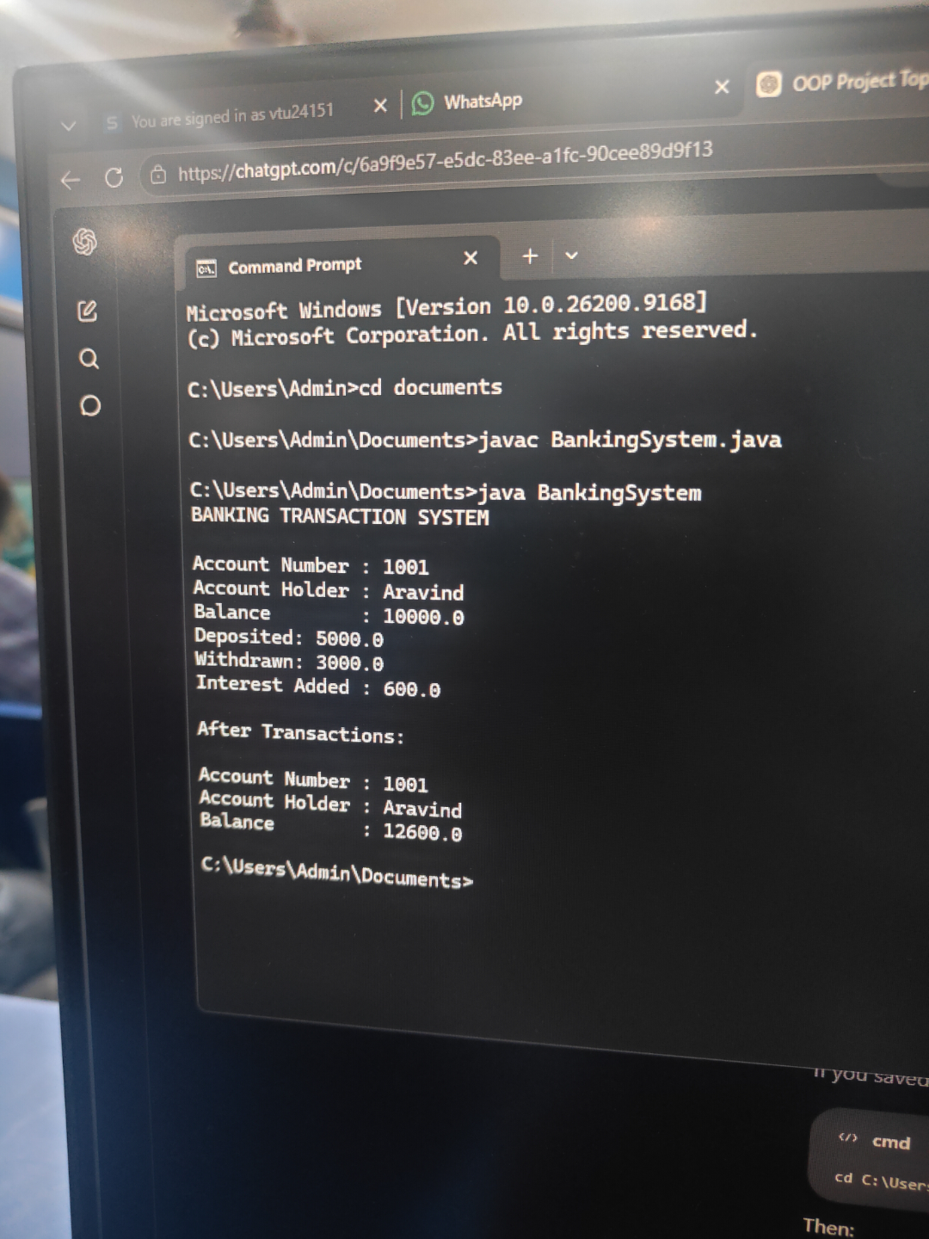
SESSION 2 RIDE SHARING SYSTEM.﻿
PROGRAM.﻿
abstract class Vehicle {﻿
protected String driverName;﻿
Vehicle(String driverName) {﻿
this.driverName = driverName;﻿
}﻿
abstract double calculateFare(double distance);﻿
abstract String getVehicleType();﻿
}﻿
class Car extends Vehicle {﻿
Car(String driverName) {﻿
super(driverName);﻿
}﻿
@Override﻿
double calculateFare(double distance) {﻿
return distance * 15;﻿
}﻿
@Override﻿
String getVehicleType() {﻿
return "Car";﻿
}﻿
}﻿
class Bike extends Vehicle {﻿
Bike(String driverName) {﻿
super(driverName);﻿
}﻿
@Override﻿
double calculateFare(double distance) {﻿
return distance * 10;﻿
}﻿
@Override﻿
String getVehicleType() {﻿
return "Bike";﻿
}﻿
}﻿
class Ride {﻿
private String passengerName;﻿
private Vehicle vehicle;﻿
private double distance;﻿
Ride(String passengerName, Vehicle vehicle, double distance) {﻿
this.passengerName = passengerName;﻿
this.vehicle = vehicle;﻿
this.distance = distance;﻿
}﻿
void displayRideDetails() {﻿
System.out.println("\nPassenger Name : " + passengerName);﻿
System.out.println("Driver Name : " + vehicle.driverName);﻿
System.out.println("Vehicle Type : " + vehicle.getVehicleType());﻿
System.out.println("Distance : " + distance + " km");﻿
System.out.println("Fare : Rs." +﻿
vehicle.calculateFare(distance));﻿
}﻿
}﻿
public class RideSharingSystem {﻿
public static void main(String[] args) {﻿
System.out.println("RIDE SHARING PLATFORM");﻿
Vehicle car = new Car("Ravi");﻿
Vehicle bike = new Bike("Kumar");﻿
Ride ride1 = new Ride("Aravind", car, 10);﻿
Ride ride2 = new Ride("Rahul", bike, 8);﻿
ride1.displayRideDetails();﻿
ride2.displayRideDetails();﻿
}﻿
}﻿
OUTPUT.
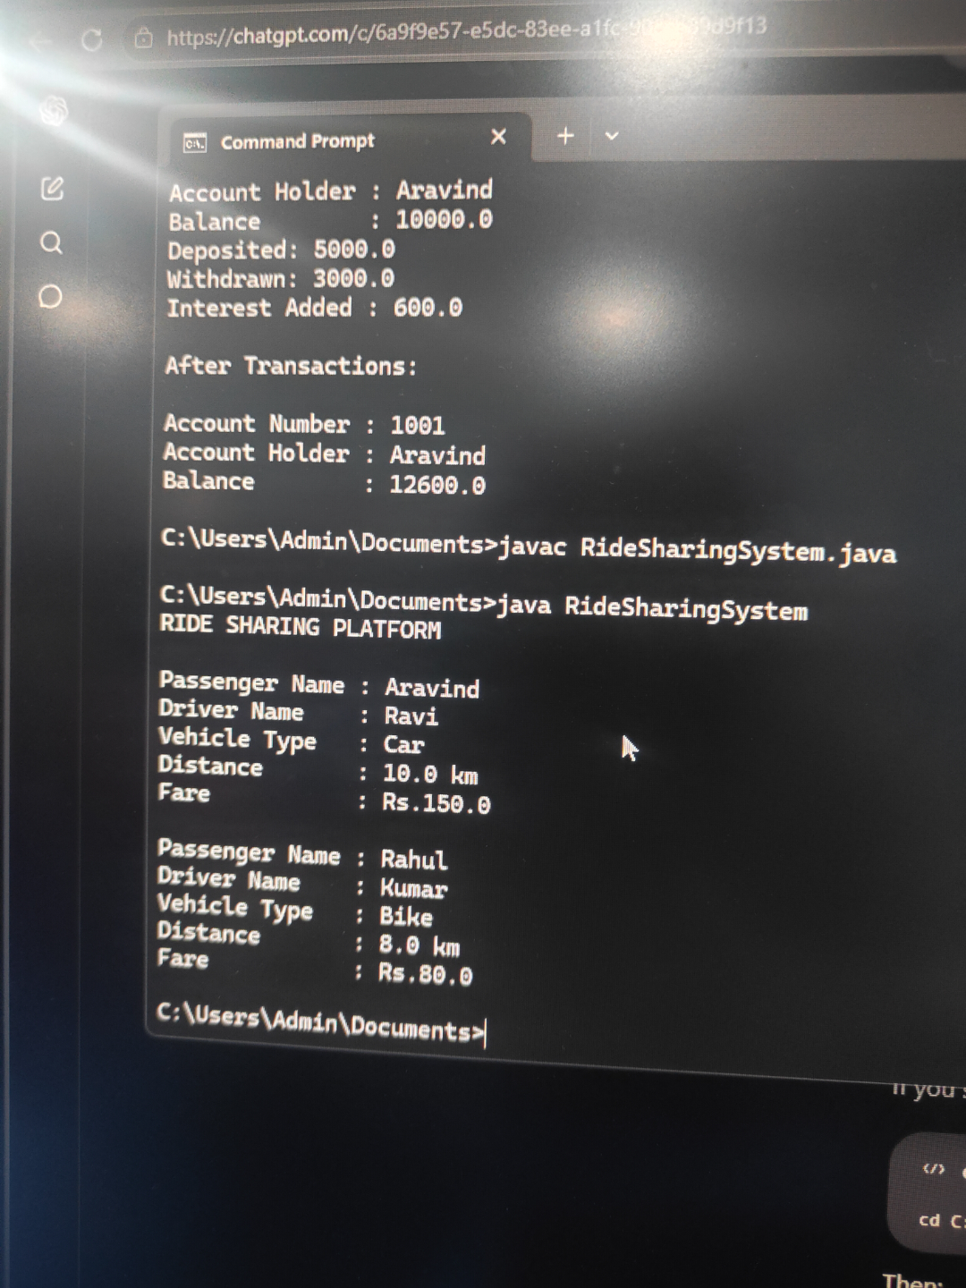
SESSION 3 INHERITANCE AND POLYMORPHISM IN ALGORITHM DESIGN.﻿
PROGRAM.﻿
import java.util.*;﻿
class Vehicle {﻿
String vehicleNumber;﻿
double rentPerDay;﻿
Vehicle(String vehicleNumber, double rentPerDay) {﻿
this.vehicleNumber = vehicleNumber;﻿
this.rentPerDay = rentPerDay;﻿
}﻿
double calculateRent(int days) {﻿
return rentPerDay * days;﻿
}﻿
}﻿
class Car extends Vehicle {﻿
Car(String vehicleNumber, double rentPerDay) {﻿
super(vehicleNumber, rentPerDay);﻿
}﻿
@Override﻿
double calculateRent(int days) {﻿
return rentPerDay * days;﻿
}﻿
}﻿
class Bike extends Vehicle {﻿
Bike(String vehicleNumber, double rentPerDay) {﻿
super(vehicleNumber, rentPerDay);﻿
}﻿
@Override﻿
double calculateRent(int days) {﻿
return rentPerDay * days * 0.90;﻿
}﻿
}﻿
class Truck extends Vehicle {﻿
Truck(String vehicleNumber, double rentPerDay) {﻿
super(vehicleNumber, rentPerDay);﻿
}﻿
@Override﻿
double calculateRent(int days) {﻿
return rentPerDay * days * 1.20;﻿
}﻿
}﻿
public class VehicleRentalSystem {﻿
public static void main(String[] args) {﻿
Scanner sc = new Scanner(System.in);﻿
int N = sc.nextInt();﻿
for (int i = 0; i < N; i++) {﻿
int vehicleType = sc.nextInt();﻿
String vehicleNumber = sc.next();﻿
double rentPerDay = sc.nextDouble();﻿
int days = sc.nextInt();﻿
// Runtime polymorphism﻿
Vehicle vehicle;﻿
if (vehicleType == 1) {﻿
vehicle = new Car(vehicleNumber, rentPerDay);﻿
} ﻿
else if (vehicleType == 2) {﻿
vehicle = new Bike(vehicleNumber, rentPerDay);﻿
} ﻿
else {﻿
vehicle = new Truck(vehicleNumber, rentPerDay);﻿
}﻿
double totalRent = vehicle.calculateRent(days);﻿
System.out.printf("%s %.2f%n",﻿
vehicleNumber, totalRent);﻿
}﻿
sc.close();﻿
}﻿
}﻿
OUTPUT.
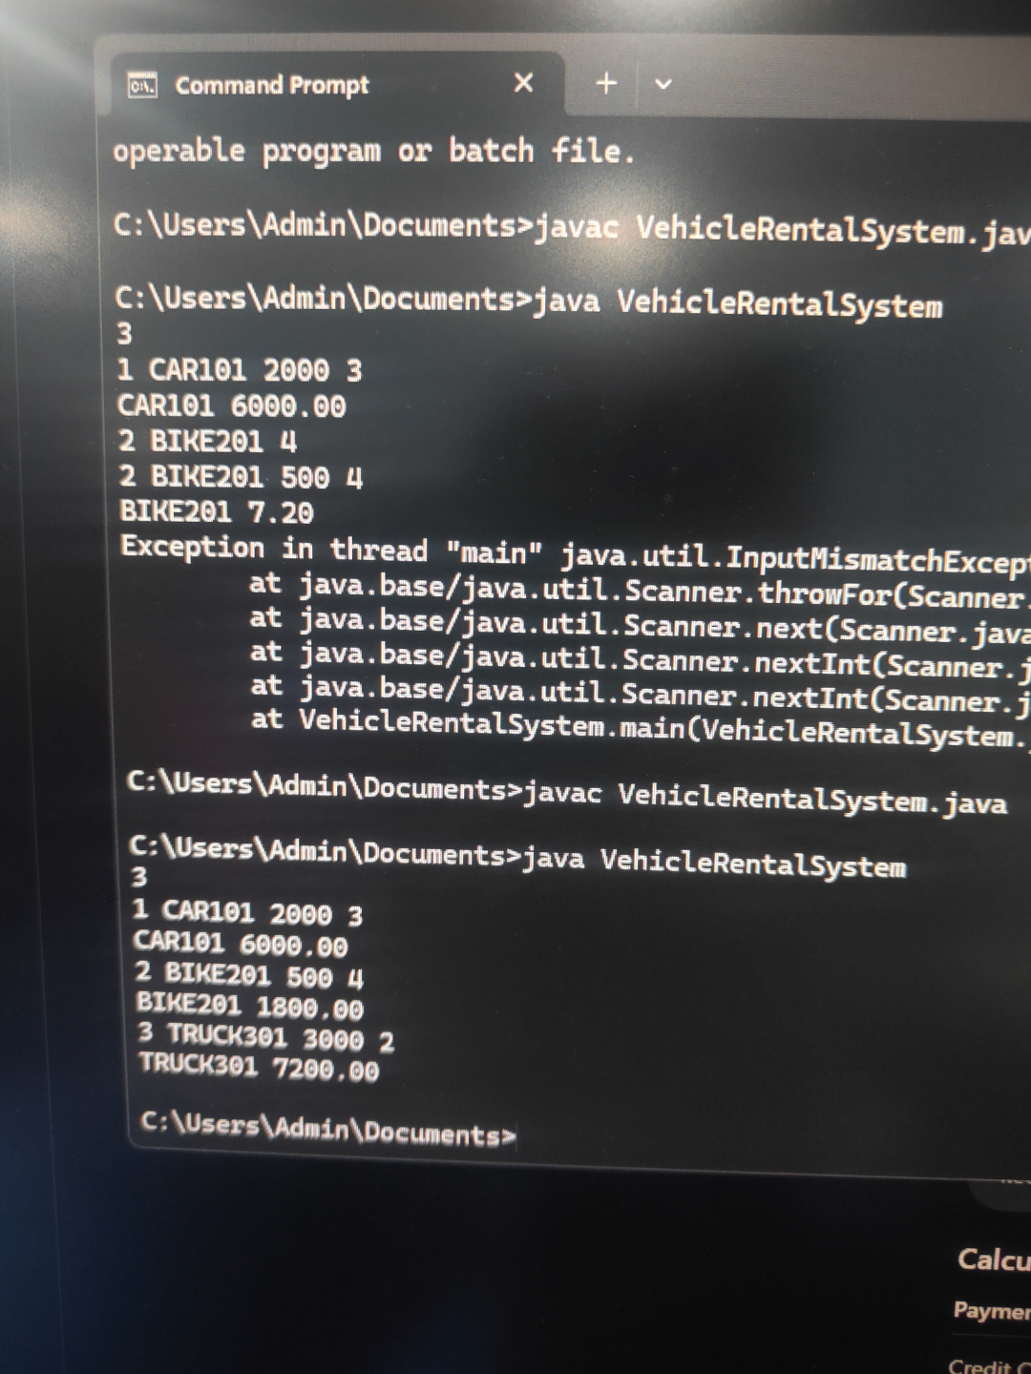
SESSION 4 INTERFACE -BASED AND ABSTRACT DESIGN.﻿
PROGRAM.﻿
import java.util.*;﻿
interface Payment {﻿
void pay(double amount);﻿
}﻿
class CreditCardPayment implements Payment {﻿
public void pay(double amount) {﻿
System.out.println("Credit Card payment: " + amount);﻿
}﻿
}﻿
class UPIPayment implements Payment {﻿
public void pay(double amount) {﻿
System.out.println("UPI payment: " + amount);﻿
}﻿
}﻿
class NetBankingPayment implements Payment {﻿
public void pay(double amount) {﻿
System.out.println("Net Banking payment: " + amount);﻿
}﻿
}﻿
abstract class PaymentProcessor {﻿
abstract double processPayment(Payment payment, double amount);﻿
}﻿
class OnlinePaymentProcessor extends PaymentProcessor {﻿
@Override﻿
double processPayment(Payment payment, double amount) {﻿
if (payment instanceof CreditCardPayment) {﻿
return amount * 1.02;﻿
} ﻿
else if (payment instanceof UPIPayment) {﻿
return amount * 1.01;﻿
} ﻿
else if (payment instanceof NetBankingPayment) {﻿
return amount * 1.015;﻿
}﻿
return amount;﻿
}﻿
}﻿
public class PaymentProcessingSystem {﻿
public static void main(String[] args) {﻿
Scanner sc = new Scanner(System.in);﻿
int N = sc.nextInt();﻿
PaymentProcessor processor = new OnlinePaymentProcessor();﻿
for (int i = 0; i < N; i++) {﻿
int paymentType = sc.nextInt();﻿
double amount = sc.nextDouble();﻿
Payment payment;﻿
String paymentName;﻿
if (paymentType == 1) {﻿
payment = new CreditCardPayment();﻿
paymentName = "CreditCard";﻿
} ﻿
else if (paymentType == 2) {﻿
payment = new UPIPayment();﻿
paymentName = "UPI";﻿
} ﻿
else {﻿
payment = new NetBankingPayment();﻿
paymentName = "NetBanking";﻿
}﻿
double finalAmount =﻿
processor.processPayment(payment, amount);﻿
System.out.printf("%s %.2f%n",﻿
paymentName, finalAmount);﻿
}﻿
sc.close();﻿
}﻿
}﻿
OUTPUT.
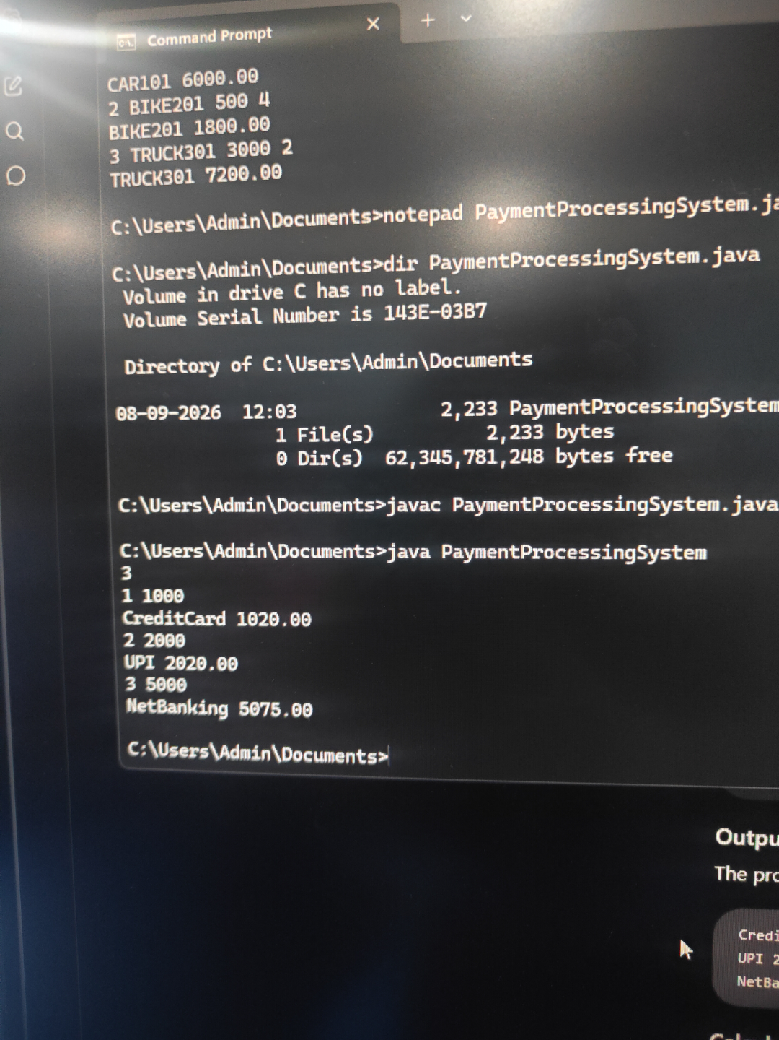
SESSION 5 JAVA EXCEPTION HANDLING TRY CATCH ﻿
PROGRAM.﻿
import java.util.*;﻿
public class Solution {﻿
public static void main(String[] args) {﻿
Scanner sc = new Scanner(System.in);﻿
try {﻿
int x = sc.nextInt();﻿
int y = sc.nextInt();﻿
System.out.println(x / y);﻿
}﻿
catch (InputMismatchException e) {﻿
System.out.println("java.util.InputMismatchException");﻿
}﻿
catch (ArithmeticException e) {﻿
System.out.println("java.lang.ArithmeticException: / by zero");﻿
}﻿
sc.close();﻿
}﻿
}﻿
OUTPUT.



