WEEK--13
SESSION -1 ﻿
TASK -1 BLACK BOX TESTING ﻿
PROGRAM ﻿
public class BlackBoxTest {﻿
static double calculate(double a, double b, String op) {﻿
switch (op) {﻿
case "add":﻿
return a + b;﻿
case "subtract":﻿
return a - b;﻿
case "divide":﻿
if (b == 0) {﻿
throw new ArithmeticException("Division by zero");﻿
}﻿
return a / b;﻿
default:﻿
throw new IllegalArgumentException("Invalid operation");﻿
}﻿
}﻿
static void test(String id, double a, double b, String op) {﻿
System.out.print(id + ": ");﻿
try {﻿
System.out.println(calculate(a, b, op));﻿
} catch (ArithmeticException e) {﻿
System.out.println("Error: " + e.getMessage());﻿
}﻿
}﻿
public static void main(String[] args) {﻿
System.out.println("BLACK-BOX TESTING - CALCULATOR");﻿
test("TC01 Addition", 10, 5, "add");﻿
test("TC02 Addition", -10, 5, "add");﻿
test("TC03 Addition", 0, 0, "add");﻿
test("TC04 Subtraction", 10, 5, "subtract");﻿
test("TC05 Subtraction", 5, 10, "subtract");﻿
test("TC06 Subtraction", 0, 0, "subtract");﻿
test("TC07 Division", 10, 2, "divide");﻿
test("TC08 Division", 7, 2, "divide");﻿
test("TC09 Division", -10, 2, "divide");﻿
test("TC10 Division", 10, 0, "divide");﻿
test("TC11 Division", 0, 5, "divide");﻿
test("TC12 Division", 0, 0, "divide");﻿
}﻿
}﻿
OUTPUT
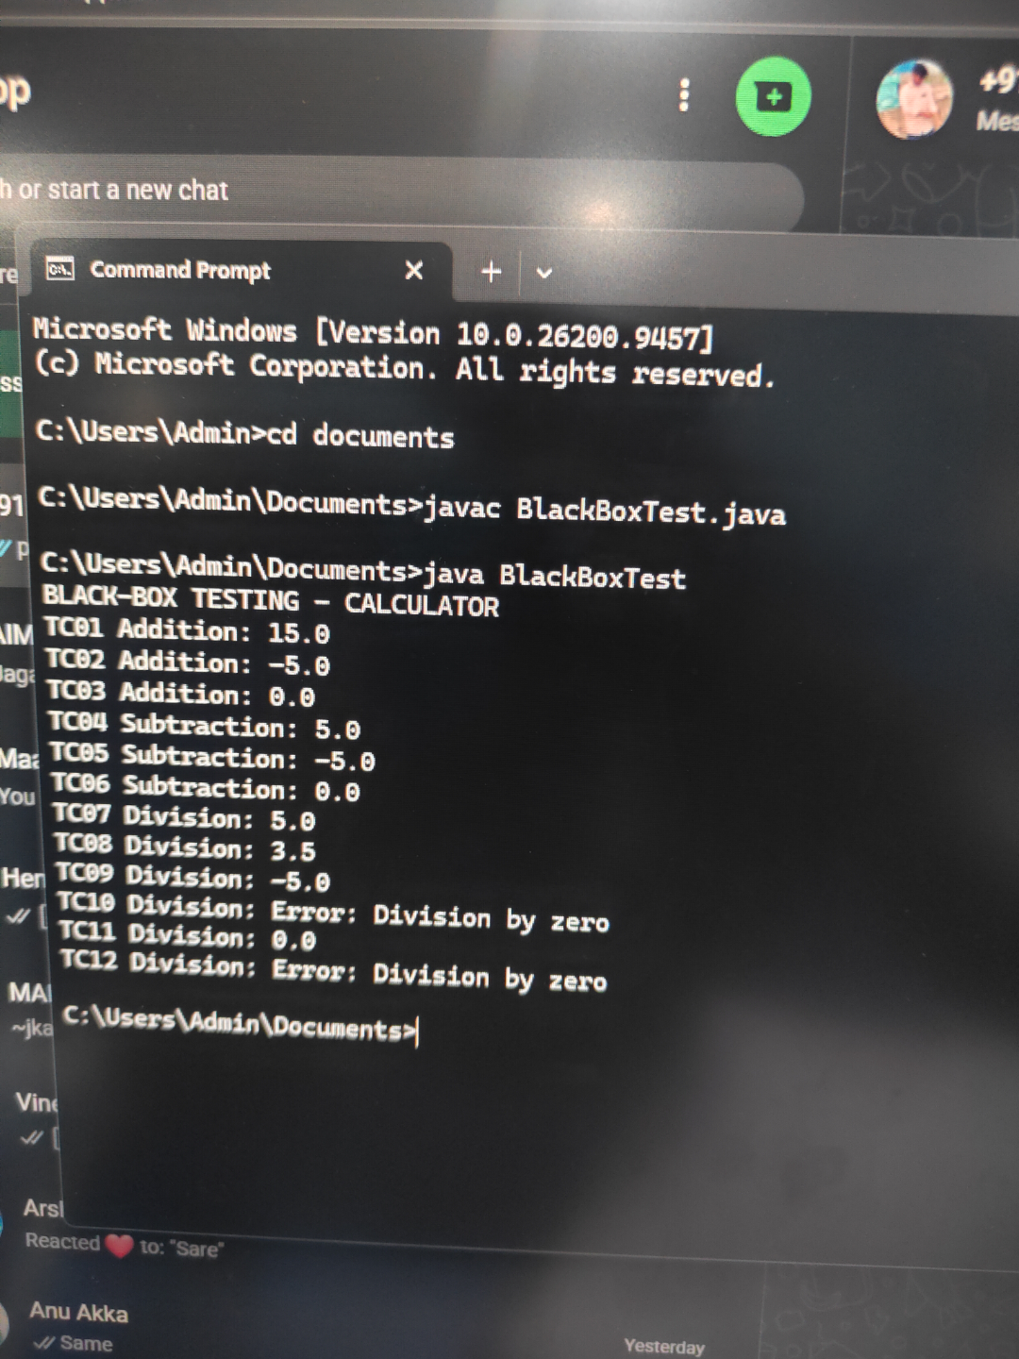
TASK -2 WHITE BOX TESTING ﻿
PROGRAM ﻿
public class WhiteBoxTest {﻿
static int countPositive(int[] numbers) {﻿
int count = 0;﻿
for (int num : numbers) {﻿
if (num > 0) {﻿
count++;﻿
} else {﻿
System.out.println("Non-positive number: " + num);﻿
}﻿
}﻿
return count;﻿
}﻿
static void test(String id, int[] numbers) {﻿
System.out.println("\n" + id);﻿
int result = countPositive(numbers);﻿
System.out.println("Positive count: " + result);﻿
}﻿
public static void main(String[] args) {﻿
System.out.println("WHITE-BOX TESTING");﻿
test("WB01 Empty array", new int[]{});﻿
test("WB02 Positive number", new int[]{5});﻿
test("WB03 Negative number", new int[]{-3});﻿
test("WB04 Mixed numbers", new int[]{1, -2, 3});﻿
test("WB05 Zero", new int[]{0});﻿
test("WB06 Multiple non-positive numbers",﻿
new int[]{-1, 0, -5});﻿
}﻿
}﻿
OUTPUT
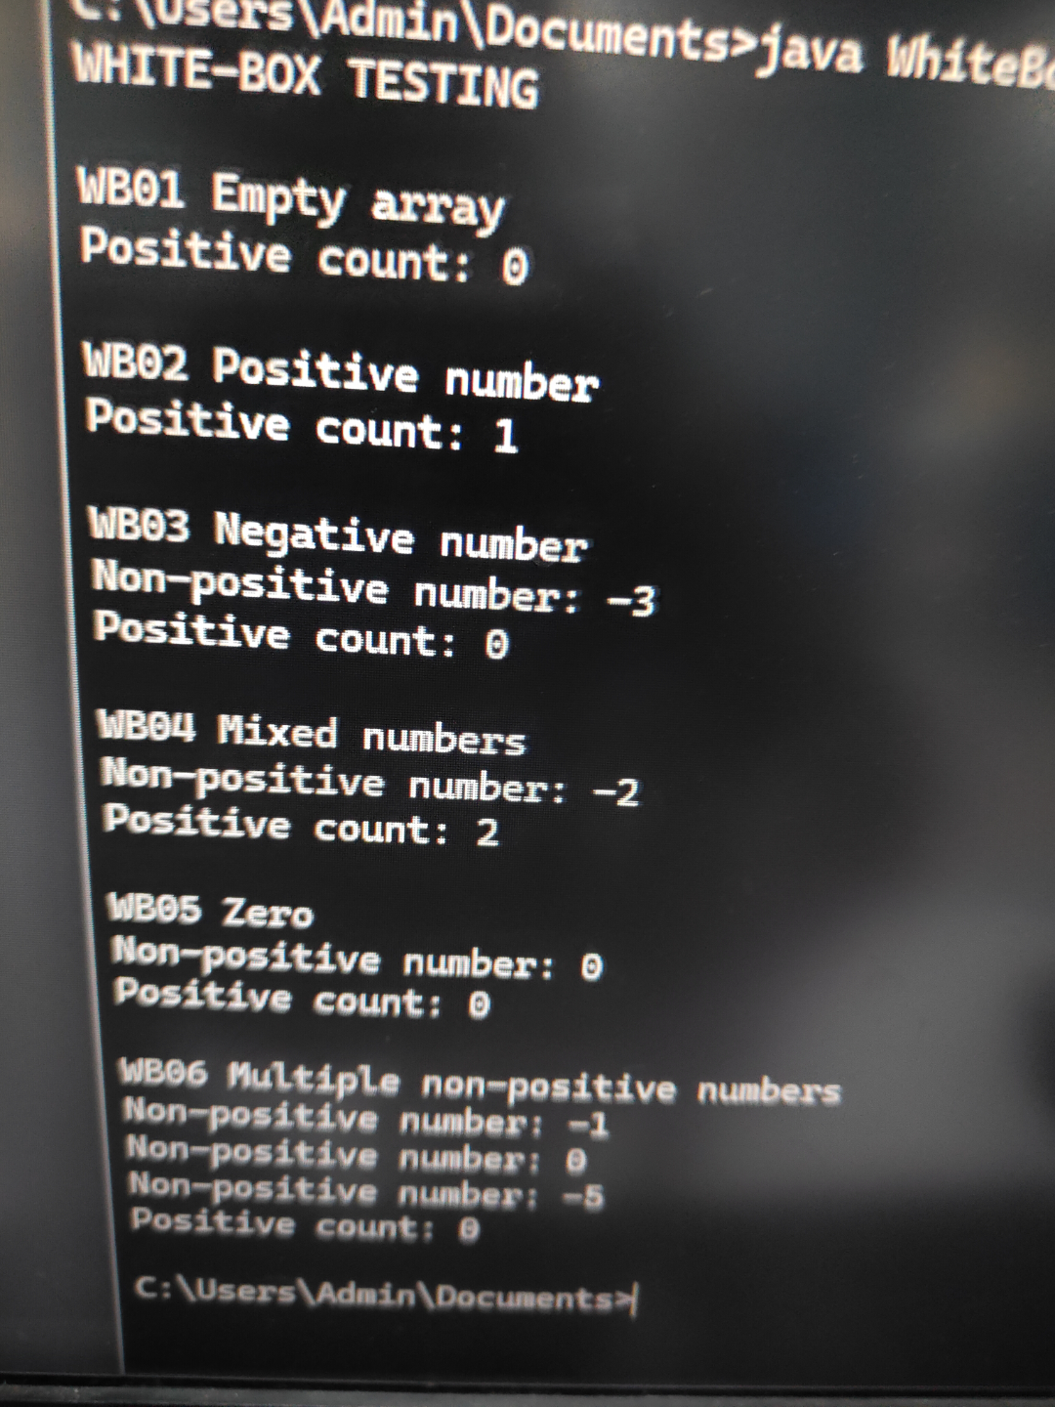
SESSION -2﻿
TASK -1 SIMPLE MATH TEST.﻿
PROGRAM ﻿
public class SimpleMath {﻿
public int add(int a, int b) {﻿
return a + b;﻿
}﻿
public int subtract(int a, int b) {﻿
return a - b;﻿
}﻿
public int multiply(int a, int b) {﻿
return a * b;﻿
}﻿
public int divide(int a, int b) {﻿
if (b == 0) {﻿
throw new ArithmeticException("Cannot divide by zero");﻿
}﻿
return a / b;﻿
}﻿
public static void main(String[] args) {﻿
SimpleMath math = new SimpleMath();﻿
System.out.println("Addition: " + math.add(10, 5));﻿
System.out.println("Subtraction: " + math.subtract(10, 5));﻿
System.out.println("Multiplication: " + math.multiply(10, 5));﻿
System.out.println("Division: " + math.divide(10, 2));﻿
}﻿
}﻿
OUTPUT
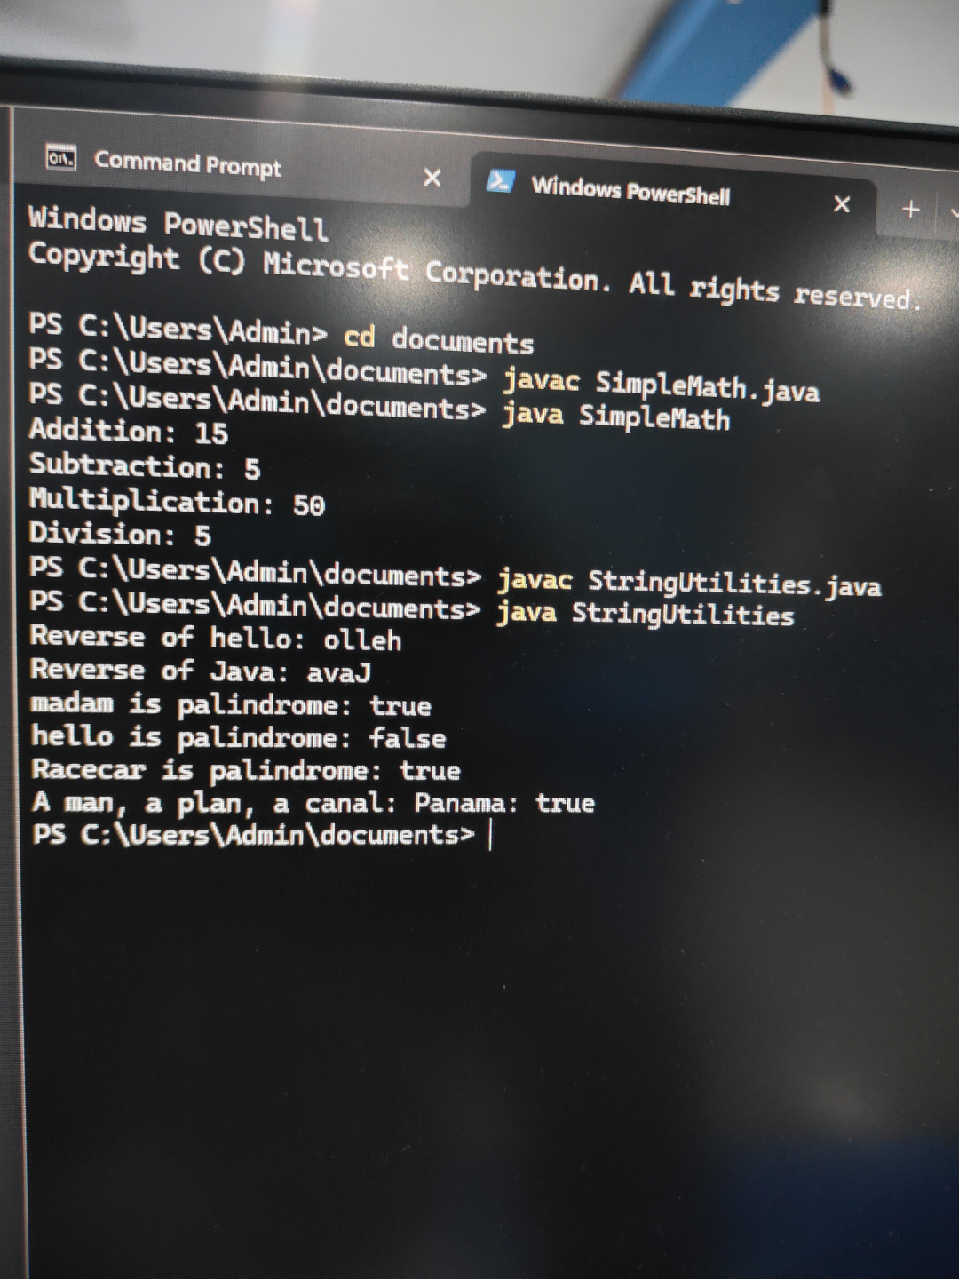
TASK -2﻿
PROGRAM STRIMG UTILITIES.﻿
public class StringUtilities {﻿
public static String reverse(String str) {﻿
return new StringBuilder(str).reverse().toString();﻿
}﻿
public static boolean isPalindrome(String str) {﻿
String cleaned = str.replaceAll("[^a-zA-Z0-9]", "")﻿
.toLowerCase();﻿
return cleaned.equals(reverse(cleaned));﻿
}﻿
public static void main(String[] args) {﻿
System.out.println("Reverse of hello: " + reverse("hello"));﻿
System.out.println("Reverse of Java: " + reverse("Java"));﻿
System.out.println("madam is palindrome: "﻿
+ isPalindrome("madam"));﻿
System.out.println("hello is palindrome: "﻿
+ isPalindrome("hello"));﻿
System.out.println("Racecar is palindrome: "﻿
+ isPalindrome("Racecar"));﻿
System.out.println("A man, a plan, a canal: Panama: "﻿
+ isPalindrome("A man, a plan, a canal: Panama"));﻿
}﻿
}﻿
OUTPUT
SESSION -3﻿
TASK-1 LIST LIFECYCLE ﻿
PROGRAM ﻿
import java.util.ArrayList;﻿
import java.util.List;﻿
public class ListLifecycle {﻿
private List<String> items;﻿
public void initialize() {﻿
items = new ArrayList<>();﻿
System.out.println("Lifecycle: List initialized");﻿
}﻿
public void addElements() {﻿
items.add("Apple");﻿
items.add("Banana");﻿
items.add("Orange");﻿
System.out.println("Elements added: " + items);﻿
}﻿
public void displayElements() {﻿
System.out.println("Current list: " + items);﻿
}﻿
public void clearList() {﻿
items.clear();﻿
System.out.println("List cleared: " + items);﻿
}﻿
public void destroy() {﻿
items = null;﻿
System.out.println("Lifecycle: Object cleanup completed");﻿
}﻿
public static void main(String[] args) {﻿
ListLifecycle obj = new ListLifecycle();﻿
obj.initialize();﻿
obj.addElements();﻿
obj.displayElements();﻿
obj.clearList();﻿
obj.destroy();﻿
}﻿
}﻿
OUTPUT
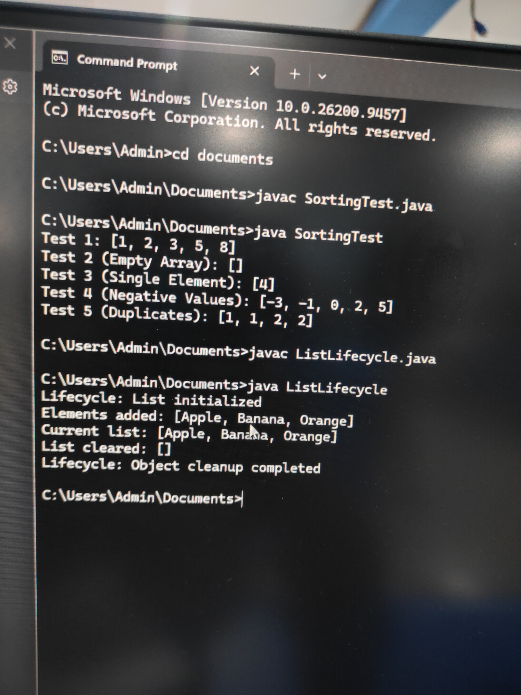
TASK-2 LIFE CYCLE ORDER TEST.﻿
PROGRAM ﻿
public class LifecycleOrderTest {﻿
static int step = 0;﻿
static void initialize() {﻿
System.out.println("Step " + (++step) + ": Initialize");﻿
}﻿
static void setup() {﻿
System.out.println("Step " + (++step) + ": Setup");﻿
}﻿
static void executeTest() {﻿
System.out.println("Step " + (++step) + ": Execute test");﻿
}﻿
static void cleanup() {﻿
System.out.println("Step " + (++step) + ": Cleanup");﻿
}﻿
static void destroy() {﻿
System.out.println("Step " + (++step) + ": Destroy");﻿
}﻿
public static void main(String[] args) {﻿
initialize();﻿
setup();﻿
executeTest();﻿
cleanup();﻿
destroy();﻿
System.out.println("Lifecycle execution completed.");﻿
}﻿
}﻿
OUTPUT
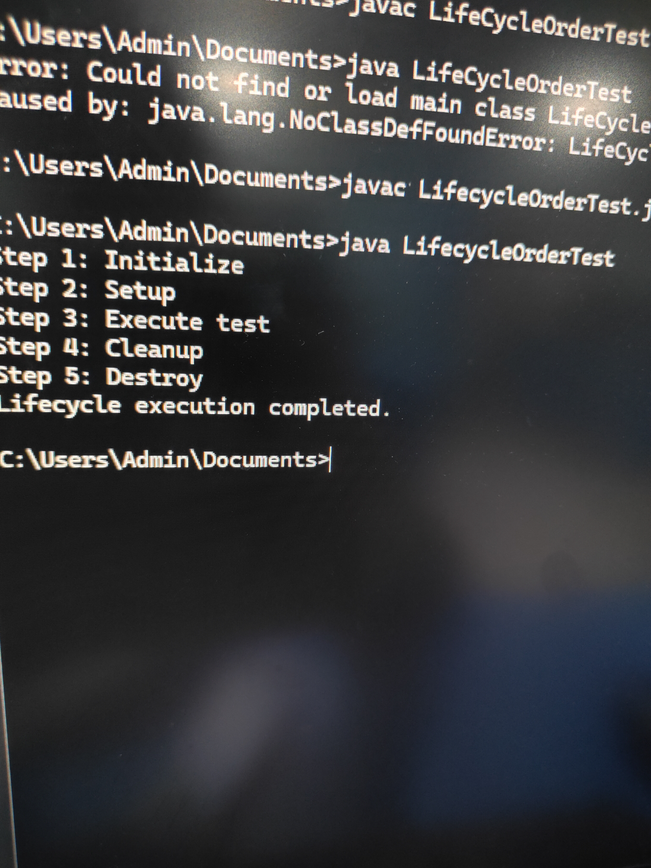
SESSION -4﻿
TASK-1 INPUT VALIDATION TESTING.﻿
PROGRAM ﻿
import java.util.Arrays;﻿
public class InputValidationTest {﻿
static int[] processArray(int[] arr) {﻿
if (arr == null) {﻿
throw new IllegalArgumentException("Input cannot be null");﻿
}﻿
int[] result = arr.clone();﻿
Arrays.sort(result);﻿
return result;﻿
}﻿
public static void main(String[] args) {﻿
﻿
System.out.println("Test 1: Empty Input");﻿
int[] empty = processArray(new int[]{});﻿
System.out.println("Output: " + Arrays.toString(empty));﻿
System.out.println("\nTest 2: Null Input");﻿
try {﻿
processArray(null);﻿
} catch (IllegalArgumentException e) {﻿
System.out.println("Exception: " + e.getMessage());﻿
}﻿
System.out.println("\nTest 3: Single Element");﻿
int[] single = processArray(new int[]{10});﻿
System.out.println("Output: " + Arrays.toString(single));﻿
}﻿
}﻿
OUTPUT
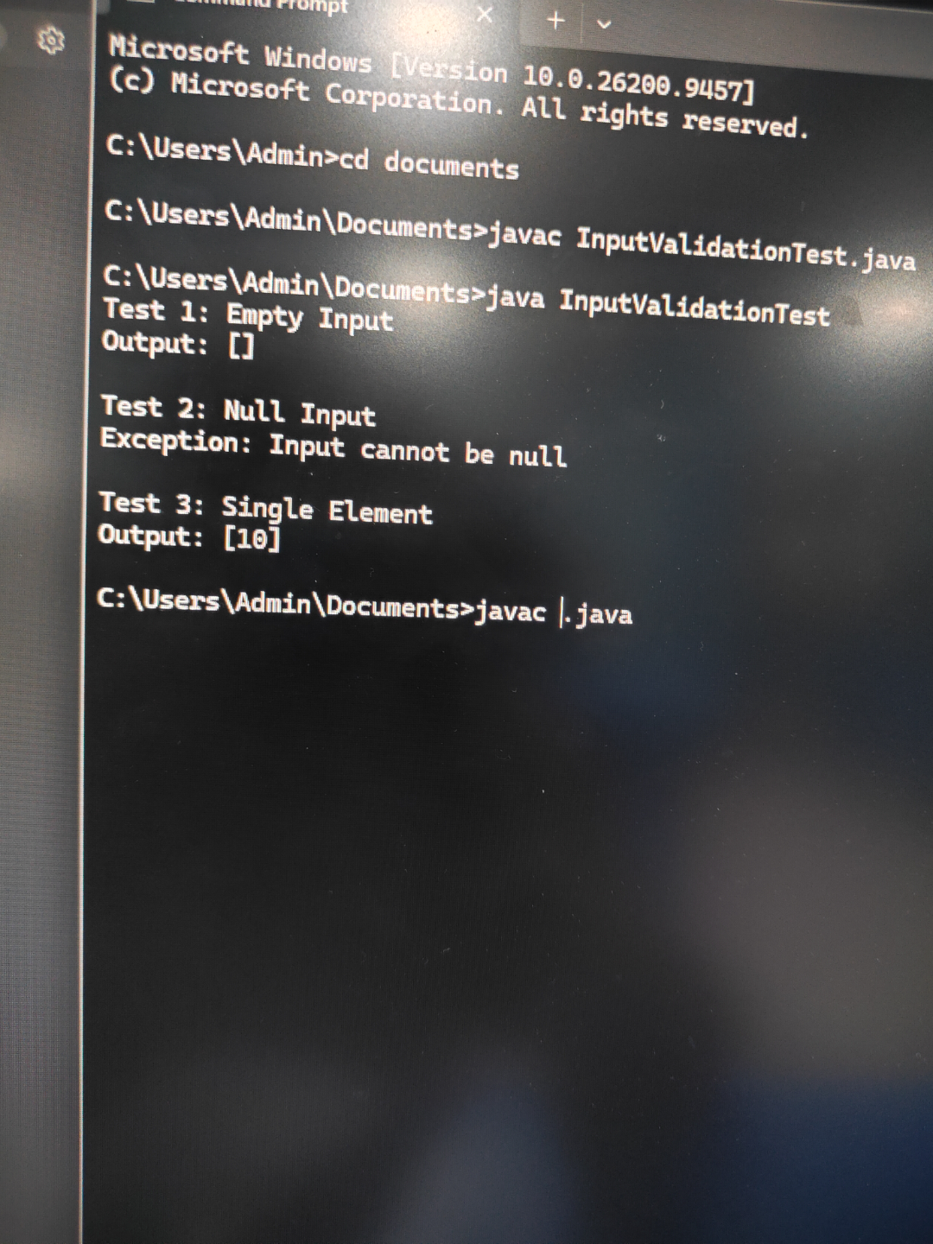
TASK-2 LOGIN TESTING.﻿
PROGRAM ﻿
public class LoginTest {﻿
static boolean login(String username, String password) {﻿
if (username == null || password == null ||﻿
username.trim().isEmpty() ||﻿
password.trim().isEmpty()) {﻿
return false;﻿
}﻿
return username.equals("admin") &&﻿
password.equals("12345");﻿
}﻿
static void test(String id, String username, String password) {﻿
boolean result = login(username, password);﻿
System.out.println(id + ": " +﻿
(result ? "LOGIN SUCCESSFUL" : "LOGIN FAILED"));﻿
}﻿
public static void main(String[] args) {﻿
System.out.println("LOGIN SYSTEM TESTING\n");﻿
test("TC01 Valid credentials", "admin", "12345");﻿
test("TC02 Invalid username", "user", "12345");﻿
test("TC03 Invalid password", "admin", "wrong");﻿
test("TC04 Both invalid", "user", "wrong");﻿
test("TC05 Blank username", "", "12345");﻿
test("TC06 Blank password", "admin", "");﻿
test("TC07 Both blank", "", "");﻿
test("TC08 Null username", null, "12345");﻿
test("TC09 Null password", "admin", null);﻿
test("TC10 Whitespace username", " ", "12345");﻿
}﻿
}﻿
OUTPUT
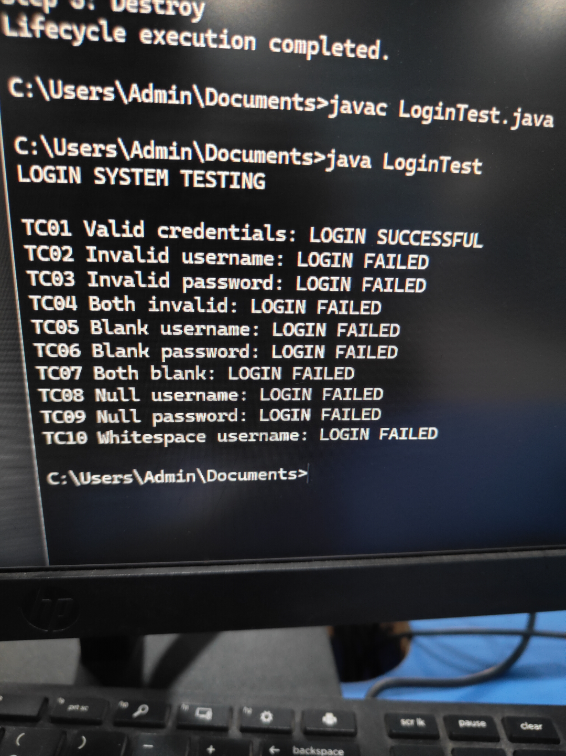
SESSION -5﻿
TASK -1 LARGE ARRAY SORTING TESTING.﻿
PROGRAM ﻿
import java.util.Arrays;﻿
import java.util.Random;﻿
public class LargeArraySortingTest {﻿
public static void main(String[] args) {﻿
int size = 100000;﻿
int[] arr = new int[size];﻿
Random random = new Random(42);﻿
for (int i = 0; i < size; i++) {﻿
arr[i] = random.nextInt(1000000);﻿
}﻿
System.out.println("Array size: " + size);﻿
Arrays.sort(arr);﻿
boolean sorted = true;﻿
for (int i = 1; i < size; i++) {﻿
if (arr[i] < arr[i - 1]) {﻿
sorted = false;﻿
break;﻿
}﻿
}﻿
System.out.println("Sorting successful: " + sorted);﻿
System.out.println("First 10 sorted elements:");﻿
for (int i = 0; i < 10; i++) {﻿
System.out.print(arr[i] + " ");﻿
}﻿
System.out.println();﻿
}﻿
}﻿
OUTPUT
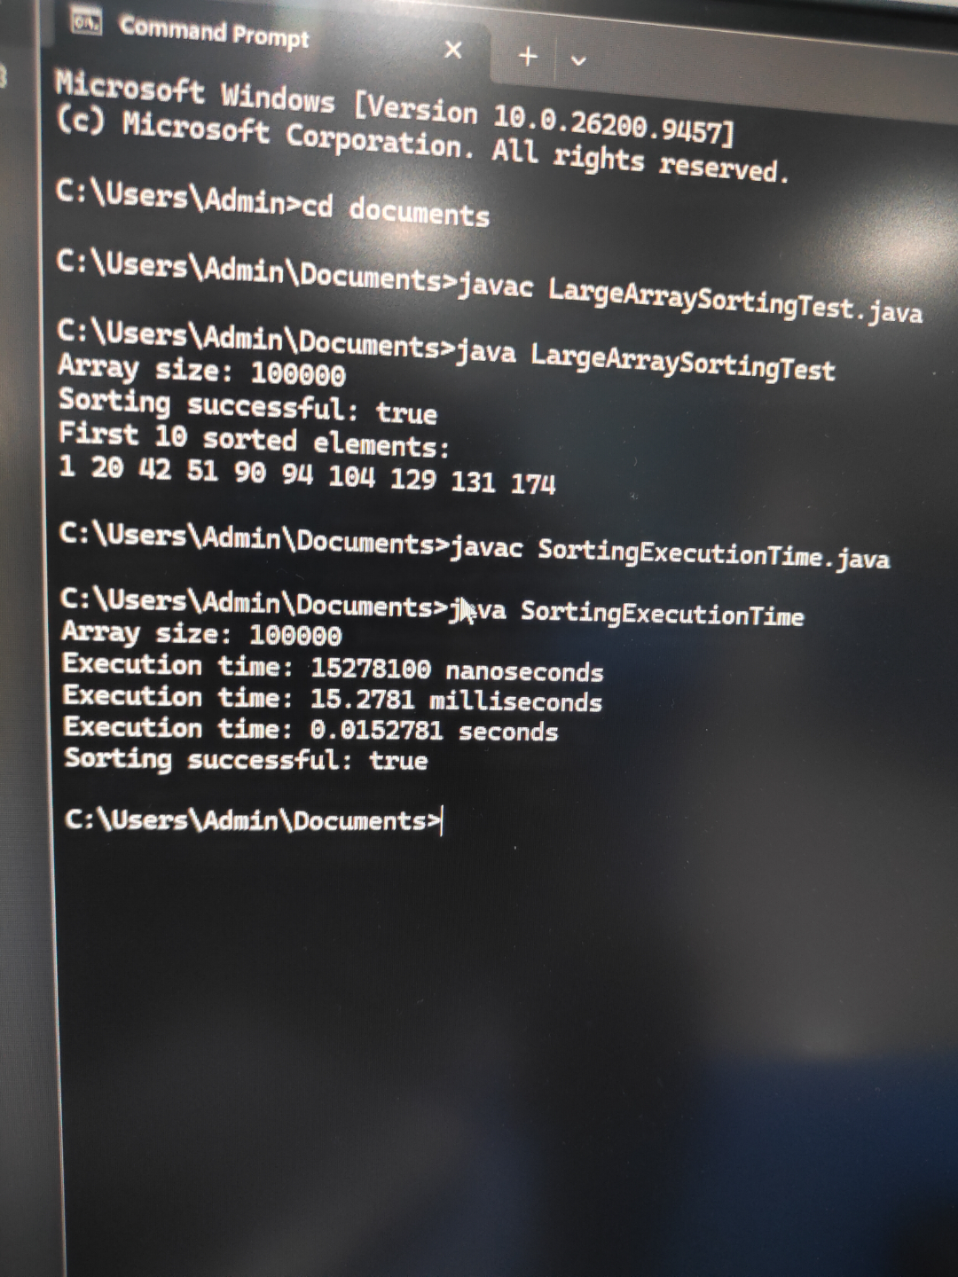
TASK -2 SORTING EXECUTION TEST.﻿
PROGRAM ﻿
import java.util.Arrays;﻿
import java.util.Random;﻿
public class SortingExecutionTime {﻿
public static void main(String[] args) {﻿
int size = 100000;﻿
int[] arr = new int[size];﻿
Random random = new Random(42);﻿
for (int i = 0; i < size; i++) {﻿
arr[i] = random.nextInt(1000000);﻿
}﻿
long startTime = System.nanoTime();﻿
Arrays.sort(arr);﻿
long endTime = System.nanoTime();﻿
long elapsedTime = endTime - startTime;﻿
System.out.println("Array size: " + size);﻿
System.out.println("Execution time: " + elapsedTime + " nanoseconds");﻿
System.out.println("Execution time: " +﻿
(elapsedTime / 1_000_000.0) + " milliseconds");﻿
System.out.println("Execution time: " +﻿
(elapsedTime / 1_000_000_000.0) + " seconds");﻿
boolean sorted = true;﻿
for (int i = 1; i < size; i++) {﻿
if (arr[i] < arr[i - 1]) {﻿
sorted = false;﻿
break;﻿
}﻿
}﻿
System.out.println("Sorting successful: " + sorted);﻿
}﻿
}﻿
OUTPUT



