WEEK--10
SESSION 1 Java Collections Framework Overview﻿
TASK 1: RUNNING SUM OF 1 D ARRAY﻿
PROGRAM.﻿
class Solution {﻿
public int[] runningSum(int[] nums) {﻿
for (int i = 1; i < nums.length; i++) {﻿
nums[i] = nums[i] + nums[i - 1];﻿
}﻿
return nums;﻿
}﻿
}﻿
OUTPUT.
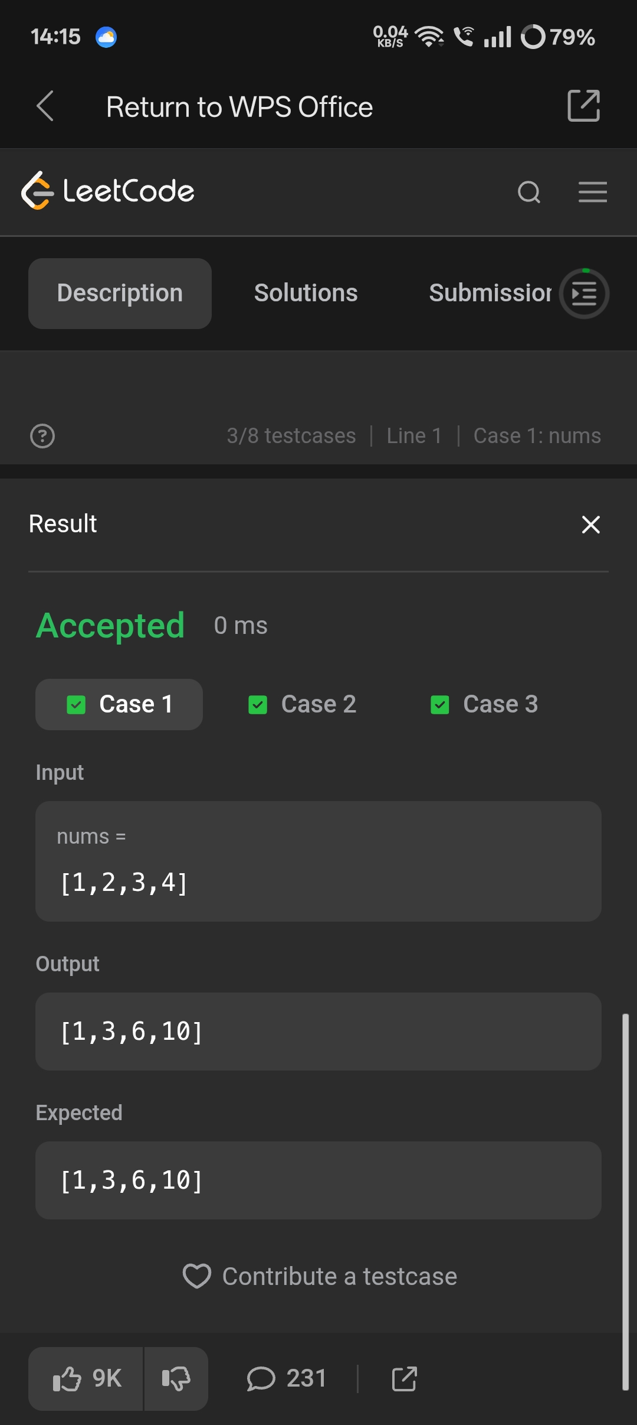
TASK 2: PHONE BOOK ﻿
PROGRAM.﻿
import java.util.*;﻿
public class Solution {﻿
public static void main(String[] args) {﻿
Scanner sc = new Scanner(System.in);﻿
int n = sc.nextInt();﻿
sc.nextLine();﻿
HashMap<String, String> phoneBook = new HashMap<>();﻿
for (int i = 0; i < n; i++) {﻿
String name = sc.next();﻿
String phone = sc.next();﻿
phoneBook.put(name, phone);﻿
}﻿
while (sc.hasNext()) {﻿
String name = sc.next();﻿
if (phoneBook.containsKey(name)) {﻿
System.out.println(name + "=" + phoneBook.get(name));﻿
} else {﻿
System.out.println("Not found");﻿
}﻿
}﻿
sc.close();﻿
}﻿
}﻿
OUTPUT.
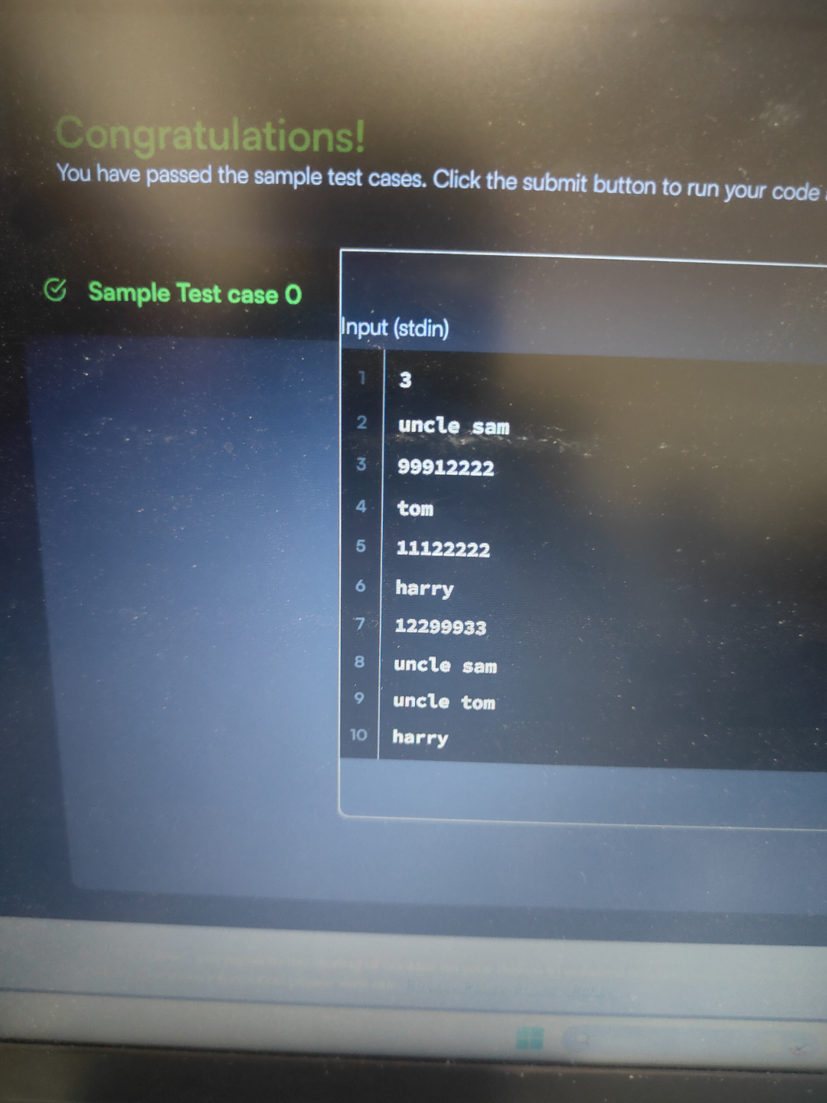
SESSION 2 ARRAYLIST - BASIC OPERATIONS.﻿
TASK 1: find all numbers disappeared in an array.﻿
PROGRAM.﻿
import java.util.*;﻿
class Solution {﻿
public List<Integer> findDisappearedNumbers(int[] nums) {﻿
List<Integer> result = new ArrayList<>();﻿
for (int i = 0; i < nums.length; i++) {﻿
int index = Math.abs(nums[i]) - 1;﻿
nums[index] = -Math.abs(nums[index]);﻿
}﻿
for (int i = 0; i < nums.length; i++) {﻿
if (nums[i] > 0) {﻿
result.add(i + 1);﻿
}﻿
}﻿
return result;﻿
}﻿
}﻿
OUTPUT.
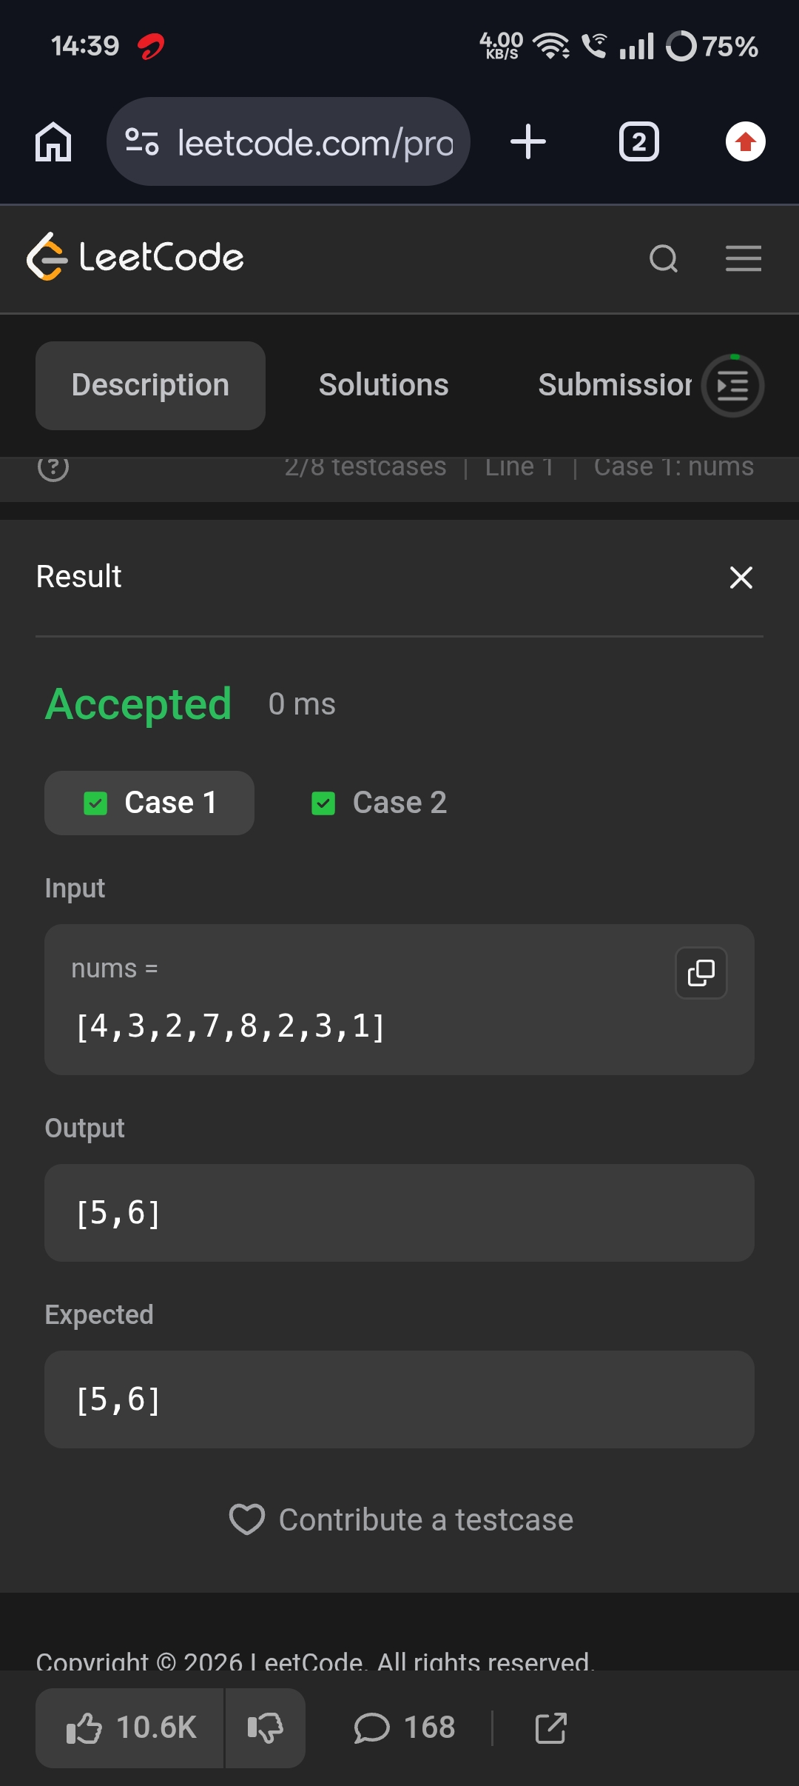
TASK 2: sort colors.﻿
PROGRAM.﻿
class Solution {﻿
public void sortColors(int[] nums) {﻿
int low = 0;﻿
int mid = 0;﻿
int high = nums.length - 1;﻿
while (mid <= high) {﻿
if (nums[mid] == 0) {﻿
int temp = nums[low];﻿
nums[low] = nums[mid];﻿
nums[mid] = temp;﻿
low++;﻿
mid++;﻿
}﻿
else if (nums[mid] == 1) {﻿
mid++;﻿
}﻿
else {﻿
int temp = nums[mid];﻿
nums[mid] = nums[high];﻿
nums[high] = temp;﻿
high--;﻿
}﻿
}﻿
}﻿
}﻿
OUTPUT.
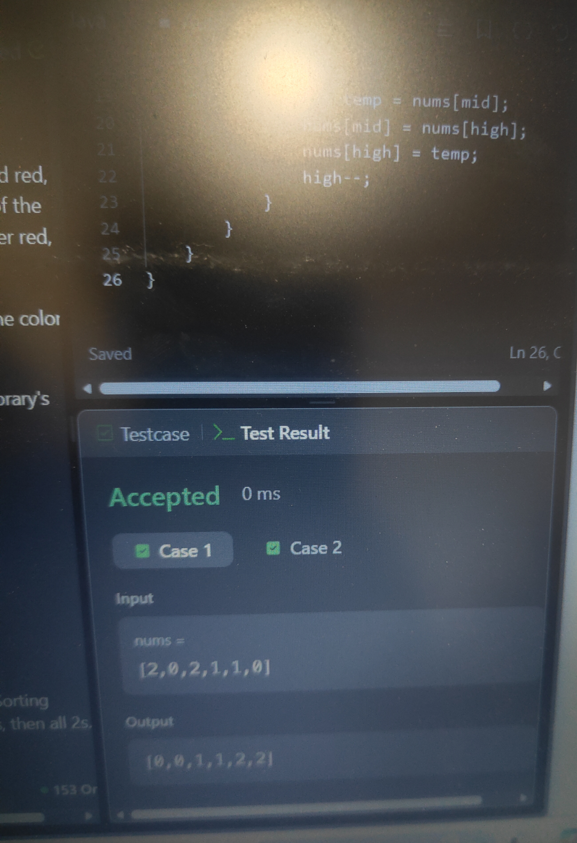
SESSION 3 LINKEDLIST QUEUE & DEQUEUE USAGES.﻿
TASK 1: design linked list.﻿
PROGRAM.﻿
class MyLinkedList {﻿
class Node {﻿
int val;﻿
Node next;﻿
Node(int val) {﻿
this.val = val;﻿
}﻿
}﻿
Node head;﻿
int size;﻿
public MyLinkedList() {﻿
head = null;﻿
size = 0;﻿
}﻿
public int get(int index) {﻿
if (index < 0 || index >= size) {﻿
return -1;﻿
}﻿
Node current = head;﻿
for (int i = 0; i < index; i++) {﻿
current = current.next;﻿
}﻿
return current.val;﻿
}﻿
public void addAtHead(int val) {﻿
Node newNode = new Node(val);﻿
newNode.next = head;﻿
head = newNode;﻿
size++;﻿
}﻿
public void addAtTail(int val) {﻿
Node newNode = new Node(val);﻿
if (head == null) {﻿
head = newNode;﻿
} else {﻿
Node current = head;﻿
while (current.next != null) {﻿
current = current.next;﻿
}﻿
current.next = newNode;﻿
}﻿
size++;﻿
}﻿
public void addAtIndex(int index, int val) {﻿
if (index < 0 || index > size) {﻿
return;﻿
}﻿
if (index == 0) {﻿
addAtHead(val);﻿
return;﻿
}﻿
Node current = head;﻿
for (int i = 0; i < index - 1; i++) {﻿
current = current.next;﻿
}﻿
Node newNode = new Node(val);﻿
newNode.next = current.next;﻿
current.next = newNode;﻿
size++;﻿
}﻿
public void deleteAtIndex(int index) {﻿
if (index < 0 || index >= size) {﻿
return;﻿
}﻿
if (index == 0) {﻿
head = head.next;﻿
size--;﻿
return;﻿
}﻿
Node current = head;﻿
for (int i = 0; i < index - 1; i++) {﻿
current = current.next;﻿
}﻿
current.next = current.next.next;﻿
size--;﻿
}﻿
}﻿
OUTPUT.
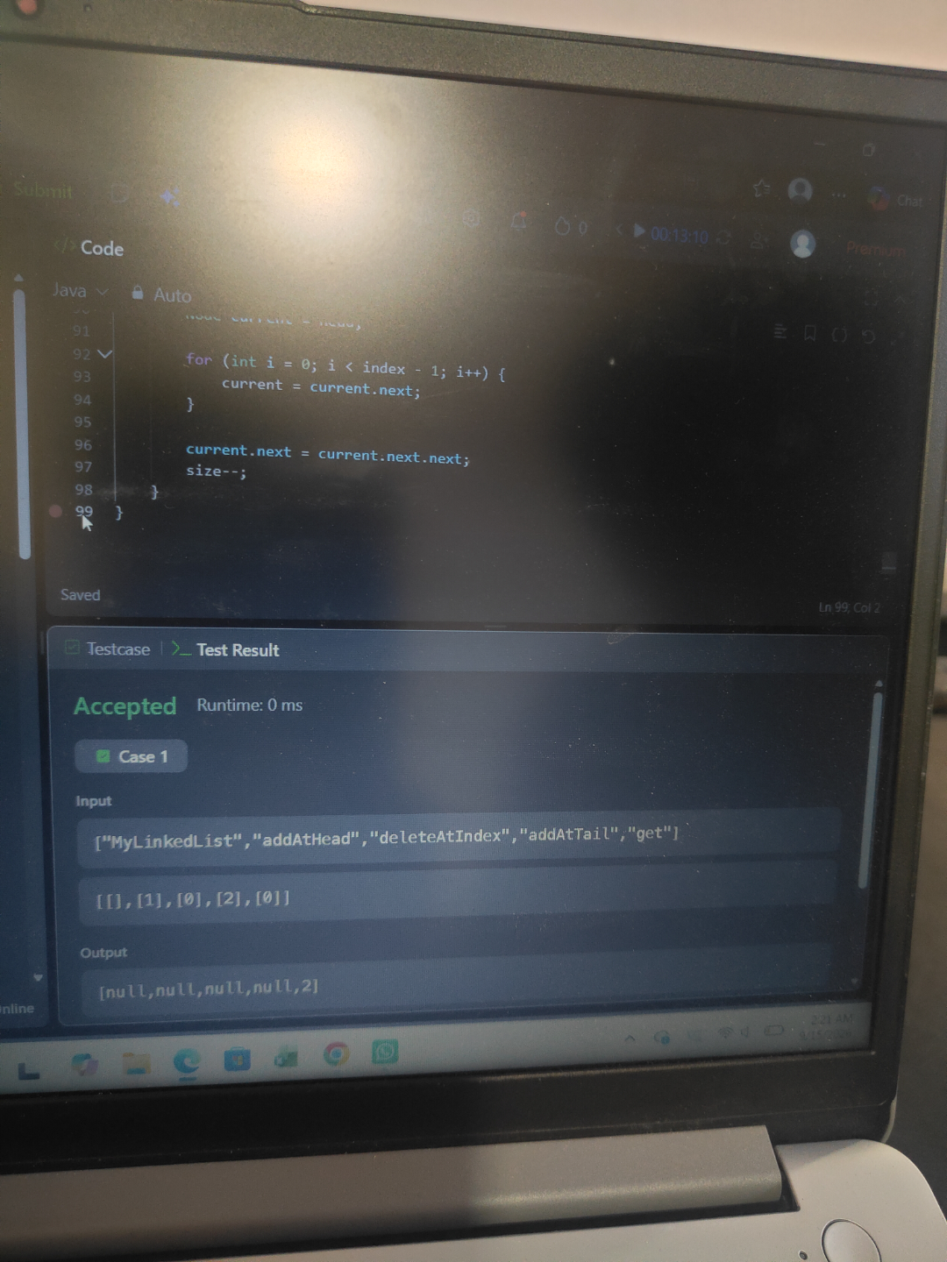
TASK 2: implement queue using stack.﻿
PROGRAM.﻿
import java.util.Stack;﻿
class MyQueue {﻿
Stack<Integer> s1 = new Stack<>();﻿
Stack<Integer> s2 = new Stack<>();﻿
public MyQueue() {﻿
}﻿
public void push(int x) {﻿
s1.push(x);﻿
}﻿
public int pop() {﻿
while (!s1.isEmpty()) {﻿
s2.push(s1.pop());﻿
}﻿
int value = s2.pop();﻿
while (!s2.isEmpty()) {﻿
s1.push(s2.pop());﻿
}﻿
return value;﻿
}﻿
public int peek() {﻿
while (!s1.isEmpty()) {﻿
s2.push(s1.pop());﻿
}﻿
int value = s2.peek();﻿
while (!s2.isEmpty()) {﻿
s1.push(s2.pop());﻿
}﻿
return value;﻿
}﻿
public boolean empty() {﻿
return s1.isEmpty();﻿
}﻿
}﻿
OUTPUT.
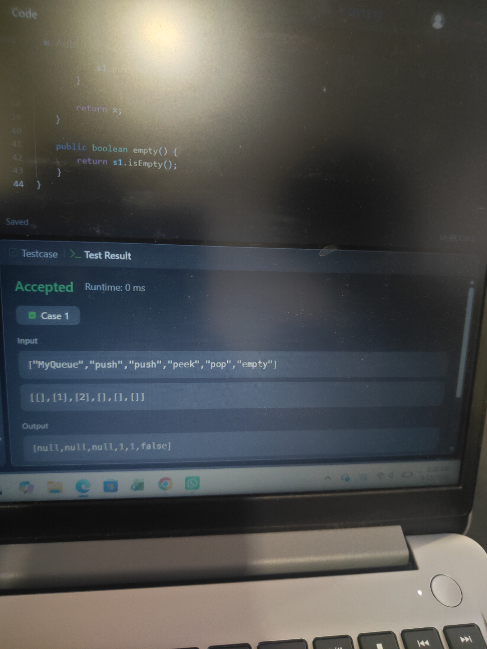
SESSION 4 VECTOR AND STACK.﻿
TASK 1: valid paranthesis﻿
PROGRAM.﻿
import java.util.*;﻿
class Solution {﻿
public boolean isValid(String s) {﻿
Stack<Character> stack = new Stack<>();﻿
for (char c : s.toCharArray()) {﻿
if (c == '(' || c == '{' || c == '[') {﻿
stack.push(c);﻿
}﻿
else {﻿
if (stack.isEmpty()) {﻿
return false;﻿
}﻿
char top = stack.pop();﻿
if (c == ')' && top != '(' ||﻿
c == '}' && top != '{' ||﻿
c == ']' && top != '[') {﻿
return false;﻿
}﻿
}﻿
}﻿
return stack.isEmpty();﻿
}﻿
}﻿
OUTPUT.
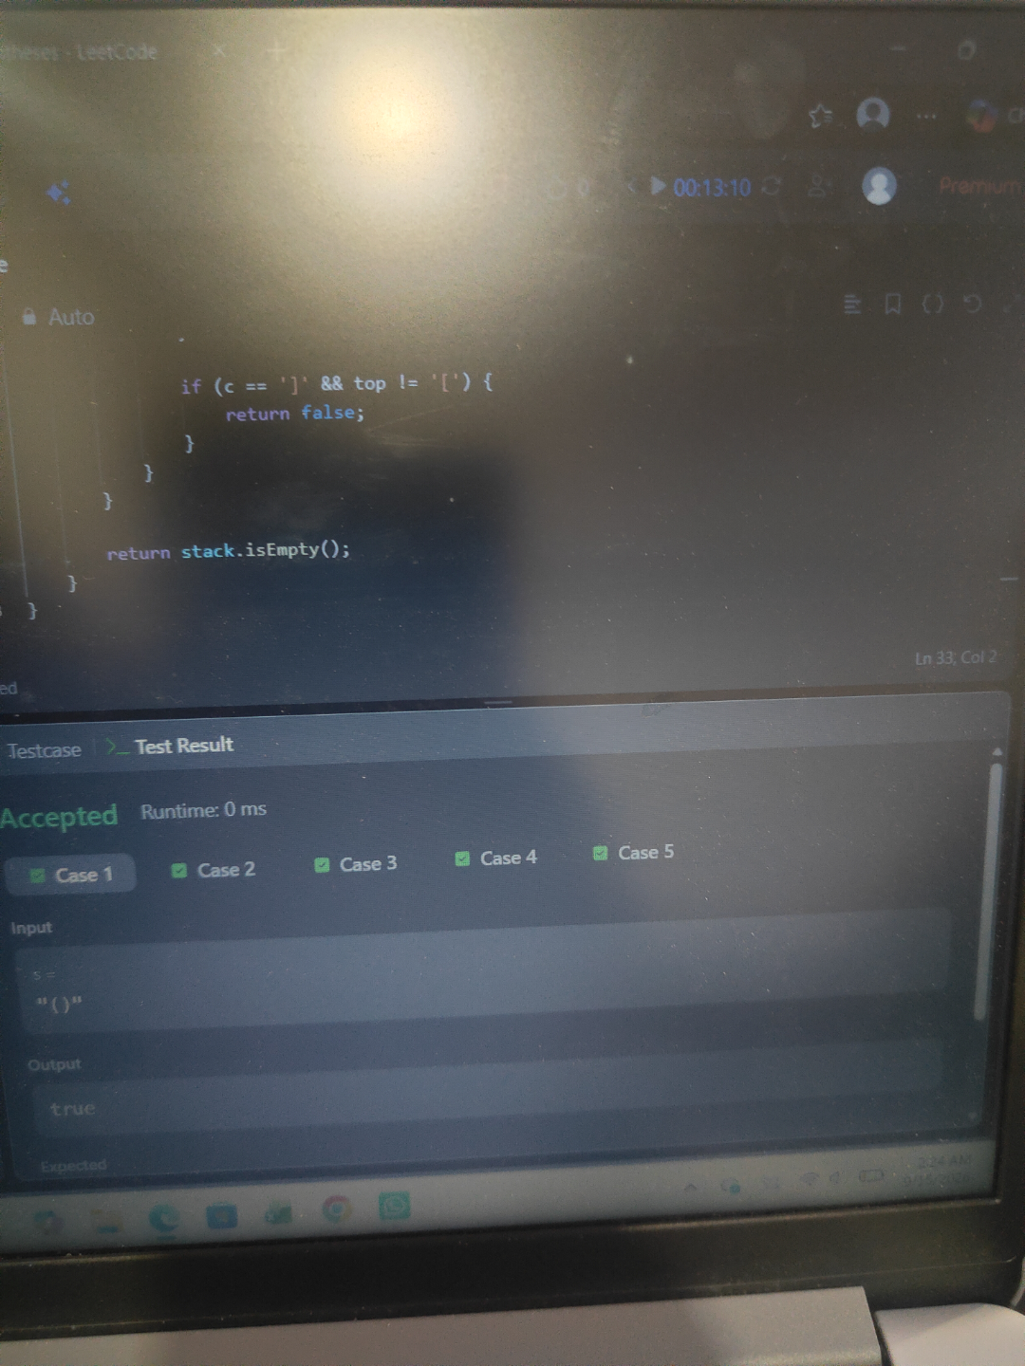
TASK 2: min stack.﻿
PROGRAM.﻿
import java.util.*;﻿
class MinStack {﻿
Stack<Integer> stack = new Stack<>();﻿
Stack<Integer> minStack = new Stack<>();﻿
public MinStack() {﻿
}﻿
public void push(int val) {﻿
stack.push(val);﻿
if (minStack.isEmpty() || val <= minStack.peek()) {﻿
minStack.push(val);﻿
}﻿
}﻿
public void pop() {﻿
if (stack.peek().equals(minStack.peek())) {﻿
minStack.pop();﻿
}﻿
stack.pop();﻿
}﻿
public int top() {﻿
return stack.peek();﻿
}﻿
public int getMin() {﻿
return minStack.peek();﻿
}﻿
}﻿
OUTPUT.
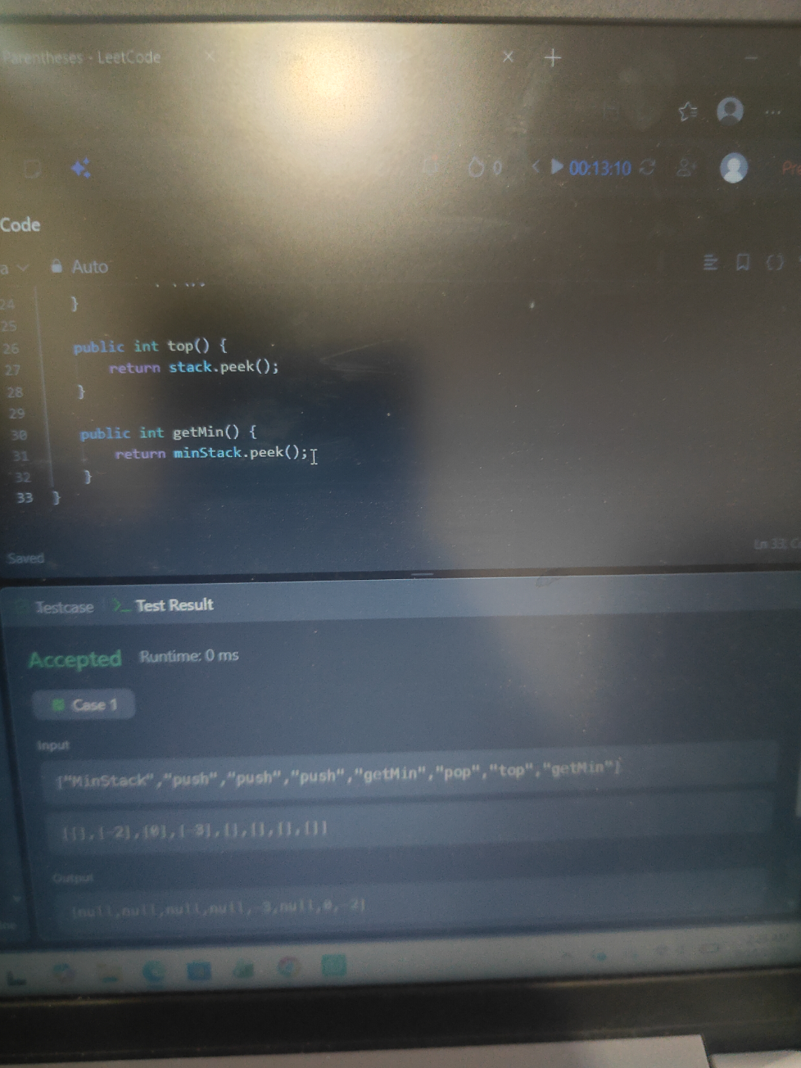
SESSION 5 ARRAYS UTILITY CLASS.﻿
TASK 1: merge sorted array.﻿
PROGRAM.﻿
class Solution {﻿
public void merge(int[] nums1, int m, int[] nums2, int n) {﻿
int i = m - 1;﻿
int j = n - 1;﻿
int k = m + n - 1;﻿
while (i >= 0 && j >= 0) {﻿
if (nums1[i] > nums2[j]) {﻿
nums1[k] = nums1[i];﻿
i--;﻿
} else {﻿
nums1[k] = nums2[j];﻿
j--;﻿
}﻿
k--;﻿
}﻿
while (j >= 0) {﻿
nums1[k] = nums2[j];﻿
j--;﻿
k--;﻿
}﻿
}﻿
}﻿
OUTPUT.
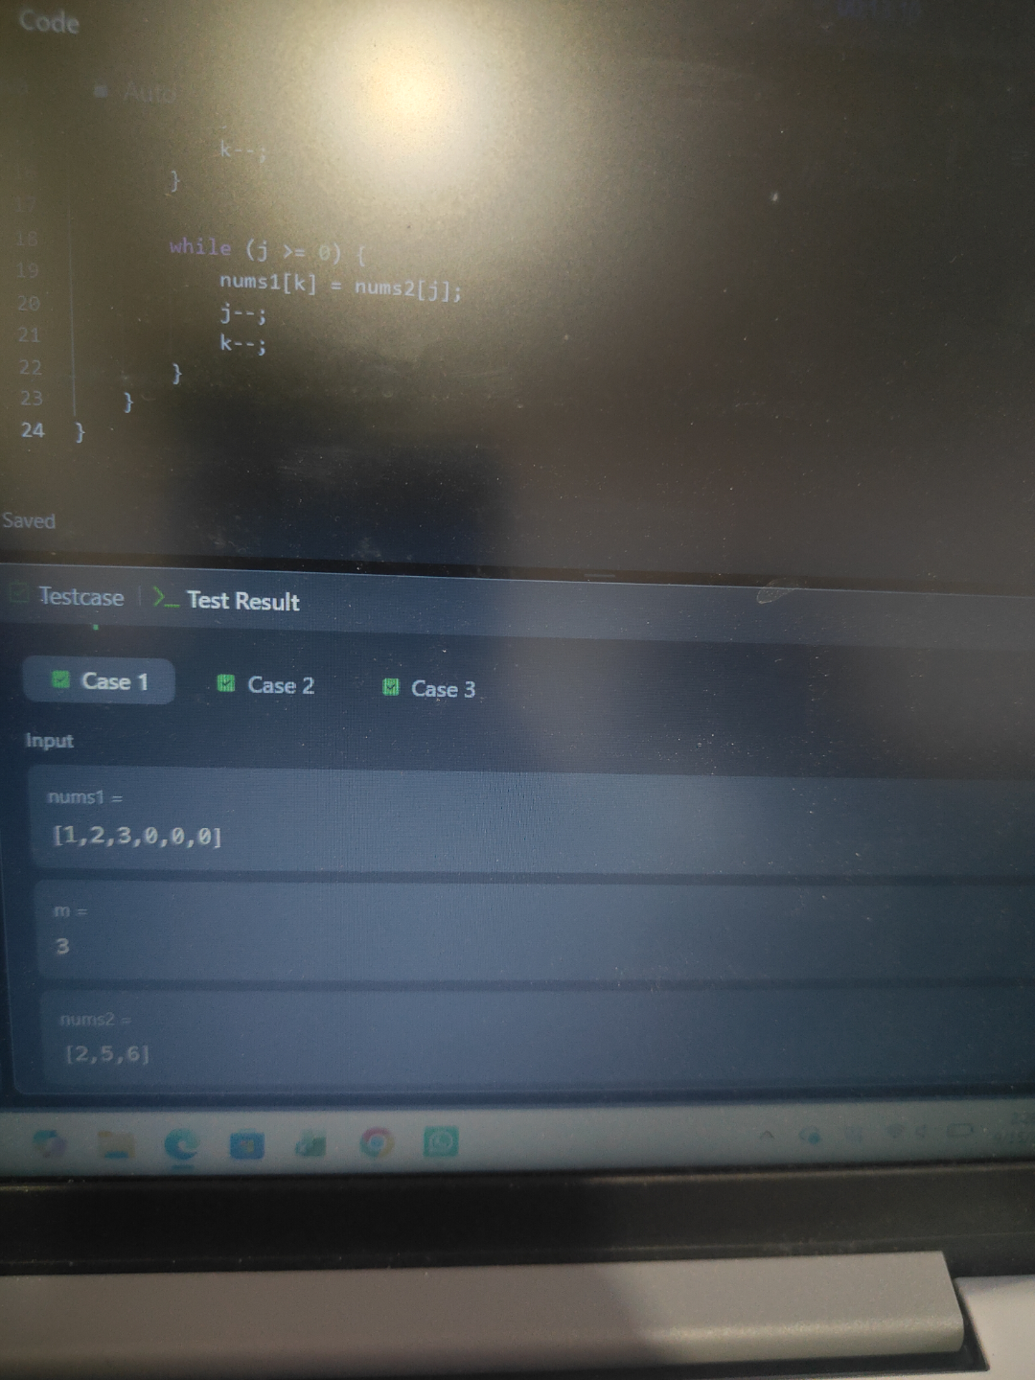
TASK 2: find smallest number greater than target.﻿
PROGRAM.﻿
class Solution {﻿
public char nextGreatestLetter(char[] letters, char target) {﻿
int low = 0;﻿
int high = letters.length - 1;﻿
while (low <= high) {﻿
int mid = low + (high - low) / 2;﻿
if (letters[mid] <= target) {﻿
low = mid + 1;﻿
} else {﻿
high = mid - 1;﻿
}﻿
}﻿
return letters[low % letters.length];﻿
}﻿
}﻿
OUTPUT.



