WEEK--5
SESSION 1 Maximum Subarray.
- Maximum Subarray
PROGRAM ﻿
class Solution {﻿
public int maxSubArray(int[] nums) {﻿
int currentSum = nums[0];﻿
int maxSum = nums[0];﻿
for (int i = 1; i < nums.length; i++) {﻿
currentSum = Math.max(nums[i], currentSum + nums[i]);﻿
maxSum = Math.max(maxSum, currentSum);﻿
}﻿
return maxSum;﻿
}﻿
} ﻿
OUTPUT
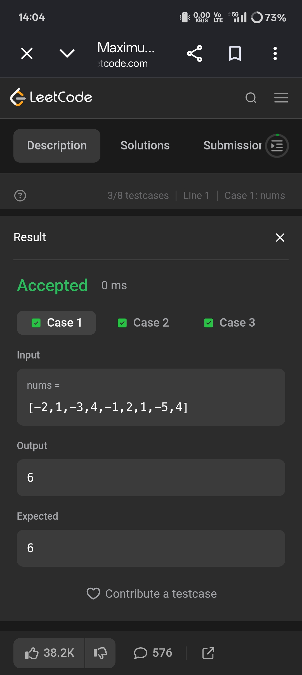
SESSION 2 Kadane's Algorithm.
- Maximum Sum Circular Subarray.
PROGRAM ﻿
class Solution {﻿
public int maxSubarraySumCircular(int[] nums) {﻿
int totalSum = 0;﻿
int currentMax = 0;﻿
int maxSum = nums[0];﻿
int currentMin = 0;﻿
int minSum = nums[0];﻿
for (int num : nums) {﻿
// Maximum subarray﻿
currentMax = Math.max(num, currentMax + num);﻿
maxSum = Math.max(maxSum, currentMax);﻿
// Minimum subarray﻿
currentMin = Math.min(num, currentMin + num);﻿
minSum = Math.min(minSum, currentMin);﻿
totalSum += num;﻿
}﻿
// All elements are negative﻿
if (maxSum < 0) {﻿
return maxSum;﻿
}﻿
// Maximum of normal and circular subarray﻿
return Math.max(maxSum, totalSum - minSum);﻿
}﻿
}﻿
OUTPUT
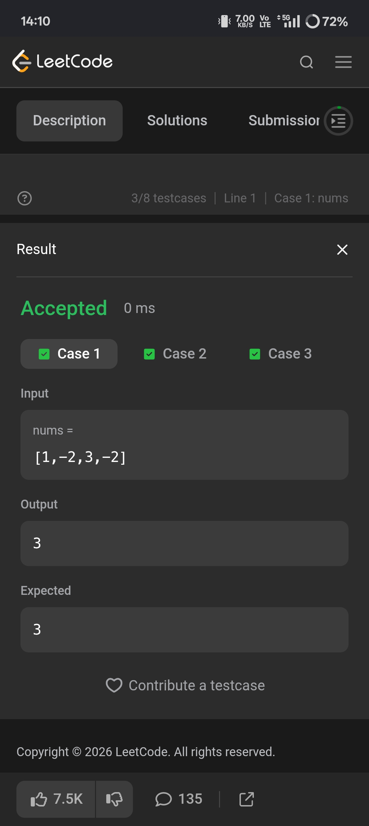
SESSION 3 String Handling Basics.
- String to integer atoi.
PROGRAM ﻿
class Solution {﻿
public int myAtoi(String s) {﻿
int i = 0;﻿
int n = s.length();﻿
// 1. Ignore leading spaces﻿
while (i < n && s.charAt(i) == ' ') {﻿
i++;﻿
}﻿
// 2. Check sign﻿
int sign = 1;﻿
if (i < n && s.charAt(i) == '-') {﻿
sign = -1;﻿
i++;﻿
} else if (i < n && s.charAt(i) == '+') {﻿
i++;﻿
}﻿
// 3. Convert digits﻿
int result = 0;﻿
while (i < n && s.charAt(i) >= '0' && s.charAt(i) <= '9') {﻿
int digit = s.charAt(i) - '0';﻿
// 4. Check overflow﻿
if (result > Integer.MAX_VALUE / 10 ||﻿
(result == Integer.MAX_VALUE / 10 && digit > 7)) {﻿
if (sign == 1)﻿
return Integer.MAX_VALUE;﻿
else﻿
return Integer.MIN_VALUE;﻿
}﻿
result = result * 10 + digit;﻿
i++;﻿
}﻿
return result * sign;﻿
}﻿
}﻿
OUTPUT
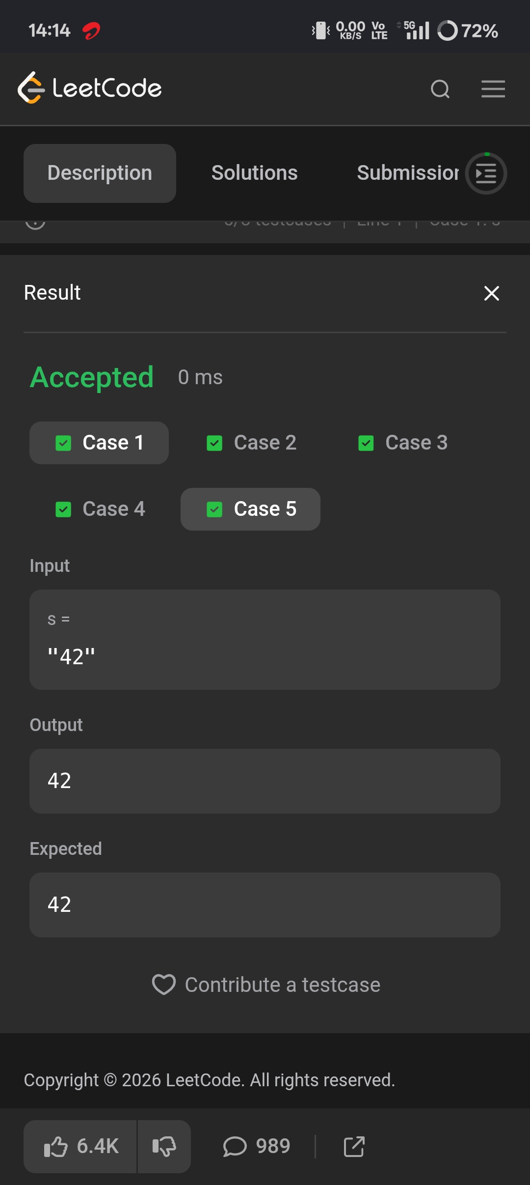
SESSION 4 Advanced String Techniques.
- Longest substring without repeating character.
PROGRAM﻿
class Solution {﻿
public int lengthOfLongestSubstring(String s) {﻿
int[] lastIndex = new int[128];﻿
int left = 0;﻿
int maxLength = 0;﻿
for (int right = 0; right < s.length(); right++) {﻿
char ch = s.charAt(right);﻿
left = Math.max(left, lastIndex[ch]);﻿
maxLength = Math.max(maxLength, right - left + 1);﻿
lastIndex[ch] = right + 1;﻿
}﻿
return maxLength;﻿
}﻿
}﻿
OUTPUT
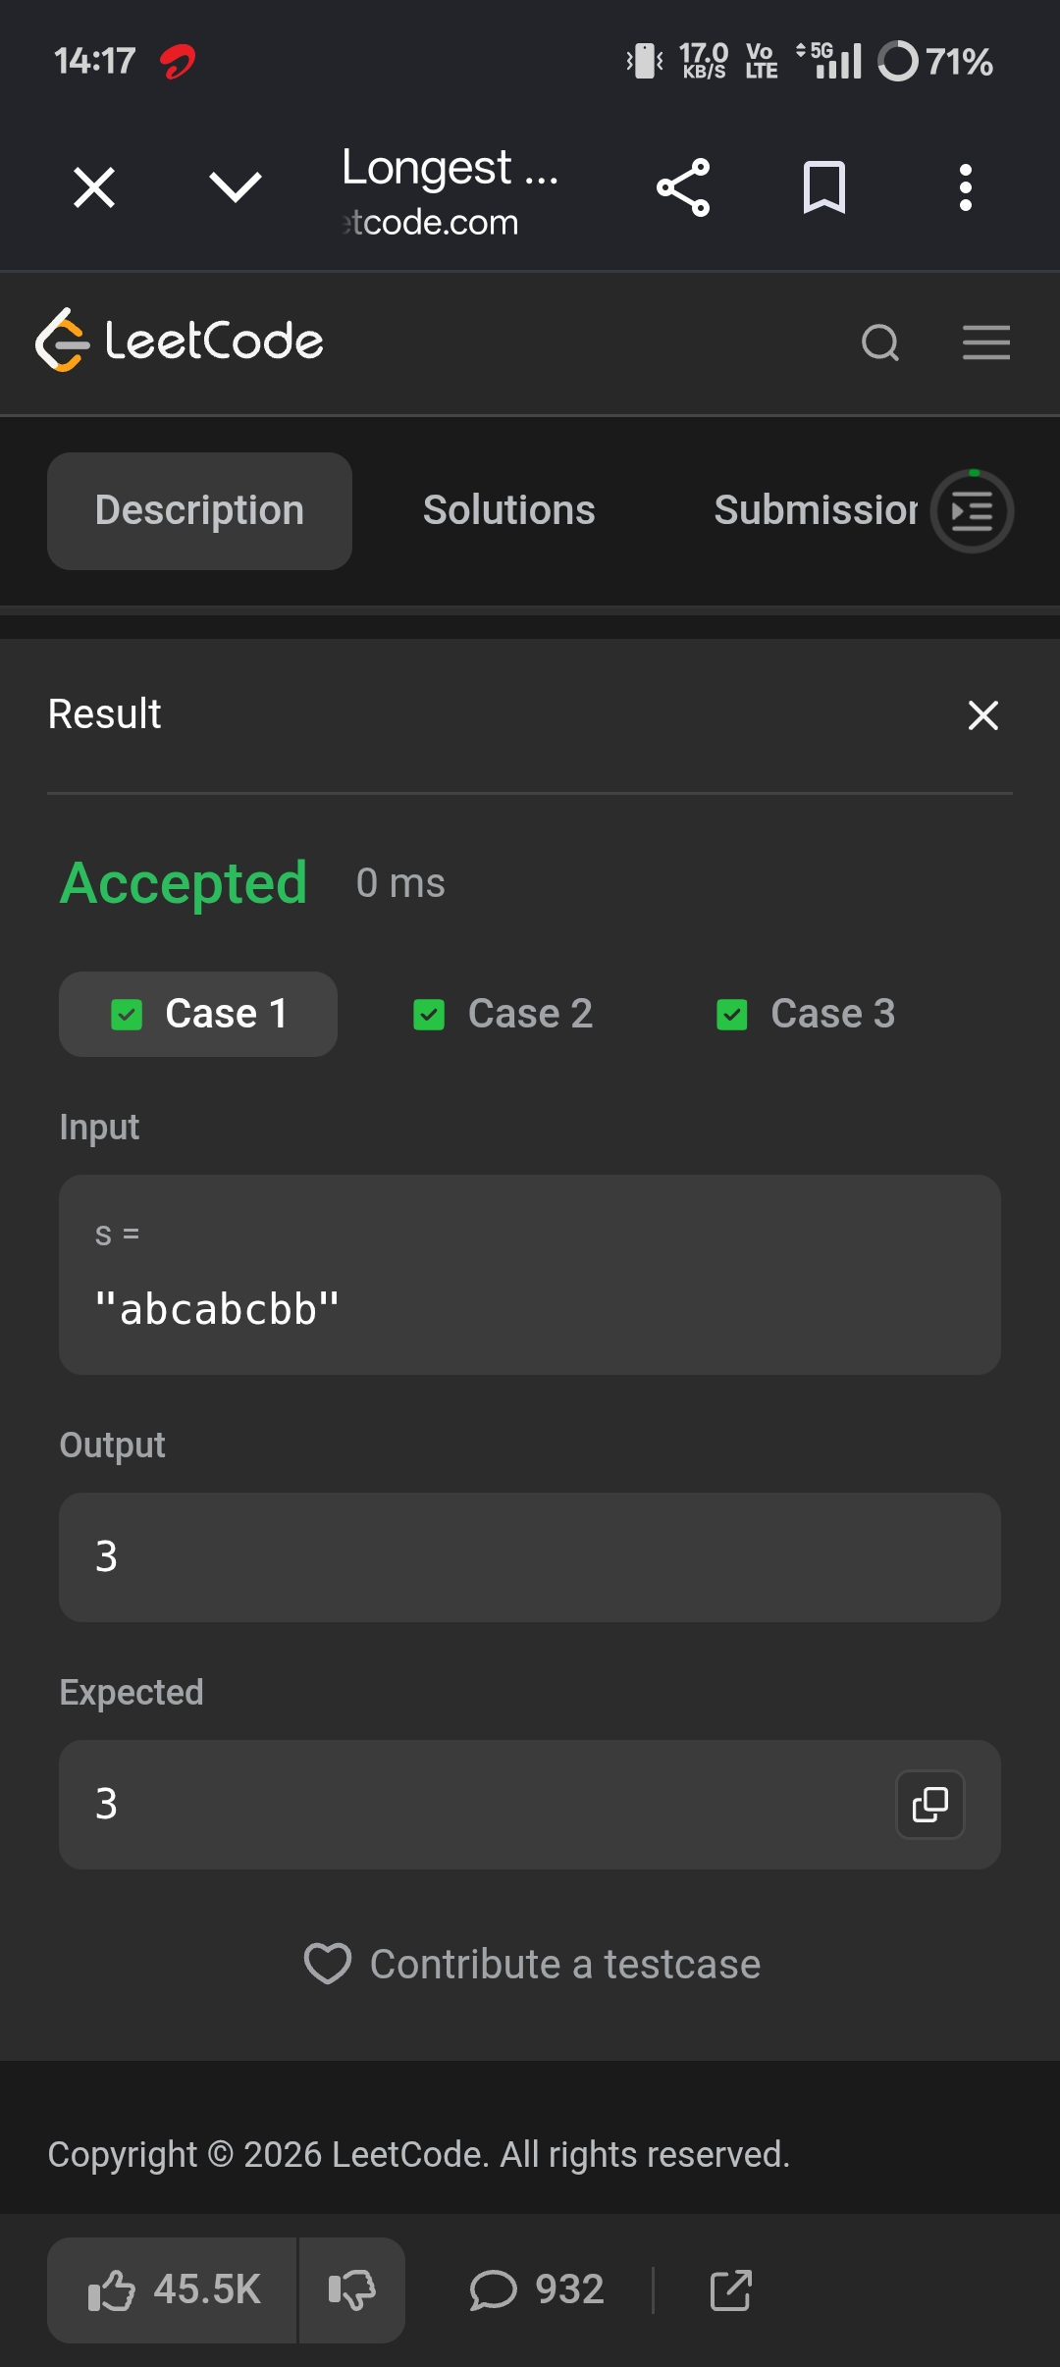
- Find and replace pattern.
PROGRAM ﻿
class Solution {﻿
public List<String> findAndReplacePattern(String[] words, String pattern) {﻿
List<String> result = new ArrayList<>();﻿
for (String word : words) {﻿
if (matches(word, pattern)) {﻿
result.add(word);﻿
}﻿
}﻿
return result;﻿
}﻿
private boolean matches(String word, String pattern) {﻿
int[] wToP = new int[26];﻿
int[] pToW = new int[26];﻿
for (int i = 0; i < word.length(); i++) {﻿
int w = word.charAt(i) - 'a';﻿
int p = pattern.charAt(i) - 'a';﻿
if (wToP[w] != 0 && wToP[w] != p + 1) {﻿
return false;﻿
}﻿
if (pToW[p] != 0 && pToW[p] != w + 1) {﻿
return false;﻿
}﻿
wToP[w] = p + 1;﻿
pToW[p] = w + 1;﻿
}﻿
return true;﻿
}﻿
}﻿
OUTPUT.
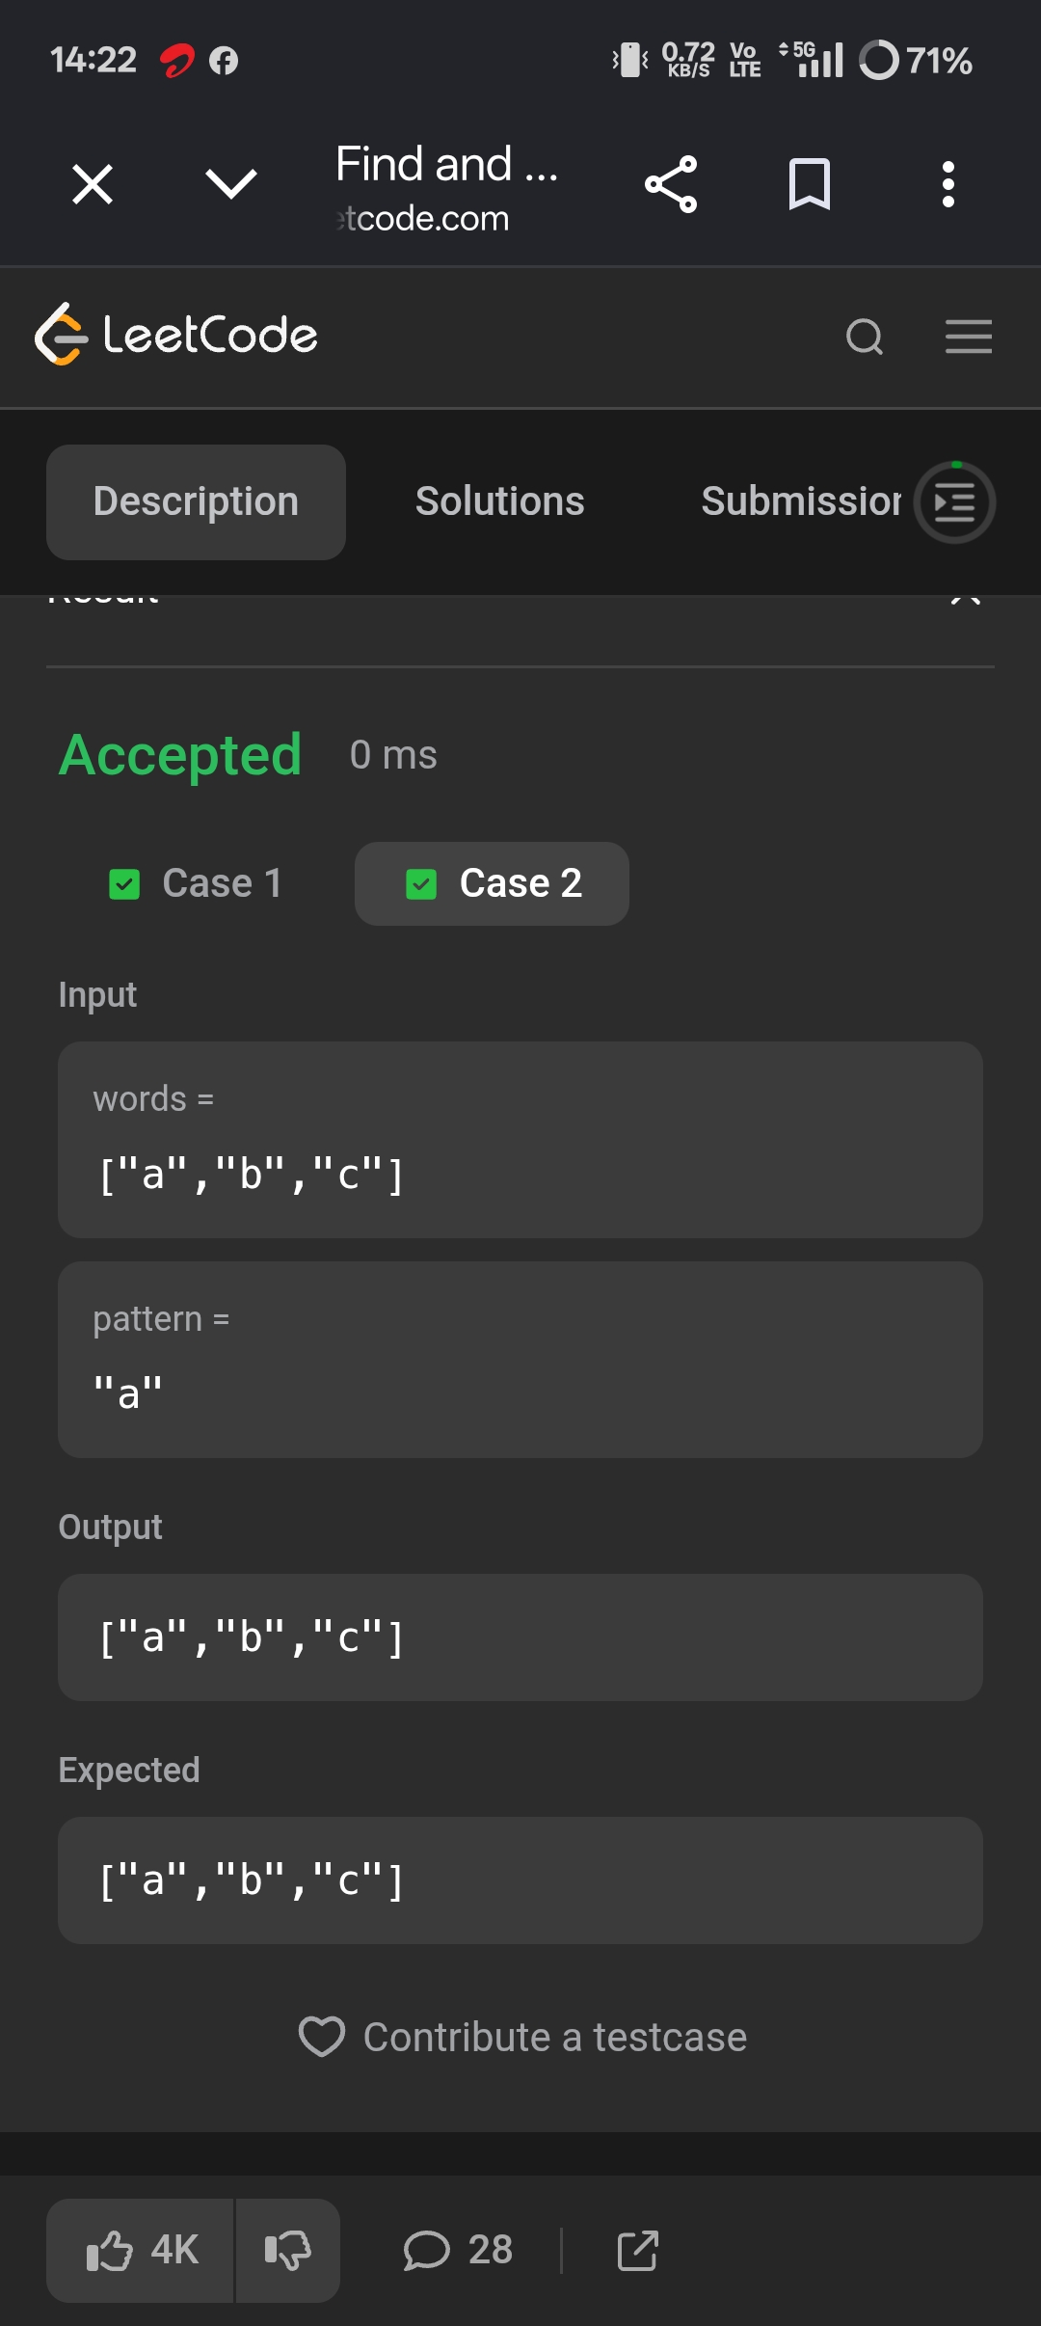
SESSION 5 Naive Pattern Matching.
- String matching in an array.
PROGRAM ﻿
import java.util.*;﻿
class Solution {﻿
public List<String> stringMatching(String[] words) {﻿
List<String> result = new ArrayList<>();﻿
for (int i = 0; i < words.length; i++) {﻿
for (int j = 0; j < words.length; j++) {﻿
if (i != j && words[j].contains(words[i])) {﻿
result.add(words[i]);﻿
break;﻿
}﻿
}﻿
}﻿
return result;﻿
}﻿
}﻿
OUTPUT



