WEEK--6
SESSION 1 KMP Algorithm.
- Repeated Substring Pattern.
PROGRAM ﻿
class Solution {﻿
public boolean repeatedSubstringPattern(String s) {﻿
int n = s.length();﻿
int[] lps = new int[n];﻿
// Build LPS array﻿
int len = 0;﻿
int i = 1;﻿
while (i < n) {﻿
if (s.charAt(i) == s.charAt(len)) {﻿
len++;﻿
lps[i] = len;﻿
i++;﻿
} else {﻿
if (len != 0) {﻿
len = lps[len - 1];﻿
} else {﻿
lps[i] = 0;﻿
i++;﻿
}﻿
}﻿
}﻿
// Length of the repeating substring﻿
int patternLength = n - lps[n - 1];﻿
return lps[n - 1] > 0 && n % patternLength == 0;﻿
}﻿
}﻿
OUTPUT
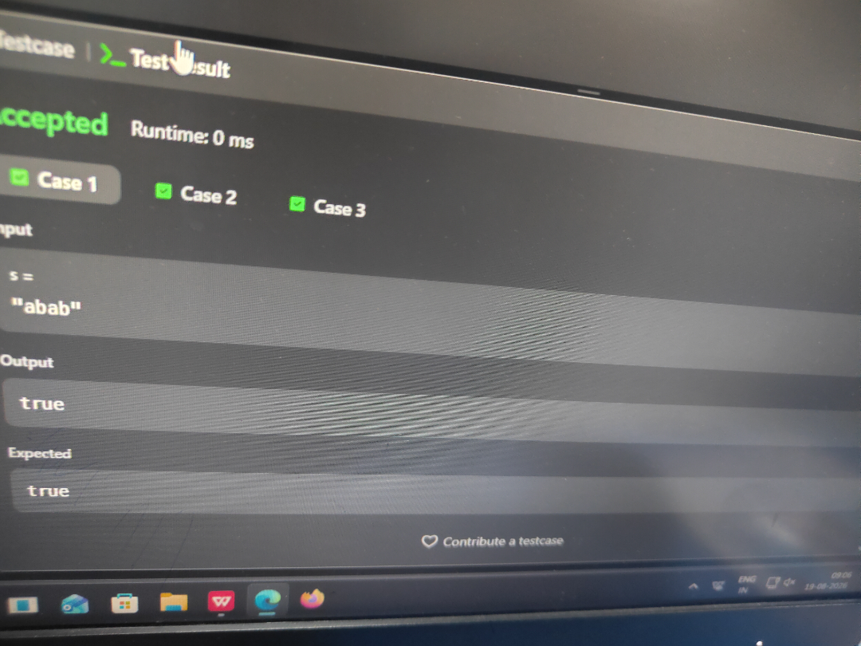
SESSION 2 KMP Applications.
- Rotate String.
PROGRAM ﻿
class Solution {﻿
public boolean rotateString(String s, String goal) {﻿
if (s.length() != goal.length()) {﻿
return false;﻿
}﻿
return (s + s).contains(goal);﻿
}﻿
}﻿
OUTPUT
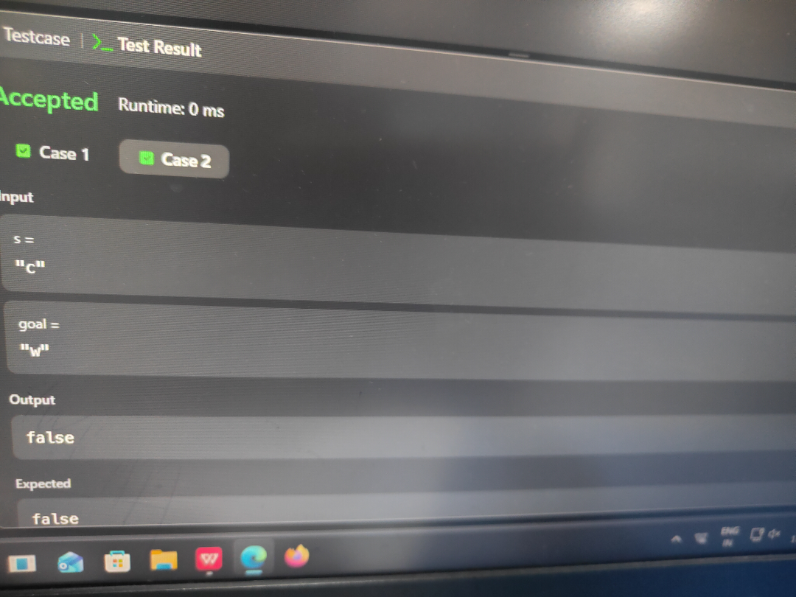
SESSION 3 BOYEL MOORE Algorithm.
- Find all Anagrams in a string.
PROGRAM ﻿
import java.util.*;﻿
class Solution {﻿
public List<Integer> findAnagrams(String s, String p) {﻿
List<Integer> result = new ArrayList<>();﻿
if (s.length() < p.length()) {﻿
return result;﻿
}﻿
int[] pCount = new int[26];﻿
int[] window = new int[26];﻿
// Frequency of characters in p﻿
for (char c : p.toCharArray()) {﻿
pCount[c - 'a']++;﻿
}﻿
int k = p.length();﻿
// Create the first window﻿
for (int i = 0; i < k; i++) {﻿
window[s.charAt(i) - 'a']++;﻿
}﻿
if (Arrays.equals(pCount, window)) {﻿
result.add(0);﻿
}﻿
// Slide the window﻿
for (int i = k; i < s.length(); i++) {﻿
// Add new character﻿
window[s.charAt(i) - 'a']++;﻿
// Remove old character﻿
window[s.charAt(i - k) - 'a']--;﻿
// Check for anagram﻿
if (Arrays.equals(pCount, window)) {﻿
result.add(i - k + 1);﻿
}﻿
}﻿
return result;﻿
}﻿
}﻿
OUTPUT
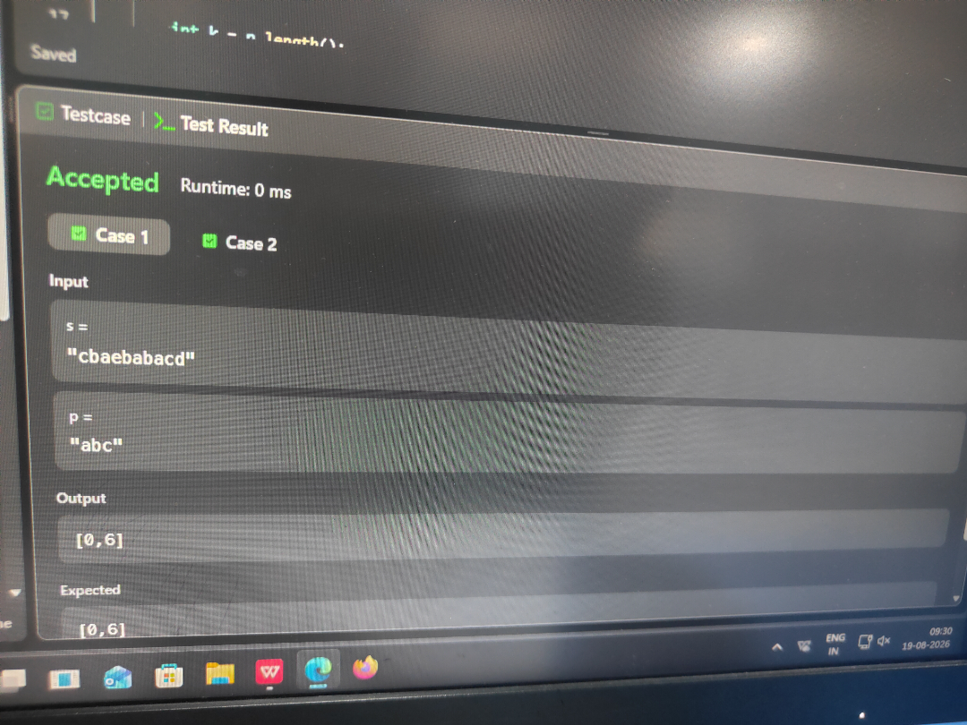
SESSION 4 PALINDROME Techniques.
- Find the index of the first occurance in a string
PROGRAM ﻿
class Solution {﻿
public int strStr(String haystack, String needle) {﻿
return haystack.indexOf(needle);﻿
}﻿
}﻿
OUTPUT
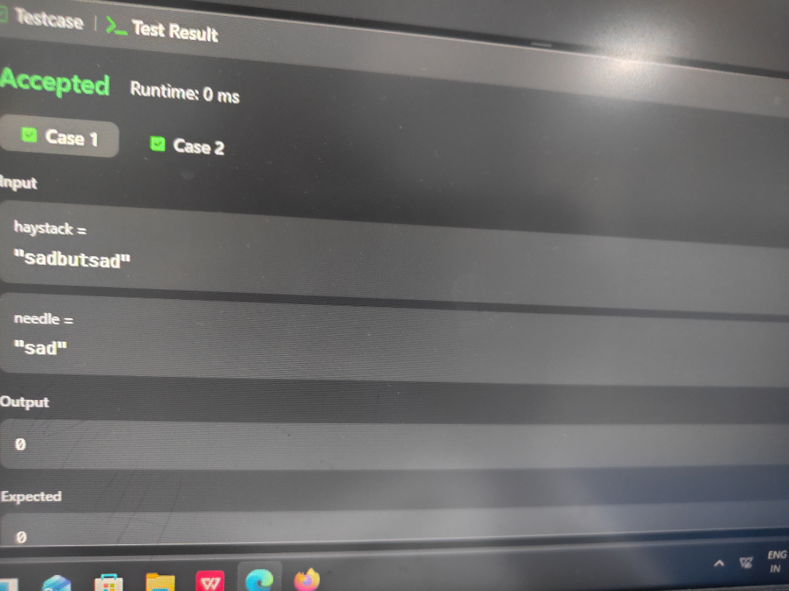
SESSION 5 Manacher Algorithm for finding longest Palindrome substring.
- Longest Palindrome substring.
PROGRAM ﻿
class Solution {﻿
public String longestPalindrome(String s) {﻿
if (s.length() < 2) {﻿
return s;﻿
}﻿
int start = 0;﻿
int end = 0;﻿
for (int i = 0; i < s.length(); i++) {﻿
// Odd-length palindrome﻿
int len1 = expand(s, i, i);﻿
// Even-length palindrome﻿
int len2 = expand(s, i, i + 1);﻿
int len = Math.max(len1, len2);﻿
if (len > end - start + 1) {﻿
start = i - (len - 1) / 2;﻿
end = i + len / 2;﻿
}﻿
}﻿
return s.substring(start, end + 1);﻿
}﻿
private int expand(String s, int left, int right) {﻿
while (left >= 0 && right < s.length()﻿
&& s.charAt(left) == s.charAt(right)) {﻿
left--;﻿
right++;﻿
}﻿
return right - left - 1;﻿
}﻿
}﻿
OUTPUT



