WEEK--7
SESSION 1 DESIGN PARKING SYSTEM.﻿
PROGRAM ﻿
class ParkingSystem {﻿
private int[] slots;﻿
public ParkingSystem(int big, int medium, int small) {﻿
slots = new int[]{big, medium, small};﻿
}﻿
public boolean addCar(int carType) {﻿
int index = carType - 1;﻿
if (slots[index] > 0) {﻿
slots[index]--;﻿
return true;﻿
}﻿
return false;﻿
}﻿
}﻿
OUTPUT.
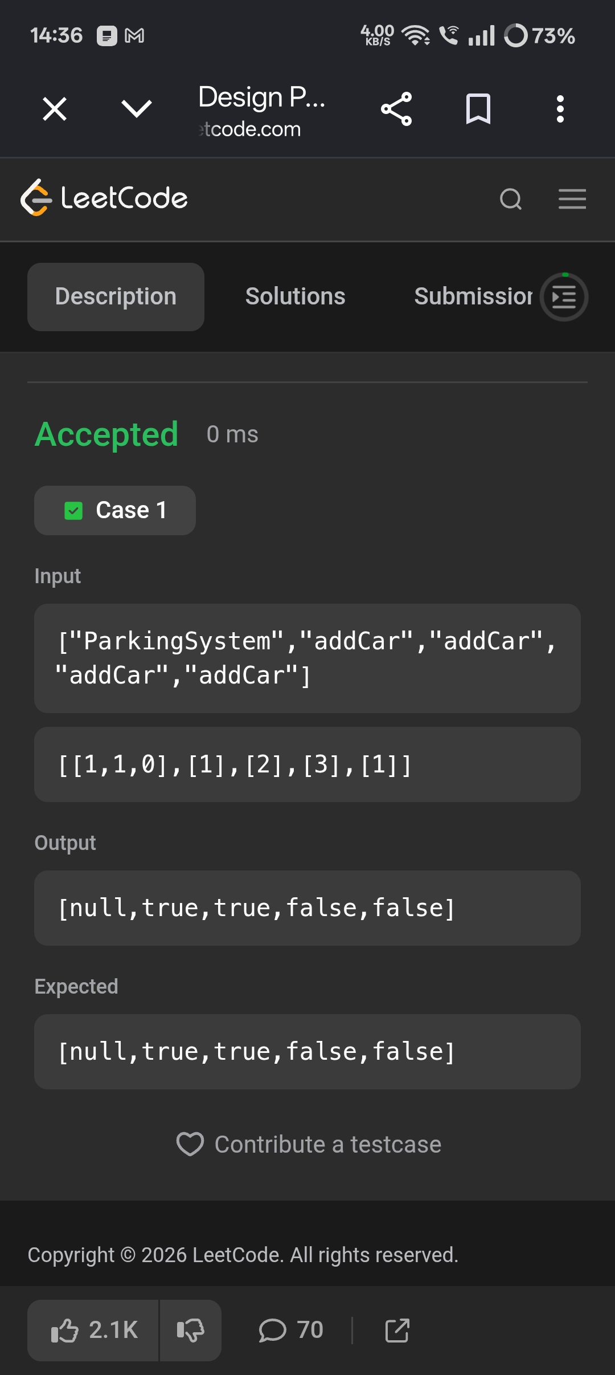
SESSION 2 DESIGN UNDERGROUND SYSTEM.﻿
PROGRAM﻿
import java.util.*;﻿
class UndergroundSystem {﻿
class CheckIn {﻿
String station;﻿
int time;﻿
CheckIn(String station, int time) {﻿
this.station = station;﻿
this.time = time;﻿
}﻿
}﻿
class Route {﻿
int totalTime;﻿
int count;﻿
Route(int totalTime, int count) {﻿
this.totalTime = totalTime;﻿
this.count = count;﻿
}﻿
}﻿
HashMap<Integer, CheckIn> checkIns;﻿
HashMap<String, Route> routes;﻿
public UndergroundSystem() {﻿
checkIns = new HashMap<>();﻿
routes = new HashMap<>();﻿
}﻿
public void checkIn(int id, String stationName, int t) {﻿
checkIns.put(id, new CheckIn(stationName, t));﻿
}﻿
public void checkOut(int id, String stationName, int t) {﻿
CheckIn checkIn = checkIns.get(id);﻿
String startStation = checkIn.station;﻿
int startTime = checkIn.time;﻿
int travelTime = t - startTime;﻿
String route = startStation + "->" + stationName;﻿
if (!routes.containsKey(route)) {﻿
routes.put(route, new Route(travelTime, 1));﻿
} else {﻿
Route r = routes.get(route);﻿
r.totalTime += travelTime;﻿
r.count++;﻿
}﻿
checkIns.remove(id);﻿
}﻿
public double getAverageTime(String startStation, String endStation) {﻿
String route = startStation + "->" + endStation;﻿
Route r = routes.get(route);﻿
return (double) r.totalTime / r.count;﻿
}﻿
}﻿
OUTPUT.
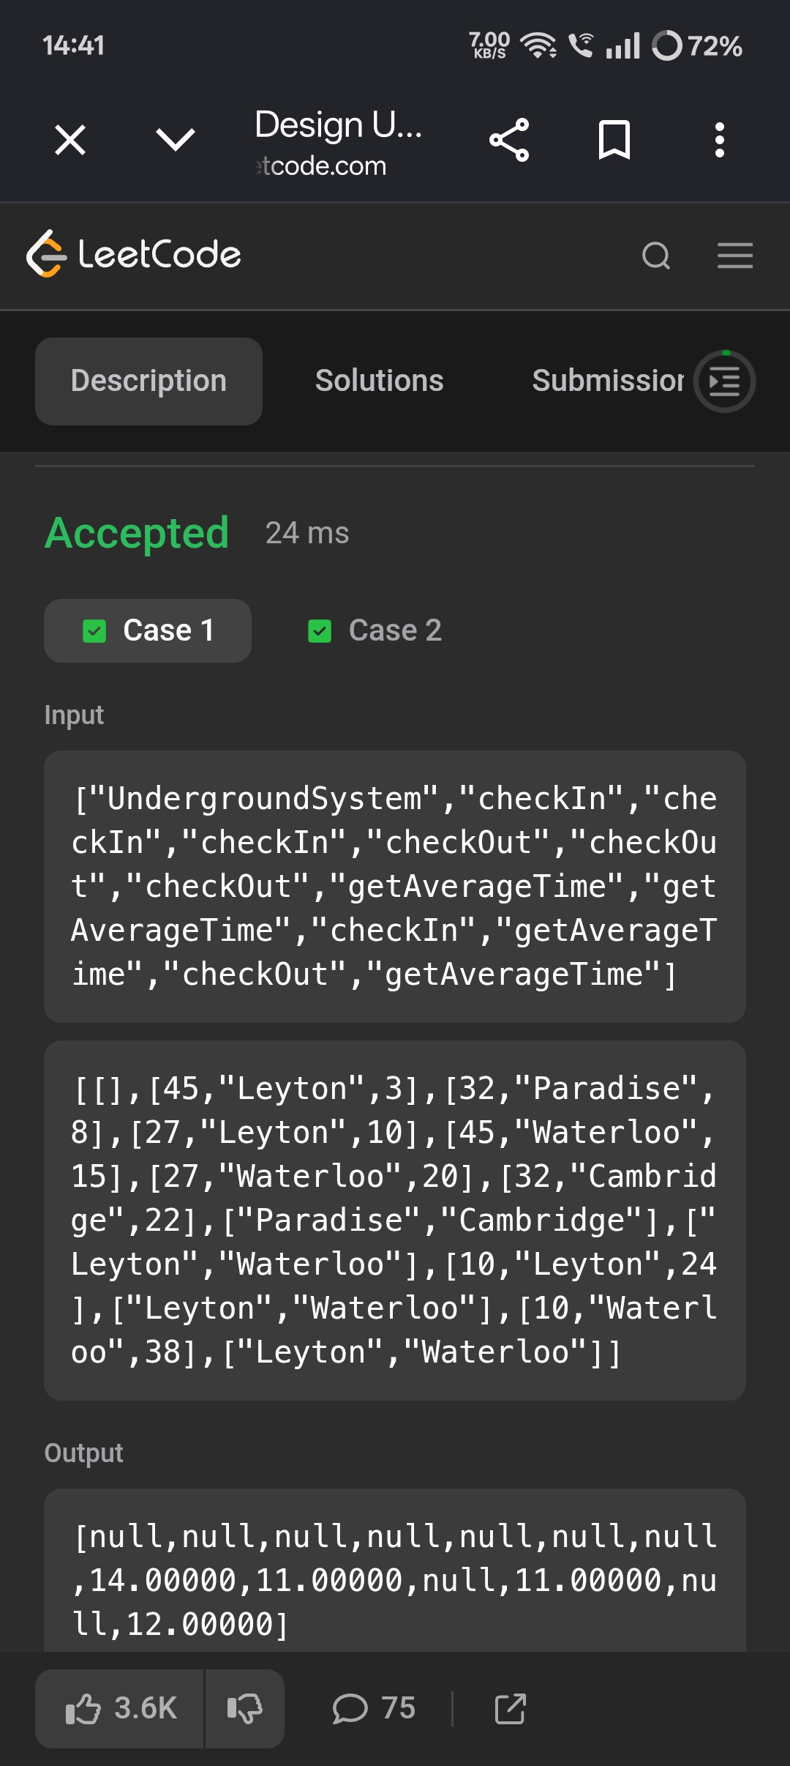
SESSION 3 DESIGN BROWSER HISTORY.﻿
PROGRAM ﻿
import java.util.*;﻿
class BrowserHistory {﻿
private ArrayList<String> history;﻿
private int current;﻿
private int last;﻿
public BrowserHistory(String homepage) {﻿
history = new ArrayList<>();﻿
history.add(homepage);﻿
current = 0;﻿
last = 0;﻿
}﻿
public void visit(String url) {﻿
current++;﻿
if (current < history.size()) {﻿
history.set(current, url);﻿
} else {﻿
history.add(url);﻿
}﻿
// Forward history is removed logically﻿
last = current;﻿
}﻿
public String back(int steps) {﻿
current = Math.max(0, current - steps);﻿
return history.get(current);﻿
}﻿
public String forward(int steps) {﻿
current = Math.min(last, current + steps);﻿
return history.get(current);﻿
}﻿
}﻿
OUTPUT.
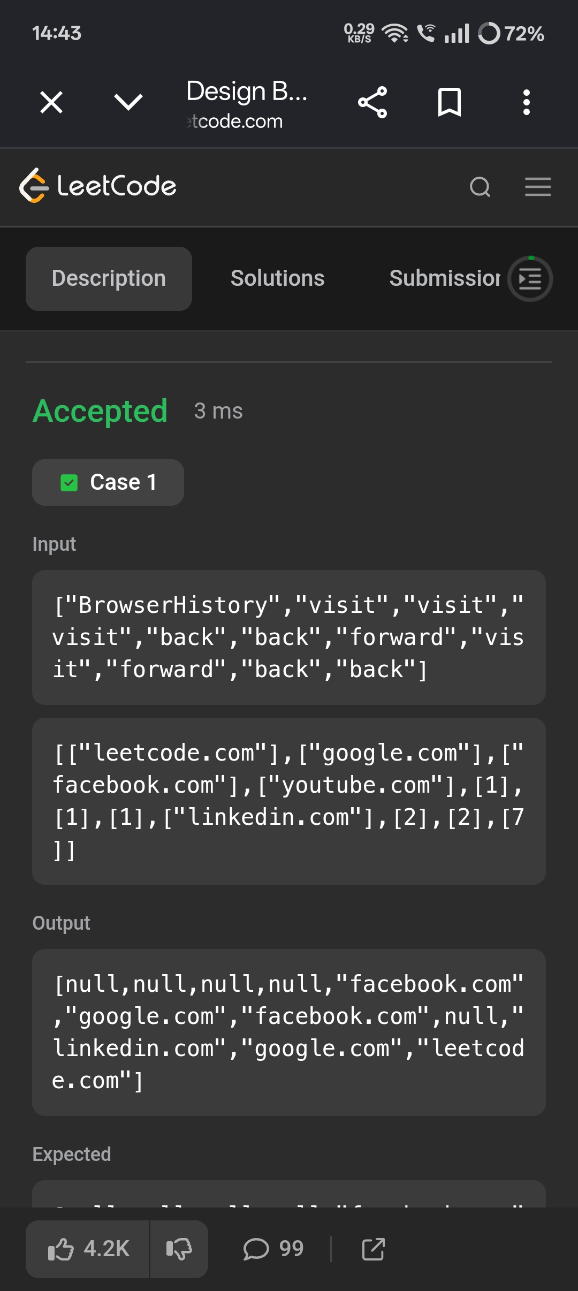
SESSION 4 DESIGN HASHSET.﻿
PROGRAM ﻿
class MyHashSet {﻿
private boolean[] set;﻿
public MyHashSet() {﻿
set = new boolean[1000001];﻿
}﻿
public void add(int key) {﻿
set[key] = true;﻿
}﻿
public void remove(int key) {﻿
set[key] = false;﻿
}﻿
public boolean contains(int key) {﻿
return set[key];﻿
}﻿
}﻿
OUTPUT.
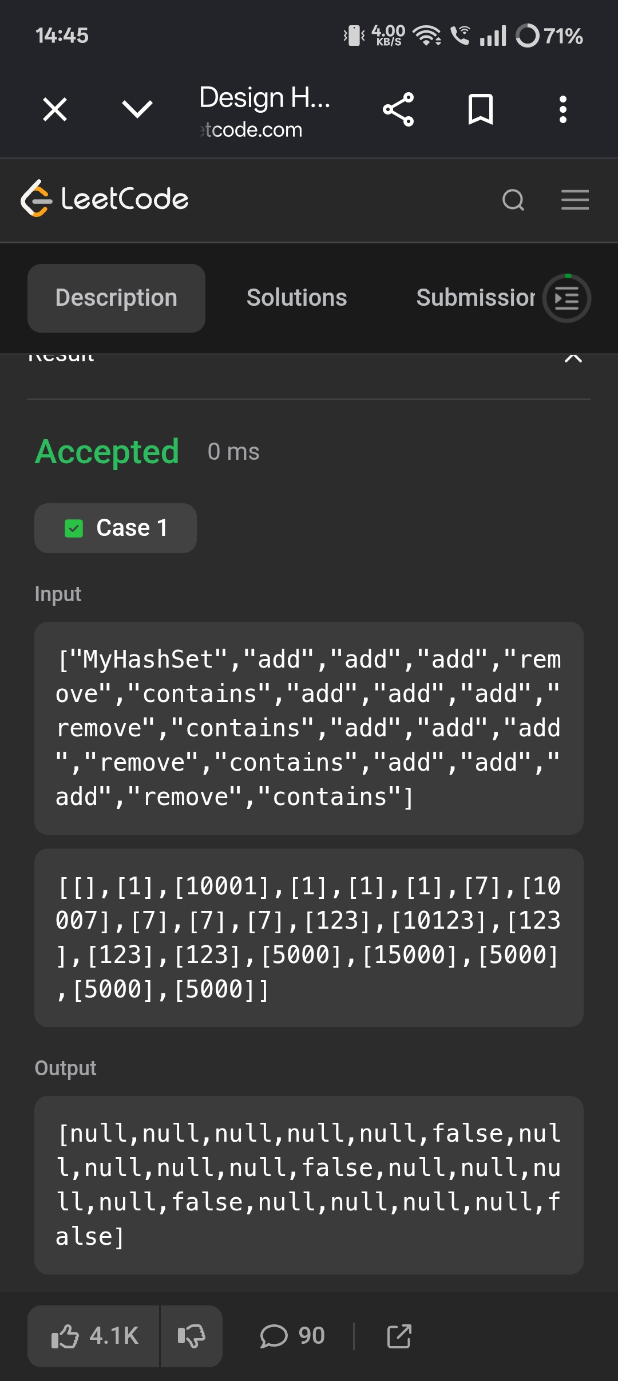
SESSION 5 THRONE INHERITANCE.﻿
PROGRAM ﻿
import java.util.*;﻿
class ThroneInheritance {﻿
private String king;﻿
private Map<String, List<String>> family;﻿
private Set<String> dead;﻿
public ThroneInheritance(String kingName) {﻿
king = kingName;﻿
family = new HashMap<>();﻿
dead = new HashSet<>();﻿
}﻿
public void birth(String parentName, String childName) {﻿
family.computeIfAbsent(parentName, k -> new ArrayList<>())﻿
.add(childName);﻿
}﻿
public void death(String name) {﻿
dead.add(name);﻿
}﻿
public List<String> getInheritanceOrder() {﻿
List<String> result = new ArrayList<>();﻿
dfs(king, result);﻿
return result;﻿
}﻿
private void dfs(String person, List<String> result) {﻿
// Add person if alive﻿
if (!dead.contains(person)) {﻿
result.add(person);﻿
}﻿
// Visit all children in birth order﻿
for (String child : family.getOrDefault(person, new ArrayList<>())) {﻿
dfs(child, result);﻿
}﻿
}﻿
}﻿
OUTPUT.



