Doan Viet Tu – 1952521

**EMBEDDED SYSTEMS – CC01**

**LAB 1**

**ESP**

**ESP-L01**

*Source code:*

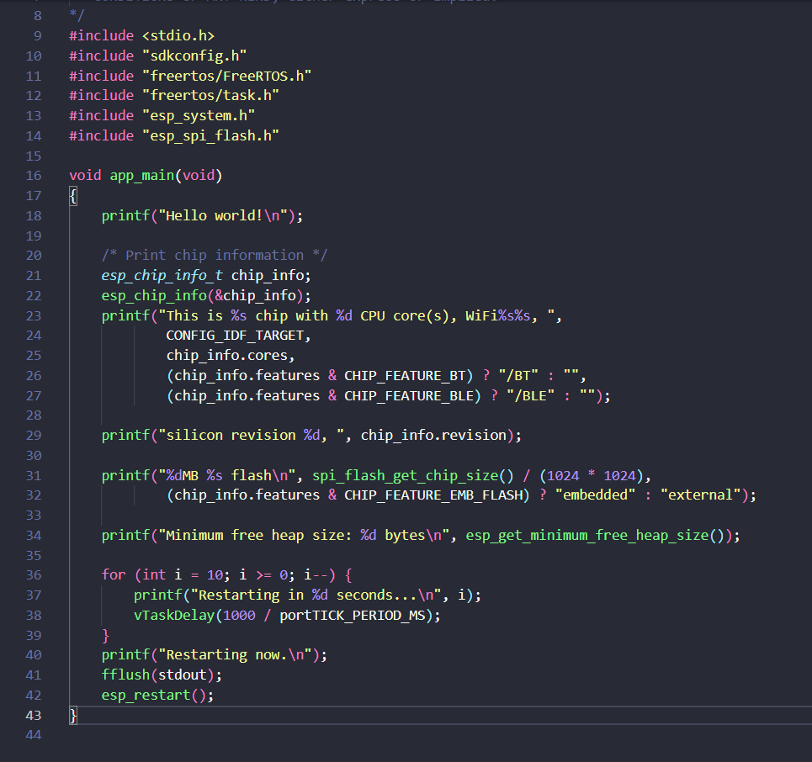

*Results:*

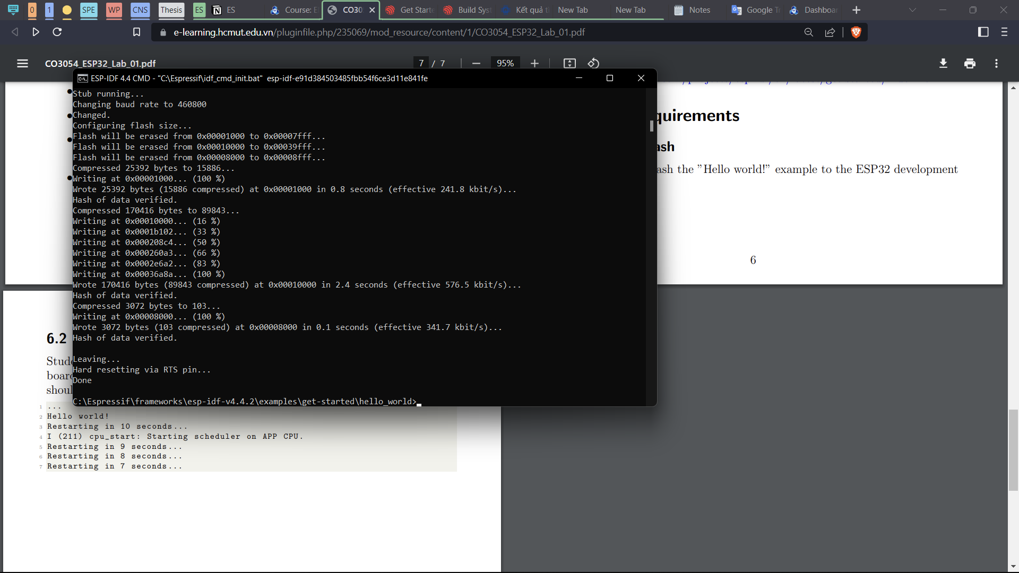

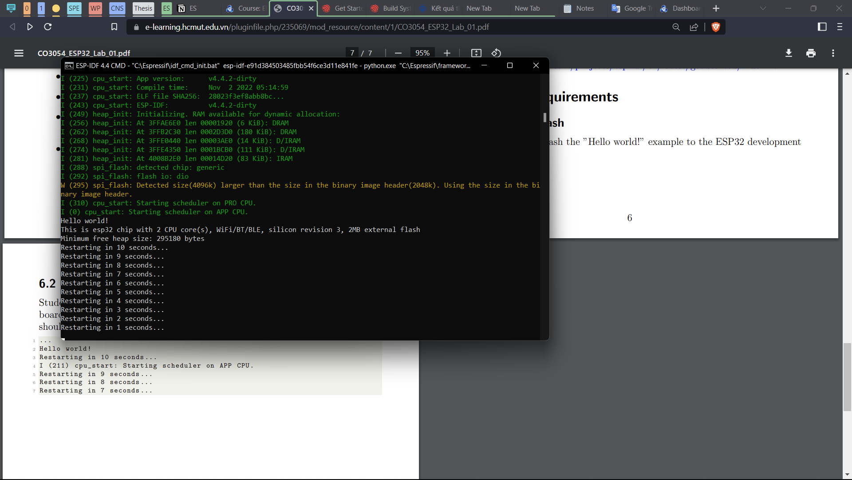

**ESP-L02**

*Source code:*

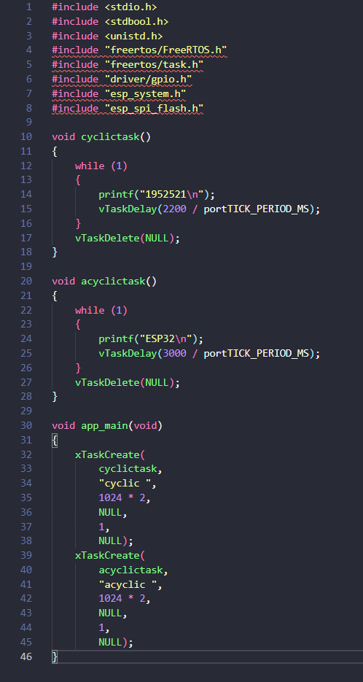

*Results:*

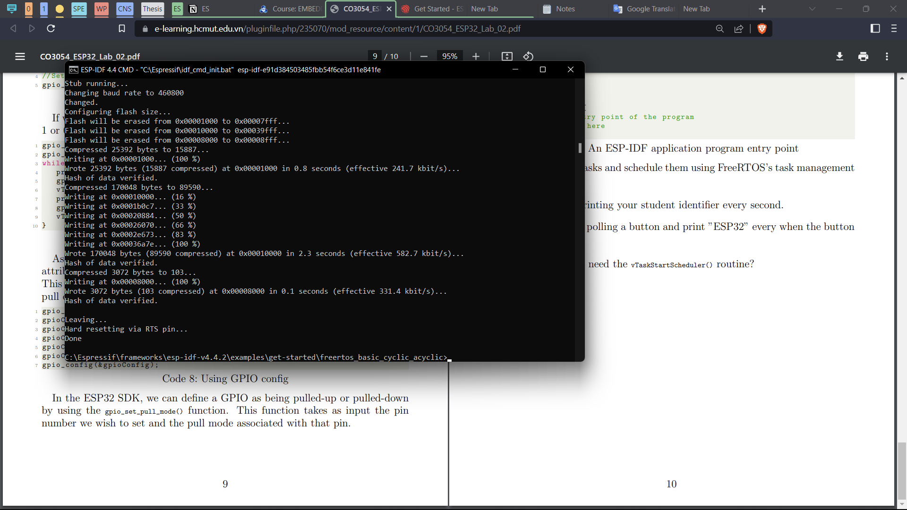

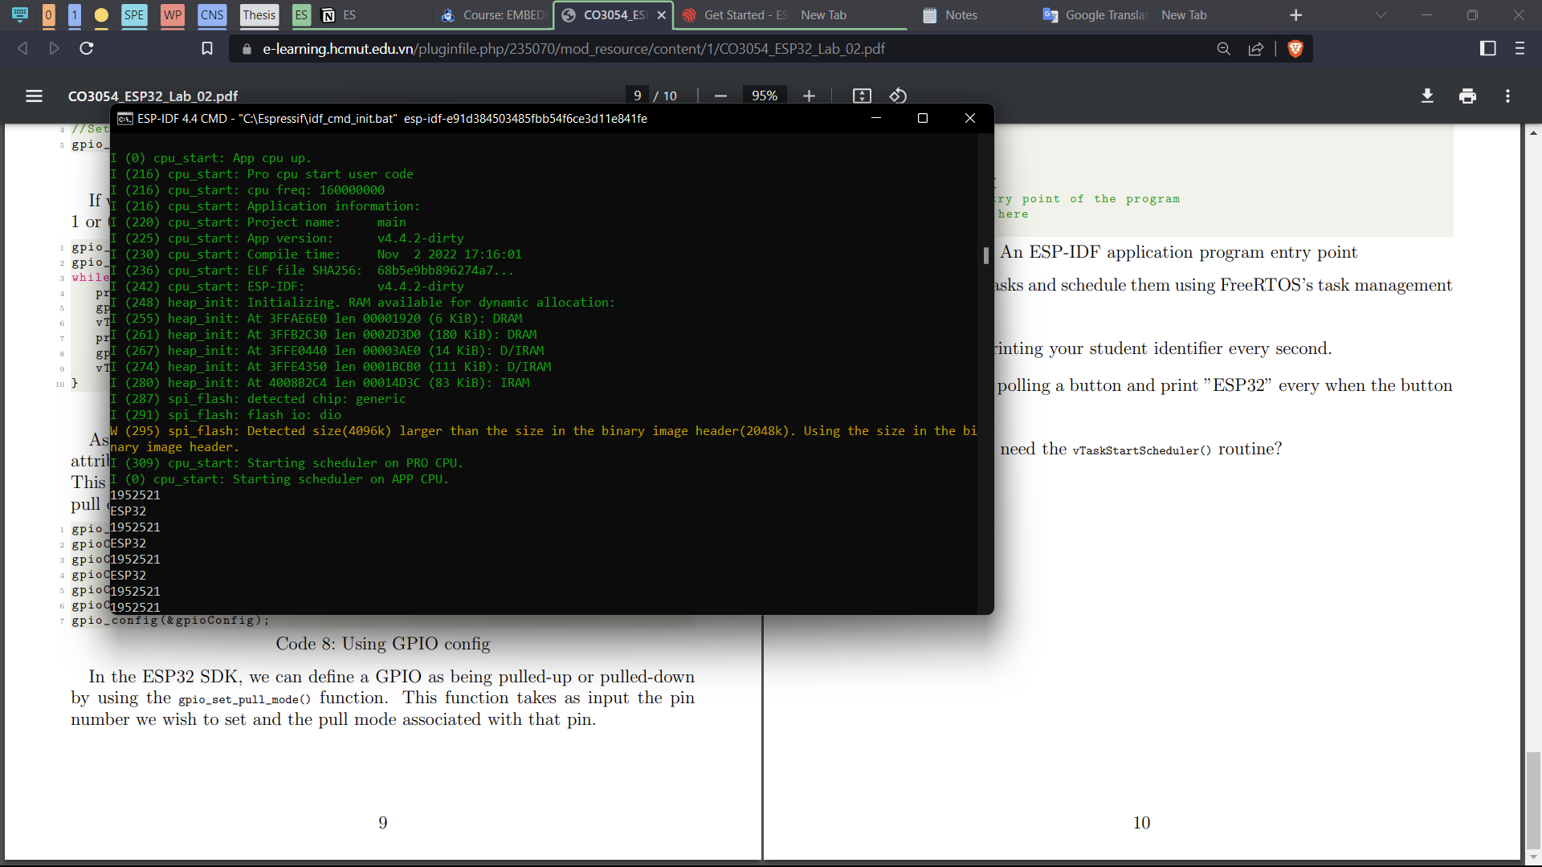

*Does the ESP-IDF need the vTaskStartScheduler() routine?*

→ No, because the startup flow of an ESP-IDF application will call this automatically.