Doan Viet Tu – 1952521

**EMBEDDED SYSTEMS – CC01**

**LAB 2**

**ESP**

**ESP-L04**

*Source code:*

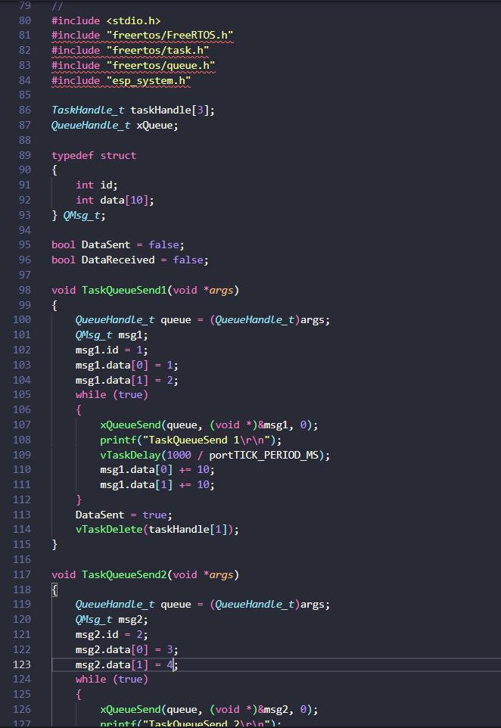

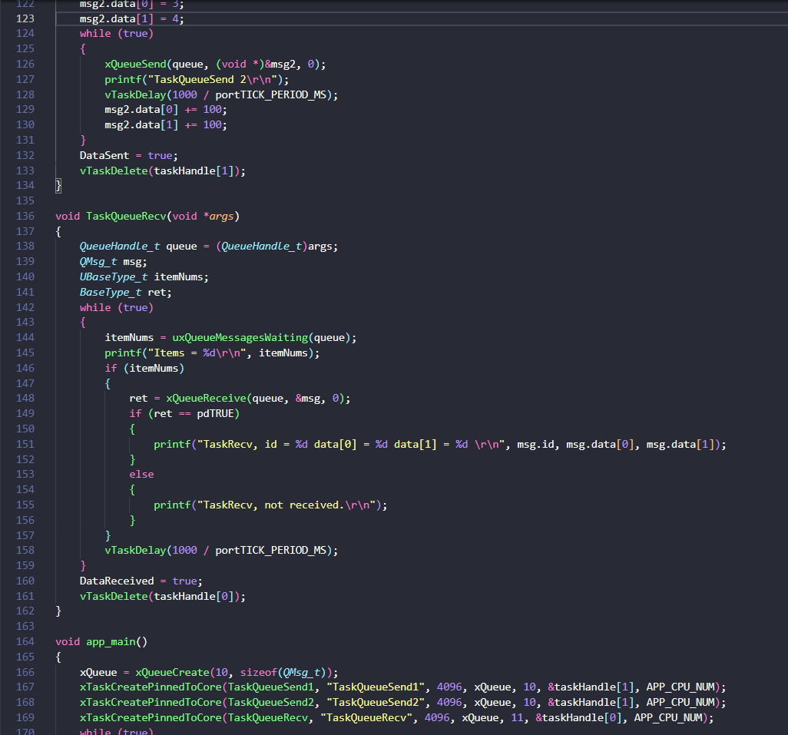

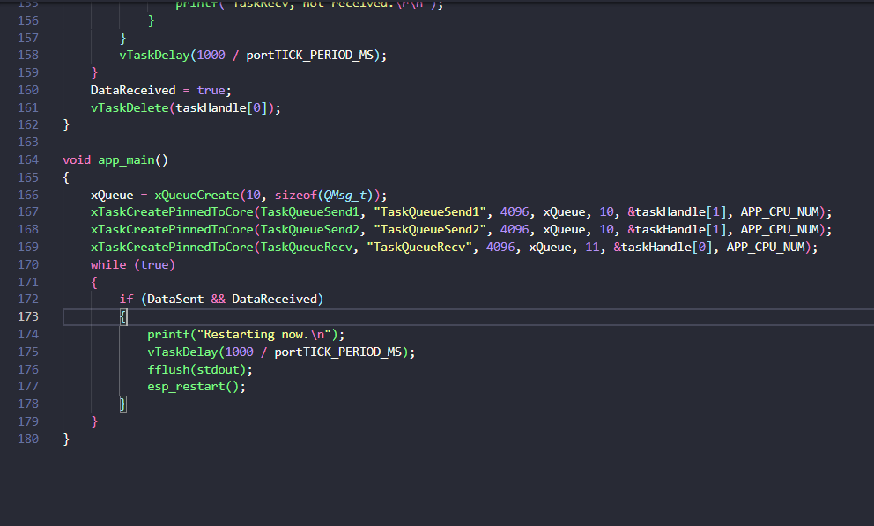

*Results:*

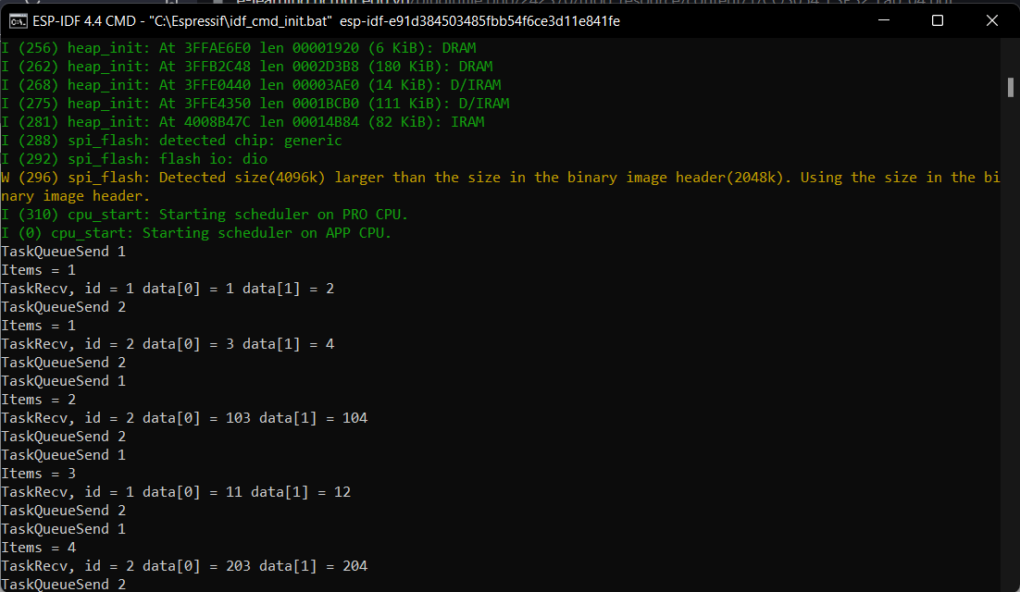

**ESP-L03**

*Source code:*

