Doan Viet Tu – 1952521

**EMBEDDED SYSTEMS – CC01**

**LAB 4**

**ESP**

**BLE-SERVER**

*Source code:*

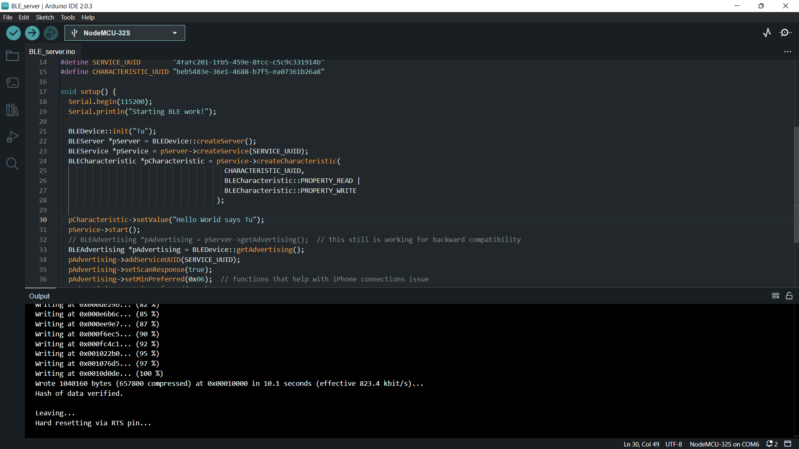

*Results:*

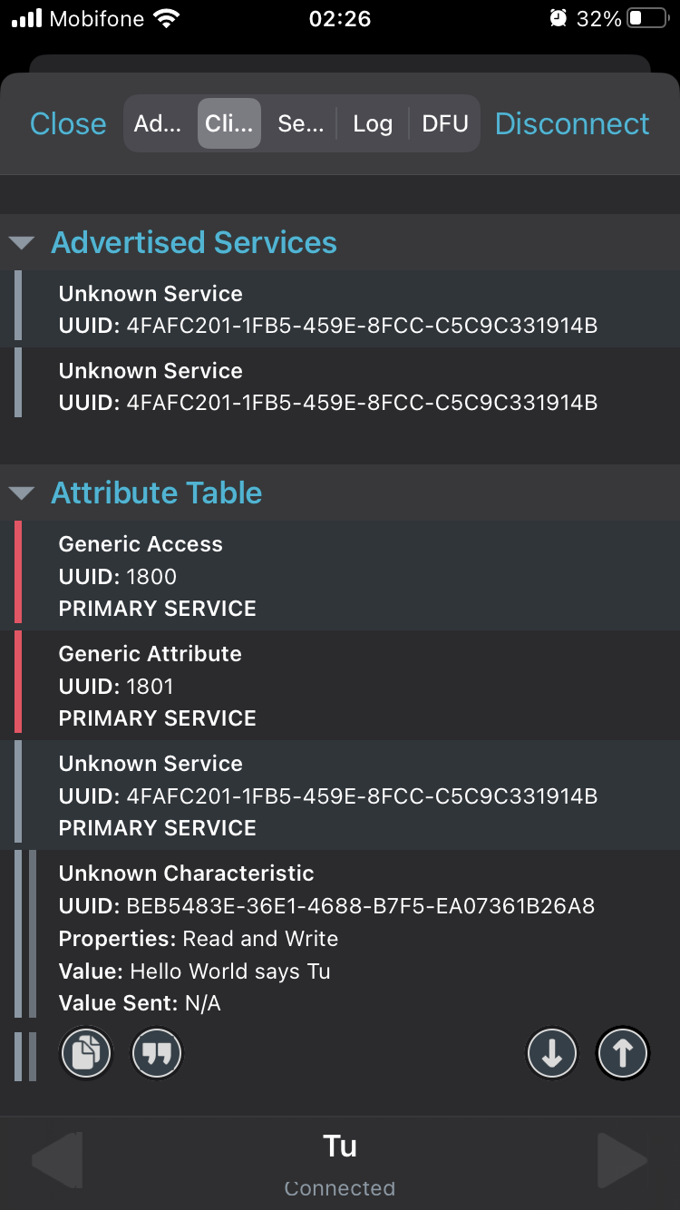

→ The result shows the service UUID, characteristic’s UUID, properties and value just as expected.

**BLE-SCANNER**

*Source code:*

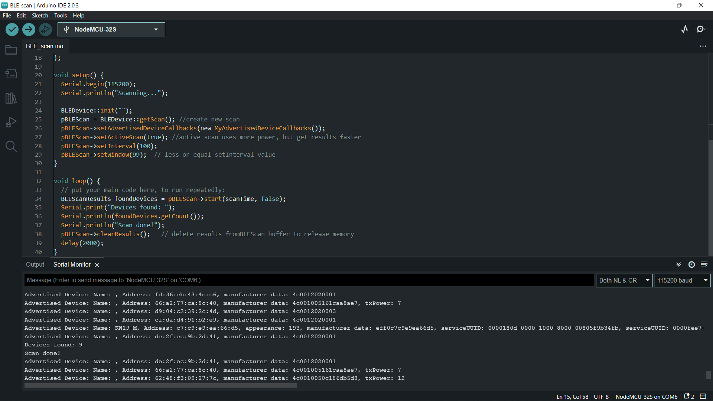

*Results:*

→ From the serial monitor above, there are 9 devices scanned successfully, including KW19-M which is my smart watches.