Students throwing recyclable materials

**USERS**

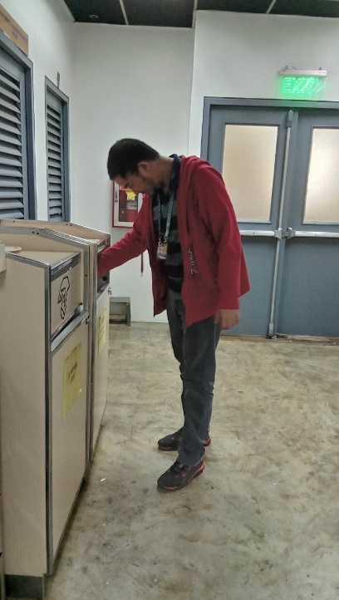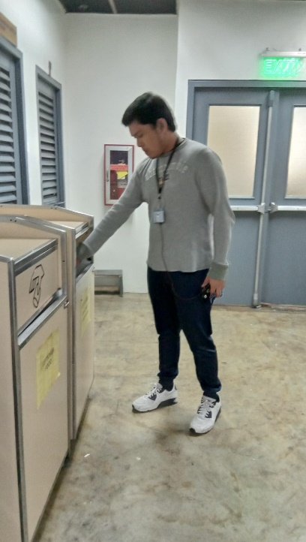

USER 1

- Doesn’t care about the labels on the waste containers.

-  Doesn’t have an idea about the school’s waste management.

USER 2

-          Always makes sure to follow the labels everyday

-          Always segregate the garbage before throwing them out in the container

**Observations**

We decided to observe students of Asia Pacific College throwing recyclable materials that can be sold per kilo for example plastic bottles, cans, paper, and cardboard. Based on our observations, we noticed that the trash that were thrown on the garbage bins located on every floor are somewhat useless because even though they have labels on them, some students do not follow it. The trash bins should have ‘BIODEGRADABLE’ and ‘NON-BIODEGRADABLE’ label on them but sometimes, two trash bins have the same label on them that’s why students will just throw their trash on either of them.

**Interviewee # 1**

What do you usually notice in our school’s waste management?

-Trashes are not thrown in a proper segregation because some waste containers do not have labels on it.

Do you know the difference between biodegradable and non-biodegradable materials?

-Yes, but sometimes I get confused

Do you think the labels in our waste containers are thoroughly followed?

-No, because some students might get confused to where they should throw their trash.

**Interviewee # 2**

What do you usually notice in our school’s waste management?

-lack of label, some floor has the same label on the trash bin.

Do you know the difference between biodegradable and non-biodegradable materials?

-I learned about it back in elementary.

Do you think the labels in our waste containers are thoroughly followed?

-Some students might not care about the materials they throw in the trash bins.

**Identify User Needs**

1. The students should be enlightened about the proper way to segregate different kinds of trash.
2. Since some recyclable materials can be sold, the school should encourage the students to pile their papers and
3. The school should encourage the students to throw their trash properly on their designated bin
4. There should be a punishment if someone is caught not using the bin properly

**Point of View**